testcurses.py – explain [C:\Pi Club\Pi-Club-Meeting-07\testcurses.py](file:///C:\Pi%20Club\Pi-Club-Meeting-07\testcurses.py)

cursesexplanation.ppt [C:\Pi Club\Pi-Club-Meeting-07\cursesexplanation.pptm](file:///C:\Pi%20Club\Pi-Club-Meeting-07\cursesexplanation.pptm)

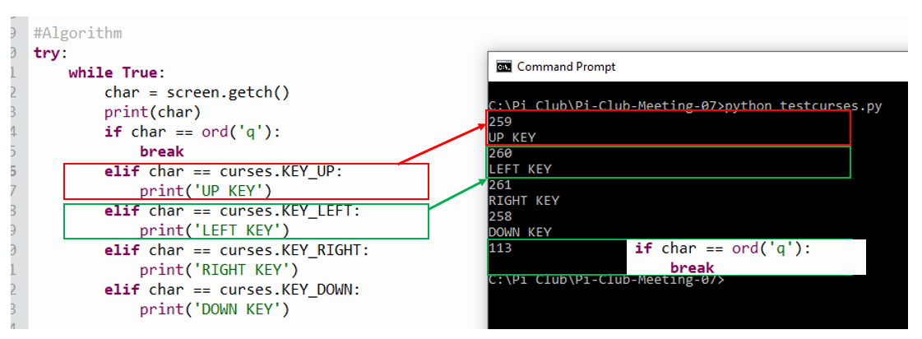

Simulation of Robot Control - Wiring Diagram [Here](Wiring%20Diagram%20LED%20for%20testing%20curses.docx) (Page 1 of handout)

cursescontrollingLEDs.py <cursescontrollingLEDS.py>

Do exercise using other keys (Page 2 of handout)

to get a better understanding of controls

Wiring up the Robotic car

L298N Wiring.ppt

Robot Car Wiring.docx

Test cursingrobby.py <cursingrobby.py>

Exercise to make robby do specific task – Page 3 of handout