
Міністерство освіти і науки України Національний технічний університет України
«Київський політехнічний інститут»

з дисципліни «Основи проектування трансляторів»

Виконав студент групи: КВ-22
ПІБ: Крутогуз Максим Ігорович
Перевірив:

Київ 2025
Мета розрахунково-графічної роботи
Метою лабораторної роботи «Розробка генератора коду» є засвоєння теоретичного матеріалу та набуття практичного досвіду і практичних навичок розробки генераторів коду.
Постановка задачі
- Разробити програму генератора коду (ГК) для подмножини мови програмування SIGNAL, заданої за варіантом.
- Програма генератора коду має забезпечувати:
- читання дерева розбору та таблиць, створених синтаксичним аналізатором, що було розроблено в розрахунково-графічній роботі;
- виявлення семантичних помилок;
- генерацію коду та/або побудову внутрішніх таблиць для генерації коду.
3. Зкомпонувати повний компілятор, що складається з розроблених раніше лексичного та синтаксичного аналізаторів і генератора коду, який забезпечує наступне:
- генерацію коду та/або побудову внутрішніх таблиць для генерації коду;
- формування лістингу вхідної програми з повідомленнями пролексичні, синтаксичні та семантичні помилки.

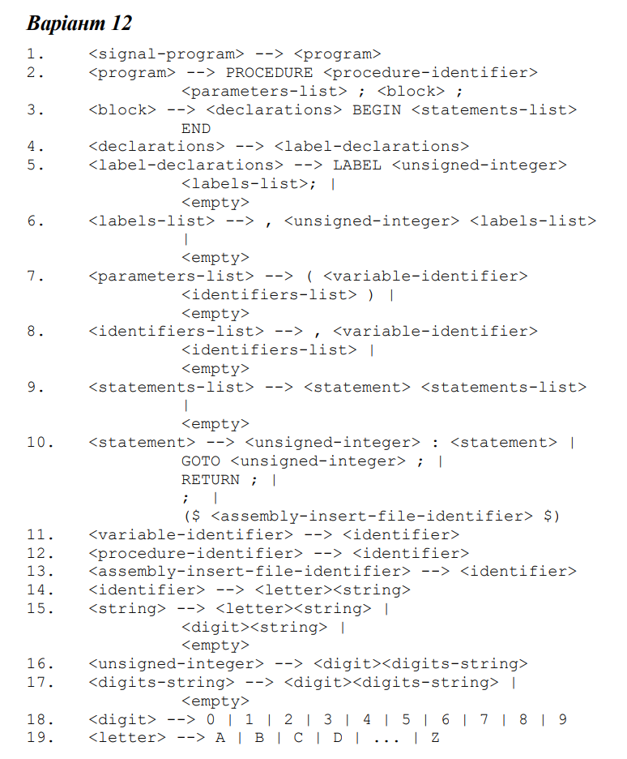
Рисунок 1 — Варіант завдання
Тестування
True тест 1:
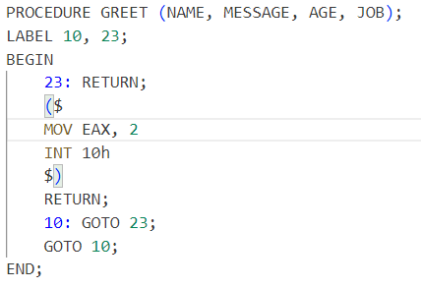
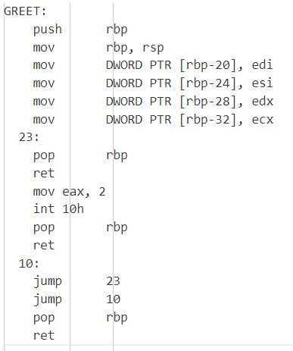
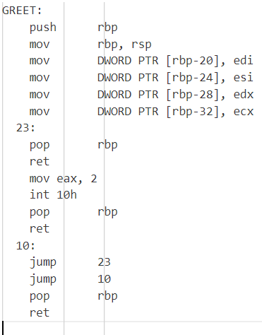
False-тест 1:
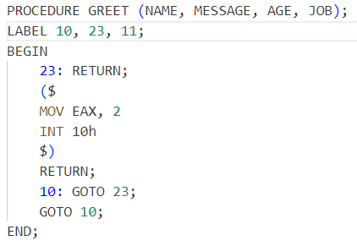
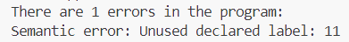
True тест 2:
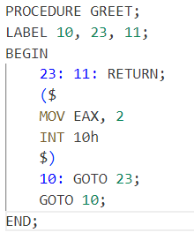
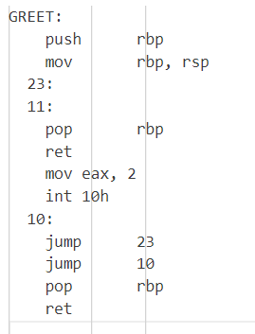
False-тест 2:
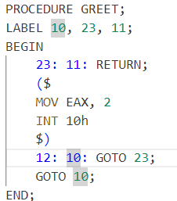
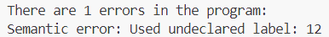
Github
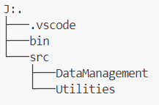
Код програми:
// App.cpp
#include "DataManagement/Global.hpp"
#include "Controller.hpp"
#include "ViewStream.hpp"
#include <string>

int main() {
ViewStream vs;
Controller("J:/Repositories/University/Translators/Lab2/bin/semantic2f.s", vs);
return 0;
}

// Controller.cpp
#include "Controller.hpp"
#include "Utilities/Parser.hpp"
#include "Utilities/CodeGenerator.hpp"

Controller::Controller(string filepath, ViewStream vs) :
_vs(vs),
_it(InformationTables(vs)),
_em(ErrorManager(vs))
{
this->run(filepath);

// _it.outputAllTables();

Parser parser(_it, _em, filepath);
parser.parse();
Tree* root = parser.getRoot();
if (root) {
// root->print();
}

CodeGenerator cg(_it, _em, "output.asm");

cg.run(root);

_em.output();
}

void Controller::run(string filepath) {
ifstream inputFile(filepath);
ostringstream buffer;

try {
if (inputFile.is_open()) {
char symbol;
int currentRow = 1;
int currentCol = 1;
bool isReadingAllowed = true;
bool isLoopActive;
while (!isReadingAllowed || inputFile.get(symbol)) {
if (inputFile.eof()) {
break;
}
isReadingAllowed = true;
switch (SYMBOL_CATEGORIES[(short)symbol]) {
case WHITESPACE:
switch (symbol)
{
case '\n':
currentCol = 1;
currentRow++;
break;
case '\t':
currentCol += 4;
break;
default:
currentCol++;
break;
}
break;
case CONSTANT_START:
do {
buffer << symbol;
} while (inputFile.get(symbol) && SYMBOL_CATEGORIES[(short)symbol] == CONSTANT_START);
_it.addConstant(buffer.str());
_it.prosessToken(NUMBER, buffer.str(), currentRow, currentCol);
currentCol += buffer.str().length();
buffer.str("");
isReadingAllowed = false;
break;
case IDENTIFIER_OR_KEYWORD_START:
do {
buffer << symbol;

} while (inputFile.get(symbol) && (SYMBOL_CATEGORIES[(short)symbol] == CONSTANT_START || SYMBOL_CATEGORIES[(short)symbol] == IDENTIFIER_OR_KEYWORD_START));
if (_it.isKeyword(buffer.str())) {
_it.prosessToken(KEYWORD, buffer.str(), currentRow, currentCol);
} else {
_it.addIdentifier(buffer.str());
_it.prosessToken(IDENTIFIER, buffer.str(), currentRow, currentCol);
}
currentCol += buffer.str().length();
buffer.str("");
isReadingAllowed = false;
break;
case UNIQUE_SEPARATORS:
buffer << symbol;
_it.prosessToken(SEPARATOR, buffer.str(), currentRow, currentCol);
buffer.str("");
currentCol++;
break;
case AMBIGUES_SEPARATORS:
buffer << symbol;
inputFile.get(symbol);
currentCol++;
short state;
isLoopActive = true;
int startRow;
int startCol;
switch (symbol) {
case '*':
buffer.str("");
state = COM;
while (isLoopActive) {
if (!inputFile.get(symbol)) {
throw Utilities::getErrorMessage(filepath, currentRow, currentCol, "Not closed commentary", "");
}

switch (symbol) {
case '\t':
currentCol += 4;
break;
case '\n':
currentCol = 1;
currentRow++;
break;
default:
currentCol++;
}
switch (state) {
case COM:
if (symbol == '*') {
state = ECOM;
}
break;
case ECOM:
if (symbol == ')') {
isLoopActive = false;
} else {
state = COM;
}
}
}
break;
case '$':
buffer.str("");
state = AI;
startRow = currentRow;
startCol = currentCol + 1;
while (isLoopActive) {
if (!inputFile.get(symbol)) {
throw Utilities::getErrorMessage(filepath, currentRow, currentCol, "Not closed assembly insertion", "");
}

switch (symbol) {
case '\t':
currentCol += 4;
break;
case '\n':
currentCol = 1;
currentRow++;
break;
default:
currentCol++;
}
bool isDollarMissed = false;
switch (state) {
case AI:
if (symbol == '$') {
state = EAI;
isDollarMissed = true;
} else {
buffer << symbol;
}
break;
case EAI:
if (symbol == ')') {
isLoopActive = false;
_it.prosessToken(ASSEMBLY_INSERTION, buffer.str(), startRow, startCol);
buffer.str("");

} else {
state = AI;
if (isDollarMissed) {
buffer << '$';
isDollarMissed = false;
}
if (symbol == '$') {
isDollarMissed = true;
state = EAI;
} else {
buffer << symbol;
}
}
}
}
break;
default:
_it.prosessToken(SEPARATOR, buffer.str(), currentRow, currentCol - 1);
buffer.str("");
// currentCol++;
isReadingAllowed = false;
break;
}
break;

case PROHIBITED_CHARACTER:
default:
_em.addCompilingError(Utilities::getErrorMessage(filepath, currentRow, currentCol, "Used prohibited character:", string(1, (char)symbol)));
currentCol++;
break;
}
}
} else {
throw string("Reading file error");
}
} catch (string erorrMessage) {
_em.addProgramError(erorrMessage);
}
}

// Controller.hpp
#include <fstream>
#include <iostream>
#include <string>
#include <sstream>
#include "DataManagement/Global.hpp"
#include "ViewStream.hpp"
#include "DataManagement/InformationTables.hpp"
#include "Utilities/ErrorManager.hpp"

#ifndef CONTROLLER_HPP
#define CONTROLLER_HPP

using namespace std;

class Controller {
public:
Controller(string filepath, ViewStream vs);
void run(string);

private:
ViewStream _vs;
InformationTables _it;
ErrorManager _em;
};

#endif

// ViewStream.cpp
#include "ViewStream.hpp"

ViewStream& ViewStream::operator<<(string data) {
cout << data;
return *this;
}

ViewStream& ViewStream::operator<<(const char data) {
cout << data;
return *this;
}

ViewStream& ViewStream::operator<<(int data) {
cout << data;
return *this;
}

// template <typename T>
// ViewStream& ViewStream::operator<<(T data) {
// cout << data;
// return *this;
// }

// template ViewStream& ViewStream::operator<<(ostream& data);
// template ViewStream& ViewStream::operator<<(istream& data);
// template ViewStream& ViewStream::operator<<(ofstream& data);
// template ViewStream& ViewStream::operator<<(ifstream& data);

// ViewStream.hpp
#include <sstream>
#include <iostream>
#include <string>

#ifndef VIEWSTEAM_HPP
#define VIEWSTEAM_HPP

using namespace std;

class ViewStream {
public:
// std::ostringstream buffer;

ViewStream& operator<<(string data);
ViewStream& operator<<(const char data);
ViewStream& operator<<(int data);

// template <typename T>
// ViewStream& operator<<(T data);
};

#endif

// Global.cpp
#include "Global.hpp"

int SYMBOL_CATEGORIES[] = {
PROHIBITED_CHARACTER, PROHIBITED_CHARACTER, PROHIBITED_CHARACTER, PROHIBITED_CHARACTER, PROHIBITED_CHARACTER,
PROHIBITED_CHARACTER,
PROHIBITED_CHARACTER,
PROHIBITED_CHARACTER,
PROHIBITED_CHARACTER,
WHITESPACE,
WHITESPACE,
WHITESPACE,
WHITESPACE,
WHITESPACE,
PROHIBITED_CHARACTER,
PROHIBITED_CHARACTER,
PROHIBITED_CHARACTER,
PROHIBITED_CHARACTER,
PROHIBITED_CHARACTER,
PROHIBITED_CHARACTER,
PROHIBITED_CHARACTER,
PROHIBITED_CHARACTER,
PROHIBITED_CHARACTER,
PROHIBITED_CHARACTER,
PROHIBITED_CHARACTER,
PROHIBITED_CHARACTER,
PROHIBITED_CHARACTER,
PROHIBITED_CHARACTER,
PROHIBITED_CHARACTER,
PROHIBITED_CHARACTER,
PROHIBITED_CHARACTER,
PROHIBITED_CHARACTER,
WHITESPACE,
PROHIBITED_CHARACTER,
PROHIBITED_CHARACTER,
PROHIBITED_CHARACTER,
PROHIBITED_CHARACTER,
PROHIBITED_CHARACTER,
PROHIBITED_CHARACTER,
PROHIBITED_CHARACTER,
AMBIGUES_SEPARATORS,
UNIQUE_SEPARATORS,
PROHIBITED_CHARACTER,
PROHIBITED_CHARACTER,
UNIQUE_SEPARATORS,
PROHIBITED_CHARACTER,
PROHIBITED_CHARACTER,
PROHIBITED_CHARACTER,
CONSTANT_START,
CONSTANT_START,
CONSTANT_START,
CONSTANT_START,
CONSTANT_START,
CONSTANT_START,
CONSTANT_START,
CONSTANT_START,
CONSTANT_START,
CONSTANT_START,
UNIQUE_SEPARATORS,
UNIQUE_SEPARATORS,
PROHIBITED_CHARACTER,
PROHIBITED_CHARACTER,
PROHIBITED_CHARACTER,
PROHIBITED_CHARACTER,
PROHIBITED_CHARACTER,
IDENTIFIER_OR_KEYWORD_START,
IDENTIFIER_OR_KEYWORD_START,
IDENTIFIER_OR_KEYWORD_START,
IDENTIFIER_OR_KEYWORD_START,
IDENTIFIER_OR_KEYWORD_START,
IDENTIFIER_OR_KEYWORD_START,
IDENTIFIER_OR_KEYWORD_START,
IDENTIFIER_OR_KEYWORD_START,
IDENTIFIER_OR_KEYWORD_START,
IDENTIFIER_OR_KEYWORD_START,
IDENTIFIER_OR_KEYWORD_START,
IDENTIFIER_OR_KEYWORD_START,
IDENTIFIER_OR_KEYWORD_START,
IDENTIFIER_OR_KEYWORD_START,
IDENTIFIER_OR_KEYWORD_START,
IDENTIFIER_OR_KEYWORD_START,
IDENTIFIER_OR_KEYWORD_START,
IDENTIFIER_OR_KEYWORD_START,
IDENTIFIER_OR_KEYWORD_START,
IDENTIFIER_OR_KEYWORD_START,
IDENTIFIER_OR_KEYWORD_START,
IDENTIFIER_OR_KEYWORD_START,
IDENTIFIER_OR_KEYWORD_START,
IDENTIFIER_OR_KEYWORD_START,
IDENTIFIER_OR_KEYWORD_START,
IDENTIFIER_OR_KEYWORD_START,
PROHIBITED_CHARACTER,
PROHIBITED_CHARACTER,
PROHIBITED_CHARACTER,
PROHIBITED_CHARACTER,
PROHIBITED_CHARACTER,
PROHIBITED_CHARACTER,
PROHIBITED_CHARACTER,
PROHIBITED_CHARACTER,
PROHIBITED_CHARACTER,
PROHIBITED_CHARACTER,
PROHIBITED_CHARACTER,
PROHIBITED_CHARACTER,
PROHIBITED_CHARACTER,
PROHIBITED_CHARACTER,
PROHIBITED_CHARACTER,
PROHIBITED_CHARACTER,
PROHIBITED_CHARACTER,
PROHIBITED_CHARACTER,
PROHIBITED_CHARACTER,
PROHIBITED_CHARACTER,
PROHIBITED_CHARACTER,
PROHIBITED_CHARACTER,
PROHIBITED_CHARACTER,
PROHIBITED_CHARACTER,
PROHIBITED_CHARACTER,
PROHIBITED_CHARACTER,
PROHIBITED_CHARACTER,
PROHIBITED_CHARACTER,
PROHIBITED_CHARACTER,
PROHIBITED_CHARACTER,
PROHIBITED_CHARACTER,
PROHIBITED_CHARACTER,
PROHIBITED_CHARACTER,
PROHIBITED_CHARACTER,
PROHIBITED_CHARACTER,
PROHIBITED_CHARACTER,
};

map<short, string> TOKEN_MAP = {
{NUMBER, "Number"},
{KEYWORD, "Keyword"},
// {CONSTANT, "Constant"},
{IDENTIFIER, "Identifier"}
};

map<int, string> PARAM_REG_MAP = {
{0, "edi"},
{1, "esi"},
{2, "edx"},
{3, "ecx"},
{4, "r8d"},
{5, "r9d"}
};

// Global.hpp
#include <map>
#include <string>

#ifndef GLOBAL_HPP
#define GLOBAL_HPP

using namespace std;

extern int SYMBOL_CATEGORIES[];

extern map<short, string> TOKEN_MAP;

extern map<int, string> PARAM_REG_MAP;

enum tokensType {
NUMBER,
KEYWORD,
IDENTIFIER,
SEPARATOR,
ASSEMBLY_INSERTION,
KEYWORD_OR_IDENDIFIER,
END_OF_FILE
};

enum category {
WHITESPACE,
CONSTANT_START,
IDENTIFIER_OR_KEYWORD_START,
UNIQUE_SEPARATORS,
AMBIGUES_SEPARATORS,
PROHIBITED_CHARACTER
};

enum state {
CNS,
IDN,
BCAI,
COM,
AI,
ECOM,
EAI,
OUT
};

#endif

// InformationTables.cpp
#include "InformationTables.hpp"

InformationTables::InformationTables(ViewStream& vs) :
_nextNumberInOneCharacterSeperatorTable(0),
_nextNumberInMultiCharacterSeperatorTable(301),
_nextNumberInKeywordTable(601),
_nextNumberInConstantTable(1001),
_nextNumberInIdentifierTable(1000001),
_nextNumberInAssemblyInsertionTable(2000001),
_vs(vs),
_currentTokenIndex(0)
{
initializeTables();
// We can estimate size of file and reserve size for optimization
_tokenTable.reserve(100000);
}

ViewStream& InformationTables::getViewStream() {
return _vs;
}

void InformationTables::initializeTables() {
initializeOneCharacterSeparatorTable();
initializeMultiCharecterSeparatorTable();
initializeKeywordTable();
}

void InformationTables::initializeOneCharacterSeparatorTable() {
_oneCharacterSeparatorTable[";"] = 0;
_oneCharacterSeparatorTable[","] = 1;
_oneCharacterSeparatorTable["("] = 2;
_oneCharacterSeparatorTable[")"] = 3;
_oneCharacterSeparatorTable[":"] = 4;
_nextNumberInOneCharacterSeperatorTable = 5;
}

void InformationTables::initializeMultiCharecterSeparatorTable() {
_multiCharecterSeparatorTable["(*"] = _nextNumberInMultiCharacterSeperatorTable++;
_multiCharecterSeparatorTable["*)"] = _nextNumberInMultiCharacterSeperatorTable++;
_multiCharecterSeparatorTable["($"] = _nextNumberInMultiCharacterSeperatorTable++;
_multiCharecterSeparatorTable["$)"] = _nextNumberInMultiCharacterSeperatorTable++;
}

void InformationTables::initializeKeywordTable() {
_keywordTable["PROCEDURE"] = _nextNumberInKeywordTable++;
_keywordTable["BEGIN"] = _nextNumberInKeywordTable++;
_keywordTable["END"] = _nextNumberInKeywordTable++;
_keywordTable["LABEL"] = _nextNumberInKeywordTable++;
_keywordTable["GOTO"] = _nextNumberInKeywordTable++;
_keywordTable["RETURN"] = _nextNumberInKeywordTable++;
}

void InformationTables::outputAllTables() {
if (_oneCharacterSeparatorTable.size() > 0) {
outputOneCharacterSeparatorTable();
_vs << '\n';
}
if (_multiCharecterSeparatorTable.size() > 0) {
outputMultiCharecterSeparatorTable();
_vs << '\n';
}
if (_keywordTable.size() > 0) {
outputKeywordTable();
_vs << '\n';
}
if (_constantTable.size() > 0) {
outputConstantTable();
_vs << '\n';
}
if (_identifierTable.size() > 0) {
outputIdentifierTable();
_vs << '\n';
}
if (_asssemblyInsertionTable.size() > 0) {
outputAssemblyInsertionTable();
_vs << '\n';
}
if (_tokenTable.size() > 0) {
outputTokenTable();
_vs << '\n';
}
}

void InformationTables::outputTokenTable() {
_vs << "Token table\n";
_vs << "Type Code Row Col\n";
for (const auto& pair : _tokenTable) {
// string str = this->token_map[pair.code];
_vs << Utilities::getLeftString(pair.type, 10);
_vs << Utilities::getLeftString(pair.code, 10);
_vs << Utilities::getLeftString(pair.row, 10);
_vs << Utilities::getLeftString(pair.col, 10) << '\n';
}
}

void InformationTables::outputOneCharacterSeparatorTable() {
_vs << "Onecharacter separator table:\n";
for (const auto& pair : _oneCharacterSeparatorTable) {
_vs << pair.first << " -> " << pair.second << '\n';
}
}

void InformationTables::outputMultiCharecterSeparatorTable() {
_vs << "Multicharacter separator table:\n";
for (const auto& pair : _multiCharecterSeparatorTable) {
_vs << pair.first << " -> " << pair.second << '\n';
}
}

void InformationTables::outputKeywordTable() {
_vs << "Keyword table:\n";
for (const auto& pair : _keywordTable) {
_vs << pair.first << " -> " << pair.second << '\n';
}
}

void InformationTables::outputConstantTable() {
_vs << "Constant table:\n";
for (const auto& pair : _constantTable) {
_vs << pair.first << " -> " << pair.second << '\n';
}
}

void InformationTables::outputIdentifierTable() {
_vs << "Identifier table:\n";
for (const auto& pair : _identifierTable) {
_vs << pair.first << " -> " << pair.second << '\n';
}
}

void InformationTables::outputAssemblyInsertionTable() {
_vs << "Assembly insertion\n";
for (const auto& pair : _asssemblyInsertionTable) {
_vs << pair.first << " -> " << pair.second << '\n';
}
}

void InformationTables::addToken(Token token) {
_tokenTable.push_back(token);
}

void InformationTables::prosessToken(short tokenType, string tokenName, int row, int col) {
int code;
switch (tokenType) {
case NUMBER:
code = _constantTable[tokenName];
addToken(Token({NUMBER, code, row, col}));
break;
case KEYWORD:
code = _keywordTable[tokenName];
addToken(Token({KEYWORD, code, row, col}));
break;
case IDENTIFIER:
code = _identifierTable[tokenName];
addToken(Token({IDENTIFIER, code, row, col}));
break;
case SEPARATOR:
code = _oneCharacterSeparatorTable[tokenName];
addToken(Token({SEPARATOR, code, row, col}));
break;
case ASSEMBLY_INSERTION:
string trimedTokenName = Utilities::trim(tokenName);

addAssemblyInsertion(trimedTokenName);

code = _asssemblyInsertionTable[trimedTokenName];
addToken(Token({ASSEMBLY_INSERTION, code, row, col}));
break;
}
}

void InformationTables::addConstant(string constantValue) {
if (!_constantTable.count(constantValue)) {
_constantTable[constantValue] = _nextNumberInConstantTable++;
}
}

void InformationTables::addIdentifier(string identifierValue) {
if (!_identifierTable.count(identifierValue)) {
_identifierTable[identifierValue] = _nextNumberInIdentifierTable++;
}
}

void InformationTables::addAssemblyInsertion(string assemblyInsertion) {
string trimedTokenName = Utilities::trim(assemblyInsertion);

if (!_asssemblyInsertionTable.count(trimedTokenName)) {
_asssemblyInsertionTable[assemblyInsertion] = _nextNumberInAssemblyInsertionTable++;
}
}

bool InformationTables::isKeyword(string token) {
auto it = _keywordTable.find(token);

if (it != _keywordTable.end()) {
return true;
} else {
return false;
}
}

Token InformationTables::getNextToken() {
if (_tokenTable.size() - 1 >= (size_t)_currentTokenIndex) {
return _tokenTable[_currentTokenIndex++];
} else {
return Token({END_OF_FILE, 0, 0, 0});
}
}

string InformationTables::getTokenValue(int tokenCode) const {
map<string, int> currentTokenTable;
if (tokenCode < 300) {
currentTokenTable = _oneCharacterSeparatorTable;
} else if (tokenCode < 600) {
currentTokenTable = _multiCharecterSeparatorTable;
} else if (tokenCode < 1000) {
currentTokenTable = _keywordTable;
} else if (tokenCode < 1000000) {
currentTokenTable = _constantTable;
} else if (tokenCode < 2000000) {
currentTokenTable = _identifierTable;
} else {
currentTokenTable = _asssemblyInsertionTable;
}

for (const auto& pair : currentTokenTable) {
if (pair.second == tokenCode) {
return pair.first;
}
}

return "Unknown token";
}

// InformationTables.hpp
#include <string>
#include <map>
#include <vector>
#include <iomanip>
#include <iostream>
#include "../ViewStream.hpp"
#include "../Utilities/Utilities.hpp"
#include "Global.hpp"

#ifndef INFORMATAIONTABLES_HPP
#define INFORMATAIONTABLES_HPP

using namespace std;

typedef struct {
short type;
int code;
int row;
int col;
} Token;

class InformationTables {
public:
InformationTables(ViewStream& vs);
void initializeTables();

void outputOneCharacterSeparatorTable();
void outputMultiCharecterSeparatorTable();
void outputKeywordTable();
void outputConstantTable();
void outputIdentifierTable();
void outputTokenTable();
void outputAssemblyInsertionTable();
void outputAllTables();

bool isKeyword(string token);

void addConstant(string constantValue);
void addIdentifier(string identifierValue);
void addAssemblyInsertion(string assemblyInsertion);

void prosessToken(short tokenType, string tokenName, int row, int col);

Token getNextToken();

string getTokenValue(int tokenCode) const;

ViewStream& getViewStream();

private:
map<string, int> _oneCharacterSeparatorTable;
map<string, int> _multiCharecterSeparatorTable;
map<string, int> _keywordTable;
map<string, int> _constantTable;
map<string, int> _identifierTable;
map<string, int> _asssemblyInsertionTable;

int _nextNumberInOneCharacterSeperatorTable;
int _nextNumberInMultiCharacterSeperatorTable;
int _nextNumberInKeywordTable;
int _nextNumberInConstantTable;
int _nextNumberInIdentifierTable;
int _nextNumberInAssemblyInsertionTable;

ViewStream _vs;

vector<Token> _tokenTable;
int _currentTokenIndex;

void initializeOneCharacterSeparatorTable();
void initializeMultiCharecterSeparatorTable();
void initializeKeywordTable();

void addToken(Token token);
};

#endif

// Tree.cpp
#include "Tree.hpp"

Tree::~Tree() {}

Tree::Tree(InformationTables& informationTables) :
_parent(nullptr),
_informationTables(informationTables),
_vs(_informationTables.getViewStream()) {}

void Tree::setParent(Tree* parent) {
_parent = parent;
}

Tree* Tree::getParent() const {
return _parent;
}

bool Tree::isNode() const {
return false;
}

void Tree::add(Tree*) {}

void Tree::remove(Tree*) {}

void Tree::clearMemory() {}

// Node class implementation

Node::Node(InformationTables& informationTables, string nodeName) : Tree(informationTables), _nodeName(move(nodeName)) {}

bool Node::isNode() const {
return true;
}

void Node::add(Tree* child) {
if (!child) {
return;
}
_children.push_back(child);
child->setParent(this);
}

void Node::remove(Tree* child) {
if (!child) {
return;
}

_children.remove(child);
child->setParent(nullptr);
}

void Node::clearMemory() {
for (auto child : _children) {
child->clearMemory();
delete child;
}
_children.clear();
}

void Node::print(int indent) const {
for (int i = 0; i < indent; ++i) {
_vs << " ";
}
_vs << _nodeName << '\n';
for (const auto& child : _children) {
child->print(indent + 2);
}
}

list<Tree*> Node::getChildren() {
return _children;
}

string Node::getName() const {
return _nodeName;
}

// Leaf class implementation

Leaf::Leaf(InformationTables& informationTables, Token token) : Tree(informationTables), _token(token) {}

void Leaf::print(int indent) const {
for (int i = 0; i < indent; ++i) {
_vs << " ";
}
_vs << _informationTables.getTokenValue(_token.code) << '\n';
}

string Leaf::getName() const {
return _informationTables.getTokenValue(_token.code);
}

Token Leaf::getToken() const {
return _token;
}

// Tree.hpp
#ifndef TREE_HPP
#define TREE_HPP

using namespace std;

#include <list>
#include <string>
#include "InformationTables.hpp"

class Tree {
protected:
Tree* _parent;
InformationTables& _informationTables;
ViewStream& _vs;

public:
virtual ~Tree();
Tree(InformationTables& informationTables);

void setParent(Tree* parent);
Tree *getParent() const;

virtual bool isNode() const;

virtual void add(Tree* child);
virtual void remove(Tree* child);

virtual void clearMemory();

virtual void print(int indent = 0) const = 0;

virtual string getName() const = 0;
};

class Node : public Tree {
public:
Node(InformationTables& informationTables, string nodeName);
bool isNode() const override;
void add(Tree* child) override;
void remove(Tree* child) override;
void clearMemory() override;

void print(int indent = 0) const override;

virtual string getName() const override;

list<Tree*> getChildren();

protected:
list<Tree*> _children;
string _nodeName;
};

class Leaf : public Tree {
private:
Token _token;

public:
Leaf(InformationTables& InformationTables, Token token);

virtual string getName() const override;

Token getToken() const;

void print(int indent = 0) const override;
};

#endif

// CodeGenerator.cpp
#include "CodeGenerator.hpp"

CodeGenerator::CodeGenerator(InformationTables& informationTables, ErrorManager& errorManager, string filename) : _file(fstream(filename, std::ios::out)), _it(informationTables), _em(errorManager) {}

CodeGenerator::~CodeGenerator() {
_file.close();
}

void CodeGenerator::run(Tree* tree) {
try {
_tree = tree;
if (tree->isNode()) {
auto programChildren = dynamic_cast<Node*>(tree)->getChildren();
for (Tree* child : programChildren) {
// cout << child->getName() << endl;
if (child->getName() == "<PROCEDURE_IDENTIFIER>") {
auto ch = dynamic_cast<Node*>(child)->getChildren();
_file << ch.front()->getName() << ":\n";
_file << setw(4) << ' ' << left << setw(10) << "push" << "rbp" << endl;
_file << setw(4) << ' ' << left << setw(10) << "mov" << "rbp, rsp" << endl;
} else if (child->getName() == "<PARAMETERS_LIST>") {
auto ch = dynamic_cast<Node*>(child)->getChildren();

int i = 0;
for (Tree* param : ch) {
// auto paramLeaf = dynamic_cast<Leaf*>(param);

// Token token = paramLeaf->getToken();
_file << setw(4) << ' ' << left << setw(10) << "mov" << "DWORD PTR [rbp-" << 20 + 4*i << "], " << PARAM_REG_MAP[i] << endl;
i++;
}
} else if (child->getName() == "<BLOCK>") {
block(child);
}
}
_file << setw(4) << ' ' << left << setw(10) << "pop" << "rbp" << endl;
_file << setw(4) << ' ' << left << setw(10) << "ret" << endl;
}

for (auto label : _labels) {
if (!label.second) {
stringstream ss;
ss << "Semantic error: Unused declared label: " << label.first;
throw runtime_error(ss.str());
}
}

}
catch (const runtime_error& e) {
_em.addProgramError(e.what());
// cout << "[]" << endl;
}
}

void CodeGenerator::block(Tree* tree) {
if (tree->isNode()) {
auto blockChildren = dynamic_cast<Node*>(tree)->getChildren();
for (Tree* child : blockChildren) {
if (child->getName() == "<LABEL_DECLARATIONS>") {
auto labels = dynamic_cast<Node*>(child)->getChildren();

for (auto label : labels) {
auto labelLeaf = dynamic_cast<Leaf*>(label);
string labelStr = _it.getTokenValue(labelLeaf->getToken().code);
_labels[stoi(labelStr)] = false;
}
} else if (child->getName() == "<STATEMENTS_LIST>") {
auto statements = dynamic_cast<Node*>(child)->getChildren();

for (auto state : statements) {
if (state->getName() == "<STATEMENT>") {
statement(state);
}
}
}
}
}
}

void CodeGenerator::statement(Tree* tree) {
auto statementChildren = dynamic_cast<Node*>(tree)->getChildren();

if (statementChildren.front()->getName() == "RETURN") {
_file << setw(4) << ' ' << left << setw(10) << "pop" << "rbp" << endl;
_file << setw(4) << ' ' << left << setw(10) << "ret" << endl;
} else if (statementChildren.front()->getName() == "<ASSEMBLY_INSERTION>") {
auto assemblyInsertionNode = dynamic_cast<Node*>(statementChildren.front());

printAssemblyInsertion(assemblyInsertionNode->getChildren().front());
} else if (statementChildren.front()->getName() == "<STATEMENT_WITH_LABEL>") {
auto statementList = dynamic_cast<Node*>(statementChildren.front())->getChildren();

int i = 0;
for (auto labelStatement : statementList) {
if (i == 0) {
Leaf* labelSatementLeaf = dynamic_cast<Leaf*>(labelStatement);

int labelValue = stoi(_it.getTokenValue(labelSatementLeaf->getToken().code));

if (_labels.count(labelValue) != 0) {
_labels[labelValue] = true;
_file << setw(2) << ' ' << labelValue << ':' << endl;
} else {
stringstream ss;
ss << "Semantic error: Used undeclared label: " << labelValue;
throw runtime_error(ss.str());
}
} else if (i == 1) {
statement(labelStatement);
}
i++;
}
} else if (statementChildren.front()->getName() == "GOTO") {
if (statementChildren.size() >= 2) {
auto it = statementChildren.begin();
++it;
auto gotoNumberLeaf = dynamic_cast<Leaf*>(*it);
_file << setw(4) << ' ' << left << setw(10) << "jump" << _it.getTokenValue(gotoNumberLeaf->getToken().code) << endl;
}
}
}

void CodeGenerator::printAssemblyInsertion(Tree* tree) {
Leaf* leaf = dynamic_cast<Leaf*>(tree);
istringstream ss(_it.getTokenValue(leaf->getToken().code));
string line;

while (getline(ss, line)) {
transform(line.begin(), line.end(), line.begin(),
[](unsigned char c) { return std::tolower(c); });
_file << setw(4) << ' ' << left << setw(10) << Utilities::trim(line) << endl;
}
}

// CodeGenerator.hpp
#ifndef CODEGENERATOR_HPP
#define CODEGENERATOR_HPP

#include <string>
#include <fstream>
#include <iomanip>
#include <map>
#include <sstream>
#include <algorithm>
#include <cctype>

#include "../DataManagement/Tree.hpp"
#include "../DataManagement/Global.hpp"
#include "Utilities.hpp"
#include "ErrorManager.hpp"

class CodeGenerator {
public:
CodeGenerator(InformationTables& informationTables, ErrorManager& errorManager, string filename);
~CodeGenerator();
void run(Tree* tree);

private:
fstream _file;
Tree* _tree;
map<int, bool> _labels;
InformationTables& _it;
ErrorManager& _em;

void block(Tree* tree);
void statement(Tree* tree);

void printAssemblyInsertion(Tree* tree);
};

#endif

// ErrorManager.cpp
#include "ErrorManager.hpp"

ErrorManager::ErrorManager(ViewStream& vs) : _vs(vs) {}

void ErrorManager::addProgramError(string errorMessage) {
this->_programErrorMessages.push_back(errorMessage);
}

void ErrorManager::addCompilingError(string errorMessage) {
this->_compilingErrorMessages.push_back(errorMessage);
}

void ErrorManager::output() {
if (_compilingErrorMessages.size() > 0 || _programErrorMessages.size() > 0) {
_vs << "There are " << to_string(_compilingErrorMessages.size() + _programErrorMessages.size()) << " errors in the program:\n";
for (auto& err : _programErrorMessages) {
_vs << err << '\n';
}
for (auto& err : _compilingErrorMessages) {
_vs << err << '\n';
}
} else {
_vs << "There are no errors in a program.\n";
}
}

// ErrorManager.hpp
#include <string>
#include <vector>
#include "../ViewStream.hpp"

#ifndef ERRORMANAGER_HPP
#define ERRORMANAGER_HPP

using namespace std;

class ErrorManager
{
public:
ErrorManager(ViewStream& vs);
void addProgramError(string errorMessage);
void addCompilingError(string errorMessage);

void output();

private:
ViewStream _vs;
vector<string> _programErrorMessages;
vector<string> _compilingErrorMessages;
};

#endif

// Parser.cpp
#include "Parser.hpp"

Parser::Parser(InformationTables& informationTables, ErrorManager& em, string filepath) : _informationTables(informationTables), _vs(_informationTables.getViewStream()), _em(em), _filepath(filepath), _currentToken(_informationTables.getNextToken()), _root(nullptr) {}

Tree* Parser::getRoot() const {
return _root;
}

void Parser::eat(short type, string message = "undefined") {
if (_currentToken.code != type || _currentToken.type == END_OF_FILE) {
stringstream ss;
if (_currentToken.type == END_OF_FILE) {
ss << Utilities::getErrorMessage(_filepath, -1, -1, "In", message) << " part of syntax was end of file without next token:" << _informationTables.getTokenValue(_currentToken.code);
throw runtime_error(ss.str());
}
ss << Utilities::getErrorMessage(_filepath, _currentToken.row, _currentToken.col, "In", message) << " part of syntax was used prohibited token " << _informationTables.getTokenValue(_currentToken.code) << " or nessasary token was missed";
throw runtime_error(ss.str());
}
_currentToken = _informationTables.getNextToken();
}

void Parser::eatType(short type, string message = "undefined") {
if (_currentToken.type != type) {
stringstream ss;
ss << Utilities::getErrorMessage(_filepath, _currentToken.row, _currentToken.col, "In", message) << " part of syntax was used prohibited token " << _informationTables.getTokenValue(_currentToken.code) << " or nessasary token was missed";
throw runtime_error(ss.str());
}
_currentToken = _informationTables.getNextToken();
}

void Parser::parse() {
try {
Tree* tree = program();
// Token token = _informationTables.getNextToken();
// Tree * root = new Node(_informationTables, "root");
// Tree* leaf1 = new Leaf(_informationTables, token);
// root->add(leaf1);
// Tree* leaf2 = new Leaf(_informationTables, _informationTables.getNextToken());
// root->add(leaf2);
// Tree* leaf3 = new Leaf(_informationTables, _informationTables.getNextToken());
// root->add(leaf3);
// root->print();

// root->clearMemory();
// delete root;

_root = tree;
}
catch (const exception& e) {
_em.addProgramError(e.what());
if (_root) {
_root->clearMemory();
delete _root;
_root = nullptr;
}
}
catch (...) {
_em.addProgramError("Unknown error occurred in parser.");
if (_root) {
_root->clearMemory();
delete _root;
_root = nullptr;
}
}

}

Tree* Parser::program() {
Tree* root = new Node(_informationTables, "<PROGRAM>");

eat(PROCEDURE, "PROGRAM");

root->add(procedureIndetifier());

if (_currentToken.code == LEFT_PARENTHESIS) {
eat(LEFT_PARENTHESIS, "PARAMETER_LIST");
root->add(parametersList());
eat(RIGHT_PARENTHESIS, "PARAMETER_LIST");
}

eat(SEMICOLON, "PROGRAM");

root->add(block());

eat(SEMICOLON, "PROGRAM");

return root;
}

Tree* Parser::procedureIndetifier() {
Tree* node = new Node(_informationTables, "<PROCEDURE_IDENTIFIER>");
node->add(new Leaf(_informationTables, _currentToken));
eatType(IDENTIFIER);
return node;
}

Tree* Parser::block() {
Tree* node = new Node(_informationTables, "<BLOCK>");

if (_currentToken.code == LABEL) {
node->add(labelDeclarations());
}

eat(BEGIN, "BLOCK");

node->add(statementsList());

eat(END, "BLOCK");

return node;
}

Tree* Parser::statementsList() {
Tree* node = new Node(_informationTables, "<STATEMENTS_LIST>");
while (_currentToken.code != END) {
node->add(statement());
}

return node;
}

Tree* Parser::statement() {
Tree* node = new Node(_informationTables, "<STATEMENT>");

switch (_currentToken.code) {
case GOTO:
{
Tree* gotoNode = new Node(_informationTables, "GOTO");
node->add(gotoNode);
eat(GOTO, "GOTO");
node->add(new Leaf(_informationTables, _currentToken));
eatType(NUMBER, "GOTO");
eat(SEMICOLON, "GOTO");
break;
}

case RETURN:
node->add(new Leaf(_informationTables, _currentToken));
eat(RETURN, "RETURN");
eat(SEMICOLON, "RETURN");
break;

default:
{
if (_currentToken.type == NUMBER) {
Tree* statementNode = new Node(_informationTables, "<STATEMENT_WITH_LABEL>");
node->add(statementNode);

statementNode->add(new Leaf(_informationTables, _currentToken));
eatType(NUMBER, "STATEMENT_WITH_LABEL");
eat(COLON, "STATEMENT_WITH_LABEL");
statementNode->add(statement());
} else if (_currentToken.type == ASSEMBLY_INSERTION) {
Tree* assemblyInsertionNode = new Node(_informationTables, "<ASSEMBLY_INSERTION>");
node->add(assemblyInsertionNode);
assemblyInsertionNode->add(new Leaf(_informationTables, _currentToken));
eatType(ASSEMBLY_INSERTION, "ASSEMBLY_INSERTION");

} else {
throw runtime_error(Utilities::getErrorMessage(_filepath, _currentToken.row, _currentToken.col, "In STATEMENT part of program is unexpected token or nessasary was missed:", _informationTables.getTokenValue(_currentToken.code)));
}
}
}
return node;
}

Tree* Parser::parametersList() {
Tree* node = new Node(_informationTables, "<PARAMETERS_LIST>");
node->add(new Leaf(_informationTables, _currentToken));
eatType(IDENTIFIER, "PARAMETERS_LIST");

while (_currentToken.code == COMMA) {
eat(COMMA, "PARAMETERS_LIST");
node->add(new Leaf(_informationTables, _currentToken));
eatType(IDENTIFIER, "PARAMETERS_LIST");
}

return node;
}

Tree* Parser::labelDeclarations() {
Tree* node = new Node(_informationTables, "<LABEL_DECLARATIONS>");
eat(LABEL, "LABEL_DECLARATIONS");

node->add(new Leaf(_informationTables, _currentToken));
eatType(NUMBER, "LABEL_DECLARATIONS");

while (_currentToken.code == COMMA) {
eat(COMMA, "LABEL_DECLARATIONS");
node->add(new Leaf(_informationTables, _currentToken));
eatType(NUMBER, "LABEL_DECLARATIONS");
}

eat(SEMICOLON, "LABEL_DECLARATIONS");

return node;
}

// Parser.hpp
#ifndef PARSER_HPP
#define PARSER_HPP

#include "../DataManagement/InformationTables.hpp"
#include "../DataManagement/Tree.hpp"
#include "../Utilities/ErrorManager.hpp"
#include "../Utilities/Utilities.hpp"
#include "../DataManagement/Global.hpp"

class Parser {
public:
enum TokenValue {
SEMICOLON = 0,
COMMA = 1,
LEFT_PARENTHESIS = 2,
RIGHT_PARENTHESIS = 3,
COLON = 4,
COMMENT_START = 301,
COMMENT_END = 302,
ASSEMBLY_INSERTION_START = 303,
ASSEMBLY_INSERTION_END = 304,
PROCEDURE = 601,
BEGIN = 602,
END = 603,
LABEL = 604,
GOTO = 605,
RETURN = 606,
};

Parser(InformationTables& informationTables, ErrorManager& errorManager, string filepath);
void parse();
Tree* getRoot() const;

private:
InformationTables &_informationTables;
ViewStream &_vs;
ErrorManager &_em;
string _filepath;
Token _currentToken;
Tree* _root;

void eat(short type, string message);
void eatType(short type, string message);

Tree* program();
Tree* procedureIndetifier();
Tree* block();
Tree* statementsList();
Tree* statement();
Tree* parametersList();
Tree* labelDeclarations();
};

#endif

// Utilities.cpp
#include "Utilities.hpp"

string Utilities::getLeftString(int value, int width) {
return getLeftString(to_string(value), width);
}

string Utilities::getLeftString(string str, int width) {
ostringstream ss;
ss << left << setw(width) << str;
return ss.str();
}

string Utilities::getErrorMessage(string filename, int row, int col, string errorMessage, string problemPart) {
ostringstream ss;
if (row != -1) {
ss << filename << ':' << row << ':' << col << ": error: " << errorMessage << ' ' << problemPart;
} else {
ss << filename << ": error: " << errorMessage << ' ' << problemPart;
}
return ss.str();
}

string Utilities::trim(const string& str) {
if (str.empty()) return str;

size_t start = str.find_first_not_of(" \t\n\r");
if (start == string::npos) return "";

size_t end = str.find_last_not_of(" \t\n\r");

return str.substr(start, end - start + 1);
}

// Utilities.hpp
#include <string>
#include <sstream>
#include <iostream>
#include <iomanip>
#include <algorithm>
#include "../DataManagement/Global.hpp"

#ifndef UTILITIES_HPP
#define UTILITIES_HPP

using namespace std;

class Utilities {
public:
static string getLeftString(int value, int width);
static string getLeftString(string value, int width);
static string getErrorMessage(string filename, int row, int col, string errorMessage, string problemPart);
static string trim(const string& str);
};

#endif

