
Міністерство освіти і науки України Національний технічний університет України
«Київський політехнічний інститут»

Лабораторна робота №3

з дисципліни «Введення до операційних систем»

Виконав студент групи: КВ-22
ПІБ: Крутогуз Максим Ігорович
Перевірив:

Київ 2025
Варіант завдання:
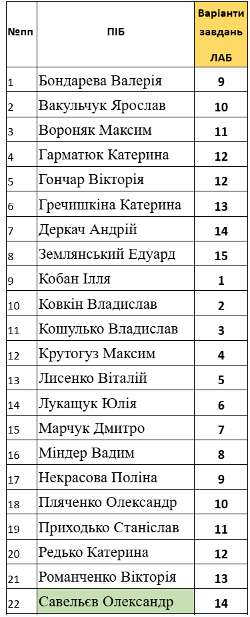
4-ий варіант:
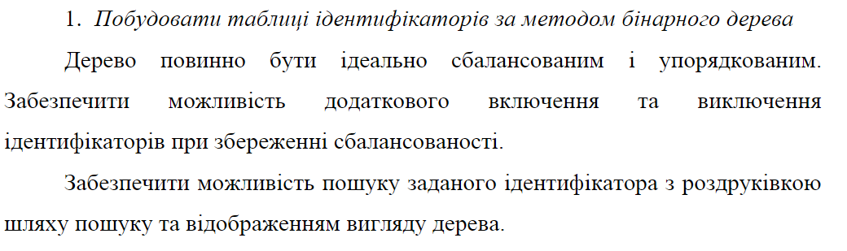
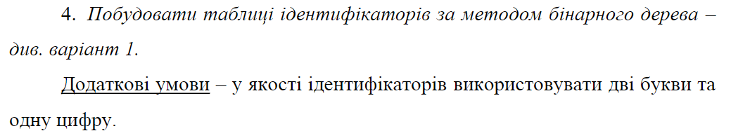
Робота програми:
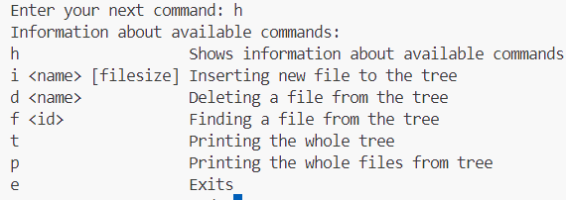
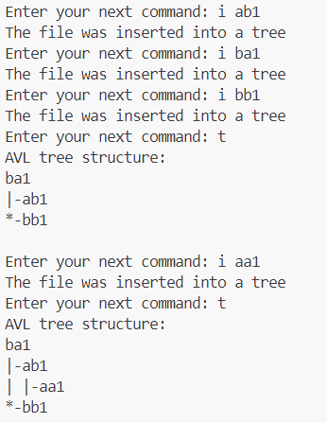
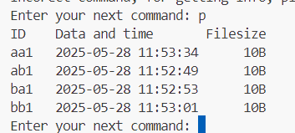
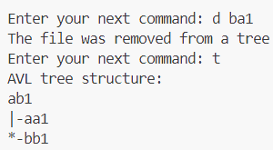
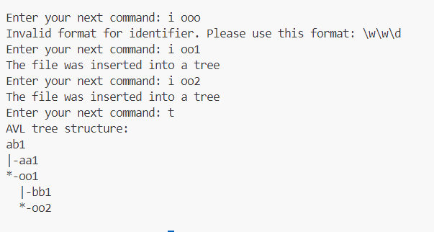
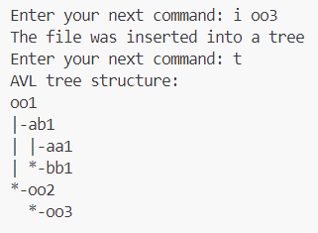

Лістинг
// App.cpp
#include <iostream>

#include "Controller.hpp"

using namespace std;

int main() {
Controller controler;

controler.run();

return 0;
}

// AVLTree.cpp
#include "AVLTree.hpp"

int AVLTree::getHeight(AVLNode* node) {
return node ? node->height : 0;
}

int AVLTree::getBalance(AVLNode* node) {
return node ? getHeight(node->left) - getHeight(node->right) : 0;
}

void AVLTree::updateHeight(AVLNode* node) {
node->height = max(getHeight(node->left), getHeight(node->right)) + 1;
}

AVLNode* AVLTree::rightRotate(AVLNode* A) {
AVLNode* B = A->left;
AVLNode* T2 = B->right;

B->right = A;
A->left = T2;

updateHeight(A);
updateHeight(B);

return B;
}

AVLNode* AVLTree::leftRotate(AVLNode* A) {
AVLNode* B = A->right;
AVLNode* T2 = B->left;

B->left = A;
A->right = T2;

updateHeight(A);
updateHeight(B);

return B;
}

AVLNode* AVLTree::insertNode(AVLNode* node, const FileInfo& file) {
if (!node) {
node = new AVLNode(file);
}

if (file < node->file) {
node->left = insertNode(node->left, file);
} else if (file > node->file) {
node->right = insertNode(node->right, file);
} else {
// duplicated found
return node;
}

updateHeight(node);

int balance = getBalance(node);

//Left left case
if (balance > 1 && file < node->file) {
return rightRotate(node);
}

//Right right case
if (balance < -1 && file > node->file) {
return leftRotate(node);
}

//Left right case
if (balance > 1 && file > node->file) {
node->left = leftRotate(node->left);
return rightRotate(node);
}

//Right left case
if (balance < -1 && file < node->file) {
node->right = rightRotate(node->right);
return leftRotate(node);
}

return node;
}

AVLNode* AVLTree::minValueNode(AVLNode* node) {
AVLNode* currentNode = node;

while (currentNode->left) {
currentNode = currentNode->left;
}

return currentNode;
}

AVLNode* AVLTree::deleteNode(AVLNode* node, const string& id) {
if (!node) {
return node;
}

if (node->file > id) {
node->left = deleteNode(node->left, id);
} else if (node->file < id) {
node->right = deleteNode(node->right, id);
} else {
if (!node->left || !node->right) {
AVLNode* temp = node->left ? node->left : node->right;
delete node;
return temp;
}

AVLNode* temp = minValueNode(node->right);
node->file = temp->file;
node->right = deleteNode(node->right, temp->file.identifier);
}

updateHeight(node);
int balance = getBalance(node);

if (balance > 1 && getBalance(node->left) >= 0) {
return rightRotate(node);
}

if (balance > 1 && getBalance(node->left) < 0) {
node->left = leftRotate(node->left);
return rightRotate(node);
}

if (balance < -1 && getBalance(node->right) <= 0) {
return leftRotate(node);
}

if (balance < -1 && getBalance(node->right) > 0) {
node->right = rightRotate(node->right);
return leftRotate(node);
}

return node;
}

AVLNode* AVLTree::search(AVLNode* node, const string& id) {
if (!node || node->file == id) {
return node;
}

if (node->file > id) {
return search(node->left, id);
} else {
return search(node->right, id);
}
}

void AVLTree::printTreeRecursion(AVLNode* node, const string& prefix = "", bool isLeft = true, bool isRoot = true) {
if (!node) {
return;
}

cout << prefix;

if (!isRoot) {
cout << (isLeft ? "|-" : "*-");
}

cout << node->file.identifier << '\n';

string newPrefix = prefix;

if (!isRoot) {
newPrefix += (isLeft ? "| " : " ");
}

bool hasLeft = node->left != nullptr;
bool hasRight = node->right != nullptr;

if (hasLeft || hasRight) {
if (node->left) {
printTreeRecursion(node->left, newPrefix, true, false);
}
if (node->right) {
printTreeRecursion(node->right, newPrefix, false, false);
}
}
}

void AVLTree::printFilesRecursion(AVLNode* node) {
if (!node) {
return;
}

printFilesRecursion(node->left);

printFile(node->file);

printFilesRecursion(node->right);
}
//---- public

AVLTree::AVLTree() : _root(nullptr) {}

void AVLTree::insert(const FileInfo& file) {
if (isValidIdentifier(file.identifier)) {
if (find(file.identifier)) {
cout << "The same identifier used" << endl;
return;
}
_root = insertNode(_root, file);
cout << "The file was inserted into a tree" << endl;
} else {
cout << "Invalid format for identifier. Please use this format: \\w\\w\\d" << endl;
}
}

void AVLTree::remove(const string& id) {
if (isValidIdentifier(id)) {
if (!find(id)) {
cout << "There are no such identifier" << endl;
return;
}
_root = deleteNode(_root, id);
cout << "The file was removed from a tree" << endl;
} else {
cout << "Invalid format for identifier. Please use this format: \\w\\w\\d" << endl;
}
}

FileInfo* AVLTree::find(const string& id) {
AVLNode* result = search(_root, id);

if (result) {
return &result->file;
} else {
return nullptr;
}
}

void AVLTree::printFile(FileInfo& file) {
cout << left << setw(6) << file.identifier << file.timestamp << right << setw(8) << file.filesize << 'B' << endl;
}

void AVLTree::printTree() {
if (!_root) {
cout << "AVL tree is empty!" << endl;
return;
}

cout << "AVL tree structure:\n";
printTreeRecursion(_root);
cout << '\n';
}

void AVLTree::printFiles() {
if (!_root) {
cout << "The tree is empty!" << endl;
return;
}
cout << left << setw(6) << "ID" << left << setw(19) << "Data and time" << " Filesize" << endl;
printFilesRecursion(_root);
}

// AVLTree.hpp
#ifndef AVLTREE_HPP
#define AVLTREE_HPP

#include <vector>
#include <random>
#include <iostream>

#include "Global.hpp"

using namespace std;

class AVLTree {
public:
AVLTree();

void insert(const FileInfo& file);
void remove(const string& file);
FileInfo* find(const string& id);
void printFile(FileInfo& file);
void printTree();
void printFiles();

private:
AVLNode* _root;

int getHeight(AVLNode* node);
int getBalance(AVLNode* node);
void updateHeight(AVLNode* node);

AVLNode* rightRotate(AVLNode* A);
AVLNode* leftRotate(AVLNode* A);

AVLNode* insertNode(AVLNode* node, const FileInfo& file);
AVLNode* deleteNode(AVLNode* node, const string& id);

AVLNode* search(AVLNode* node, const string& id);

AVLNode* minValueNode(AVLNode * node);

// void printTreeRecursion(AVLNode* node, int depth);
void printTreeRecursion(AVLNode* node, const string& prefix, bool isLeft, bool isRoot);
void printFilesRecursion(AVLNode* node);
};

#endif

// Controller.cpp
#include "Controller.hpp"

Controller::Controller() : _tree(AVLTree()) {}

void Controller::run() {
while (true)
{
cout << "Enter your next command: ";
string commandString;
getline(cin, commandString);

istringstream ss(commandString);

vector<string> command;
string token;

while (ss >> token) {
command.push_back(token);
}

try {
if (command.size() <= 0 || command.size() > 3) {
throw "prohibited";
}

string commandName = command[0];
if (command.size() == 1) {
if (commandName == "h") {
help();
} else if (commandName == "e") {
exit(0);
} else if (commandName == "t") {
_tree.printTree();
} else if (commandName == "p") {
_tree.printFiles();
} else {
throw "prohibited";
}
} else if (command.size() == 2) {
if (commandName == "i") {
_tree.insert({command[1], 10, getCurrentTime()});
} else if (commandName == "d") {
_tree.remove(command[1]);
} else if (commandName == "f") {
file(command[1]);
} else {
throw "prohibited";
}
} else {
if (commandName == "i") {
_tree.insert({command[1], stoi(command[2]), getCurrentTime()});
}
}
} catch(...) {
cout << "Incorect command, for getting info, please type h" << endl;
}
}
}

void Controller::help() {
int indent = 20;
cout << "Information about available commands:" << endl;
cout << left << setw(indent) << "h" << "Shows information about available commands" << endl;
cout << left << setw(indent) << "i <name> [filesize]" << "Inserting new file to the tree" << endl;
cout << left << setw(indent) << "d <name>" << "Deleting a file from the tree" << endl;
cout << left << setw(indent) << "f <id>" << "Finding a file from the tree" << endl;
cout << left << setw(indent) << "t" << "Printing the whole tree" << endl;
cout << left << setw(indent) << "p" << "Printing the whole files from tree" << endl;
cout << left << setw(indent) << "e" << "Exits" << endl;
}

void Controller::file(const string& id) {
FileInfo* file = _tree.find(id);
if (file) {
cout << "The file is found:" << endl;
_tree.printFile(*file);
} else {
cout << "The file doesn't exist or format is not \\w\\w\\d" << endl;
}
}

// Controller.hpp
#ifndef CONTROLLER_HPP
#define CONTROLLER_HPP

#include <iostream>
#include <string>
#include <sstream>
#include <vector>
#include <iomanip>
#include <cstdlib>

#include "AVLTree.hpp"

using namespace std;

class Controller {
public:
Controller();
void run();

private:
void help();
void file(const string& id);

AVLTree _tree;
};

#endif

// Global.cpp
#include "Global.hpp"

bool FileInfo::operator<(const FileInfo& other) const {
return this->identifier < other.identifier;
}

bool FileInfo::operator>(const FileInfo& other) const {
return this->identifier > other.identifier;
}

bool FileInfo::operator==(const FileInfo& other) const {
return this->identifier == other.identifier;
}

bool FileInfo::operator!=(const FileInfo& other) const {
return this->identifier != other.identifier;
}

bool FileInfo::operator<(const string& other) const {
return this->identifier < other;
}

bool FileInfo::operator>(const string& other) const {
return this->identifier > other;
}

bool FileInfo::operator==(const string& other) const {
return this->identifier == other;
}

bool FileInfo::operator!=(const string& other) const {
return this->identifier != other;
}

AVLNode::AVLNode(const FileInfo& f) : file(f), left(nullptr), right(nullptr), height(1) {}

unsigned seed = chrono::system_clock::now().time_since_epoch().count();

default_random_engine generator(seed);

bool isValidIdentifier(const string& id) {
return id.size() == 3 &&
isalpha(id[0]) &&
isalpha(id[1]) &&
isdigit(id[2]);
}

string getCurrentTime() {
auto now = chrono::system_clock::now();
time_t nowTime = chrono::system_clock::to_time_t(now);

time_t utcPlus2 = nowTime + (3 * 3600);

tm* utcPlus2Tm = gmtime(&utcPlus2);

ostringstream oss;
oss << put_time(utcPlus2Tm, "%Y-%m-%d %H:%M:%S");
return oss.str();
}

// Global.hpp
#ifndef GLOBAL_HPP
#define GLOBAL_HPP

#include <random>
#include <chrono>
#include <string>
#include <iomanip>
#include <sstream>

using namespace std;

struct FileInfo {
string identifier;
int filesize;
string timestamp;

bool operator<(const FileInfo& other) const;
bool operator>(const FileInfo& other) const;
bool operator==(const FileInfo& other) const;
bool operator!=(const FileInfo& other) const;
bool operator<(const string& other) const;
bool operator>(const string& other) const;
bool operator==(const string& other) const;
bool operator!=(const string& other) const;
};

struct AVLNode {
FileInfo file;
AVLNode* left;
AVLNode* right;
int height;

AVLNode(const FileInfo& file);
};

bool isValidIdentifier(const string& id);

string getCurrentTime();

extern default_random_engine generator;

#endif

