**USING PYTHON TO ANALYZE ESSEX CRIME STATISTICS FROM JANUARY 2021 TO OCTOBER 2022**

**Data set**

We were able to obtain a csv file from https://data.police.uk from the years 2021 to 2022 so that we could analyse the crimes in Essex.

We were able to pose the following queries after analysing this data:

1. The highest number of crime
2. The lowest number of crime
3. The city with the highest and lowest number of crime
4. The month with the highest and lowest number of crime
5. The most safest and dangerous locations in Essex

**ANALYSIS AND INTERPRETATION**

According to the graphic above, the most common crimes committed in Essex is violence and sexual offences, whereas the least common crimes include bicycle theft, possession of weapons, robbery, and stealing from a person.

The pie chart above displays the percentages of various crimes committed, and we can see that violence and sexual offences account for 39.3%, while bicycle theft accounts for 0.8%, possession of weapons 0.7%, robbery 0.7%, and stealing from a person accounts for 0.6%.

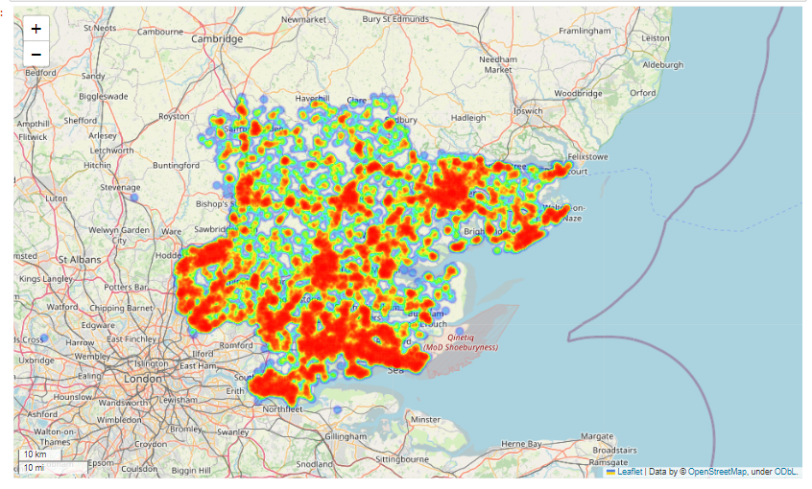

The map above displays the location in Essex where the crimes were committed.

According to the data, the month of July 2021 has the largest number of crimes, while the month of February 2022 has the lowest.

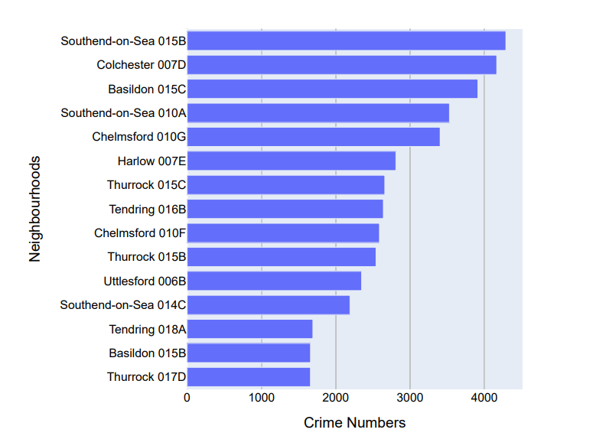

Southend-on-Sea has the highest number of crimes committed, making it the most dangerous area in Essex, while Tendring, Basildon, and Thurrock have the lowest number of crimes committed, making them the safest locations in Essex.

References

* Folium documentation at: [https://python-visualization.github.io/folium/](https://jovian.com/outlink?url=https%3A%2F%2Fpython-visualization.github.io%2Ffolium%2F)
* LSOA areas for City of London described at: [https://democracy.cityoflondon.gov.uk/documents/s36237/REVIEWED Ch 2 The Citys geography and 3 The Citys population.pdf](https://jovian.com/outlink?url=https%3A%2F%2Fdemocracy.cityoflondon.gov.uk%2Fdocuments%2Fs36237%2FREVIEWED%2520Ch%25202%2520The%2520Citys%2520geography%2520and%25203%2520The%2520Citys%2520population.pdf)
* Matlibplot documentation at: [https://matplotlib.org/stable/contents.html](https://jovian.com/outlink?url=https%3A%2F%2Fmatplotlib.org%2Fstable%2Fcontents.html)
* Numpy documentation at: [https://numpy.org/doc/](https://jovian.com/outlink?url=https%3A%2F%2Fnumpy.org%2Fdoc%2F)
* Pandas documentation at: [https://pandas.pydata.org/docs/](https://jovian.com/outlink?url=https%3A%2F%2Fpandas.pydata.org%2Fdocs%2F)
* Plotly documentation at: [https://plotly.com/python-api-reference/](https://jovian.com/outlink?url=https%3A%2F%2Fplotly.com%2Fpython-api-reference%2F)
* Renwick, D (2021) "Swindon Crime Map" [https://www.danielrenwick.co.uk](https://jovian.com/outlink?url=https%3A%2F%2Fwww.danielrenwick.co.uk)
* Seaborn documentation at: [https://seaborn.pydata.org/api.html](https://jovian.com/outlink?url=https%3A%2F%2Fseaborn.pydata.org%2Fapi.html)