**VAPOR PRESUURE OF UNKNOWN LIQUID AS A FUNCTION OF TEMPERATURE**

**CHEM 3150 PHYSICAL CHEMISTRY 1**

**WPU-CHEMISTRY DEPARTMENT**

**OBJECTIVE:**

The objective of this experiment is twofold: first, to check the response of a differential pressure meter, and second, we will measure the vapor pressure of three liquids as a function of temperature which will allow us to determine the enthalpies of vaporization/condensation of the liquids.

**BACKGROUND:**

The vapor pressure of a liquid is an indicator of the strength of the cohesive forces in a liquid.

The change of the vapor pressure of a liquid with temperature is related to the enthalpy of vaporizations as per Classius-Clapeyron equation,

$ln\left(\frac{P_{f}}{P_{i}}\right)= \frac{∆H_{vaporization}}{R} \left(\frac{1}{T_{f}}- \frac{1}{T_{i}}\right)$, Eq. 1

See Chapter 8 of *“Physical Chemistry”*, T. Engel, P. Reid, 3rd edition, Pearson.

*Question1: What assumptions are made to obtain the Classius-Clapeyron equation above?*

*Question2: How is the Classius-Clapeyron equation above related to the commonly used equation below?*

$ln\left(P_{vapor}\right)= \frac{∆H_{vaporization}}{R} \left(\frac{1}{T_{vapor}}\right)+C$ Eq. 2

**Pre-lab assignment:**

*Search for the $∆H_{vaporization}$ of water, ethanol and hexane on the web.*

* 1. *Plot in Excel the Vapor pressure in mmHg vs. Temperature.*
  2. *Compare your results against tabulated Vapor pressure vs. Temperature for the corresponding liquids.*
  3. *Use the tabulated data and perform a fitting of the data, what would be the function best fitting the tabulated data*

*Discuss your results from above.*

**SAFETY:**

1. **IN THIS EXPERIMENT WE WILL HANDLE CLOSED LIQUID/VAPOR CONTAINERS UNDER HEATING USE SAFETY GOGGLES ALL THE TIME. BE EXTREMELY CAUTIOUS NOT TO CLOSE THE TEST CONTAINER WHEN HEATING IT UP.**
2. **USE GLOVES WHEN HANDLING HAZARD MATERIALS.**

**MATERIALS AND EQUIPMENT:**

1. Materials:
   1. **Distilled water**
   2. **Ethanol**
   3. **Cyclohexane**
   4. Table salt
2. Digital Pressure Gage or DPG
3. Water Bath and Unknown Vapor Chamber

- Large Beaker, 600mL.

- Heating-Stirring Plate (shown in **Schematic**)

- Large Teflon coated stir bar

- Small Teflon coated stir bad

- Two-neck round bottom flask with two openings

- Two glass Thermometers

1. Connections and accessories

- Vacuum hose as needed to perform connection

- Glass T valve, V1

- Two perforated rubber stoppers

**EXPERIMENTAL PROCEDURE:**

1. **Experimental schematic**

We are building the instrument show in the picture to measure the vapor pressure of a liquid.

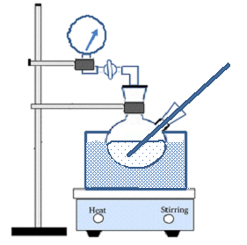

**Thermometer**

**Pressure gage**

**Hot plate**

**Water bath**

**V 1**

**Figure 1: Schematic** of the Isoteniscope

1. **Digital Pressure Gage Calibration**

The purpose of this section is to check the differential pressure gage and determine its “equilibration readout”. Since we will use this gage for only determine the vapor pressure when there is the same pressure in both sides it is important to determine as accurate as possible the “equilibration readout”

* 1. Connect one side of the *DPG* the Lab vacuum valve
  2. Open fully the vacuum valve and wait for stabilization of the reading. The DPG should read a negative pressure (vacuum) below 700 mmHg otherwise either DPG is not reading properly or there is not vacuum on the line.

1. **Experimental Setup**

3.1 Set up the ring stand, empty beaker, and the *two-neck bottom flask* as in Figure 1 in such way that most of the *two-neck bottom flask* will be submerge when the beaker is filled.

3.2 Assemble *Thermometer 1* and perforated rubber stopper. Use vacuum grease for easy sliding.

3.3 Secure the *DPG* to the stand (Figure 1)

3.4 Attach a hose connecting one of the bottom flask port to the *T valve V1* and to the *DPG* (Figure 1) The glass *T valve V1* should be between the *two-neck bottom flask* and the *DPG* (Figure 1 and 2). The hose length should be the shortest possible and well tighten.

3.5 Place the stirrer bar inside the beaker fill the beaker to a half and check that the stirrer bar operates properly.

3.6 Check that the round flask-Rubber stopper-glass thermometer port seals okay. Leave this round flask port open until as instructed below.

3.7 Once all the setup is ready, fill the water bath beaker leaving a safe level height difference between the water and the beaker top edge (~ 1 inch).

3.8 Add approximately 20 g of table salt to the beaker water.

3.9 Set the external glass Thermometer 2 to monitor the water bath temperature.

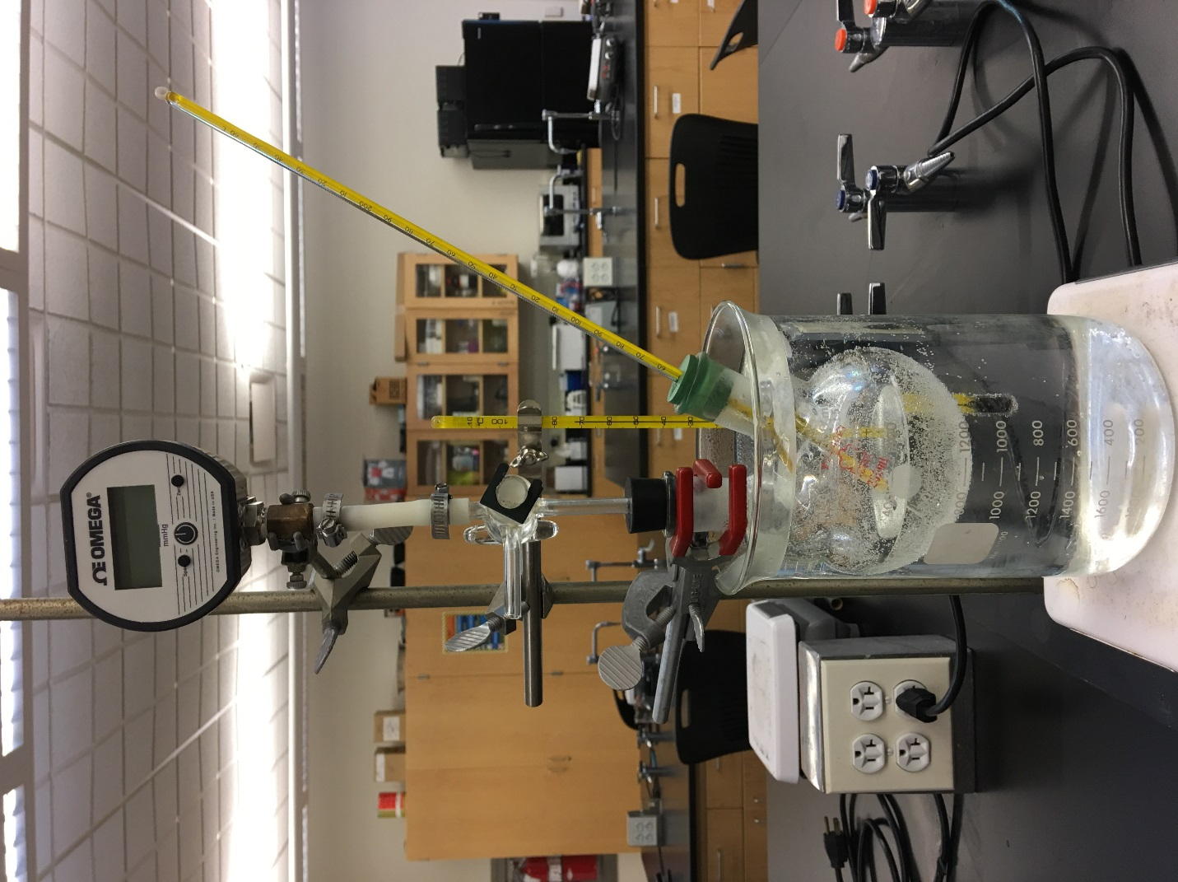

***T valve V1***

**Position 1-**Round bottom flask to Pressure Gauge

**Position 2-**Round bottom flask vented to atmosphere

***Thermometer-1***

temperature in the test liquid

***Thermometer-2***

temperature in water bath

Two-neck round bottom flask with sample

***DPG*** Pressure Gauge

Ring stand

Hose connected to the two-neck round bottom flask and the first port of the manometer

**Figure 5:** Hot water bath with sample and a second thermometer to monitor temperature of the water bath

**EXPERIMENTAL PROCEDURE:**

After the system is set up and you have read and understood the procedure and goals of the experiment, proceed as follows:

1. The *T valve V1* should be venting the flask to atmosphere. Round bottom flask- *Thermometer 2* port should be open and deliver your unknown/test liquid into the flask through the opening until the level is such that the tip of *Thermometer 2* will be submerged once it is assembled.
2. *With the Thermometer 2 port close and T valve V-1 open to air*: Heat the water bath until the tests sample liquid inside round bottom flask boils.

IT IS IMPORTANT TO SLOWLY REGULATE THE HEATER POWER WHILE RAISING THE TEMPERATURE OF THE WATER BATH TO AVOID OVERSHOOTING THE BOILING POINT OF THE TEST SAMPLE LIQUID.

FAILING TO DO SO WILL CONSUME YOUR LIQUID, CAUSING YOU TO HAVE TO RESTART THE PROCEDURE.

During this process switch momentarily V1 valve to DPG position twice to let some of the test liquid vapor to go into the DPG.

1. Once the liquid is boiling, reduce or turn off the water bath heater until the temperature stabilizes at the minimum temperature where the liquid boils.

**DO NOT CLOSE THE THERMOMETER PORT WHILE HEATING UP AND BEFORE TEMPERATURE IS STABLE AND HEAT IS Turn DOWN (STEP 3)**

1. Once the temperature is stabilized switch the *T valve V1* to the position connecting the DPG to round bottom flask.
2. Keep the heating power unchanged to allow the temperature stabilize for the first reading. Let the system equilibrate at the boiling for 2-3 minutes**.**
3. Reduce heating power to allow the temperature decrease about 10-15oC (see Notes below). Let the system equilibrate at the selected temperature for 5 minutes. The DPG reading should be stable or lightly fluctuating around a stable value.

IF NOT THEN YOUR SETUP MAY HAVE A LEAK

Record Temperature and Pressure (use attached table)

1. Repeat Step 6 until for two more temperatures above ambient. You need to collect two data points between boiling and ambient temperature.
2. Replace liquid in the beaker with ambient temperature water. With *T Valve V1* in the venting position. Evacuate some gas by connecting the exit to the vacuum line twice. DO NOT APPLY FULL VACUUM. The purpose of this step if to saturate the closed volume with Test liquid vapor. Let the system stabilize for 3-4 minutes. Record Temperature and Pressure (use attached table). Search for the test liquid vapor pressure at that temperature.
3. Repeat 3 and 4 for two temperatures below ambient temperature. For this step you will replace the water with a water-ice bath and allow the temperature equilibrate. Record Temperature and Pressure (use attached table)

Notes:

For temperatures below 55 oC, it will be more efficient to start adding ice cold water for decreasing the temperature while keeping the heat power to a minimum.

**Perform this procedure for the other two liquids provided by the instructor**

**DATA ANALYSIS:**

Data recording table

|  |  |  |  |  |  |
| --- | --- | --- | --- | --- | --- |
| **Experiment 1** | | **Experiment 2** | | **Experiment 3** | |
| Temperature  (oC) | Pressure  ( mmHg) | Temperature  (oC) | Pressure  ( mmHg) | Temperature  (oC) | Temperature  (oC) |
|  |  |  |  |  |  |
|  |  |  |  |  |  |
|  |  |  |  |  |  |
|  |  |  |  |  |  |
|  |  |  |  |  |  |
|  |  |  |  |  |  |
|  |  |  |  |  |  |
|  |  |  |  |  |  |
|  |  |  |  |  |  |
|  |  |  |  |  |  |
|  |  |  |  |  |  |
|  |  |  |  |  |  |
|  |  |  |  |  |  |
|  |  |  |  |  |  |
|  |  |  |  |  |  |
|  |  |  |  |  |  |
|  |  |  |  |  |  |
|  |  |  |  |  |  |
|  |  |  |  |  |  |

In Excel, plot and analyze your Pressure (DPG) vs. Temperature (Thermometer 1) data using Equation 2 for the test liquid to calculate the enthalpy of vaporization.