Investigation of native defects on the PbIBr Janus monolayer: A DFT study

Aditya Shankar1, Anjana E Sudheer1, G. Tejaswini1, D. Murali1, a), M. Posselt2

1 Indian Institute of Information Technology Design and Manufacturing Kurnool 518008, Andhra Pradesh, India

2Helmholtz-Zentrum Dresden-Rossendorf, Institute of Ion Beam Physics and Materials

Research, Bautzner Landstraße 400, 01328 Dresden, Germany

a) Corresponding author: dmurali@iiitk.ac.in

**Abstract.** The growth of any material especially two-dimensional layers involves unavoidable defects. These point defects will have a significant effect on the geometry, electronic and optical properties of the structure. Herein, we investigate the influence of point defects on the electronic properties of the Janus monolayer PbIBr using first-principles based Density Functional Theory (DFT) calculations. The formation energy of the point defects I, Br and Pb in PbIBr has been calculated. Using the calculated formation energy, we found the concentration the three different defects as a function of temperature. Later, to understand the electronic properties of the defected structures we have calculated electronic density of states (DOS) and observed the evolution of the defect states in the band gap region.

# Introduction

From the past few years 2D Janus materials are being explored for various applications such as photocatalysis, photovoltaics, optoelectronics and thermoelectrics. Among all the Janus structures post transition metal halide structures are recently predicted and explored because of their unique structural and electronic properties. The experimental growth of these two- dimensional materials can be done using the technique of chemical vapor deposition. The growth of high-quality crystalline samples also involves minute defects due to the atomically thin layered structure and more exposed surface. The presence of these defects will influence the electronic, magnetic and optical properties of the materials. It was also reported that, defects can be introduced deliberately to tune the properties of the materials. In the present study we have studied the role of halide defects in the PbIBr Janus structure.

First, we have analyzed the defect formation energy and after that the electronic properties of the defective system are calculated and compared with the pristine system.

# Computational Details

All the Density Functional Theory (DFT) calculations are performed using Vienna Ab-initio Simulation Package (VASP) with projector augmented wave (PAW) pseudopotentials. Exchange-correlations are treated by Perdew–Burke-Ernzerhof (PBE) Functional of the Generalized Gradient Approximation (GGA). The van der Waals corrections are incorporated using DFT-D2 method of Grimme. A kinetic energy cut-off of 650 eV and a k-point grid of 16×16×1 is used for structural optimization of Janus structure. In the process of optimization, the forces on each atom and total energy are converged up to 0.001 eV/ Å and 10−6 eV/cell. A vacuum layer of around 20 Å is provided along the Z direction to prevent interactions between the neighboring layers. A 4×4×1 supercell is used to investigate the defect study. VASPKIT software is used for extracting data from VASP-generated output files. VESTA has been used for geometry visualization.

# Results and discussion

Recently, we have designed and explored Pb based Janus structures for photocatalytic, photovoltaics, optoelectronic and thermoelectric applications2. From the designed six Janus structures, in the current study, we have chosen PbIBr and analyzed the effect of point defects on the structure. The optimized lattice constant of the PbIBr monolayer is 4.49 Å. The Pb-I and Pb-Br bond lengths are measured to be 3.24 and 3.06 Å respectively. The thickness of the layer is 3.6 Å. After this, we have introduced a single point defect of Pb, I and Br separately and the structural optimization has been performed by allowing only the ions in the lattice to move. The optimized structures of pristine I, Br, Pb defected PbIBr monolayers are presented in Fig. 1. From the optimized defect structures, we can observe that The structure with Br defect distorted more compared to the I and Pb defected structures. Later, the defect formation energy has been calculated using the following equation1

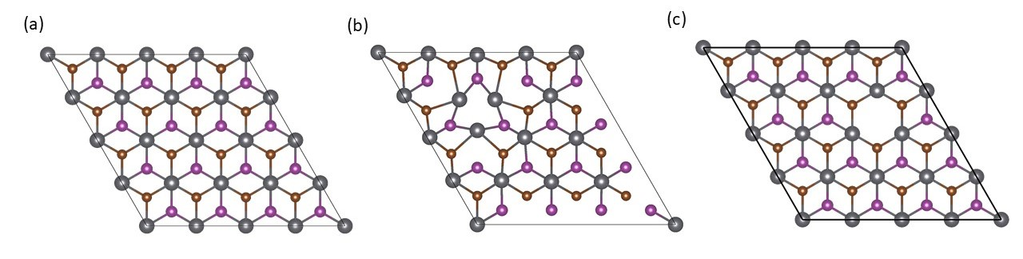Where, and $E_{host}$ are the total energies of the structure with and without defect, $n_{j}$ is the number of removed atoms and $μ_{j}$ is the chemical potential of the corresponding atom.

**Figure 1.** (a) The atom resolved density of states of the pristine Janus monolayer, (b) I, (c) Br and (d) Pb defected structures.

The defect formation energies for I, Br and Pb defected structure are calculated to be 2.32, 2.76 and 4.23 eV. From these values we can say that in the synthesis of the PbIBr monolayer, the I defect is more like to be present. From the calculated defect formation energies, we have calculated the concentration of defects as function of temperature using the following equation

$$c_{i}^{d}=c_{i}^{0}exp⁡(-\frac{∆E_{i}^{d}}{KT})$$

Here, $c_{i}^{0}$ is the number of sites available for defects on the respective sublattice per volume and $∆E_{i}^{d}$ is the defect formation energy of the corresponding defect. The concentration of I, Br and Pb defects with respect to the variation in temperature as shown in Fig. 2. From this we can observe that, the concentration of I defect is very much high compare to the Br and Pb defects in the PbIBr monolayer.

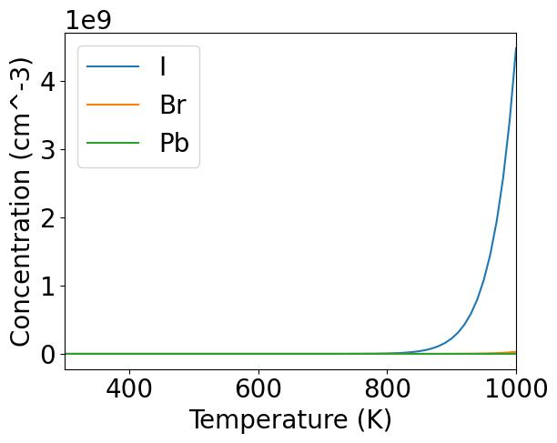

**Figure 3.** The concentration of defects as a function of temperature.

Next, we have calculated the atom resolved DOS of the defected structures and presented in Fig. 3. The band gap of the pristine PbIBr structure is 2.75 eV. In the DOS of I defected structure, the valence states are shifted towards the negative energy region and the defects states are coming in the band gap region. The same scenario is observed in the case of Br defected structure. There are no much defect states observed in the case of the structure with Pb defect.

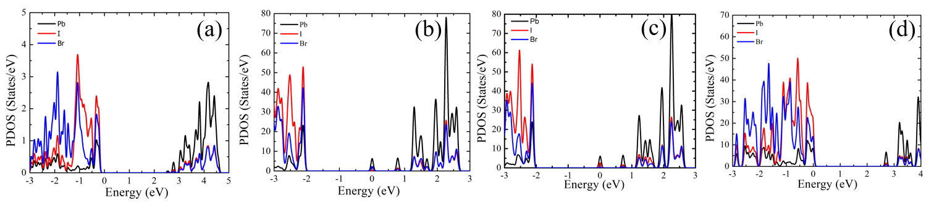

**Figure 3.** (a) The atom resolved density of states of the pristine Janus monolayer, (b) I, (c) Br and (d) Pb defected structures.

# CONCLUSION

In summary, we have performed density functional theory calculations to the properties of the defected PbIBr Janus structure. Three vacancy defects of I, Br and Pb has been introduced in the structure and calculated their formation energies. To understand the concentration of defects at higher temperatures, using the defect formation energies we have calculated the defect concentration and found, I defect is more likely to be present in the PbIBr monolayer. Later, the electronic density of states of the pristine Janus layer and the defected structures have been compared and found the presence of the defect states in the band gap region which will alter the electronic properties.

# References

1. P. Erhart and K. Albe, *J. Appl. Phys.* **104**, 044315 (2008).
2. E. S. Anjana, G. Tejaswini, M. Posselt and D. Murali, *Comput. Mater. Sci.* **243**, 113123 (2024).