- 关于BEC是什么的问题
- BEC的难度。
- BEC证书在求职中的作用。
- BEC证书和出国留学的关系。
- BEC中高级考试写作部分简介
- 各两篇文章，原始分数均为10分和20分。
- 中级写作时间45分钟；高级写作时间70分钟。
- 中级写作两部分介绍……
- 高级写作两部分介绍……
- 评分标准
- 参考书目
- BEC中级（Vantage）Part Ⅰ
- 四种文体
- 基本格式……
- 按照文章内容分类讲解
- 离开类
——调职、出差
- 典型的开头部分写作
- 离开时间的问题
- 典型开头的句型练习
- 典型的正文部分写作
- 典型的结尾部分写作
例一（课堂带写，三段式）：
  - You are the Head of Research for an international car manufacturer. You have to make an urgent trip tomorrow to visit Pierre Blanco, a colleague who works for a subsidiary.
- Write a memo of 40-50 words to your secretary:
    - Telling her who you are going to see and when
    - Asking her to book flight tickets and accommodation
    - Telling her what work you would like her to do in your absence.
- Write on your answer sheet.
例二（课堂5分钟快速练习，一段式）：
- You are a manager in a company which manufactures office furniture. Next month, you are going to London to discuss an important contract.
- Write a note of 40-50 words to your assistant:
  - Saying when you want to leave and return
  - Asking him to book flights
  - Telling him which hotel to book.
- Write on your answer sheet.
例三（课堂10分钟常规练习，三段/一段式）：
- Your company has just opened a new office in the United States. You have agreed to go and work there for six months.
- Write a memo of 40-50 words to all your colleagues:
  - Explaining why you will be absent
  - Saying when you are leaving the office
  - Expressing your wish to keep in touch
- Write on your answer sheet
——请假、缺席
- 典型的开头部分写作
- 典型的正文部分写作
- 典型的结尾部分写作
例一（课堂带写）：
- You would like to go to a seminar on presentation skills.
- Write an email of 40-50 words to your line manager:
- Requesting time off work to go to the seminar
- Saying when the seminar is
- Explaining why you want to go
- Write on your answer sheet
例二（课堂10分钟常规练习）：
- You are a regional sales manager for an international company. You have been asked to go to a meeting at your company’s head office. You cannot go, so somebody else will go in your place.
- Write an email of 40-50 words to Erica Young, who is organizing the meeting:
- Apologizing for not being able to go to the meeting
- Explaining why you cannot go
- Saying who will go
- Write on your answer sheet
2) 告知信息
- 典型的文章结构
- 典型的开头部分写作
- 典型的结尾部分写作
- 真题写作范例：
例一（课堂带写）：
- You are a Project Team Leader. You have had to cancel your next project meeting because some of the members of your team will be abroad.
- Write a memo of 40-50 words to your project team:
- Informing them of the cancellation and giving the reason
- Stating a new date and time for the meeting
- Requesting suggestions for the agenda
- Write on your answer sheet.
例二（课堂5分钟快速拓展练习）：
- You are the Research and Development Director of an engineering company, which is a subsidiary of a large corporation. The Chairman of the corporation is visiting your company next week.
- Write a memo of 40-50 words to all your staff:
  - Informing them of the visit
  - Telling them why the visitor is coming
  - Telling them when he will arrive and asking them to be at the welcome reception for him
- Write on your answer sheet.
例三（课堂5分钟快速拓展练习）：
- You are the managing director of a company whose profits have recently increased and you would like to reward staff for this.
- Write a memo of 40-50 words to all staff:
  - Thanking them for their contribution
  - Explaining why profits increased
  - Telling them what their reward will be.
- Write on the answer sheet
例四（课堂10分钟常规练习）：
- You need to inform your marketing team about a radio advertising campaign for one of your company’s new products.
- Write an email of 40-50 words to your team:
  - Reminding them which new product is
  - Explaining why you’ve chosen to advertise on radio
  - Saying what you expect, the advertising campaign to achieve
- Write on your answer sheet
3) 组织会议培训活动
- 典型结构
- 典型的开头部分写作
例一（课堂带写）：
- You are the training manager of a company which has won a large export order. You have been asked to organize foreign language training for some of your staff.
- Write a memo of 40-50 words to staff:
  - Explaining why the course is necessary
  - Saying which members of staff should attend
  - Announcing when the course will start
- Write on the answer sheet
例二（课堂10分钟常规练习）：
- You have been asked to organize your company’s staff training program. Before the program starts you would like to identify training areas that staff are interested in.
- Write a memo of 40-50 words to all staff:
  - Saying when the training program will start
  - Asking for suggestions for what to include in the program
  - Giving a deadline for suggestions.
- Write on your answer sheet
4) 询问类及其他
- 典型结构
- 典型的开头部分写作
例（课堂5分钟快速练习）：
- You are the factory manager of a car company. You are waiting for urgently needed components from your purchasing department.
- Write a note of 40-50 words to Mr. Grayson, the Assistant Purchasing Manager:
  - Enquiring about the reason for the delay
  - Stating when the components are needed
  - Suggesting a meeting to discuss future deliveries.
- Write on your answer sheet.

- BEC中级（Vantage）Part Ⅱ
- 文体——Correspondence / Report / Proposal
- 写作者的口吻
- 语言的整合
- 按照文体讲解：
- Business Correspondence
- 考试频率
- 7种内容类型（补充求职信和简历）
- 基本格式:
- Make Change
- 写作的注意事项
- 典型的开头部分写作
- 典型的正文部分写作
- 真题写作范例：
例一（课堂带写）：
- Your Managing Director has asked you to reply to the letter below which is about a proposed educational visit to your company by a local school. He has written his comments on the letter.

SUNDSTORM TECHNICAL COLLEGE

Dear Mr. Takahashi,

Re: Educational Visit

Thank you for your recent letter accepting our request for an educational visit to your company.
Too many, 25 maximum

I have spoken to the students concerned as well as the teacher who will accompany them. They are a group of 35 students, aged between 17 and 18, and will be taking part in the visit as part of their careers development program.

I would like to suggest Friday 10th December. The group will leave here at 9:00am and should be with you by 9:45am.

Monday of following week better——time’s fine!

I understand the training officer is willing to give a talk to the students about the company’s training program. This will be of considerable value, and I wondered if it would be most effective at the beginning of the visit.

Training officer not available until 11:30

Finally, would it be possible for the students to talk to some new employees in an informal ‘question and answer’ session?

No, sorry! Cannot release employees from duties

I would be grateful if you could inform me as to whether these proposals are suitable and would like to thank you once again for your cooperation with the scheme for ‘School and Business Links’.

Yours sincerely,
Please request the phone to confirm arrangements

Yamaguchi,

Headteacher

- Write a letter of 120-140 words to the head teacher explaining the changes the Managing Director would like to make to the visit.
- Write on your answer sheet.
例二（课堂12分钟快速练习）：
- The company where you work is organizing a sales conference. Your Sales Manager has asked you to reply to the letter below, from a transport hire company called A1 Coaches, concerning arrangements for the conference. He has written his comments on the letter.
- Write a letter of 120-140 words to Mr. Otley of A1 Coaches, to make sure that the arrangements are changed.
- Do not include address.
- Write on your answer sheet.

Dear Conference Organizer,

Transport arrangements-Sales Conference 9/10 December

Following your telephone call yesterday, I am writing to confirm the coach and car hire details for your Sales Conference in December.
8:30 better, not far from Conference Centre
Friday 9, December
8:15 am Collect delegates from Grand Hotel
Transfer passengers to Whitestone Conference Centre by 9 am
48 passengers-1 coach

8:45 am Collect Chairman and guests from your Head Office (Silver Street) to arrive at Conference Centre by 9 am.
10 passengers-2 car

6:00 pm Collect all delegates from Conference Centre. Take to Grand Hotel, for overnight stay.
Collect Chairman and guests by car-transfer to Grand Hotel.
48 passengers-1 coach
Cancel cars-Chairman’s party staying at Conference Centre
10 car passengers-2 cars

Saturday 10, December (1 coach booked for 48 passengers. No cars booked)
9:00 am Transfer delegates from Grand Hotel to Conference Centre.

10:30 am Take delegates to your factory site in Station Road
Should be Commercial Road site. My mistake, please give my apologies.

1:00 pm Collect delegates from factory to return to Grand Hotel for ‘End of Conference’ lunch

Please confirm that these arrangements are correct.
Ask if coach can wait at the Grand Hotel until 2:30 pm-12 people need transport to the airport. Also say that I’ll phone next week to check everything. Thanks.

Yours sincerely,

PJ Otley

A1 Coaches Ltd.

例三（课堂20分钟常规练习）：

- You are responsible for planning the magazine advertising of your company’s new product, which is a polish for cars. You have just received the letter below from the magazine that you are going to advertise with. You have also received a memo from your Marketing Manager about the advertising campaign.
- Write a letter of 120-140 words to Mr. Ellwood at the magazine, telling him about the changes to the advertisement booking, and asking him or any other information that you require.
- Do not include addresses
- Write on your answer sheet

Dear Ms. Beddington,

Thank you for your advertisement booking, the details of which I confirm below.
Name of Company: Autocare Products
Name of Product: Supergloss
Details of Advert: 1/2-page, black and white
Advert will appear in: July and August issues of the magazine
Cost of Advert: $350 per issue (3 issues=$1050)
Discount: 5% for early booking
Total Cost: $997.50

We trust that this is satisfactory.

Yours sincerely,

Nelson Ellwood

Nelson Ellwood

Memo

To: Cathy Beddington
From: John Humphrey

Re: New Product Advertising

The Managing Director has approved an increase of budget on this campaign, so we can go for: color advert, six issues.

Could you contact the magazine and get them to change this? Please check the price and the possibility of a bigger discount.

Also tell them to get the product name right——Supagloss.

Thanks

2) 推荐信
- 推荐信的分类——自荐与推荐
- 推荐信的原则——开门见山
- 推荐信的典型开头部分写作——开门见山
- 真题写作范例：
例一（课堂带写——自荐）：
- You work for RCT, a company which sells business stationery. RCT is interested in becoming an agent for Novestat, a company which manufactures paper products.
- Read Novestat’s advertisement below, on which you have made some notes.
- Then, using all your notes, write a letter of 120-140 words to James Dowling at Novestat.
- Do not include addresses.
- Write on your answer sheet.

NOVESTAT
AGENTS REQUIRED
FOR A NEW PAPER PRODUCT

Novestat, a leading manufacturer of business stationery, is delighted to announce its exciting new range of designer paper products. This range allows customers to create their own business stationery to the highest professional standards, using their own computer printers.

We are looking for companies world-wide to distribute the NOVESTAT DESIGNER PAPER range.

If your company has:
- Minimum 5 years’ relevant experience
10 years; say what RCT does
- Dynamic, motivated salesforce
- Excellent distribution network
National Sales Award last year

Tell them about our retail outlets

Then, please write to James Dowling, Novestat, Unit 3, Basing EASTAT, Hampton, Middlesex, TW13 5SA, UK.

Arrange a meeting with them next month?

例二（课堂20分钟快速拓展练习——推荐信）：
- The international organization you work for makes an award every month to a person in each department based on the following criteria:
  - Productivity
  - Relations with customers
  - Contribution to the team
- Your line manager has asked you to recommend someone from your department for this month’s award.
- Write your recommendation, stating who the person is and the reason for your choice. Describe how this person meets each of the three criteria for receiving the award.
- Write 200-250 words on your answer sheet.
专题：求职信与简历（Covering Letter / Letter of Application and Resume）：
例一：求职信
- You have seen a job with a multi-national company advertised in a newspaper.
- Write a letter to the company applying for the job. Refer to relevant factors such as the nature of the job and why you are interested in it, your qualification and experience, what you are doing now and what you could contribute to the position.
- Write 200-250 words on your answer sheet.

Letter of Application

Room 320, Building 3, Lane 5
130 Nanjing Road
Huangpu District
Shanghai, 200000
P. R. China
22 June, 2008

Mr. Julian Proctor
Director of Sales & Marketing
Fortune Travel Agency
4490 Emmett Avenue
London, WC1 AC1
UK

Dear Mr. Proctor,

I wish to apply for the position of Regional Sales Manager, as advertised in today’s Toronto Star. As the attached resume suggests, my experience in the travel industry has prepared me for this challenging position and I would welcome the opportunity to work for a prestigious and well respected employer such as Fortune Travel.

My academic background includes a degree in Business Administration from Queen’s University, where I completed all of my marketing courses with honors. I also have two years of experience in advertising and public relations, when I designed and implemented a marketing plan for Interprovincial Business Systems. My communication skills have always been a major asset to me and I take pride in my ability to work well with others in a managerial and supervisory capacity. These skills will allow me to contribute to your sales and marketing effort from the start.

I would really appreciate an opportunity of interview to further discuss my qualification and fitment to the position. I’m available anytime in the following 3 months and I’m looking forward to your favorable reply!

Yours sincerely,

John Steven

John Steven

Encl: Resume

3）解释信/报告
- 中高级考试对于“解释信/报告”要求的异同点
- 典型的开头部分写作
- 典型的结尾部分写作
例一（课堂带写）：
- You are the manager of a TV and radio repair workshop. One of your employees has received the letter below about a faulty cassette player which he inspected. He has his comments on the customer’s letter and asked you to write a reply.
- Write a letter of 120-140 words to the customer, using the employee’s comments and explaining why your company cannot repair the cassette player.
- Do not include address
- Write on your answer sheet

35 Dorset Road
London W6
12 September 2007

Mr. D. Mason
Radio World
6 Adelaide Park
London W6

Dear Mr. Mason,
Sorry! Technician off sick.
Re: Repair of Tashita Cassette Player

You returned our cassette player to us on 5th September, after having it in your shop for over a month, saying that you could not repair the following faults:
Needs replacing; part not available
- A problem with the volume control
- Difficulty operating the on/off switch.
Possible to replace, but very expensive

I was very surprised to hear this, because the equipment is not all that old. Therefore I would be grateful if you could explaining in writing why the equipment is, in your opinion, beyond repair, so that I can discuss this matter with the manufacturers.
Manufactured in 1995!

Yours sincerely,
Out of business since 2000
Paul Johnson
例二（课堂带写——报告）：
- Your company or organization is becoming more successful. In order for this success to continue, you want to expand and increase the budget of your department. The Directors have asked you to write a report saying why your department needs extra money.
- Write a report of 200-250 words, explaining why your department needs more money, and include the following points:
  - Whether extra staff are needed (and if so, why?)
  - Whether changes to the office space and equipment should be made
  - What plans you have for future development
  - How the investment would generate extra business.
- Write on your answer sheet.
4) 多选一 题型特点及中高级区别
- Your company exports to a number of countries around the world and is looking for a new agent for international freight. The Export Sales Manager has asked you to write a proposal saying which agent you recommend.
- Read the two advertisements below, on which you have already made some notes.
- Then, using all your handwritten notes, write your proposal of 120-140 words for the Export Sales Manager.
- Write on your answer sheet.
Globelink

25 years’ experience in sea freight

Worldwide destinations
Air freight also available
All documentation provided

Competitive rates——quotes available on request
Tel: 0208 344 879
May need for urgent orders
They complete all custom forms—FTDdon’t

FTD Shipping Agents

Freight agents to many major ports

- Refrigerated shipping
- Containers available
- No quantity too small

Contact Martin Taylor on 0207 234 5675 for further information and details of charges

Contact Martin Taylor on 0207 234 5765 for further information and details of charges
Mainly in Europe

Could be useful for small orders

A bit higher than Globelink

5）询问类
- 常用句型
例题：
- The company you work for is expanding rapidly and is looking for new premises. Your Managing Director is interested in Waterside Industrial Park, and has asked you to write a letter to find out more information.
- Read Waterside Industrial Park’s advertisement below, on which your Managing Director has already made some notes.
- Then, using all your Managing Director’s handwritten notes, write your letter to Rosemary Brown at Waterside Industrial Park.
- Do not include postal addresses.
- Write 120-140 words on a separate sheet.

WATERSIDE INDUSTRIAL PARK

A variety of large and small units available.
Financial help available for many companies moving to the area.
Excellent road and rail links with all parts of the country.
Skilled labour force for manufacturing or service sector business.

For an information pack, please contact:Rosemary Brown
Waterside Industrial Park
Phone (11) 8008866
Fax (11) 323 6644
Who would qualify?

Which other firms are in the area?
Sizes?
Ask for this
Labour costs compared with other areas?
6）投诉信
- 典型结构
- 典型开头部分写作
- 典型结尾部分写作
- You recently attended a one-day training course on health and safety. You were disappointed with the course and you have decided to write a letter of complaint to the training company.
- Read the advertisement below, which gives details of the course. You have already made some notes on the advertisement.
- Then, using all your handwritten notes, write your letter to Moira Geddings at GBG Certification Services.
- Do not include postal addresses.
- Write 120-140 words on a separate sheet.
GBG Certification Services
Good for business, good for you.

Regardless of whether you are in a manufacturing or service industry, you are required by law to operate your business in a manner which is safe and healthy for your workforce. Our courses will help you provide a safe and legally sound working environment for your staff.

Our one-day courses include:

Experienced and highly-qualified trainers

High-quality information packs

Small groups (maximum 8 people)

Price includes lunch and refreshments

All one-day courses run Monday-Friday from 9.30-17.00.

For more information contact:

Mora Geddings
GBG House
Summerfield Road
Oxford OX8 4DN

trainer was sick -
replacement poor

pile of loose photocopies!

not true!
explain what was wrong with lunch

started late

7）道歉信
- 典型结构
- 典型开头部分写作
- 典型结尾部分写作

例题
- You are the secretary in a company which makes plastic tableware. Your boss has left the letter below for you to answer.
- Write a letter of 120 - 140 words to Ms. Jereme, explaining the reason for the damaged goods. Use the information in her letter and the notes from your boss.
- Do not include addresses.
- Write on your Answer Sheet.

Chris: please write back to Ms Jereme with
regrets, etc. We mustn’t lose this customer
Thanks - Hugh.

QUALITY
CAFETERIAS INC.
NEW ROAD
MELBOURNE
6 October 2007
The Manager
Plastic – A – Plenty Co.
Gough Industrial Estate
Melbourne

Dear Sir or Madam 5 years to be exact
.
PLASTIC TABLEWARE-Product nos. 0821 (forks) and 7234 (bowls)
We have used your company as a supplier to our restaurants for several years, and until recently the quality of your products has always been good.

However, on 2 September this year, we took delivery of some plastic tableware which was of extremely poor quality. Many of the bowls were chipped and several of the forks were broken. We cannot use them in our cafeterias.
We will replace them free of charge.

I do hope that such a delivery will not be repeated, and that your supplies to us in the future will again be of high quality. If, however, we receive any further faulty plastic tableware from you, we will be obliged to find another supplier to provide us with goods which meet our own high standards. I am sure you will be able to provide us with a satisfactory explanation.

So do I! It was the
faulty packing machine
( now repaired. )
Tell her it won’t happen again –
she’s an excellent Customer,
so please offer our apologies.

Yours faithfully,

Ann Jereme

Restaurants Director

    - BEC高级（Higher） PartⅠ----图表作文
- 图表作文的文章结构
- 引言部分
- 主体段落
- 结论部分
The bar chart below shows the number of complaints made by consumers about different products and services in the years 1994 and 1997.
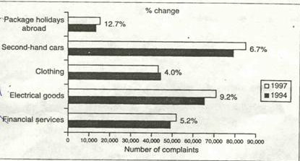
Write a short report for a university lecturer describing the information in the graph. You should write at least 140 words.

The bar chart displays the changes in the number of complaints made by consumers about five kinds of products and services between 1994 and 1997. According to the diagram, there was an increase in the complaints about most of the products and services.

The number of complaints about package holidays abroad and financial services increased over the period. The complaints made about the package holidays abroad rose by 12.7% from 15,000 in 1994 to about 18,000 in 1997. And there were about 52,000 complaints about the financial services in 1997, 5.2% up on 1994.

There were also more complaints about electric goods and second-hand cars in 1997 than in 1994. The complaints about the two products rose by 9.2% and 6.7% respectively. The former increased from 66,000 in 1994 to about 70,000 in 1997 and the latter went up from 80,000 to 86,000. And clothing is the only sector where the number of complaints dropped over the period. In 1994, there were around 45,000 complaints while the figure decreased by 4% to around 43,000 in 1997.

In conclusion we can see there were more complaints about the products and services in 1997 than in 1994 with the only exception of clothing.
- 图表作文常用的语言手段
- 作文的开头——表示“出处”的句子结构。
- 描述“数据变化”的常用表达方式
- 表示变化的副词和形容词
- 描述“数据”的表达方式
- “大约”的表达方式
例：
- The graph below shows the sales of a product in three major international markets in the period between June 1994 and January 1997. A new marketing strategy was introduced in June 1995.
- Write a letter for a university lecturer describing the information given in the graph.
- You should write at least 150 words on your answer sheet.

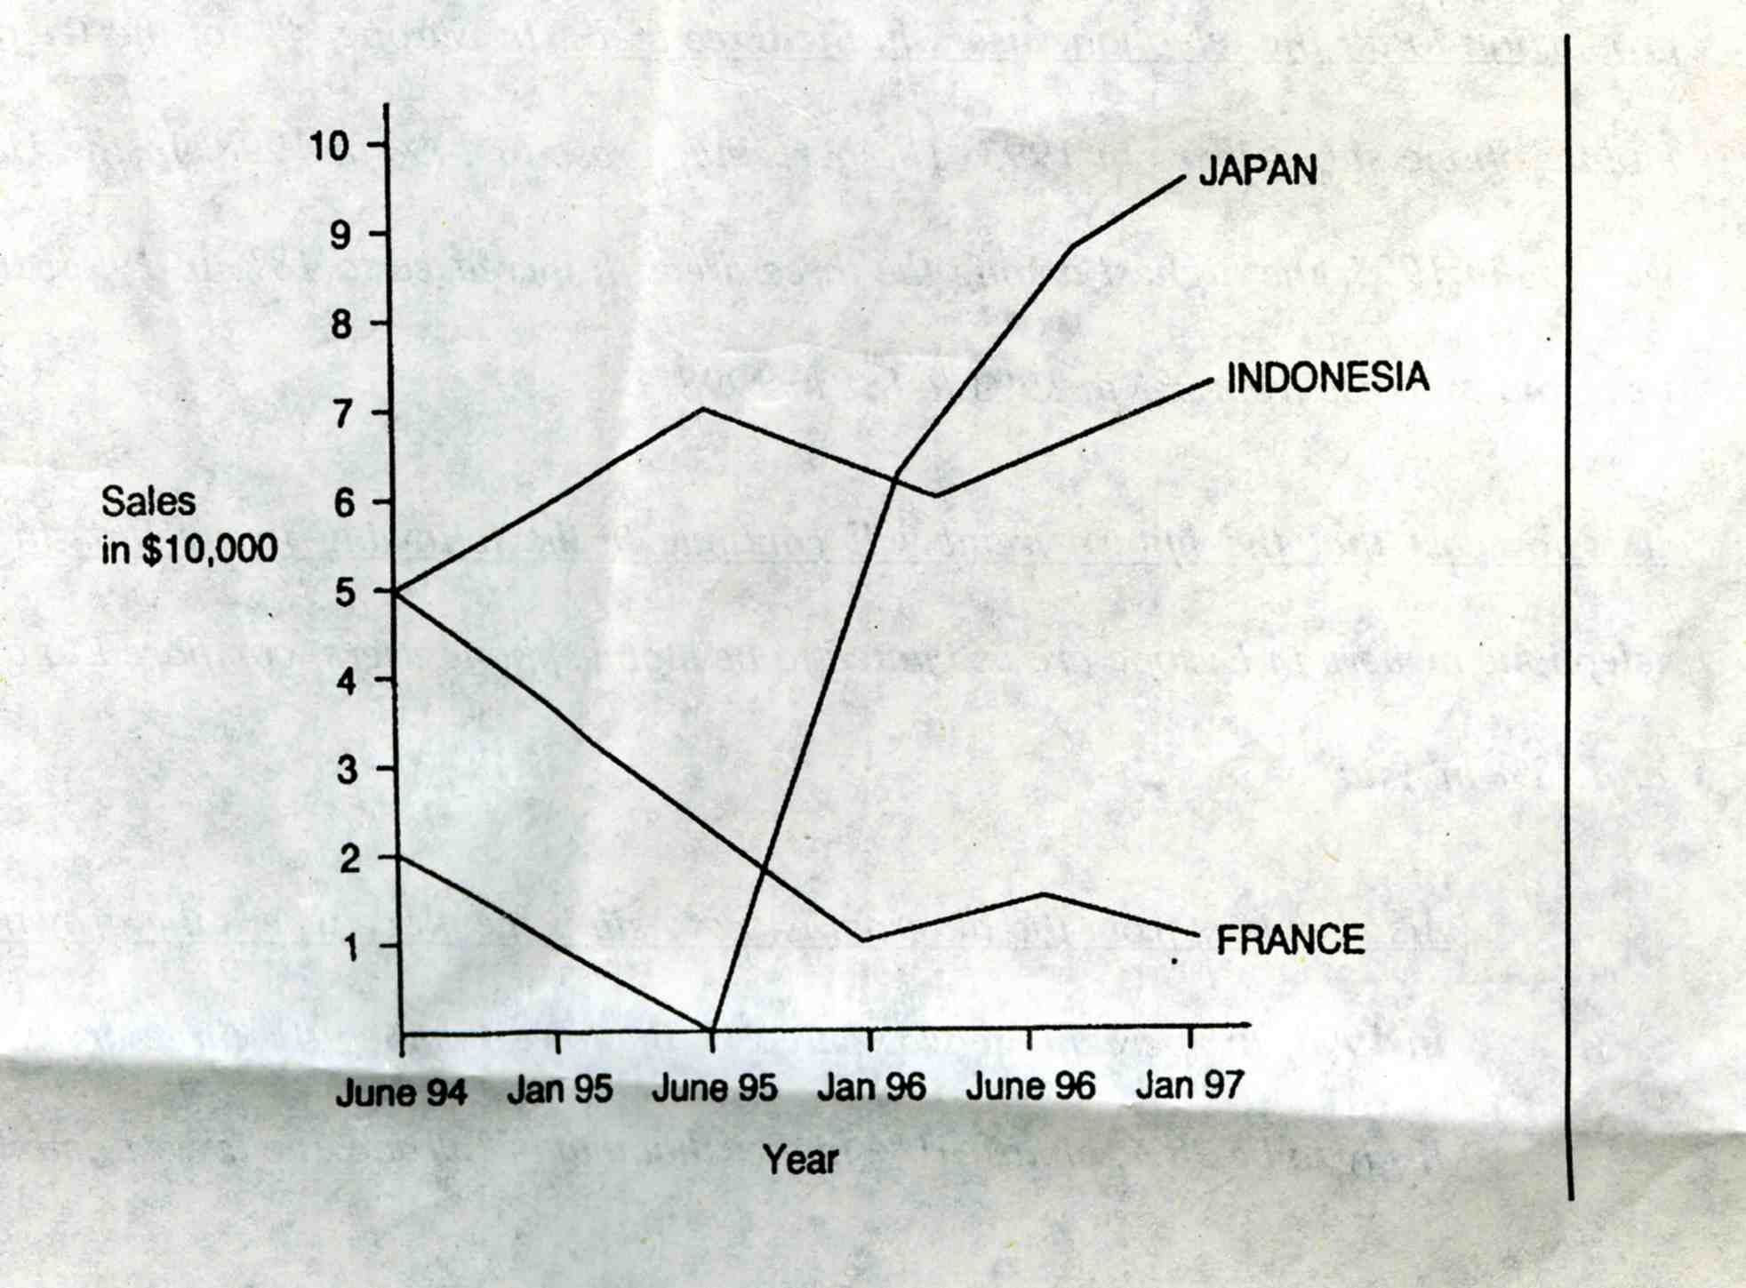

The graph shows the sales of a product in Japan, France and Indonesia during the period between June 1994 and Jan 1997.

In Japan, sales stood at $20,000 in June 1994, the lowest in comparison with the other two areas. The sales figure went down within the next year. In June 1995, there were virtually no sales at all. After a new strategy was introduced, the sales began to pick up and rose steadily over the following one and a half years to reach a peak of $90,000 in January 1997.

In France, the sales were $50,000 in June 1994. Unfortunately, the sales fell significantly between June 1994 and January 1996 despite the new marketing strategy. In January 1996 sales were only $10,000. After that the sales figure leveled off for one and a half years.

In Indonesia, the sales were the same as in France in June 1994. it kept going up and arriving at a peak of $70,000 in June 1995. After the new strategy was introduced the figure fell slightly to around $60,000 over the next year before it bottomed out in May 1996. (187 words)

BEC higher3 Test4
PART ONE
Question 1
- The bar chart below shows the profits made by each of a company’s three factories for each quarter of the year 2003. The pie chart shows the number of workers in each of the factories during that year.
- Using the information from the charts, write a short report describing the trends in profits and the number of employees in each factory.
- Write 120-140 words.

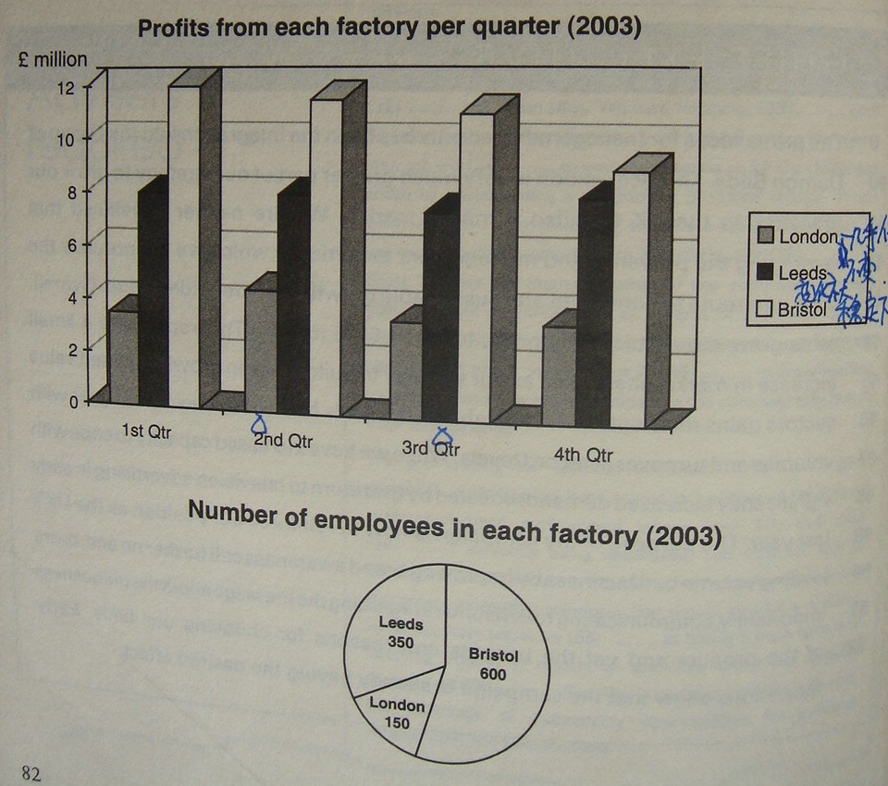
Sample A
REPORT

This pie chart shows the number of employees in each factory in the year 2003. The factory in Bristol has the most employees with a number of 600. The factory in Leeds has 350employees and finally, London employs 150 employees.

Bristol made each quarter most of the profits also if it is slowly going down during the year. The profits in Leeds remain stable except for the 3rd quarter where the profits decreased but not dramatically. The factory in London has the worse profits, but they reached a high in the 2nd quarter. Afterwards the profits remain stable. As a result we can see that more the number of employees in the factory is high, more it will have a positiv impact on the profit.

Band 3
This is a simplistic answer, but the range of structure and vocabulary is nevertheless adequate for the task and there are minimal errors. The target reader would be informed about the trend in profits.

Sample B
This report outlines the development of profits in three plants, in London, Leeds and Bristol, in 2003 and describes the staffing situation in each plant.

Bristol, the company’s largest factory, employed 600 people and reached profits of £12 million in the first quarter of 2003. The profits declined steadily, dropping to £9 million in the last quarter.

The factory in Leeds had a workforce of 350 people. This made it the company’s second largest plant. Profits remained almost unchanged at £8 million. In the third quarter however, they reached a low at £7.5 million.

The London factory’s workforce comprised 150 people. Profits did not vary much and remained just over £3 million. Nevertheless, they peaked in the second quarter with earnings exceeding the £4 million level.

Band 5
This is a virtually flawless answer, which fits all the descriptors for a band 5.

BEC Samples 一、BEC中级 Part Ⅰ
1．
To: Mary, Secretary
From: John, Head of Research
Date: 13 March, 2008
Subject: Urgent Trip

I’m leaving tomorrow to meet Pierre Blanco in the French branch of our company.

In that case, please subscribe for me a return air ticket and a single room at a hotel around the branch.

Also be sure to maintain the order of all the documents and make notes of all the contacts when I’m away.
2．
To: Chris, Assistant
From: John, Manager
Date: 19 March, 2008
Subject: Business Trip

A quick note to inform you about my following business trip to London on April 20th and back on 23rd. Please reserve for me a return air ticket and a suite at the Hilton near Waterloo Bridge in that period.

3．
To: All Staff
From: Kelly, Commercial Manager
Date: 26 March, 2008
Subject: Transfer Notice

I’m writing to inform all of you about my job transference to the US office, since the company has just started up business there.

I’m planned to leave on 15 April, and would probably stay in the US for half a year to monitor business development there.

During my absence, Assistant Commercial Manager Mr. Chris Clinton would take my charge. It is my great pleasure to have worked with you in the past few years and I sincerely hope that you could contact me through company email.
4．
To: Chris, Line Manager
Cc:
Subject: Time off Work

I would request 2 days off work to attend a seminar on presentation skills on 22 March as my current job involves frequent presentations to customers, which can be learnt from the seminar.

Please carefully consider my request and I’m looking forward to your favorable reply.

Best,

John
5．
To: Erica Young
Cc:
Subject: Meeting

I sincerely apologize for not being able to attend the meeting at the head office for the reason that there is some emergency in the process of an important export order. As a regional sales manager, I couldn’t leave at this moment but have to stay with it for the company’s benefits. In that case, I hope you could accept my proposal that Mr. Smith would go instead of me.

Thanks,

John
6．
To: Project Team
From: John, Project Team Leader
Date: 19 March, 2008
Subject: Project Meeting

I’m writing to inform you about the cancellation of our next project meeting on 21 April, as some of our members would be abroad at that moment.

In that case, I would suggest another appointment (Or: I would reschedule/rearrange it) at 9:00AM, 28 April if there is no problem with you.

Any question about the agenda please feel free to contact me (Or: do not hesitate to contact me), and I would take full account/consideration of it.
- (从此篇开始省略title的格式，只有正文内容)
I’m writing to inform you about the visit of the corporation’s Chairman to our company on 24 March, next Monday.

The purpose of his visit is to reward the distinctive/outstanding staff of the past year / inspect the completion of the first quarter’s assignment/task / settle/handle/tackle/deal with/solve the emergency arose yesterday / meet a VIP/Premier Customer of our company.

Please wait at the welcome reception before 8:50 next Monday morning for his coming at 9:00.
8．
I’m writing to inform all of you about the reward in the form of an extra monthly salary for your recent contribution to our company.

Thanks to your full efforts, the company’s profits have steadily increased, and are estimated to boost continuously.

We really appreciate your hard work, and wish you could keep up with it.
9．
I’m writing to inform you about the radio advertising campaign for the company’s newly developed washing power ‘Super White’, which would begin early next month and last for three months.

After systematic analysis, radio has been selected as the main channel for advertising, since our market survey shows most housewives, out target customers, are exposed to radio programs for 2-3 hours per day, highest among all media.

The advertising campaign is supposed to enhance the new brand’s publicity, and thus bringing up sales revenue in the coming months.

10．
I’ve been requested to start a foreign language training to cope with the process of a recently received export order.

Those who are involved in the dealing of this order are all required to attend this training course.

The final remind is that please make full preparation for it that is to start from 24 March.
11．
I’ve been assigned to start a staff training program from 31 March about skill improvement.

As the content of the training course has not been identified, I’d like to collect / Could you please submit your advice in terms of what to concentrate on in this program./?

Please also be reminded / alert that the deadline for your voice is 25 March.
12．
I’m writing to inquire/enquire about the reason why the components are delayed. As they are vital/crucial/essential/imperative to the daily operation, could you please send them to me by the end of tomorrow?

Besides, I would like to arrange a meeting to confirm further deliveries between us. Looking forward to your soonest reply.

二、BEC中级Part Ⅱ
13．
Dear Mr. Yamaguchi,

We’re pleased to receive your last letter concerning the educational visit to our company. We’ve made the following alterations after careful consideration.

Firstly, the number of students is too many for us to handle/deal with. The maximal capacity could not exceed 25 persons.

Secondly, Friday 10th December is not the most convenient date for us. Then, could you please rearrange it on Monday of the following week, 13th December? The time you are to arrive at the company is fine.

Thirdly, training officers are not available until 11:30. In that case, their communications with the students could only be held from 11:40 after 10 minutes’ break.

Furthermore, as new employees could not be released from their regular duties, your request may not be satisfied.

Finally, please also include your phone number for further confirmation of the arrangements. We’re looking forward to your favorable reply.

Yours Sincerely,

Takahashi
14．
Dear Mr. Otley,

Thank you for your recent letter confirming the coach and car rent for our conference. Here are some alterations made by us.

Firstly, Grand Hotel is not far from the Conference Centre. In that case, we’d better set out at 8:30 AM, 9th December.

Secondly, please cancel car arrangements as Chairman’s party remains at the Conference Centre and the 10 car passengers are also to stay there.

Moreover, at 10:30 AM, 10th December, please take delegates to our factory site in Commercial Road instead of Station Road. I sincerely apologize for this mistake.

Finally, could I request the coach to wait at Grand Hotel until 2:30 PM on 10th December and transfer 12 people to the airport?

I’ll make a phone call next week to confirm everything, and I really appreciate all your efforts!

Yours Sincerely,

John
15．
Dear Mr. Ellwood,

Thank you for your recent letter confirming the details of the advertisement booking. As the budget has increased for this advertising campaign, we would like to make a few alterations as follows.

Firstly, we’d like to use color advertisement instead of black and white, and increase to six issues from June till November. In that case, would you please quote the price again with a bigger discount?

Then, the name of our product is Supagloss rather than Supergloss. Please change it to the right version.

Finally, please confirm all above details as soon as possible. We are looking forward to your favorable reply!

Yours Sincerely,

Cathy Beddington
16．
Dear Mr. Dowling,

After careful review of your recent advertisement looking for qualified agents, we would like to apply for this vacancy without reservation.

We believe that RCT is a suitable applicant as it is a company selling business stationery for ten years and still maintains notable reputation in this area. Our sales force is quite energetic and result-oriented. Last year, our sales figure had increased by 20% in comparison with the previous year, and that’s the reason why we were granted the Annual National Sales Award. Furthermore, our retail networks have spread throughout the country, in which more than 1,000 outlets are operated in order.

In brief, we are strongly confident that our cooperation would benefit both of us. If you are interested in our strength, could we arrange a meeting next month for further discussion? We’re looking forward to your favorable reply!

Yours sincerely,

John
17．
Dear Mr. Johnson,

After careful reviewing the staff’s overall performance in Sales Department, I would like to recommend Mr. Jiang for this month’s award.

Mr. Jiang is selected firstly because of his great sales record ever from his entering the organization six month ago as a junior salesman. He has always been ranked one of the three best salespersons all through the period. This month, especially, he has reached the peak and made others lag far behind.

In addition, he has maintained firm relationship with most of his clients, especially some VIPs, whose consumptions have counted for over 60% of all his sales revenue. This case could strongly demonstrate the bilateral trust between him and his customers.

Last but not least, Mr. Jiang is a warm-hearted team member and always ready to share his resources as well as tactics with others. Whenever there are new faces, he always shows up and lends his hands to him/her. Last month, he even recommended two of his regular clients to a fresh salesman, in order to help him into the right track.

In summary, I strongly believe Mr. Jiang is the right candidate to receive this month’s award for his solid performance.

Yours sincerely

John
18．
Dear Mr. Johnson,

Thank you for your recent letter concerning the faulty cassette player. I’m writing to clarify all the points stated in the letter.

Firstly, please accept my deepest apology for keeping your cassette player for such a long time. The reason for this is that our technician has requested time off work due to illness.

In addition, the volume control does not work and have to be replaced. However, a new one is not available at this moment. The on/off switch is also broken, but changing it may cost you considerably.

Finally, you should be reminded that the equipment was manufactured in 1995 and the manufacturer had been out of business since 2000.

We trust that this is satisfactory.

Yours Sincerely,

John
19．
Report on maintaining business success of the Sales Department

Introduction
This report aims to clarify/explain the reason for budget expansion in Sales Department.

Findings
In order to make the current business success continue, we would like to request extra budget for the following reasons.

Firstly, two more staffs are needed as our daily routine work has increased due to the growing sales targets. They are supposed to process import-export orders and arrange warehouse for the incoming as well as outgoing cargos.

Secondly, the office space is much too limited for our everyday work. At least 6 sets of desk chair are needed in the office. However, there is no where to put them. The laser printer is also broken, which makes numerous orders lag behind.

Furthermore, aside from the above points, we have made a decision to purchase professional software, which will maximally simplify the routine work and free the staff from trivial details and repeat work. In that case, their efficiency would be dramatically enhanced, and they could concentrate more on exploring potential customers.

Finally, if we have achieved the above stated aspects, our sales could be expected to increase by 20% and also our staff would work in a more comfortable environment, which would largely enhance their loyalty to the company.

Conclusion
The extra budget would increase both sales revenue and staff loyalty to the company.
20．
Proposal on Globelink and FTD Shipping Agents

Introduction
The purpose of this proposal is to present and compare the service of Globelink and FTD as possible new agents for international freight.

Findings
Globelink has 25 years’ experience in sea freight worldwide. They offer air freight as well, which we may need for urgent orders. This company will also complete all Customs forms and provide all documentations.

FTD operates mainly in Europe. They offer refrigerated shipping, containers and accept small orders, which would be useful for us. However the charges are a bit higher at FTD than at Globelink, and they never provide documentation service.

Conclusions
Choosing Globelink will save us work on Customs forms and cost less.

Recommendations
It is recommended that Globelink is chosen due to their international network and documentation service.
附Vantage 2 Test 2 P48
Proposal on TELECARS and STREETLIGHT CABS taxi firms

Introduction
The purpose of this proposal is to present and compare the service of TELECARS and STREETLIGHT CABS as possible taxi firms for our regular transportation.

Findings
TELECARS, which is a traditional taxi firm with 50 years experience, has good references. It provides long-distance travel for special business and offers 24-hour service that is useful especially during night meetings. This company also has website so that we can book cars through Internet.

Streetlight Cabs is a brand-new company and there are no references on it. Long-distance travel service that it can provide is good for us as some of our premier customers live far from our company. However, internet booking is not available.

Conclusion
Choosing TELECARS is more suitable because of its long tradition, full-day service and internet booking.
21.
Dear Mrs. Brown,

I am writing to enquire about more information with reference to your advertisement in the local newspaper.

Could you tell us which other firms are in the area, and what are the sizes of the units available for rental. Regarding the financial help mentioned, could you inform us who would qualify for it and how to apply. Another point to clarify is the skilled labour costs compared with other areas.

Finally, we would be grateful if you could send us the information pack to our address.We look forward to hearing from you soon.

Yours Sincerely

Chris
22.
Dear Mrs. Geddings,

I am writing to complain about the training course on health and safety dated 27 November.

When I booked this course, I chose your company as it came highly recommended and the courses seemed to be of a high standard. I was promised an experienced trainer but unfortunately he was sick and the replacement was not as good as expected. Regarding the information packs these were only a pile of loose photocopies. The class was supposed to be about 8 people but in mine there were about 15. Finally, I should make it clear that the class started 1 hour late, and the lunch that was served, was cold.

I would very much appreciate it if you could investigate this matter as soon as possible and hope to hear from you soon.

Yours Sincerely,

Lisa
23.
Dear Ms. Jereme,

Thank you for your letter dated 6 October. After supplying your restaurants for 5 years, we sincerely apologize for not being able to send you qualified bowls and forks.

After careful investigation, we found that the cause of the problem was a faulty packing machine which has now been repaired. We can promise you that this type of problem will not happen again. (We will make every effort to prevent a recurrence.)

According to the sales contract between us, we will, of course, replace your faulty delivery free of charge.

Once again, please accept my deepest apology for any inconvenience it has caused and thank you being an excellent customer.

Yours Sincerely,

Chris

