CISC7204 Data Science and Data Visualization
Assignment 2 – Project Proposal
Visitor Arrivals and Hotel Occupancy in Macau: Does Tourist Volume Drive Hotel Demand?
Students: Kong Kin Meng, mc652817 | Kuan Chi Kit, MC653235

1. Project Topic Name
Research Question: How do monthly visitor arrivals to Macau affect hotel occupancy rates, and does this relationship differ between mainland Chinese tourists and other international visitors?
Region and Domain Category: Macau SAR, China — Tourism and Hospitality (tourism and gaming statistics; time-series economics).

1.1 Scope of the Study
This study focuses on monthly tourism and hotel-industry data in Macau from January 2015 to December 2024. The period includes normal tourism activity before COVID-19, the severe disruption caused by travel restrictions, and the tourism recovery after border reopening. The study examines statistical association rather than causation; therefore, a positive relationship does not prove that visitor arrivals are the only cause of occupancy changes.
The analysis will examine total visitor arrivals and compare mainland Chinese visitors with visitors from other markets. Hotel room supply and calendar month will be considered because occupancy may also be affected by available rooms and recurring seasonal patterns.

1.2 Preliminary Expectations
The project expects months with higher visitor arrivals to generally have higher hotel occupancy rates. This association may differ across pre-COVID, COVID-disruption, and post-reopening periods. The project also expects seasonal differences in hotel occupancy, but it will not attribute changes to a particular holiday unless the data support that interpretation.

2. Project Purpose
Outcomes. This project applies CISC7204 learning outcomes in data extraction, data cleaning, data analysis, and data visualization to a practical Macau tourism question. The findings are relevant to hotel revenue management, tourism policy, and future study or careers in tourism analytics and hospitality data science.
Skills. The project will develop skills in handling monthly time-series data, aligning datasets, checking data quality, conducting correlation and regression analysis, and communicating findings through Python visualizations.
Knowledge. The project will develop understanding of hotel occupancy, visitor-market composition, tourism seasonality, hotel-room supply, and the effect of COVID-19 on tourism-related data.

3. Datasets
Three public datasets are available for this project. The main analysis will use the common period from January 2015 to December 2024 (120 months). The first two datasets are official Macau statistics and are the core sources.
# | Dataset Name | Source / Link | Time Range | Role in Project
1 | DSEC Visitor Arrivals (total and by origin) | DSEC Tourism Statistics: https://www.dsec.gov.mo/en-US/ | Official series available monthly; analysis uses 2015-01 to 2024-12 | Core independent variable: total monthly visitor arrivals and origin-specific comparisons.
2 | DSEC Hotel Occupancy Rate and Hotel Room Supply | DSEC Monthly Bulletin / Tourism Statistics: https://www.dsec.gov.mo/en-US/ | Official series available monthly; analysis uses 2015-01 to 2024-12 | Core outcome variable: hotel occupancy rate (%); room supply is a control variable.
3 | TULIP Lab Macau2018 | https://github.com/tulip-lab/open-data/tree/main/Macau2018 | 2011-01 to 2018-08 | Supplementary contextual source for earlier visitor trends and search-intensity data; not the main dataset.

The DSEC datasets will be downloaded from the official DSEC statistics portal. Raw files will be saved locally together with the cleaned merged dataset so that the analysis can be reproduced.

3.1 Data Management and Quality Control
Raw files will be stored separately from cleaned files. The project folder will contain raw data, cleaned data, figures, notebooks, and final outputs. A data dictionary and cleaning log will document variable definitions, transformations, missing-value treatment, and exclusions.
- Check that every month from January 2015 to December 2024 is present.
- Check for duplicate dates after merging datasets.
- Confirm consistent numeric units for visitor-arrival variables and percentage units for occupancy.
- Identify missing values, unusual values, and unexpected changes in room supply.
- Compare summaries before and after cleaning to detect possible transformation errors.

4. Project Tasks
Task | Work and Deliverable
1. Data acquisition | Download DSEC monthly visitor-arrival, hotel-occupancy, and room-supply data. Deliverable: raw files and data dictionary.
2. Data cleaning and preparation | Standardize dates and units; check missing months; merge total and origin-specific arrivals with occupancy and room supply. Deliverable: cleaned merged CSV and cleaning log.
3. Exploratory analysis | Calculate descriptive statistics and create a time-series chart, scatter plot, and seasonal box plot. Deliverable: three labelled figures with captions.
4. Statistical modelling | Estimate correlations and regression models; compare pre-COVID, COVID-disruption, and post-reopening observations. Deliverable: table of coefficients, R-squared, and p-values.
5. Report and presentation | Interpret findings, limitations, and practical implications. Deliverable: final report, notebook, and presentation materials.

5. Planned Analytical Approach
The project will begin with descriptive statistics for visitor arrivals, hotel occupancy, and room supply. Mean, minimum, maximum, standard deviation, and period-specific summaries will be calculated. The time-series chart will show how arrivals and occupancy change over time. The scatter plot will show the overall relationship and whether observations differ by period. The seasonal box plot will reveal recurring differences across calendar months.
Pearson correlation will measure the direction and strength of the linear association between monthly arrivals and hotel occupancy. A simple regression will estimate the relationship between total monthly visitor arrivals and hotel occupancy. A multiple regression will then add room supply and calendar-month controls. A further model will compare mainland Chinese arrivals with arrivals from other markets.
Hotel Occupancy Rate = β₀ + β₁(Visitor Arrivals) + ε
Hotel Occupancy Rate = β₀ + β₁(Visitor Arrivals) + β₂(Room Supply) + β₃(Month) + ε
Residual diagnostics, including Durbin–Watson and autocorrelation checks, will be used to identify possible time-series dependence. Results will be interpreted cautiously because monthly observations may be affected by seasonality and external shocks.

6. Criteria for Success
Deliverable | Success Criteria
Cleaned dataset | Full 120-month coverage (2015-01 to 2024-12), or documented exclusions; consistent dates and units; missing values checked and recorded.
Visualizations | Reproducible from the notebook; meaningful titles; correct axis labels and units; clear legends and captions; COVID disruption distinguished where relevant.
Statistical results | Correlation, regression, effect sizes, R-squared, and p-values reported; key limitations and time-series assumptions discussed.
Final report | Directly answers the research question; cites data sources; includes limitations and reproducible analysis files.

A four-level rubric (Excellent, Good, Fair, Poor) will assess data quality, statistical rigor, visualization clarity, and interpretation. A pre-submission checklist will verify completeness, source citation, figure labels, and reproducibility.

7. Limitations, Ethics, and Risk Management

7.1 Limitations
The data are aggregated monthly and cannot explain differences between individual hotels, visitor spending, trip purpose, or length of stay. Occupancy may also be affected by hotel prices, events, transport capacity, exchange rates, and economic conditions not included in the model. The COVID-19 period is a major structural break, so it will be examined separately where possible. Correlation and regression indicate association, not definite causation.

7.2 Ethics and Responsible Data Use
The project uses publicly available aggregate statistics and does not use personal data, hotel customer records, or personally identifiable information. The team will cite sources, preserve raw data, document data cleaning, and present results honestly, including findings that do not support initial expectations.

7.3 Risk Management
Potential Risk | Planned Response
Missing or revised data | Record download dates, document unavailable months, and use the common available period.
Inconsistent units or dates | Standardize data during cleaning and verify variables against the data dictionary.
COVID period distorts results | Compare pre-COVID, COVID-disruption, and post-reopening periods.
Model assumptions not fully met | Report diagnostics, explain limitations, and avoid overclaiming conclusions.
Team member delay | Use shared files, regular progress checks, and early communication about problems.

8. Project Collaboration
Member | Responsibility
Kong Kin Meng | Data acquisition and cleaning; data dictionary and cleaning log; report writing and presentation design.
Kuan Chi Kit | Statistical analysis and visualization; model-results documentation; report writing and presentation design.

Group Structure. Kong Kin Meng will act as project coordinator and progress tracker. Kuan Chi Kit will act as project scribe and project liaison. The team will hold regular meetings, communicate possible delays early, review each other’s work before submission, and maintain respectful collaboration.

9. Justification of Visualizations
The preliminary visualizations show how the selected data can address the research question. All figures will use readable titles, labelled axes, appropriate units, and consistent colours. COVID-disruption observations are clearly identified because they represent an exceptional period in the data.
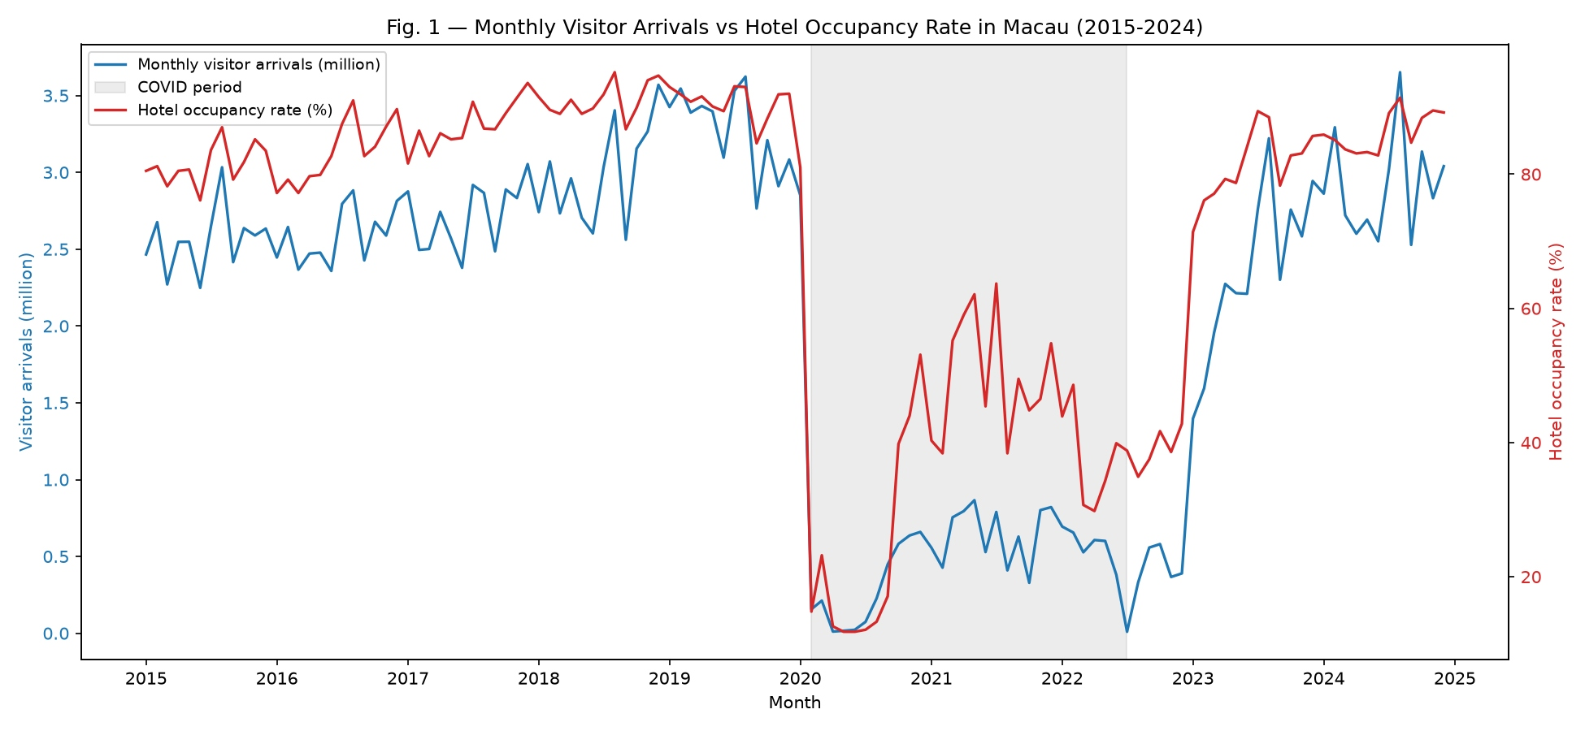
Figure 1. Monthly visitor arrivals and hotel occupancy rate in Macau, 2015–2024. Source: DSEC tourism statistics.
The dual-axis time-series plot places monthly arrivals and hotel occupancy on the same timeline. It helps readers identify whether the two series move together and how their patterns changed during the COVID disruption. Since it uses two vertical axes, it compares movement over time rather than proving the size of an effect.
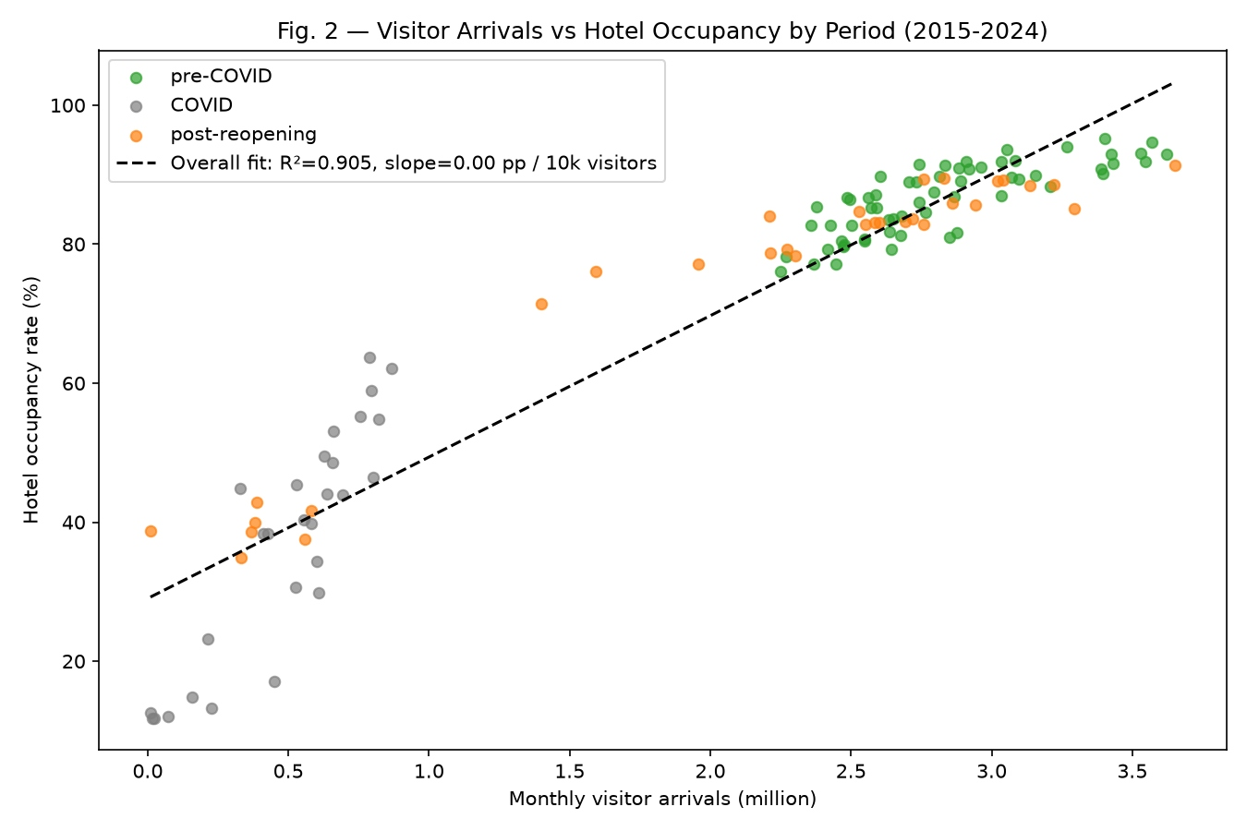
Figure 2. Visitor arrivals and hotel occupancy rate by period, 2015–2024. Source: DSEC tourism statistics.
The scatter plot visualizes the overall association between visitor arrivals and hotel occupancy. Colours distinguish pre-COVID, COVID, and post-reopening observations, while the dashed line shows an overall fitted relationship. The final figure should report the slope in a clear unit, such as percentage points per one million visitors.
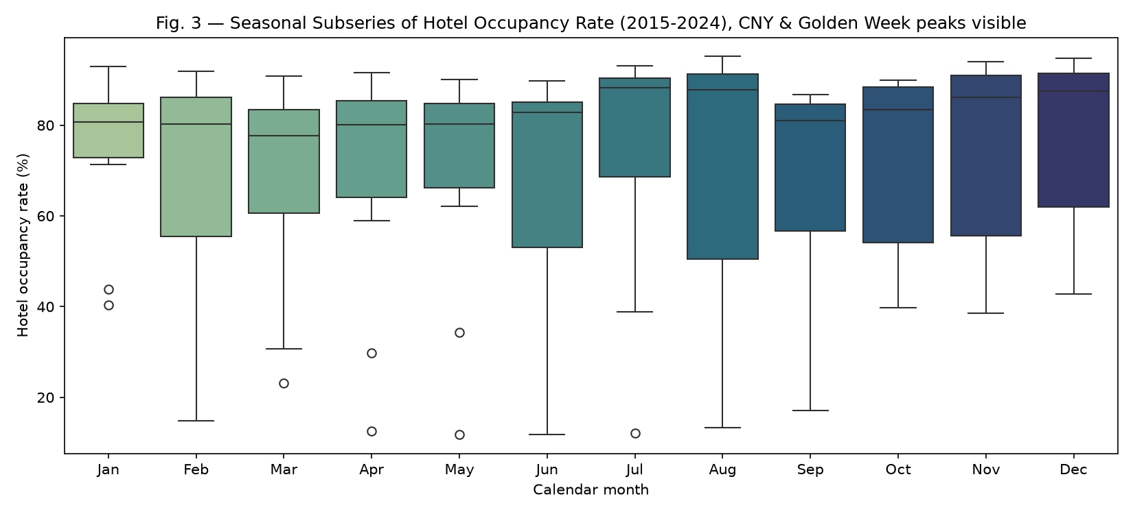
Figure 3. Monthly distribution of hotel occupancy rate in Macau, 2015–2024. Source: DSEC tourism statistics.
The box plots compare the distribution of occupancy across calendar months. They show why month or seasonality should be included as a control in the regression model. They do not, by themselves, prove that a particular holiday causes an occupancy peak because holiday dates vary by year.
Notebook: CISC7204-Assgn02-mc652817-MacauTourismAnalysis.ipynb (Python 3) will contain code for loading, cleaning, analysing, and visualizing the data.

