Team Project Proposal

1. Cover Page
Cover page

2. Document Writing Distribution
Deliverable | Due | Assigned Writers
Work Plan I (this doc) | 2026-10-29 | Vivi
Group picture | 2026-11-05 | Vivi
Proposal — Cover page | 2026-11-05 | Sonia
Proposal — Title & Research Question | 2026-11-05 | Song
Proposal — Purpose | 2026-11-05 | Qilan
Proposal — Data Context (with ≥2 dataset links) | 2026-11-05 | Lucas (M1), Ray (M2), Vivi (M3); Qilan consolidates
Proposal — Tasks & Deliverables | 2026-11-05 | Lucas
Proposal — Success Criteria | 2026-11-05 | Ray
Proposal — Team Collaboration | 2026-11-05 | Song (reuse Work Plan section)
Proposal — Timeline | 2026-11-05 | Lucas
Proposal — References (≥7, APA) | 2026-11-05 | Sonia
Proposal — Integration & proofread | 2026-11-05 | Song (quality review)

3. Title & Research Question

4. Purpose

5. Data Context
M3 — Bus Ridership
The M3 module supplies the public bus side of the team project, Visualizing the Relationship Between Visitor Arrivals, Hotel Occupancy, and Bus Ridership (Class E – Team 01, CISC7204 Data Science and Data Visualisation). Its question is whether Macao's public bus network is sized to the visitor demand it faces at the district and hourly levels, measured as the alignment between scheduled supply and observed demand rather than as a causal account. Macao recorded 40,069,360 visitor arrivals in 2025 and 28,964,737 in the first eight months of 2026, an increase of 7.7 per cent year on year (Statistics and Census Service, 2026), and the network analysed here has 586 geocoded stops, 91 routes and 920 timetable service windows (ngsiolei, n.d.). Visitors crowd into a few districts and hours, while bus routes and frequencies are designed for the wider resident pattern; whether the two line up is exactly what the module tests.
In space, the pilot already shows a sharp mismatch. Using 2026 January–July visitor demand and the current timetable, scheduled departures account for 28.42 per cent of the network total in Taipa and Cotai, while the zone receives 56.10 per cent of visitors; the resulting supply-to-demand ratio is 0.507. The Macau Peninsula has a ratio of 1.577 and Coloane 2.988. The same network is therefore thin in the resort districts where visitors concentrate and comparatively generous elsewhere. Because the ratios are computed from the same district departures table that this proposal describes, they serve as reference values against which the finished module will be checked.
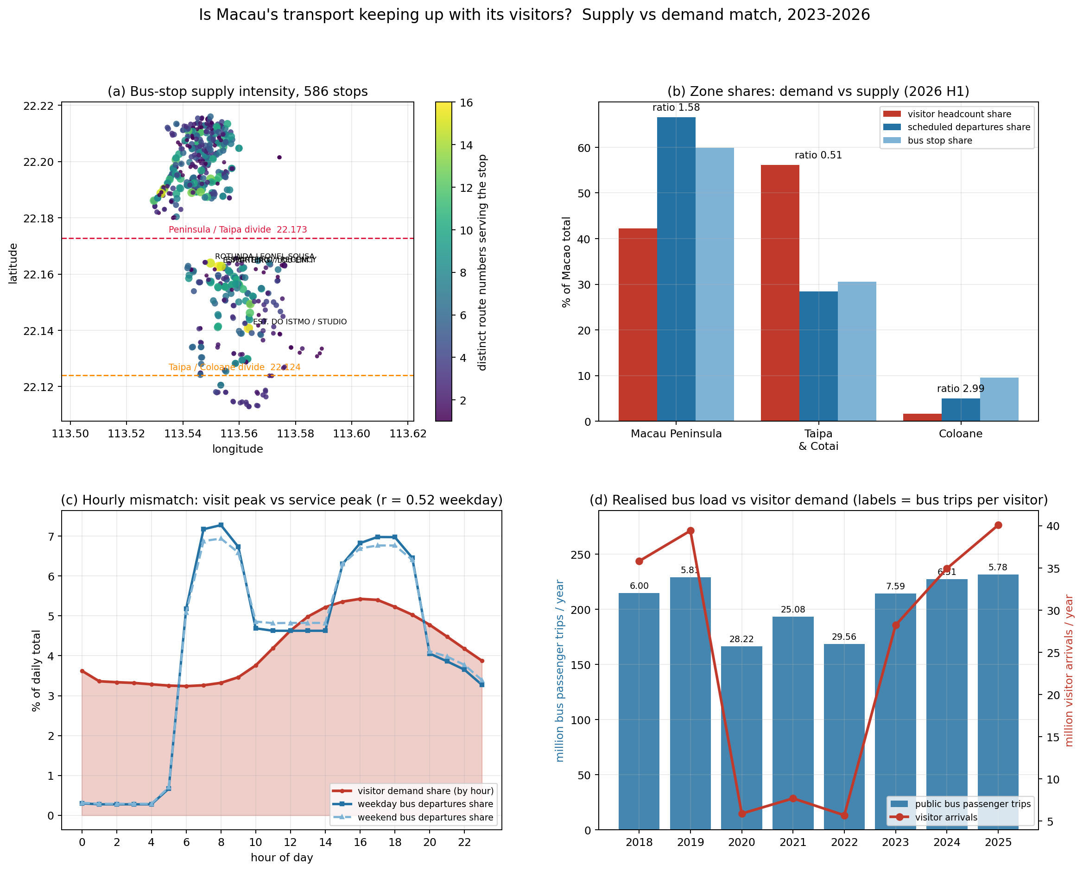
Figure 1. Supply and demand match for Macao's public bus network, 2023-2026. Panels: (a) stops by service intensity and district visitor share; (b) departure share against visitor share by zone; (c) hourly headcount against hourly departures; (d) annual ridership against annual arrivals. Source: authors' analysis of DSEC, MGTO, DSAT and MOPubBus data.
Figure 1 condenses the module's core evidence of supply-demand mismatch. Panel (a) plots stops by service intensity against district visitor share, showing that the districts where visitors concentrate are not always the most intensively served. Panel (b) reduces the comparison to one ratio per macro-zone: scheduled departures account for 28.42 per cent of the network total in Taipa and Cotai while the zone receives 56.10 per cent of visitors, giving a supply-to-demand ratio of 0.507 against 1.577 for the Macau Peninsula and 2.988 for Coloane. Panel (c) overlays hourly shares of headcount and departures, where demand peaks at 16:00 and service at 08:00, weekday and weekend correlations are r = 0.524 and r = 0.547 respectively, and the largest gaps fall between 00:00 and 05:00. Panel (d) places the exercise in longer-run context by pairing annual ridership with annual arrivals, keeping the 43-month district-by-hour panel (2023-01 to 2026-07) and the 2025 arrival total of 40,069,360 in view. The figure therefore ties the network description, 586 geocoded stops, 91 routes and 920 timetable service windows, to the ratio and correlation indicators that the finished module will turn into visualisations.
In time, service runs earlier than demand. Hourly visitor-demand shares and scheduled-departure shares correlate at r = 0.524 on weekdays and r = 0.547 at weekends; demand peaks at 16:00, service at 08:00, and the largest gaps occur between midnight and 05:00, when hotels and early flights still generate arrivals. Event weeks add a further layer: crowding on trunk routes 3 and AP1 is clearly higher during the Macao Grand Prix than in normal weeks, and Golden Week periods show pronounced daily arrival peaks relative to monthly averages.
The first supply-side dataset describes the bus network and timetable as maintained by the Transport Bureau on the Macao Open Data Platform (Transport Bureau, 2026). It covers the current network configuration and carries stop locations, route sequences and network segments, with the identifiers needed to link stops, routes and timetable windows. The release is openly downloadable at https://data.gov.mo/Detail?id=e7b2e84d-3333-42f0-b676-64ce95306f0d (accessed 2026-09-19), and it is used in M3 as the authoritative geometry and routing reference for the network.
The second dataset is an open mirror of route, stop and schedule files that resolves the network at a finer practical level for analysis (ngsiolei, n.d.). It provides 586 geocoded stops, 91 routes and 920 timetable service windows, and is maintained as versioned plain files on GitHub at https://github.com/ngsiolei/macau-bus-data (accessed 2026-09-19). Because the mirror carries geometry and schedule text together, we parsed the 920 service windows into scheduled departures per route, direction and hour, then mapped the 586 stops onto the 24 statistical districts and the three macro-zones (Macau Peninsula, Taipa and Cotai, and Coloane) by spatial join with the district shapefile. The result is a district-level departures table that every M3 indicator, including the supply-to-demand ratios and hourly share gaps, draws on.
The third dataset supplies the trip-level event layer (Kim, 2025). MOPubBus records arrival times, crowding levels and traffic conditions for trunk routes 3 and AP1 in normal and Grand Prix weeks, documenting five routes overall, and is archived on figshare at https://doi.org/10.6084/m9.figshare.29578121.v1 (accessed 2026-09-19). The pilot uses it to compare crowding during the Macao Grand Prix with normal weeks and to contrast Golden Week arrival peaks with monthly averages; in both comparisons, the event layer supports the spatial and hourly mismatch shown by the supply-to-demand ratios rather than adding a separate causal claim.
Cleaning followed two steps. We harmonised the district and hour taxonomies used by the different agencies, so that visitor headcounts, hotel indicators and bus departures can be compared on the same district and hour axes. We then parsed shapefiles, JSON route files and plain-text timetables into a single departures table at route, direction and hour level. All transformations run in Python 3 (pandas, NumPy) notebooks, and every indicator reported in this proposal can be reproduced from the archived datasets without manual editing.
On the demand side, M3 relies on the MGTO district-by-hour visitor headcounts, a core panel of 24 districts by 24 hours by 43 months (2023-01 to 2026-07) rebuilt from the four year-to-date workbooks 202312, 202412, 202512 and 202607 (Macao Government Tourism Office, 2026), and on the monthly DSEC visitor arrivals baseline (Statistics and Census Service, 2026). The M3 outputs, the cleaned departures table, the district mapping and the event comparison, feed directly into the joint analysis track of the team project, where arrivals, hotel occupancy and bus ridership are integrated into one master dataset.

6. Tasks & Deliverables

7. Success Criteria

8. Team Collaboration

9. Timeline

10. References

