**SQL Server**

Nhóm G23A

1. 22002575 – Trần Gia Nguyên Phong
2. 22003006 – Đặng Minh Tiến
3. 22010176 - Trần Duy Khánh

Relational Diagram (*Hình của bài HW2 – có cập nhật*)

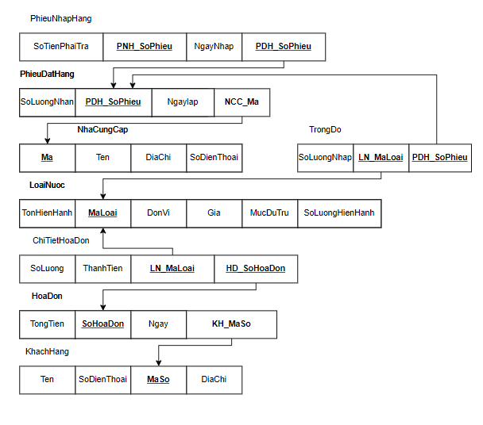

1. **Create database:**
2. CREATE DATABASE Beverage ON PRIMARY
3. (
4. NAME = 'Beverage',
5. FILENAME = 'D:\Desktop\WorkSpace\IT\SQL Data Base\InSchool\CantBackUp\Beverage.mdf',
6. SIZE = 3072KB,
7. MAXSIZE = UNLIMITED,
8. FILEGROWTH = 1024KB
9. )
10. LOG ON
11. (
12. NAME = 'Beverage_log',
13. FILENAME = 'D:\Desktop\WorkSpace\IT\SQL Data Base\InSchool\CantBackUp\Beverage_log.ldf',
14. SIZE = 1024KB,
15. MAXSIZE = 2048KB,
16. FILEGROWTH = 10%
17. );
18. --GO
19. GO
20. **Create tables**

USE Beverage;

GO

--Tao Bang

--Loai Nuoc

CREATE TABLE LoaiNuoc

(

MaLoai varchar(30) Not Null,

DonVi varchar(8) Null,

Gia smallmoney Null,

SoLuongHienHanh smallint Null,

TonHienHanh smallint Null,

MucDuTru smallint Null

);

GO

--Hoa Don

CREATE TABLE HoaDon

(

SoHoaDon varchar(5) Not Null,

Ngay datetime Null,

MaSoKH varchar(5) Not Null,

TongTien smallmoney Null

);

GO

--Khach Hang

CREATE TABLE KhachHang

(

MaSo varchar(5) Not Null,

HoTen varchar(25) Null,

SoDienThoai smallint Not Null,

DiaChi varchar(50) Null

);

GO

--Chi Tiet Hoa Don

CREATE TABLE ChiTietHoaDon

(

SoHoaDon varchar(5) Not Null,

MaLoai varchar(30) Not Null,

SoLuong smallint Null,

ThanhTien smallmoney Null

);

GO

--Nha Cung Cap

CREATE TABLE NhaCungCap

(

Ma varchar(10) Not Null,

Ten varchar(15) Null,

SoDienThoai smallint Not Null,

DiaChi varchar(50) Null

);

GO

--Phieu Dat Hang

CREATE TABLE PhieuDatHang

(

SoPhieu varchar(6) Not Null,

MaNCC varchar(10) Not Null,

NgayLap datetime Null,

// SoLuongNhan smallint Null

);

GO

--Phieu Nhap Hang

CREATE TABLE PhieuNhapHang

(

SoPhieu varchar(6) Not Null,

SoPhieuDH varchar(6) Not Null,

NgayLap datetime Null,

SoTienPhaiTra smallmoney Null

);

GO

--Trong do

CREATE TABLE TrongDo

(

MaLoai varchar(30) Not Null,

SoPhieuDH varchar(6) Not Null,

SoLuongNhap smallint Null

);

GO

1. **Add Primary key**

USE Beverage;

GO

--Khoa Chinh

--Loai Nuoc

ALTER TABLE LoaiNuoc

ADD CONSTRAINT pk_LN PRIMARY KEY(MaLoai);

GO

--Hoa Don

ALTER TABLE HoaDon

ADD CONSTRAINT pk_HD PRIMARY KEY(SoHoaDon);

GO

--Khach Hang

ALTER TABLE KhachHang

ADD CONSTRAINT pk_KH PRIMARY KEY(MaSo);

GO

--Chi Tiet Hoa Don

ALTER TABLE ChiTietHoaDon

ADD CONSTRAINT pk_CTHD PRIMARY KEY(SoHoaDon, MaLoai);

GO

--Nha Cung Cap

ALTER TABLE NhaCungCap

ADD CONSTRAINT pk_NCC PRIMARY KEY(Ma);

GO

--Phieu Dat Hang

ALTER TABLE PhieuDatHang

ADD CONSTRAINT pk_PDH PRIMARY KEY(SoPhieu);

GO

--Phieu Nhap Hang

ALTER TABLE PhieuNhapHang

ADD CONSTRAINT pk_PNH PRIMARY KEY(SoPhieu);

GO

--Trong Do

ALTER TABLE TrongDo

ADD CONSTRAINT pk_TD PRIMARY KEY(MaLoai, SoPhieuDH);

GO

1. **Add Foreign key**

USE Beverage;

GO

--Khoa Ngoai

--Hoa Don

ALTER TABLE HoaDon

ADD CONSTRAINT fk_HD_MaSoKH FOREIGN KEY(MaSoKH)

REFERENCES KhachHang(MaSo);

GO

--Chi Tiet Hoa Don

ALTER TABLE ChiTietHoaDon

ADD CONSTRAINT fk_HD_SoHoaDon FOREIGN KEY(SoHoaDon)

REFERENCES HoaDon(SoHoaDon);

GO

ALTER TABLE ChiTietHoaDon

ADD CONSTRAINT fk_LN_MaLoai FOREIGN KEY(MaLoai)

REFERENCES LoaiNuoc(MaLoai);

GO

--Phieu Dat Hang

ALTER TABLE PhieuDatHang

ADD CONSTRAINT fk_NCC_MaNCC FOREIGN KEY(MaNCC)

REFERENCES NhaCungCap(Ma);

GO

--Phieu Nhap Hang

ALTER TABLE PhieuNhapHang

ADD CONSTRAINT fk_PDH_SoPhieuDH FOREIGN KEY(SoPhieuDH)

REFERENCES PhieuDatHang(SoPhieu);

GO

--Trong Do

ALTER TABLE TrongDo

ADD CONSTRAINT fk_TD_LN_MaLoai FOREIGN KEY(MaLoai)

REFERENCES LoaiNuoc(MaLoai);

GO

ALTER TABLE TrongDo

ADD CONSTRAINT fk_TD_PDH_SoPhieu FOREIGN KEY(SoPhieuDH)

REFERENCES PhieuDatHang(SoPhieu);

GO

**SQL Server Relational Diagram:**

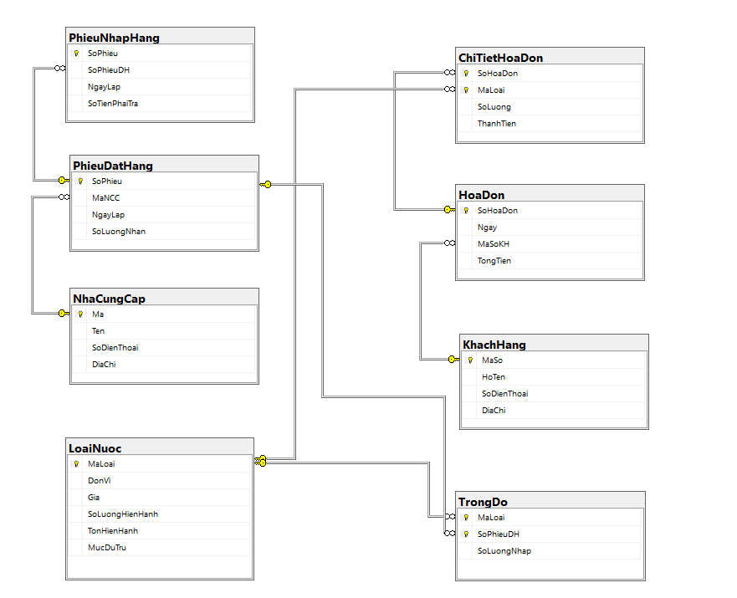

**Data demo:**

**LoaiNuoc**

|  |  |  |  |  |  |
| --- | --- | --- | --- | --- | --- |
| **MaLoai** | **DonVi** | **Gia** | **SoLuongHienHanh** | **TonHienHanh** | **MucDuTru** |
| Coca 330ml | Lon | $0.44 | 20 | 80 | 70 |
| Pepsi 330ml | Lon | $0.43 | 25 | 75 | 80 |
| 7up 390ml | Chai | $0.36 | 30 | 70 | 75 |
| Aquafina 500ml | Chai | $0.20 | 15 | 85 | 40 |
| Pocari sweat 500ml | Chai | $0.52 | 10 | 90 | 30 |

**HoaDon**

|  |  |  |  |
| --- | --- | --- | --- |
| **SoHoaDon** | **Ngay** | **MaSoKH** | **Tongtien** |
| HD001 | 24/11/2022 | KH001 | $4.4 |
| HD002 | 23/11/2022 | KH002 | $4.3 |
| HD003 | 22/11/2022 | KH003 | $1.8 |
| HD004 | 4/10/2022 | KH004 | $3.0 |
| HD005 | 15/10/2022 | KH005 | $7.8 |

**KhachHang**

|  |  |  |  |
| --- | --- | --- | --- |
| **MaSo** | **HoTen** | **SoDienThoai** | **DiaChi** |
| KH001 | Nguyen Van A | 011 222 333 444 | 218, Phan Dinh Phung |
| KH002 | Tran Van B | 022 333 444 555 | 119, Tran Cao Van |
| KH003 | Nguyen Thi C | 033 444 555 666 | 128/2A, Hai Ba Trung |
| KH004 | Ho Cam D | 044 555 666 777 | 45, Nguyen Thi Loi |
| KH005 | Dinh Van L | 055 666 777 888 | 428, Vo Thi Sau |

**ChiTietHoaDon**

|  |  |  |  |
| --- | --- | --- | --- |
| **SoHoaDon** | **MaLoai** | **SoLuong** | **ThanhTien** |
| HD001 | Coca 330ml | 10 | $4.4 |
| HD002 | Pepsi 330ml | 10 | $4.3 |
| HD003 | 7up 390ml | 5 | $1.8 |
| HD004 | Aquafina 500ml | 15 | $3.0 |
| HD005 | Pocari sweat 500ml | 15 | $7.8 |

**NhaCungCap**

|  |  |  |  |
| --- | --- | --- | --- |
| **Ma** | **Ten** | **SoDienThoai** | **DiaChi** |
| CoVn01 | Coca-cola Co | 012 345 678 910 | 123, Song Hanh |
| PepVn02 | Pepsi Co | 088 999 111 222 | 234, Nguyen Van Linh |
| OtsVn03 | Otsuka Co | 099 888 777 654 | 678, Pham Van Dong |

**PhieuDatHang**

|  |  |  |
| --- | --- | --- |
| **SoPhieu** | **MaNCC** | **NgayLap** |
| PDH001 | CoVn01 | 12/5/2020 |
| PDH002 | PepVn02 | 1/6/2020 |
| PDH003 | OtsVn03 | 27/7/2020 |

**PhieuNhapHang**

|  |  |  |  |
| --- | --- | --- | --- |
| **SoPhieu** | **SoPhieuDH** | **NgayNhap** | **SoTienPhaiTra** |
| PNH001 | PDH001 | 20/5/2020 | $39.99 |
| PNH002 | PDH002 | 10/6/2020 | $36.99 |
| PNH003 | PDH003 | 5/8/2020 | $45.99 |

**TrongDo**

|  |  |  |
| --- | --- | --- |
| **MaLoai** | **SoPhieuDH** | **SoLuongNhap** |
| Coca 330ml | PDH001 | 100 |
| Pepsi 330ml | PDH002 | 100 |
| Pocari sweat 500ml | PDH003 | 150 |

**END.**