University of Macau
Faculty of Information Science and Computing
Department of Computer Science

CISC7204: Data Science and Data Visualization
Assignment 01 – Preliminary Project Proposal
Is Macau's Transport Keeping Up With Its Visitors? A District-Level Assessment of Visitor Demand and Public Bus Supply

Fong Chin Wai, Vivi (mc653748)
Fong Hoi Lam (mc654953)

19/09/2026

Introduction
Macao recorded 40,069,360 visitor arrivals in 2025 and 28,964,737 in the first eight months of 2026, up 7.7 per cent year on year (Statistics and Census Service, 2026). Visitors crowd into a few districts and hours, while the public bus network follows routes and frequencies designed for residents. Whether supply keeps up with demand is testable with Macao's open data, and this proposal sets out that study, building on a completed pilot analysis and its first composite visual (Figure 1).

Project Topic and Research Question
Project topic. Is Macau's Transport Keeping Up With Its Visitors? A District-Level Assessment of Visitor Demand and Public Bus Supply.
Research question. How does visitor demand, measured as average headcount by statistical district and hour, align with the capacity of Macao's public bus network, and which districts and hours are relatively under-served in share terms?
Four sub-questions guide the work: the first asks about the share of scheduled departures against the share of visitor headcount by zone; the second examines the timing of service peaks against visitor peaks; the third turns to gateway coverage at each border crossing, ferry terminal and the airport; and the fourth focuses on crowding during Golden Week and the Macao Grand Prix. The study measures alignment and accessibility gaps rather than causality.

Purpose
Outcomes. The project applies the course learning outcomes end to end, from importing and wrangling data to modelling and visualising it, and connects to the students' own region, where tourism planning and transport operations depend on supply-and-demand evidence. Skills. It practises auditing open datasets, parsing monthly Excel workbooks, shapefiles, JSON route files and plain-text timetables, harmonising district and hour taxonomies, assigning stops to districts spatially, and running correlation, regression and forecasting analyses reproducibly. Knowledge. It builds familiarity with Macao's statistical infrastructure, notably the district taxonomy shared by its statistics, transport and tourism agencies, and with supply-and-demand matching, accessibility scoring and crowding measurement in a tourism-dominated city.

Region, Domain and Data Sources
Region. Macao Special Administrative Region, China, studied across its 24 statistical districts and three macro-zones. Domain categories. Tourism and the visitor economy, with urban public transport.
All four datasets are real, openly downloadable and cited in APA style. Visitor arrivals, the demand baseline, cover monthly arrivals with same-day and overnight splits and arrivals by checkpoint from 2008-01 to 2026-08 (Statistics and Census Service, 2026). District and hour headcount form the core demand panel, average visitor headcount per district and hour slot from monthly workbooks covering 2023-01 to 2026-07 (Macao Government Tourism Office, 2026); each MGTO monthly workbook is year-to-date, so four anchor files (202312, 202412, 202512, 202607) reconstruct the full 43-month district-by-hour panel. On the supply side, the bus network and timetable provide stop locations, route sequences and network segments (Transport Bureau, 2026), together with 586 geocoded stops, 91 routes and 920 service windows in an open mirror (ngsiolei, n.d.). Trip-level crowding supplies the event layer, with arrival times, crowding levels and traffic conditions for two routes, 3 and AP1, in normal and Grand Prix weeks, within a dataset that documents five routes overall (Kim, 2025).

Visualisation: How Figure 1 Addresses the Question
Figure 1 is the central artefact, and it is composite because the question compares two distributions rather than one quantity: keeping up can only be read as the gap between where and when visitors are and where and when service runs. Panel (a) plots stops by service intensity against district visitor share, (b) reduces the comparison to one ratio per macro-zone, (c) overlays hourly shares of headcount and departures, and (d) places the exercise in longer-run context by pairing annual ridership with annual arrivals.
The panels answer the question in stages. Using 2026 January-July demand and the current timetable, a departure share of 28.42 per cent against a visitor share of 56.10 per cent gives Taipa and Cotai a supply-to-demand ratio of 0.507, against 1.577 in the Peninsula and 2.988 in Coloane, so the same network is thin in the resort districts and generous elsewhere. Hourly shares correlate at r = 0.524 on weekdays and 0.547 at weekends; demand peaks at 16:00 while service peaks at 08:00, the largest shortfalls falling between midnight and 05:00. Figure 2 supplements Figure 1 by adding the district layer, event-week crowding and the shuttle channel; it does not feed the main supply-demand ratio but shows where the mismatch is concentrated and how visitors move when public bus supply is thin.
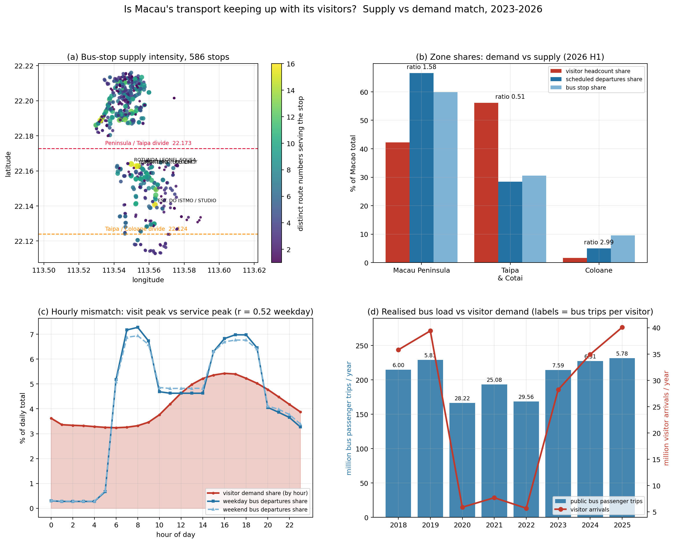
Figure 1. Supply and demand match for Macao's public bus network, 2023-2026. Panels: (a) stops by service intensity and district visitor share; (b) departure share against visitor share by zone; (c) hourly headcount against hourly departures; (d) annual ridership against annual arrivals. Source: authors' analysis of DSEC, MGTO, DSAT and MOPubBus data.
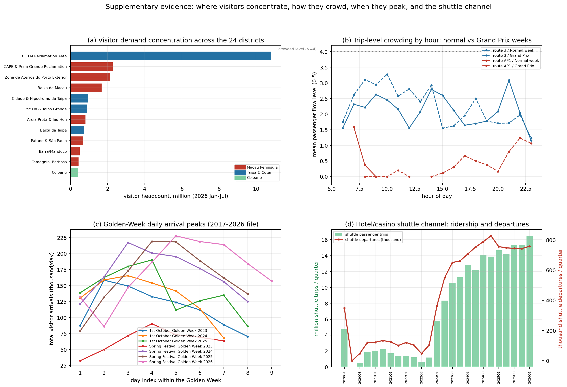
Figure 2. Supplementary evidence on visitor concentration, event-week crowding and the shuttle channel. Panels: (a) visitor headcount by district; (b) hourly crowding on routes 3 and AP1 in normal and Grand Prix weeks; (c) Golden Week arrival peaks; (d) hotel and casino shuttle ridership and departures by quarter. Source: authors' analysis of DSEC, MGTO, DSAT and MOPubBus data.

Tasks, Steps and Deliverables
- The project runs in eight steps, each with a named deliverable. The work begins by auditing the sources, inventorying every file by coverage and usability into an inventory table, then building the demand panel for 24 districts, 24 hour slots and 43 months into a cleaned demand table, and parsing the 920 timetable windows into departures per route, direction and hour into a departures table.
- The 586 geocoded stops are then mapped onto the 24 districts to form a district departures table, from which zone ratios, hourly share gaps, gateway coverage and an accessibility score are computed and tested by correlation and regression into metrics tables.
- An event layer compares Grand Prix weeks with normal weeks and Golden Week with monthly averages into an event figure. In Phase 2, arrivals and departures will be projected into 2027 and published on a dashboard; in this preliminary proposal these are planned deliverables rather than completed ones. The final step packages the proposal, notebook, figures and dataset archive, and exports a merged analysis dataset and a SQLite database for reproducibility.
The work follows the course Proposal Ideation and Proposal Guideline, uses Python 3 with pandas, NumPy, Matplotlib, Seaborn, SciPy and scikit-learn, and is documented in a Jupyter notebook in which every code cell is executed. A fully executed notebook (CISC7204-Assgn01-mc653748-ProposalVerification.ipynb) accompanies this proposal, and its Python 3 code reproduces every figure and indicator reported here.

Criteria for Success
A finished product is successful when all of the following hold, and this checklist is the self-assessment instrument. Every figure is regenerated by the submitted notebook from the archived datasets with no manual editing; demand and supply are compared on the same district and hour axes, with a matching ratio for every zone; the pilot findings are reproduced, namely 0.507, 1.577 and 2.988 by zone, and hourly correlations of 0.524 and 0.547; hourly gaps are quantified, including the midnight-to-05:00 shortfall.
- Event effects are tested separately for Golden Week and the Grand Prix, because the two datasets operate at different temporal resolutions and are not pooled into a single event index. The forecast and dashboard carry stated assumptions, with the repository link public before the deadline. No separate rubric is provided in the brief, so this proposal defines its own checklist: Figure 1 serves as the annotated example, Figure 2 as the supplementary final visual, and the executed notebook as the reproducibility instrument.

Collaboration
This is a two-person pair submission. The division of work follows the data pipeline: Fong Chin Wai takes the demand side, covering arrivals and district-by-hour ingestion, the demand panel, the matching metrics and the forecast, and also authors the proposal and Figure 1; Fong Hoi Lam takes the supply side, covering stop and route geography, timetable parsing, district assignment and Figure 2, and also handles notebook quality assurance and the packaging checklist. Both members review the merged dataset, verify every figure, and submit through their own submission links, since each student submits individually even for pair work.
As ground rules, the pair holds weekly check-ins, logs every dataset change, regenerates figures from the notebook rather than editing them by hand, admits no number into the report unless a stored script reproduces it, and settles disagreements by re-running the analysis.
Within the group, Fong Chin Wai takes the roles of project coordinator and project progress tracker, and also acts as the final quality gate; Fong Hoi Lam takes the roles of project scribe and project liaison, keeping the analysis log, the checklist and the communication record. Progress is tracked on a task board reviewed at each check-in.

Conclusion
Visitor numbers are at record highs, the data needed to test whether bus supply matches them are open, and the pilot analysis already shows misalignment in space and time. Completing the district-level match, the event layer and the forecast will turn that indication into a reproducible, decision-ready picture of where capacity is missing and where it is idle.

References
- Kim, S. (2025). Macao public bus (MOPubBus) [Data set]. figshare. https://doi.org/10.6084/m9.figshare.29578121.v1 (accessed 2026-09-19)
- Macao Government Tourism Office. (2026). Macao district tourism data: Visitor headcount by statistical district and hour slot [Data set]. Macao Tourism Data Plus. https://dataplus.macaotourism.gov.mo/Publication/StatisticalTables?lang=E (accessed 2026-09-19)
- ngsiolei. (n.d.). Macau bus data: Routes, stops and schedules [Data set]. GitHub. https://github.com/ngsiolei/macau-bus-data (accessed 2026-09-19)
- Statistics and Census Service. (2026). Visitor arrivals: Monthly key indicators [Data set]. https://www.dsec.gov.mo/en-US/Statistic?id=402 (accessed 2026-09-19)
- Transport Bureau. (2026). Bus route data [Data set]. Macao Open Data Platform. https://data.gov.mo/Detail?id=e7b2e84d-3333-42f0-b676-64ce95306f0d (accessed 2026-09-19)

