**meon**



**Target Platforms**

**Windows (future plans of macOS, Linux, Android and iOS).**

**Genre**

**Platform shooter, one versus one local multiplayer.**

**Theme**

**Various retro style locations.**

**Objective**

**Kill your opponent with the avaiable methods.**

**Core Mechanics**

**Jump and move around the map, use your weapons and try to dodge**

**the enemy.**

**Gameplay Elements**

**Power-ups and various weapons.**

**Controls**

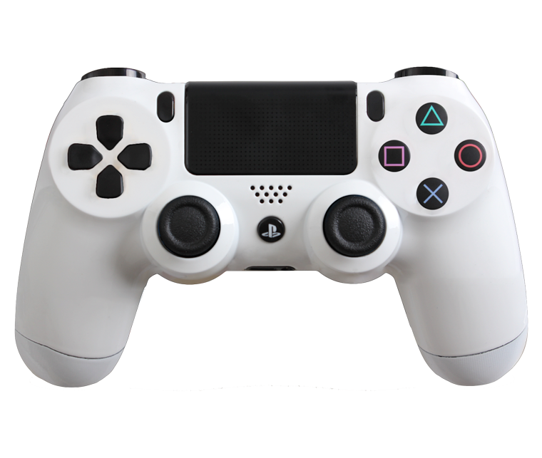

**X – Jump**

**Square – Punch**

**Triangle – Pick-up weapons**

**R1 – Use weapons**

Ana Rita Lamelas

João Fonseca