Dialogue System V1 – Documentation

This tutorial will show you how this project's blueprints work and how to implement your own NPC with its dialog.

This tutorial is divided into two parts, as I said before, the first part will teach you how blueprints work and the second part will teach you how to create your own dialog system.

[1] How do dialog, Player and NPC's blueprints work?

[2] How to implement your own NPC and dialogue?

[1] How do dialog, Player and NPC's blueprints work?

To introduce this part I want to divide this section into 5 parts:

1.1) Dialogue blueprints:

- BP_StartDialogue

- BP_EndDialogue

- BP_DisplayLine

- BP_Choices

1.2) Behavior Tree and blackboard:

- BT_Test

- BB_InteractBlackboard

1.3) NPC controller:

- BP_NPC_Controller

1.4) Interface and widgets blueprint:

- BI_InteractBPI

1.5) Player blueprint:

- BP_Player

1.1):

"BP_StartDialogue":

This blueprint starts the dialogue with the NPC; it must be used at the beginning of your behavior tree, see more information inside the blueprint in the comments.

"BP_EndDialogue":

This blueprint closes the dialogue with the NPC; it must be used at the end of your behavior tree, see more information inside the blueprint in the comments.

"BP_DisplayLine":

This blueprint writes the chosen text letter-by-letter and is displayed in the dialog widget, it can also apply a speaker name, see more information inside the blueprint in the comments.

"BP_Choices":

This blueprint starts the choice system (Yes or No), it can be used to create quests if you want to implement it in your own project.

1.2):

"BP_Test":

This is a behavior tree test, it shows how a simple dialog system works. there is also another behavior tree that shows the dialog with choices, take a look at them inside the project.

"BB_InteractBlackboard":

This is a simple blackboard that contains the variables of the "DialogueBox" widget, to show the text in the game, and a boolean variable to indicate the choice that the player can make during any dialogue.

1.3):

"BP_NPC_Controller":

This is the NPC controller, it will start the selected behavior tree; it has dialog initialization and termination functions to change the logic.

1.4):

"BI_InteractBPI":

This interface is used to link the Player's interaction with dialog startup.

1.5):

"BP_Player":

This is the player's blueprint, it has within it the mechanics of interacting with NPC's; see more information in the comments of the same.

[2] How to implement your own NPC and dialogue?

First Part:

Let's start directly with the NPC Character, the idea is to create a child of "BP_NPC_Test" so that you already have your own NPC, but I will explain what happens inside it.

In the "Begin Play" event it sets the NPC behavior tree selected in the level.

In the "Interact" event, it casts the controller itself to call the "Start Interaction" function that runs the selected behavior tree; and continuing, he still makes some NPC rotation adjustments to face the player.

That's all about the NPC blueprint.

As I already mentioned the NPC Controller I will explain how it works.

The NPC Controller has two functions, one that I mentioned earlier, "Start Interaction", and "End Interaction".

The "End Interaction" is triggered by the "EndDialogue" task which turns off the dialogue logic.

That's all for that part.

Second Part:

Now I will explain the parts of the behavior tree; there are two test behavior trees if you want to see a ready example.

To make it easier, you will only use 4 types of tasks:

"StartDialogue" to start the dialog,

"EndDialogue" to end the dialog,

"DisplayLine" to show the text,

"Choices" to make yes or no choices;

You must start your behavior tree with the "StartDialogue" task and select "DialogueWidget" in the "BK" variable, this is for the task to identify that you want the widget object to be identified as an object within the task and for it to work.

If you want to create a dialog without choices, you just need to start with "StartDialogue" and put your "DisplayLine"s in sequence and then finish with "EndDialogue". Talking a little about the "DisplayLine" you can put a text and a name that appears when you talk to your NPC, and of course, the same process in the "StartDialogue" with the "DialogueWidget".

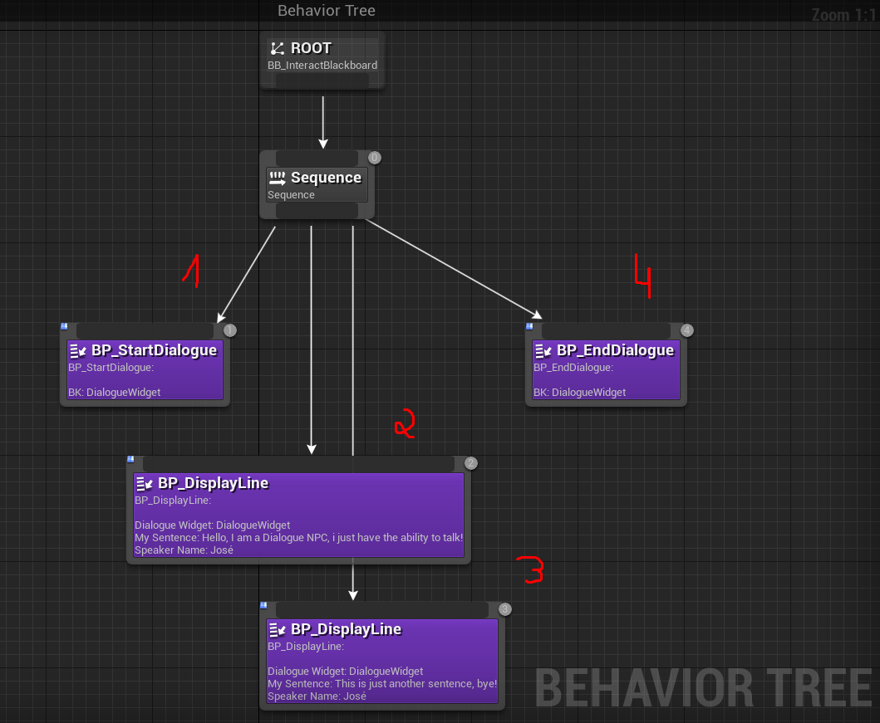

If you want to create a dialogue with choices it is a little more complex, it will be explained. Every time you want to put a yes or no choice you must put it directly after your last "DisplayLine"; after that, you must create a Selector and place two Sequences, one will be "yes" and the other "no", in the first place a blackboard decorator, the key being the blackboard variable YN.

