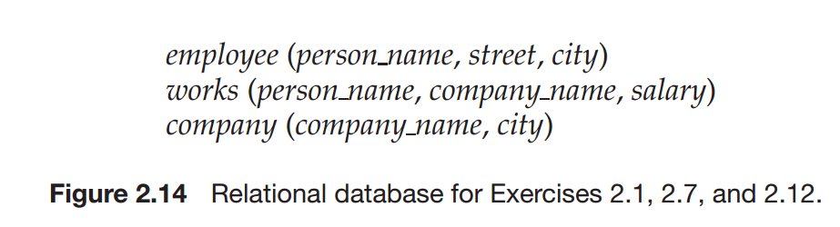

2.12 Consider the relational database of Figure 2.14. Give an expression in the  
relational algebra to express each of the following queries:  
a. Find the names of all employees who work for “First Bank Corporation”.  
b. Find the names and cities of residence of all employees who work for  
“First Bank Corporation”.  
c. Find the names, street address, and cities of residence of all employees  
who work for “First Bank Corporation” and earn more than $10,000.

Solution:

2.12a:



2.12b:

$$∏_{name,city}({employee ⋈ (σ}_{company_name }="First Bank Corporation")(works)))$$

2.12c:

$${\prod{}}_{name,city,street}(σ_{company_{n}ame}="First Bank Corporation"∧ salary >10000)(works⋈employee)))$$

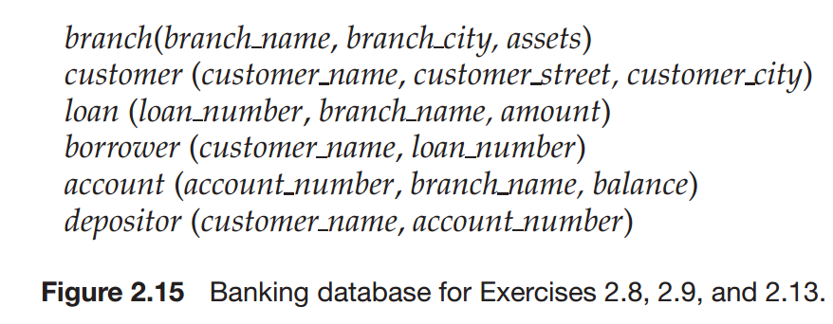

2.13 Consider the bank database of Figure 2.15. Give an expression in the relational algebra for each of the following queries:  
a. Find all loan numbers with a loan value greater than $10,000.  
b. Find the names of all depositors who have an account with a value  
greater than $6,000.  
c. Find the names of all depositors who have an account with a value  
greater than $6,000 at the “Uptown” branch

Solution

2.13a:

$$∏_{loan_number}(σ_{amount > 10000 }(loan))$$

2.13b:

$$∏_{customer_name}(σ_{balance > 6000 }(depositor⋈ account))$$

2.13c:

$$∏_{customer_name}(σ_{balance > 6000 ∧ branch_name = "Uptown" }(depositor⋈ account))$$