SFBRN Accessible Procurement Rubric
The unified accessibility review matrix for the San Francisco Bay Region Network, applied at requisition intake.
Review matrix version 2. Built 2026-10-19 from review-matrix.js, the model the SFBRN campuses run.

Each section states one part of the rubric, in the words the review tester shows a reviewer, followed by its grounding. Calibration names the choices no rule sets, which the pilot will test. Appendix A collects the binding rules, federal and California law, the federal standards California applies, and CSU policy. Appendix B collects the principles, the commitments the ATI framework holds. Both are grouped by the section they ground.

Contents
Right-click and choose Update Field to build the contents.

How a review reaches a decision
Reviews either conclude with one of three final decisions or remain paused in one of five numbered routes, each held by a named party until the condition the route names is met.
- Approve
- Approve with TAAP
- Deny
Routes 1 to 3, in priority order, gate the risk grade, a fixed Approve or Needs TAAP value for each pairing of an Exposure level with a Severity level. A review with no accessibility evidence holds with the requesting unit (route 1). Unknown Exposure answers hold the review with the requesting unit when those answers alone raise the Exposure level (route 2).
Severity read from the evidence on file is a minimum, and the review proceeds only on evidence at the Veracity floor. Below the floor, the review holds with the ATI review team (route 3), which raises the evidence with the requesting unit and the vendor, re-rates Severity and resumes at the Severity step. The need for Veracity rises with Exposure and Severity, and both parties share the interest in establishing the barriers. When the evidence cannot be raised, the review proceeds under the fallback, with Breadth as found, or 2 with no evidence at all, because unproven conformance is treated as hiding a blocking barrier and the TAAP is the remedy when the truth cannot be established. A Deny stands on the evidence in hand, because evidence below the floor can hide barriers but not invent them, so the pressure and the TAAP standard computed from the findings on file are minimums.
An Approve risk grade maps to an Approve final decision. A Needs TAAP risk grade requires a TAAP meeting the TAAP standard, a required count of the six requirements that Exposure-plus-Breadth pressure scales from 3 at pressure 0 or 1 to all 6 at pressure 3 or more.
The remedy step maps a Needs TAAP risk grade to a final decision by the TAAP on file. With no TAAP on file, the review holds with the requesting unit (route 4), carrying the TAAP standard and the warning level. A TAAP at or above the standard gives Approve with TAAP. An S2 product is never denied, so at S2 every TAAP on file gives Approve with TAAP.
Three conditions deny an S3 product.
- A more accessible product meets the same need, with or without a TAAP.
- The TAAP meets none of the six requirements.
- The TAAP falls below the standard at pressure 3 or more, with no written undue burden or fundamental alteration determination on file.
A TAAP below the standard at pressure 3 or more is a Non-Equal Alternative that the matrix otherwise denies. The exception (28 CFR 35.164 and 35.204; Section 508 E202.6) is the lawful basis for such a plan, a written determination by the president or a designee, counting all university resources, that equally effective access would be an undue burden or a fundamental alteration. A claim holds the review with the president or designee (route 5). A determination on file gives Approve with TAAP under a high warning, with named support for each missed requirement as the access the law still requires to the maximum extent possible. The exception is a defence against this one required action and never a property of the product, so it never arises at intake.
Any other TAAP below the standard gives Approve with TAAP. Every Needs TAAP risk grade carries a warning level derived from pressure plus the TAAP's shortfall against the standard, never below the pressure level, because TAAP coverage manages barriers without removing them.
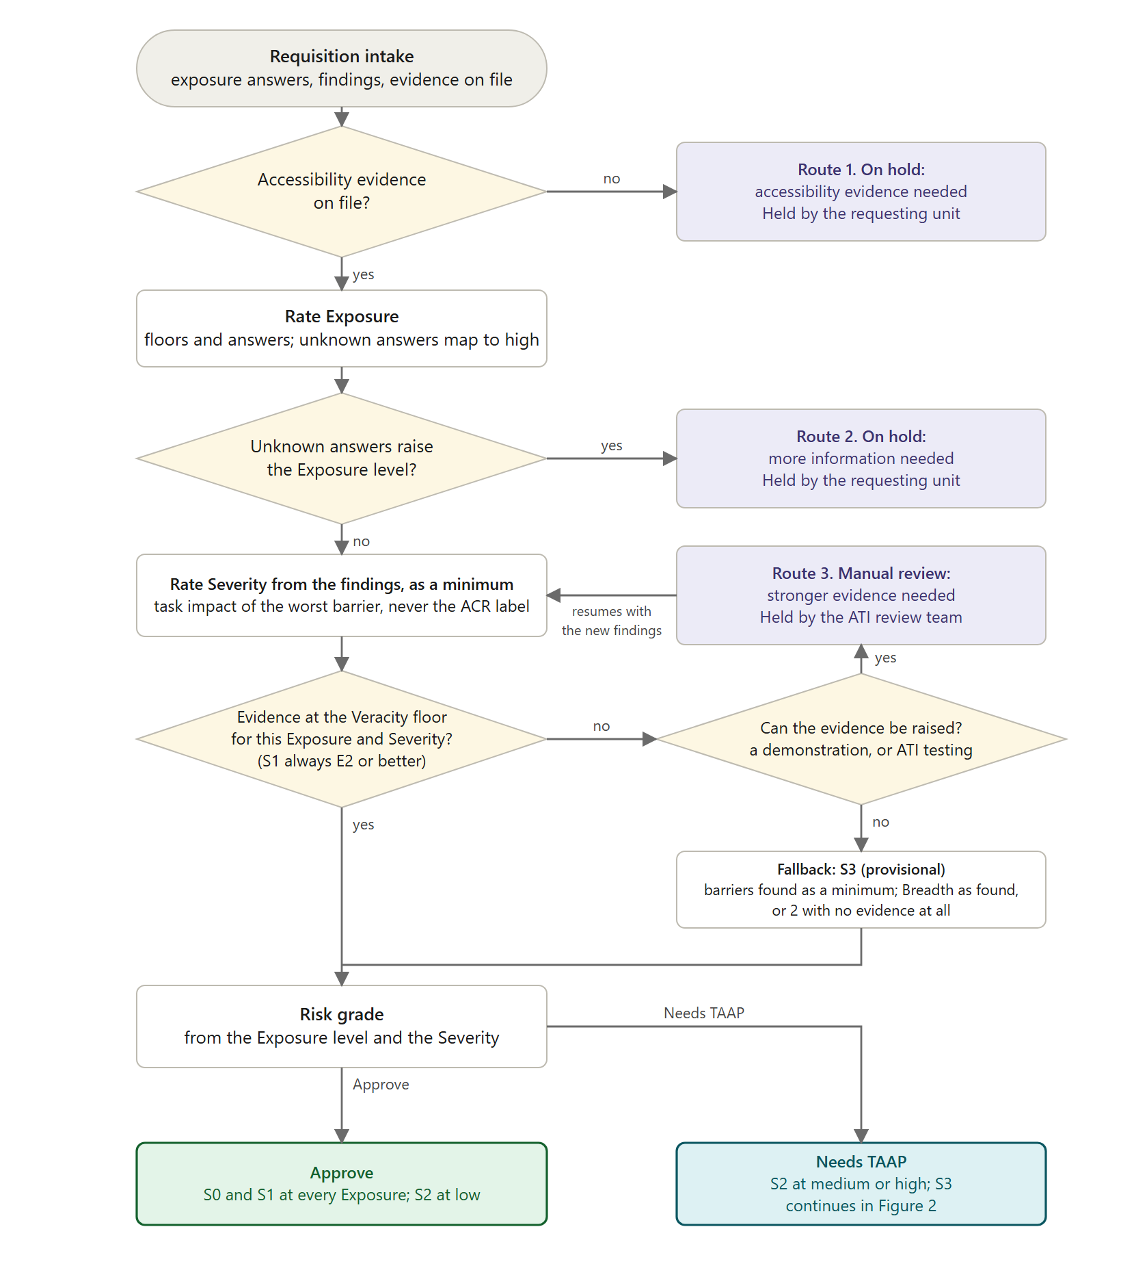
Figure 1. The shared checks, from requisition intake to the risk grade. Routes 1 to 3 hold the review, and route 3 loops back to the Severity step.
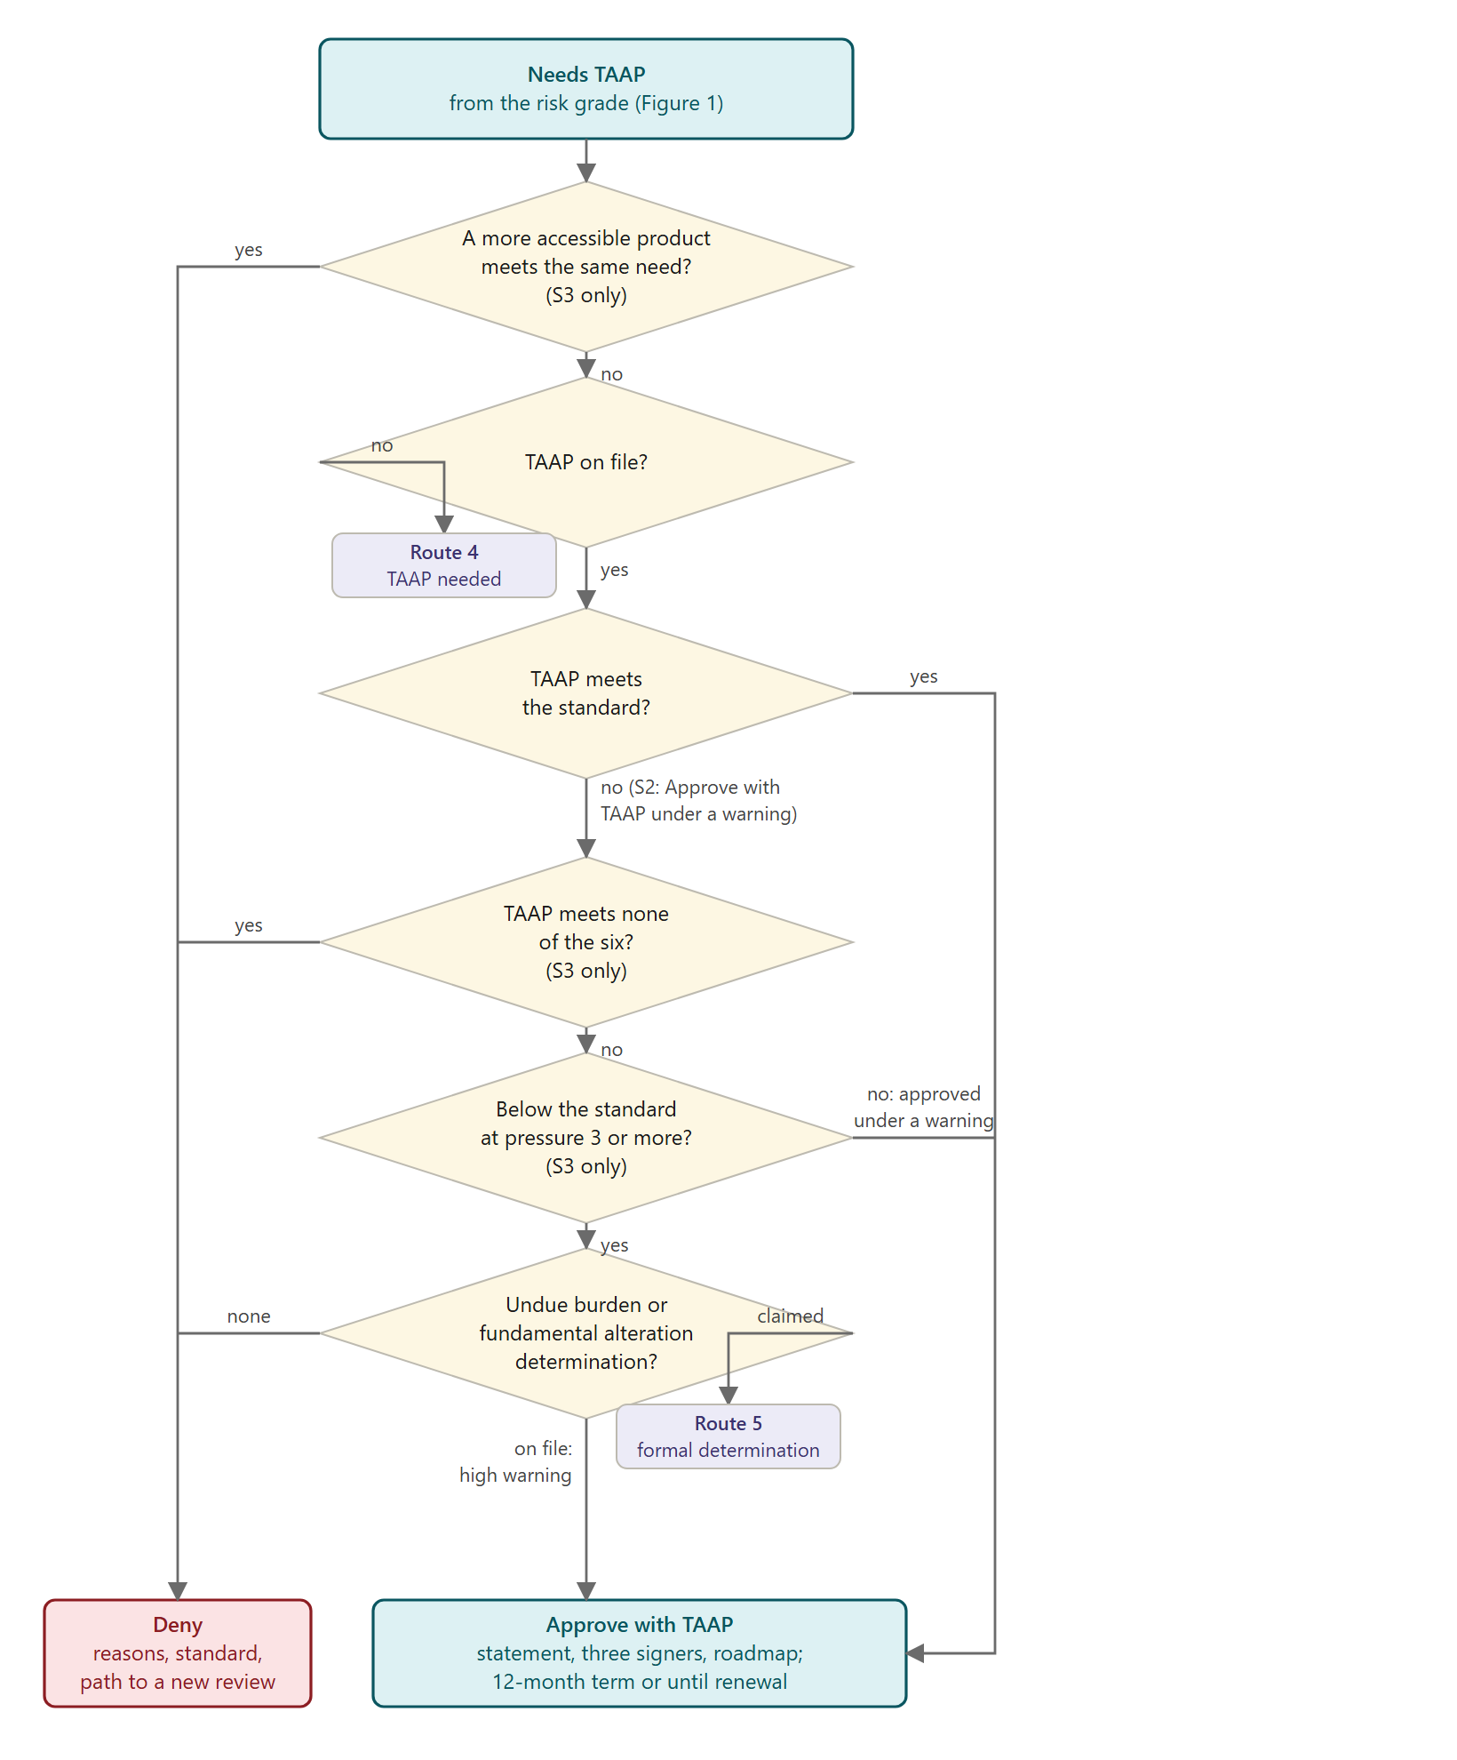
Figure 2. The remedy step, from a Needs TAAP risk grade to Deny or Approve with TAAP. Routes 4 and 5 hold the review.

Grounding
Calibration. The split into risk grade, routes and remedy step is the matrix's own design. No rule prescribes a hold state, a holder or a resume point. Appendix A lists the binding rules and Appendix B the principles behind this section, each under the heading How a review reaches a decision.

The rubric on one page
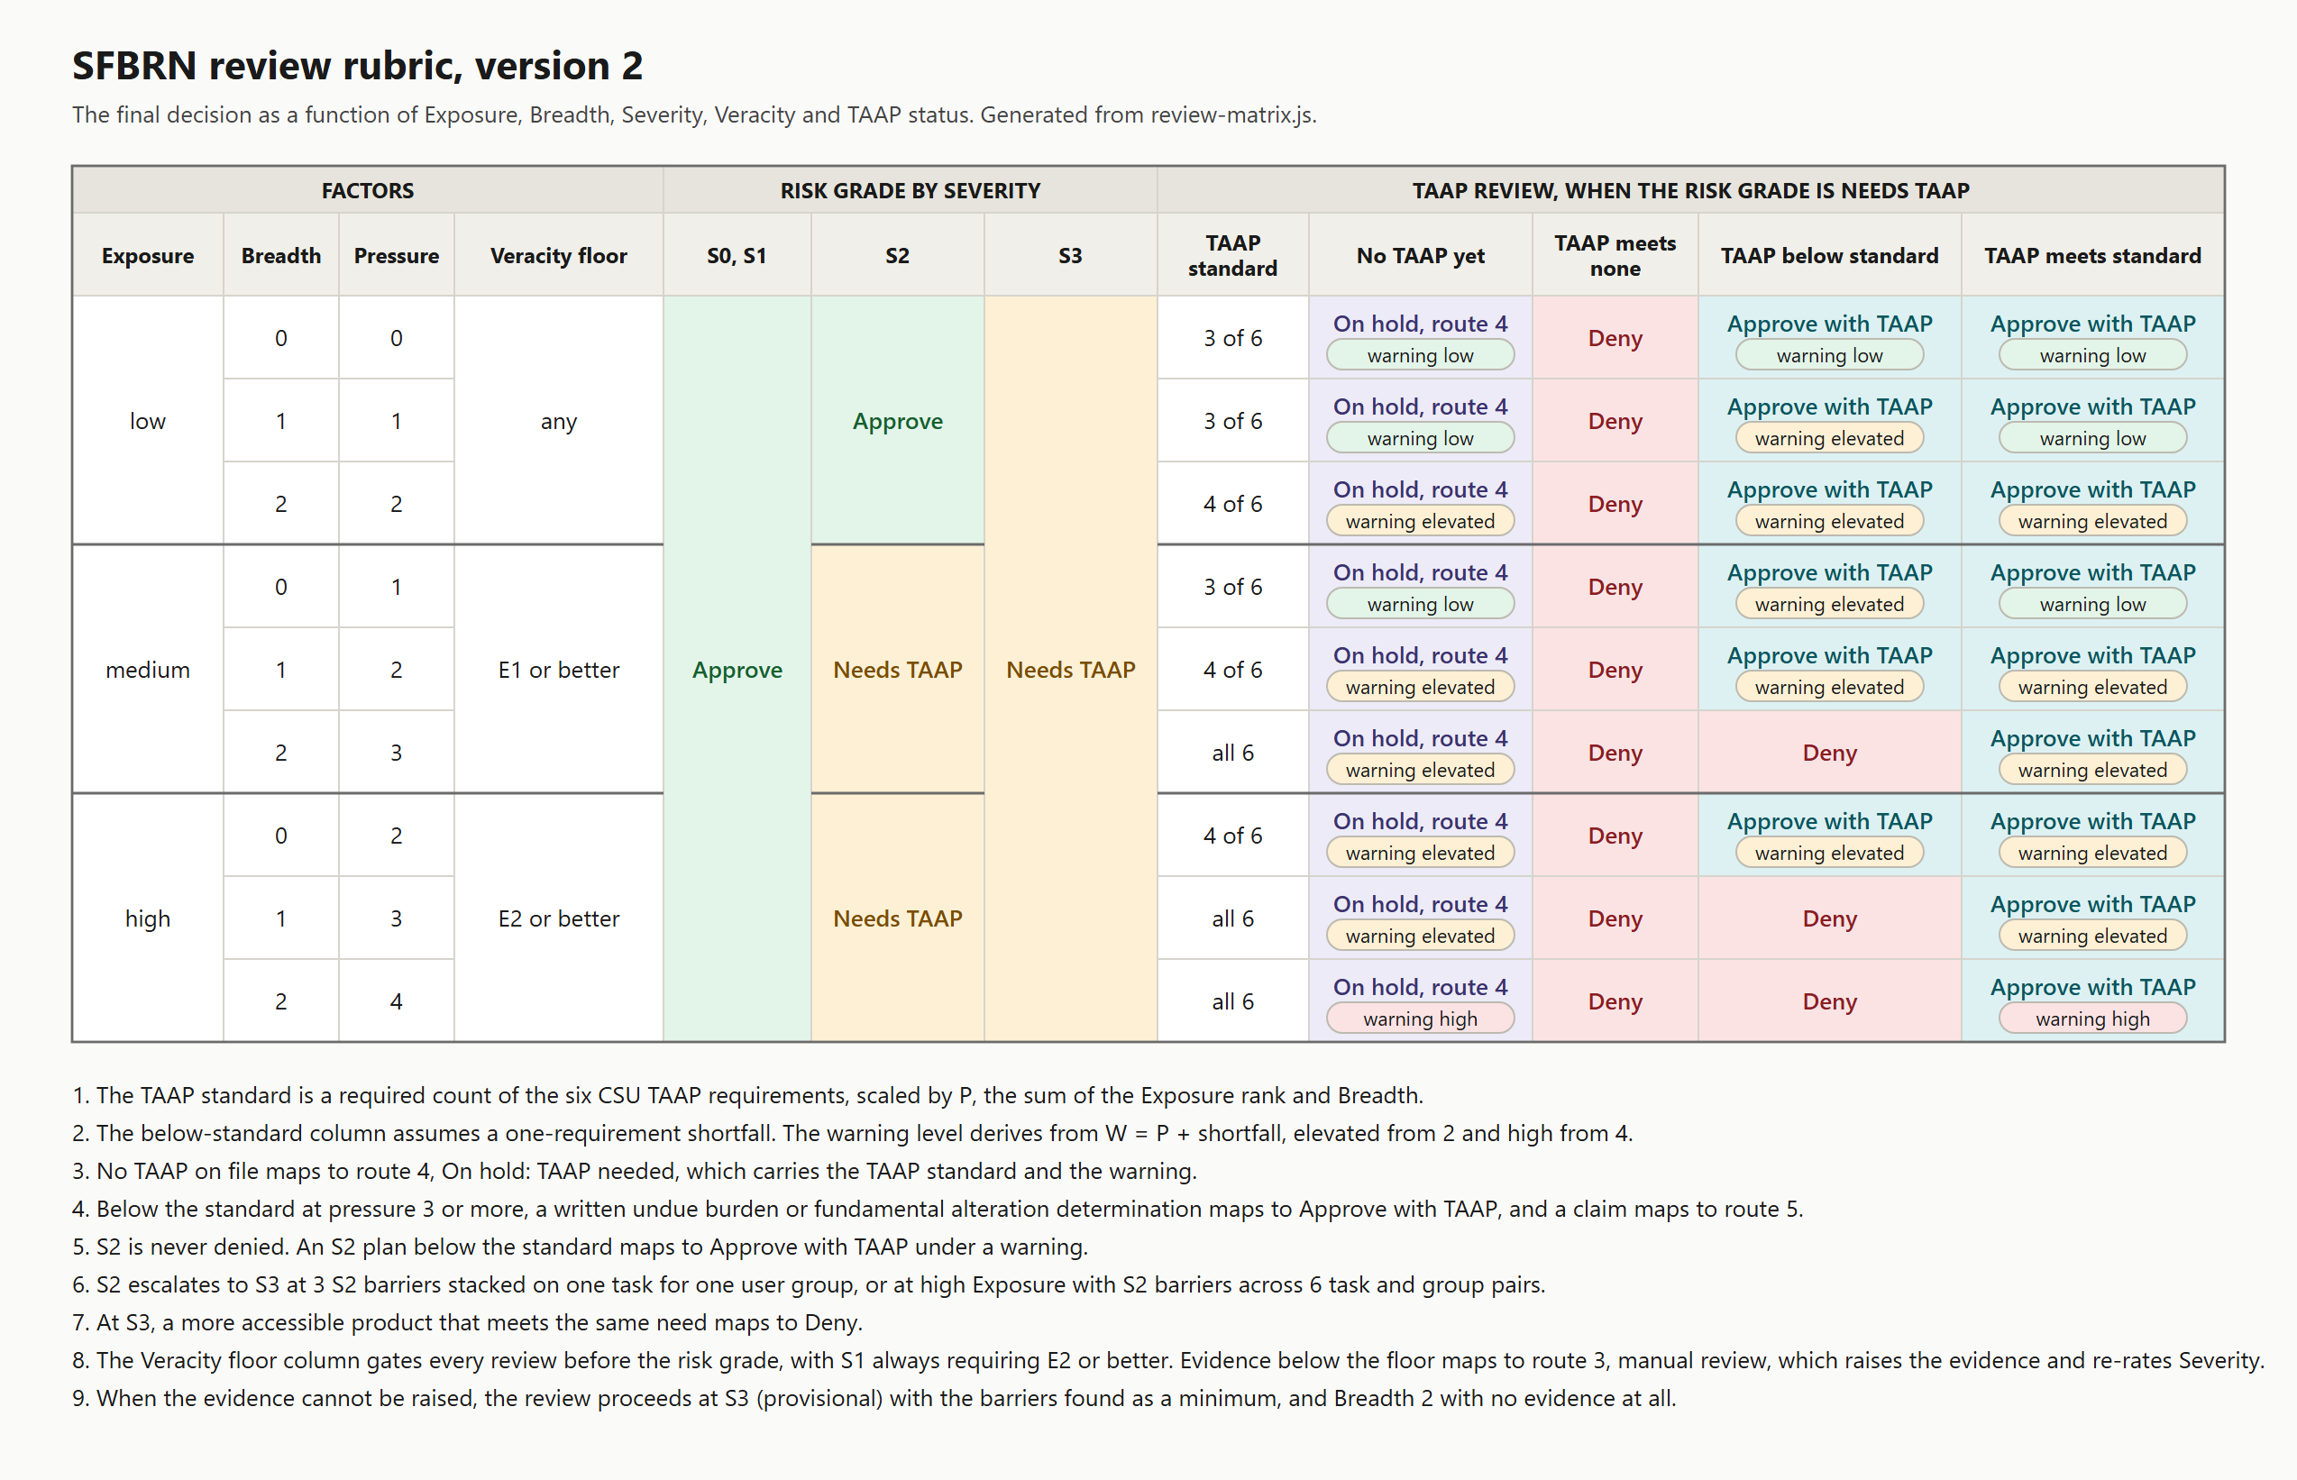
Figure 3. The rubric core, generated from the same model as this document. It collects the values the sections that follow define: the risk grade for each pairing of Exposure and Severity, the Veracity floor, the TAAP standard by pressure and the warning level.

Barriers and findings
Each review tests one campus-requested product against its review standard, WCAG 2.1 AA for web and mobile products or the Section 508 Standards for other software and hardware.
A core task is a task the product exists to support. Registering for a class, submitting homework and paying a bill are core tasks.
- Test. A task is core when its removal would change the product's use or purpose. WCAG-EM applies the same test to essential functionality.
- Source. The requester lists the minimum functional requirements, which CSU Procurement Step 1 calls "essential functionality", and the reviewer confirms the list.
- Scope. A core task covers its complete process, including sign-in, navigation, the content read along the way and the final submission. WCAG 2.1 requires every page in a complete process to conform.
- Other names. CSU TAAP documents say "core functionality" and "essential functions". The "essential functions" of a job under ADA Title I are a separate concept.
The review separates a failure in the product from its effect on users.
- Nonconformance. A failed success criterion or provision of the review standard, belonging to the product.
- Barrier. The effect of a nonconformance on one core task for one of the nine Section 508 disability groups listed below. One nonconformance produces a barrier for every core task and disability group it affects.
A finding records one barrier in four fields.
- Role. The users the barrier affects, among them students, employees, applicants and members of the public.
- Disability group. The group the barrier affects.
- Core task. The task the barrier blocks or slows.
- Severity. Task impact of the barrier, from S0 (no effect) to S3 (the user cannot finish the task alone).
An ACR lead is a row marked "Partially Supports" or "Does Not Support" in the vendor's ACR (Accessibility Conformance Report). A lead becomes a finding once its remark names the affected feature and the reviewer places that feature on a core task.
Severity attaches to the barrier and never to the nonconformance, because the level of the failed criterion (A or AA) does not predict the effect on users. S1, S2 and S3 match the GSA severity terms minor, major and critical. CSU procurement documents say "gap" or "issue" for a barrier.
The Section 508 functional performance criteria name nine disability groups.
- without vision
- limited vision
- without color perception
- without hearing
- limited hearing
- without speech
- limited manipulation
- limited reach and strength
- limited language cognitive learning

Grounding
Calibration. None. The definitions restate the law's own tests. Appendix A lists the binding rules and Appendix B the principles behind this section, each under the heading Barriers and findings.

Exposure
Exposure rates audience size and product reliance as low, medium or high.
A single floor fact sets a minimum exposure regardless of the answers.
Floor | Minimum exposure
Required of students for coursework or a grade | high
The only route to a university service (enrollment, aid, payment, housing) | high
Campus-wide, or all sections of a course in a curriculum | high
A person with a disability is known to be in the user group, or an accommodation request is open | high
A prior accessibility complaint about the product | high
Required for a job duty, or used in hiring | medium
Open to the public without single sign-on, publishes to the public, or in a public space | medium

The requester's answers map uniquely across four distinct groups.
- Reach. Number of users and organizational scope.
- Stakes. Required use and criticality.
- Spread. Content the product publishes.
- Duration. Frequency of use and contract length.
Each group level is the group's highest answer. The exposure level is the range containing the aggregate share of the maximum score, with cut points at 25% and 55% partitioning the share range into low, medium and high, unless a floor sets a higher level.
An unknown answer maps to its highest level. Where that mapping alters exposure, the review halts pending the requester's answers.

Grounding
Calibration. The user count cuts (25 and 250), the band cut points (0.25 and 0.55), the equal group weights and the assignment of each floor to medium or high are pilot calibration. No rule sets them. Appendix A lists the binding rules and Appendix B the principles behind this section, each under the heading Exposure.

Severity
Product severity derives entirely from maximum task impact across the findings, independent of vendor report conformance labels or the failed WCAG criterion level.
Severity | GSA term | Meaning
S0 | none | No effect on information, interactions, transactions or participation
S1 | Minor | Minimal impact, demonstrated: the four 35.205 tests documented as met
S2 | Major | A core task can be completed independently, with clearly unequal time or effort
S3 | Critical | A core task cannot be completed independently, or only with help

S? marks unknown severity, in the absence of any ACR, demonstration or testing. S3 (provisional) marks the fallback, defined under Evidence.
Two conditions escalate S2 findings to S3, shown as "S3 (accumulated)".
- Stacking. 3 or more S2 findings on one core task for one disability group, regardless of exposure.
- Spread. S2 findings on 6 or more pairs of core task and disability group, at high exposure only.

Grounding
Calibration. The accumulation thresholds (3 S2 findings stacked on one task and group, and 6 pairs at high exposure) are the matrix's. The reasoning is that task completion is conditional on every barrier on the task, so stacked S2 barriers block the task, and S2 barriers across most of the product exceed minimal impact in aggregate. The GSA labels minor, major and critical are used so vendor reports read across, and they are not a rule. Appendix A lists the binding rules and Appendix B the principles behind this section, each under the heading Severity.

Evidence (Veracity)
Veracity rates the reliability of the evidence behind the findings, by evidence level.
Evidence | What it is
E0 | Nothing, or marketing statements
E1- | Vendor ACR that fails a quality check
E1 | Vendor ACR that passes every quality check
E1+ | E1 plus GSA issue-level supplement
E2a | Live vendor demonstration of core tasks with assistive technology
E2b | Third-party audit with a named method
E3 | ATI team testing of core tasks by a named method

Severity read from the evidence on file is a minimum. Every review needs evidence at the Veracity floor for its exposure and severity before Severity is confirmed.
- Low exposure. Any evidence.
- Medium exposure. E1, E1+, E2a, E2b, E3.
- High exposure. E2a, E2b, E3.
An S1 finding always needs E2a, E2b or E3, because the reviewer must show the impact is minimal.
Below the floor, the review holds with the ATI review team, which raises the evidence with the requesting unit and the vendor, re-rates Severity and resumes. The need for Veracity rises with exposure and severity, and both parties share the interest in establishing the barriers. A demonstration or ATI testing ranks 4 or 5, which clears every floor, so one loop closes it.
When the evidence cannot be raised, the ATI review team records that and the review proceeds under the fallback. Severity is S3 (provisional) and the barriers found are a minimum. Unproven conformance is treated as hiding a blocking barrier, so the review requires an alternate access plan (TAAP, defined below). Deny stands on the evidence in hand, because weak evidence can hide barriers but not invent them.

Grounding
Calibration. The floor values (any evidence at low exposure, E1 at medium, E2 at high), the two-year ACR age and the eight ACR quality checks are calibration, drawn from CSU practice rather than a rule. The reasoning that a Deny stands on weak evidence is the matrix's own. Vendor self-reports understate barriers and do not invent them, so a standard computed from the findings on file is a minimum. Appendix A lists the binding rules and Appendix B the principles behind this section, each under the heading Evidence (Veracity).

Breadth
Breadth rates barrier reach across core tasks and disability groups, on a scale of 0 to 2.
Breadth derives from the count of blocked pairs (core task and disability group pairs stopped by an S3 finding or stacked S2 findings), with 2 blocked pairs giving 1 and 4 giving 2, plus 1 for 3 or more S2 findings, capped at 2. Under the fallback with no evidence at all, the review assumes Breadth 2.

Grounding
Calibration. The blocked-pair steps (2 and 4), the S2 count (3) and the cap at 2 are the matrix's. The assumption of Breadth 2 under the fallback with no evidence at all mirrors how unknown exposure answers map to high. Appendix A lists the binding rules and Appendix B the principles behind this section, each under the heading Breadth.

TAAP
A TAAP (Temporary Alternate Access Plan) is the CSU's written plan for equally effective access during vendor remediation, held to the six requirements of the CSU TAAP template.
- Allows access to the same information, engagement, and services
- Offers the same availability as the primary solution
- Can be accessed independently without additional assistance
- Does not result in disparate burden or impact on the user
- Has substantially equivalent ease of use
- Protects the privacy of the individuals affected
Each TAAP includes a campus-written TAAP accessibility statement, separate from the vendor's own statement and posted wherever the product is available and in use, including course syllabi where applicable, with the following content.
- Known barriers in the product interface
- The impacted disability groups
- A reference to the TAAP
- A disclaimer that unknown barriers may remain
- A contact for further accessibility assistance
Three people sign each TAAP.
- Department Chair/Manager
- Dean/Division Vice President
- ADA Compliance Officer
A TAAP below the standard at pressure 3 or more is approved only under a written determination by the president or a designee that equally effective access would be an undue burden or a fundamental alteration (28 CFR 35.164, 35.204). The determination covers this product only, counts all university resources, and lists the support that remains for each missed requirement. High cost alone does not establish an undue burden. The exception is a defence against this one required action, never a property of the product, so the review never asks for it at intake.
A TAAP lasts 12 months or until contract renewal, whichever comes first, with no extension.
The department using the product provides TAAP-defined support on any problem report, independent of accommodation, which starts with one person's request. The procurement review never relies on accommodation.

Grounding
Calibration. None. Every term here is the template's or the law's. Appendix A lists the binding rules and Appendix B the principles behind this section, each under the heading TAAP.

Risk grade
The risk grade is a fixed mapping from each pairing of an exposure level with a severity to one of two values.
- Approve. The barriers need no TAAP at this exposure.
- Needs TAAP. A TAAP is required before a final decision.
Exposure | S0 | S1 | S2 | S3
low | Approve | Approve | Approve | Needs TAAP
medium | Approve | Approve | Needs TAAP | Needs TAAP
high | Approve | Approve | Needs TAAP | Needs TAAP

Grounding
Calibration. The Approve grade for S2 at low exposure is the matrix's choice. The law does not scale with exposure, and the product still fails the standard, which the approval says in writing. Appendix A lists the binding rules and Appendix B the principles behind this section, each under the heading Risk grade.

Pressure and the TAAP standard
The TAAP standard, the number of TAAP requirements a plan must meet, derives from pressure, the sum of exposure rank (low 0, medium 1, high 2) and Breadth.
Pressure | TAAP standard
0, 1 | 3 of 6
2 | 4 of 6
3, 4 | all 6

An S3 plan below the standard is denied at pressure 3 or more, unless a written undue burden or fundamental alteration determination is on file, and approved with a warning below that pressure. TAAP work costs staff time, so purchases with less at stake get a lower bar.
Under the fallback, the TAAP standard is provisional and may rise when evidence arrives, and the first TAAP review re-rates Severity on evidence at the Veracity floor.

Grounding
Calibration. The counts (3 of 6 at pressure 0 or 1, 4 at 2, all 6 at 3 or more) and the denial line at pressure 3 are the matrix's. The template sets the risk tiers, and no rule sets how many requirements a plan must meet at each exposure. Low-pressure leniency is deliberate, because TAAP work costs staff time. Appendix A lists the binding rules and Appendix B the principles behind this section, each under the heading Pressure and the TAAP standard.

Warning level
The warning level, the purchase risk shown to the purchaser, derives from pressure plus the shortfall of requirements the plan misses below the standard.
- Low. Under 2.
- Elevated. 2 or 3.
- High. 4 or more.
No TAAP lowers the warning below the pressure level, because a TAAP manages barriers and only the vendor removes barriers.

Grounding
Calibration. The cut points (elevated at 2, high at 4) are the matrix's. The rule that no TAAP lowers the warning below the pressure level follows from the template, which says a TAAP manages barriers while the vendor removes them. Appendix A lists the binding rules and Appendix B the principles behind this section, each under the heading Warning level.

Final decision
The final decision settles the purchase as one of three values.
Final decision | Meaning
Approve | The purchase goes ahead, with any barriers acceptable at this exposure without a TAAP.
Approve with TAAP | The purchase goes ahead under the TAAP on file, a temporary plan that leaves the product's conformance unchanged.
Deny | The purchase stops, as a procurement decision rather than a verdict on the TAAP.

Three conditions deny an S3 product.
- A more accessible product meets the same need, with or without a TAAP.
- The TAAP on file meets none of the six requirements.
- The TAAP on file falls below the standard at pressure 3 or more, with no written undue burden or fundamental alteration determination on file.
An S2 product is never denied.

Grounding
Calibration. None. Each deny condition rests on a rule above. Appendix A lists the binding rules and Appendix B the principles behind this section, each under the heading Final decision.

Routes
Reviews either conclude with one of three final decisions or remain paused in one of five numbered routes, each held by a named party until the condition the route names is met. Routes 1 to 3, in priority order, gate the risk grade, and route 3 loops to the Severity step with the new findings or the fallback. Routes 4 and 5 come from the TAAP checks, with route 4 holding a Needs TAAP risk grade until a TAAP is on file, and route 5 referring an undue burden or fundamental alteration claim for a written determination.
Route | Headline | When it applies | Held by | Resumes at
1 | On hold: accessibility evidence needed | No ACR, demonstration or testing exists. | the requesting unit | The evidence check
2 | On hold: more information needed | Unknown answers could change the exposure level. | the requesting unit | The exposure check
3 | Manual review: stronger evidence needed | The evidence is below the Veracity floor for this exposure and severity, and a demonstration or ATI testing can still raise it. | the ATI review team | The Severity step, with the new findings or the fallback
4 | On hold: TAAP needed | The risk grade is Needs TAAP and no TAAP is on file. | the requesting unit | The remedy step
5 | Referred for a formal determination | The TAAP falls below the standard at pressure 3 or more, and the requesting unit claims that equally effective access would be an undue burden or a fundamental alteration (28 CFR 35.164, 35.204). | the president or a designee with budget authority | The remedy step

Grounding
Calibration. The numbering, the holders and the resume points are the matrix's design. Appendix A lists the binding rules and Appendix B the principles behind this section, each under the heading Routes.

Appendix A. Binding rules
The rules below bind the CSU. They are federal and California law, the federal standards California applies through Government Code 7405 and 11135, and CSU policy. Each entry states what the rule says and which part of the section it carries. Guidance, settlements, cases from other institutions and peer practice are not listed, because they do not bind the CSU.

How a review reaches a decision
CSU ATI Procurement Process, Step 3. The ATI reviewer approves or denies the acquisition on the review findings. A denial is recorded with a detailed rationale, and each campus provides a way to request reconsideration.
28 CFR 35.200. Web content and mobile apps that a public university provides, directly or through a vendor, must conform to WCAG 2.1 AA.
Section 508 Standards, E202.7 (36 CFR 1194), through Gov Code 7405. When no conforming product meets the need, the CSU buys the product that best meets the standard, documents why, and provides the information and functions by an alternative means.
CSU TAAP Authoring Template, instructions. A TAAP is needed when barriers are "severe enough to prevent users from performing essential functions". Failures "that do not prohibit core functionality do not require this process."

Barriers and findings
28 CFR 35.205. A nonconformance counts as compliant only when its impact is so minimal that people with disabilities still get the same information, interactions and transactions, with substantially equivalent timeliness, privacy, independence and ease of use. The test measures the effect on a person, which is why severity attaches to the barrier and not to the failed criterion.
Section 508 Standards, Chapter 3 (36 CFR 1194). The functional performance criteria name the nine disability groups a finding records.
WCAG 2.1, conformance requirement 3. Every page in a complete process must conform, so a core task is judged across its whole process.
CSU ATI Procurement Process, Step 1. The requester states the product's "essential functionality", which is the source of the core task list.

Exposure
ADA Title II, Section 504 and CSU policy. No binding rule contains a user-count, criticality or exposure threshold. Exposure therefore sets how deep the review goes, how strong the evidence must be and who signs, and never whether access is owed.
CSU ATI Procurement Process. The depth of review depends on how the product will be used, which is why unknown answers hold the review.
28 CFR 35.205 and Section 504 (34 CFR 104). The transactions test and the duty across academic programs ground the floors for coursework and for the only route to a service.
28 CFR 35.200. Content the university provides to the public falls under the web rule, which grounds the public floor.
ADA Title I (29 CFR 1630) and FEHA. Employment and hiring carry their own duty, which grounds the job-duty floor.
CSU Executive Order 1111. A known user with a disability or an open accommodation request makes the barrier concrete, which grounds that floor.

Severity
28 CFR 35.205. The four tests define S1. A barrier that makes a task clearly harder fails the minimal-impact test, so S2 does not conform. The university must be able to show minimal impact, so S1 needs demonstration.
CSU TAAP Authoring Template, instructions. Barriers "severe enough to prevent users from performing essential functions" require a TAAP, which is the S3 line.
Section 508 Standards, E202.7 (36 CFR 1194). Section 508 has no minimal-impact exception, so for non-web technology an S1 or S2 product is acceptable only when no conforming product meets the need.

Evidence (Veracity)
CSU ATI Procurement Process, Step 2. The CSU asks for a current Accessibility Conformance Report for each interface before it buys, which is route 1.
CSU ATI success indicator 1.8-pro. Each campus has a process to validate vendors' conformance claims, which is the loop under route 3.
CSU ATI Procurement Process, Step 3. The ATI reviewer decides on the review findings, so the findings are confirmed before the decision is made.
28 CFR 35.205. The university must be able to show that a nonconformance has minimal impact, which is why S1 always needs a demonstration, an audit or ATI testing.
Section 508 Standards, E202.7.2 (36 CFR 1194); CSU TAAP Authoring Template. Where conforming technology is not available, access is provided by an alternative means planned in advance. The fallback applies that remedy when conformance cannot be shown.

Breadth
28 CFR 35.130(b)(3). A university may not use methods of administration that have the effect of discriminating on the basis of disability. A product whose barriers reach most tasks and groups has that effect more widely, which is what Breadth measures.
CSU TAAP Authoring Template, Process Outcome and Institutional Risk. The template grades a plan by how many requirements it meets. Breadth raises the pressure, and pressure raises how many a plan must meet.

TAAP
CSU TAAP Authoring Template, Requirements Checklist. To qualify as an equally effective alternative, the plan must meet all six requirements. The six listed are the template's own words.
CSU TAAP Authoring Template, Product Specific Accessibility Statement, Administrative Approval and Annual Review. The TAAP includes a product-specific statement posted wherever the product is in use, is signed by the Department Chair or Manager, the Dean or Division Vice President and the ADA Compliance Officer, and "must be reviewed and updated annually or when renewing the ICT".
CSU TAAP Authoring Template, If the Vendor Fails to Meet Compliance Requirements. A TAAP stays valid only while the vendor is actively remediating. Without measurable progress, keeping the product needs a formal risk memo signed by executive leadership.
CSU ATI Procurement Process, Step 3; Section 508 Standards, E202.7.2 (36 CFR 1194). The TAAP provides equally effective alternate access "in a timely manner, for anyone that later reports a problem accessing the product". The duty is the institution's and is planned before anyone asks.
28 CFR 35.130(b)(1); 28 CFR 35.160(b)(2); 28 CFR 35.130(e); 34 CFR 104.4(b). An alternative must be as effective as what others get, timely, private and usable independently, and a person may decline it.
CSU Executive Order 1111. An accommodation comes from an interactive process with one person, in response to that person's request. TAAP support is given on the terms the plan sets, to anyone who reports a problem, and the review never relies on accommodation.
28 CFR 35.164 and 35.204; Section 508 Standards, E202.6. Only the head of the university or a designee may decide, in writing and after considering all resources available to the program, that conforming is an undue burden or a fundamental alteration. The university must still give access to the maximum extent possible. Because the decision weighs all resources of the program, the cost of one purchase on its own does not establish the burden.

Risk grade
CSU TAAP Authoring Template, instructions. A TAAP is needed only for barriers that prevent essential functions, so S0 and S1 are Approve and S3 is Needs TAAP at every exposure.
28 CFR 35.205; CSU Executive Order 1111, section IV. At medium or high exposure, barriers that make tasks clearly harder reach too many people for the impact to be minimal, so S2 is Needs TAAP there.
Section 508 Standards, E202.7 (36 CFR 1194). For non-web technology, a high-exposure S3 approval also carries a best-meets record with market research.

Pressure and the TAAP standard
CSU TAAP Authoring Template, Process Outcome and Institutional Risk. A plan meeting all six requirements is Equally Effective with low institutional risk, one to five is a Non-Equal Alternative with moderate risk, and none is a need for individualized accommodation with high risk.
CSU TAAP Authoring Template, Administrative Approval. Each signer confirms they have "evaluated the associated institutional risks" and found the plan "an acceptable interim solution." A plan below the standard is a risk the signers accept.
28 CFR 35.130(b)(1); 34 CFR 104.4(b). An alternative with fewer functions is not as effective as what others get. The law does not scale with exposure, so a plan below six requirements is an accepted risk and never a compliant result.

Warning level
CSU TAAP Authoring Template, Institutional Risk. The template names the institutional risk a plan carries, and the warning level is how the review tells the purchaser that risk.

Final decision
28 CFR 35.200; Gov Code 7405 and 11135. Web and mobile content must conform to WCAG 2.1 AA, and California applies the Section 508 Standards to the technology the CSU buys.
CSU ATI Procurement Process. The CSU buys the most accessible product that meets the business need, and the ATI reviewer approves or denies on the findings, with a recorded rationale and a reconsideration path.
CSU Accessible Technology Initiative Policy (2024). "The CSU seeks to improve product accessibility through partnerships and by leveraging the procurement process."
28 CFR 35.130(b)(1) and (b)(3); 34 CFR 104.4(b)(1). A university may not give people with disabilities a less effective service, or use methods of administration that have a discriminating effect. Requiring a product some users cannot use can have that effect.
Section 508 Standards, E202.7 (36 CFR 1194). When a more accessible product meets the need, the CSU chooses it.
CSU TAAP Authoring Template, Process Outcome; CSU Executive Order 1111, section IV.C.4. A plan that meets none of the six requirements is "unable to provide alternative means of access". Access would then rest on individual accommodation, which the CSU's Universal Design commitment aims to reduce.

Routes
CSU ATI Procurement Process, Step 2. A current ACR for each interface before purchase (route 1).
CSU ATI Procurement Process. The depth of review depends on how the product will be used (route 2).
CSU ATI success indicator 1.8-pro; CSU ATI Procurement Process, Step 3. A process to validate vendor claims, and a decision made on confirmed findings (route 3).
CSU TAAP Authoring Template. The TAAP standard a plan is held to before the remedy step resumes (route 4).
28 CFR 35.164 and 35.204; Section 508 Standards, E202.6. The written determination belongs to the president or a designee, after considering all resources (route 5).

Appendix B. Principles
A principle is a commitment the ATI framework holds, recorded in the ATI knowledge graph with the law, policy and scholarship that ground it. Each entry states the principle and the part of the section it carries. A principle marked "proposed" was drafted for this matrix and is not yet recorded in the graph.

How a review reaches a decision
Time-bound alternative access when full conformance is not yet achieved. Where content cannot yet meet the standard, the institution provides a documented, time-limited, equally effective alternative while it remediates, and does not treat the non-conformance as acceptable. A TAAP is that alternative, never compliance.
Deference is earned through a documented, individualized process. Courts and OCR defer to an institution's judgment only when a record shows the responsible officials considered the individual and the alternatives. Every route names its holder and every decision its reasons for that record.

Barriers and findings
Severity is judged by the effect on a task. A barrier's severity comes from what it does to a named group of users on a core task. Neither an ACR's conformance label nor a criterion's level says how severe a barrier is.
The audience determines which duty governs. Who uses a system decides which law governs its accessibility, so a finding records the role.

Exposure
Exposure sets scrutiny, not entitlement (proposed). How widely a product is used decides how closely it is reviewed and who signs. It does not decide whether people with disabilities are owed access.
Prioritization by impact under finite resources. Campuses direct accessibility work at the barriers with the greatest impact rather than spreading it evenly.
Same facts, same answer (proposed). Two reviewers given the same facts reach the same result. Each question maps to one group so no fact is counted twice.

Severity
Severity is judged by the effect on a task. Severity derives from task impact, independent of the vendor label and the criterion level.
Severity calls need anchors. Trained reviewers disagree on severity often enough that one reviewer's call carries known error, so each level has a written anchor and a call made from documents alone stays open to testing.
Remedy proportionate to barrier severity. Formal alternative-access planning applies to barriers that block essential functions, not to every conformance flaw.

Evidence (Veracity)
Vendor conformance claims require proportionate validation. A vendor's conformance report is an unverified claim. The institution checks it in proportion to the product's exposure, and a claim the product contradicts counts as no evidence.
Report quality and product accessibility are separate measures. How far an ACR can be trusted and how accessible the product is are two measures, scored apart. A report with no reported failures is a warning sign.
Program accessibility is a proactive, systemic duty. Access is planned before deployment, whether or not anyone has asked. Unproven conformance is treated as hiding a blocking barrier for that reason.

Breadth
Remedy proportionate to barrier severity. The weight of the remedy matches the severity of the barrier, and Breadth is the part of severity that measures reach.

TAAP
Equally effective access. Accessible technology must give a person with a disability the same result, benefit or opportunity as others, not merely some alternative.
Undue burden and fundamental alteration bound the duty. The duty has limits, but the institution must still take other action that gives people with disabilities the program's benefits to the maximum extent possible. That is why the exception is claimed against the TAAP standard and never at intake.
Notice is part of access, not administration around it. A remedy the affected person cannot find is not a remedy, which is why the TAAP statement is posted where the product is used.
Conformance and accommodation are parallel duties. Approval under a TAAP never ends the individual accommodation duty.

Risk grade
Remedy proportionate to barrier severity. The grade places the formal remedy on the barriers that block essential functions.
Exposure sets scrutiny, not entitlement (proposed). Exposure moves the S2 row only, and never makes an S3 product acceptable.

Pressure and the TAAP standard
Remedy proportionate to barrier severity. The number of requirements a plan must meet rises with the reach of the barriers and the exposure of the product.

Warning level
Deference is earned through a documented, individualized process. The warning is recorded with the determination, so the risk the signers accepted is visible later.

Final decision
Procurement as an accessibility lever. The institution advances accessibility at the point of purchase. A denial states its findings, the standard it applied and the route to a new review.
Universal Design reduces accommodation. Designing for accessibility up front reduces the need for individual accommodations, so the review prefers the more accessible product.

Routes
Deference is earned through a documented, individualized process. Each hold names who holds it and what releases it, so the record shows the review waited for a fact rather than assumed one.
Undue burden and fundamental alteration bound the duty. The claim leaves the reviewer and goes to the officer the law names.

