corr(ay, az)
corr(ay, ay)
cov(ax,ax)
cov(ax',ax')
corr(ax, ay)
size(ax)
corr(ax(1:50,1), ay(1:50,1))
corr(ax, ay)
corr(ax(1:100,1), ay(1:100,1))
corr(ax(1:1000,1), ay(1:1000,1))
corr(ax, ay)
corr(ax(1:50,1), ay(1:50,1))
cov(ax,ax)
cov(ax',ax')
cov(ay,ax)
cov([1 2 3 4 5], [2 4 6 8 10])
X=[4 2 .6; 4.2 2.1 .59; 3.9 2 .58; 4.3 2.1 .62; 4.1 2.2 .63]
mean(X)
cov(X)
var(X(:, 1))
cov([ax,ay])
var(ax)
cov([ax,ay])
cov(ay,ax)
cov(ay,az)
cov(ax,az)
corr(ax, ay)
[rho, pval]=corr(ax,ay)
x=rand(30,1);
y=x+1;
corr(x,y)
y=x+3.6;
corr(x,y)
corr(ax,ax)
corr(ax,-ax)
corr(ax(1:50, 1),ay(1:50,1))
corr(ax(1:500, 1),ay(1:500,1))
corr(ax(1:100, 1),ay(1:100,1))
corr(ax(1:200, 1),ay(1:200,1))
corr(ax(100:200, 1),ay(100:200,1))
autocorr(ax)
autocorr(ax,25)
autocorr(ax,250)
autocorr(ax,500)
autocorr(ax,250)
autocorr(ax)
autocorr(resultant)
autocorr(resultant,250)
autocorr(resultant,250)
%autocorr(resultant(1:100,1),250)
autocorr(resultant(1:100,1))
autocorr(resultant(1:100,1),50)
gigi=autocorr(resultant(1:100,1),50)
plot(gigi)
gigi=autocorr(resultant,50)
gigi=autocorr(resultant,50);
plot(gigi)
gigi=autocorr(resultant,500);
plot(gigi)
gigi=autocorr(resultant,5000);
figure(2); plot(gigi)
ans =
0.4012
ans =
1.0000
ans =
6.1410 6.1410
6.1410 6.1410
ans =
6.1410 6.1410
6.1410 6.1410
ans =
-0.1608
ans =
8710 1
ans =
-0.0147
ans =
-0.1608
ans =
-5.6174e-04
ans =
8.9431e-04
ans =
-0.1608
ans =
-0.0147
ans =
6.1410 6.1410
6.1410 6.1410
ans =
6.1410 6.1410
6.1410 6.1410
ans =
17.6363 -1.6738
-1.6738 6.1410
ans =
2.5000 5.0000
5.0000 10.0000
X =
4.0000 2.0000 0.6000
4.2000 2.1000 0.5900
3.9000 2.0000 0.5800
4.3000 2.1000 0.6200
4.1000 2.2000 0.6300
ans =
4.1000 2.0800 0.6040
ans =
0.0250 0.0075 0.0017
0.0075 0.0070 0.0014
0.0017 0.0014 0.0004
ans =
0.0250
ans =
6.1410 -1.6738
-1.6738 17.6363
ans =
6.1410
ans =
6.1410 -1.6738
-1.6738 17.6363
ans =
17.6363 -1.6738
-1.6738 6.1410
ans =
17.6363 7.2414
7.2414 18.4738
ans =
6.1410 0.0270
0.0270 18.4738
ans =
-0.1608
rho =
-0.1608
pval =
1.4600e-51
ans =
1
ans =
1.0000
ans =
1.0000
ans =
-1.0000
ans =
-0.0147
ans =
0.0245
ans =
-5.6174e-04
ans =
0.0164
ans =
0.0302
gigi =
1.0000
0.7840
0.4171
0.1750
0.0910
0.0800
0.0255
-0.1192
-0.2747
-0.3447
-0.3367
-0.3184
-0.3174
-0.3211
-0.2980
-0.2498
-0.2113
-0.1726
-0.1094
-0.0312
0.0363
0.0832
0.0970
0.0970
0.1192
0.1685
0.2223
0.2410
0.2106
0.1601
0.1277
0.1269
0.1371
0.0996
0.0034
-0.0987
-0.1528
-0.1550
-0.1341
-0.1231
-0.1284
-0.1360
-0.1682
-0.2391
-0.2976
-0.2871
-0.1852
-0.0127
0.1335
0.1953
0.1757
gigi =
1.0000
0.7088
0.2135
-0.0676
-0.1029
0.0159
0.1275
0.0243
-0.2349
-0.3998
-0.3764
-0.2448
-0.1023
-0.0512
-0.1082
-0.1935
-0.2535
-0.2421
-0.1481
-0.0336
0.0460
0.0863
0.1064
0.1410
0.2122
0.2944
0.3213
0.2668
0.1834
0.1254
0.0943
0.0640
0.0114
-0.0752
-0.1788
-0.2425
-0.2354
-0.1748
-0.0995
-0.0741
-0.1438
-0.2702
-0.3614
-0.3229
-0.1427
0.0377
0.0723
-0.0060
-0.0448
0.0797
0.3859
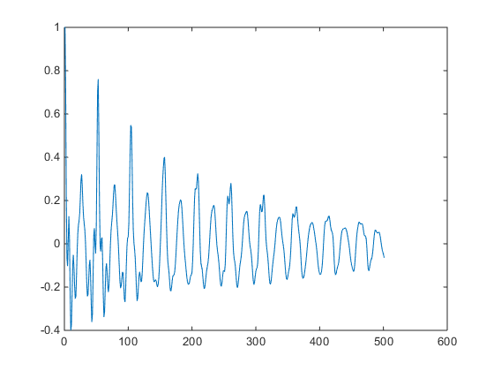
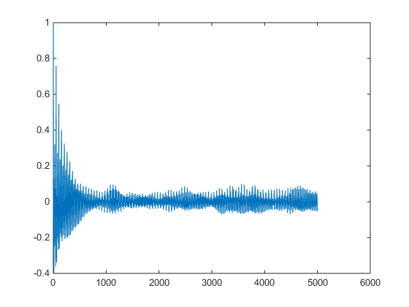
Published with MATLAB® R2014b

