Technical Report

Industry Project T-CB-ITS2-CMK

Teacher: Qin Zhao, Xuemei Pu

Date: 21 – 06 – 2020

Group 4

Authors: Victor Florea, Ivo Belitts, Valentin Stoyanov, Yvan Koopmans

Here you will find the summary of the Indoor Climate Control System Project of Group 4. Information about how we planned, worked and what came out to be the final version of this project.

Table of Contents

Introduction 4

Procedure: 4

Designs: 5

Results: 8

Conclusion: 9

Retrospective and recommendations: 10

Comfort Home Project – Semester II

Introduction:

The goal of the project was to create a fully functional system which would regulate the air flow and air quality of a room or building based on measurements made by sensors and algorithms processing said measurements.

# Procedure:

During the development of the project the main concerns were:

* How the sensors are going to operate
* How the sensors are communicating with the VentilationBox
* How the Ventilation Box is communicating with the server

The operation of the sensors is split and done on separate bords due to the Corona virus outbreak. The actual operation of the Sensors will be dictated by a single microcontroller. The current implementations worked fine and ensures not only the robustness of each sensor but also the stability of sensor to Ventilation box communication.

The communication between the sensors and the Ventilation Box is handled by a P2P connection based on the TCP Socket. However, this is not the finest of solving the problem, a better solution is utilizing the MQTT protocol.

The way the Ventilation Box and the Server communicate is through HTTP Requests (Post Request). This is an efficient way of transferring data over the internet. The only downside to it is that the data send is not encrypted.

# Designs:

We have drawn a few diagrams that represent our system and how it works.

System architecture diagram:

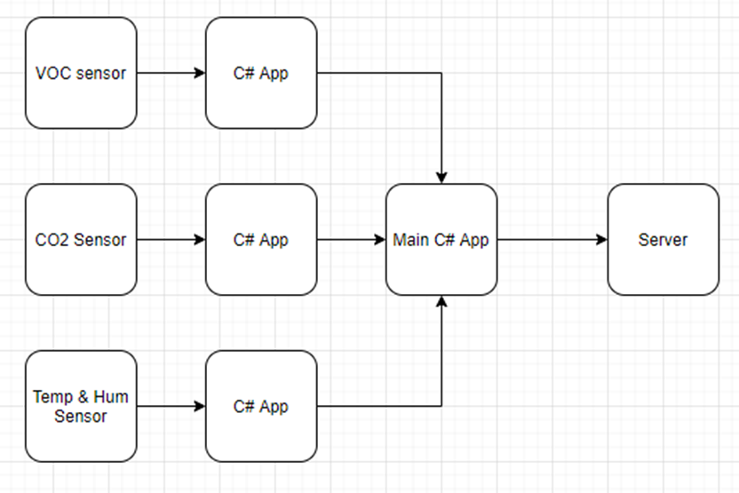

System context diagram:

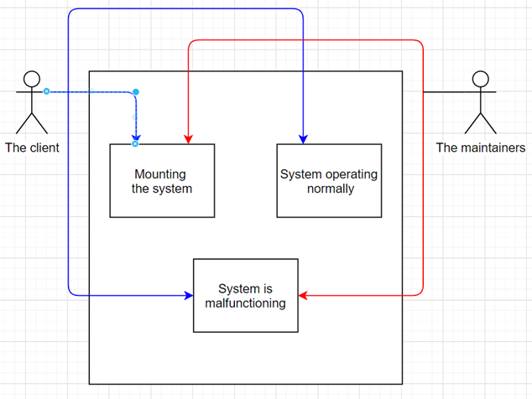

State diagram:

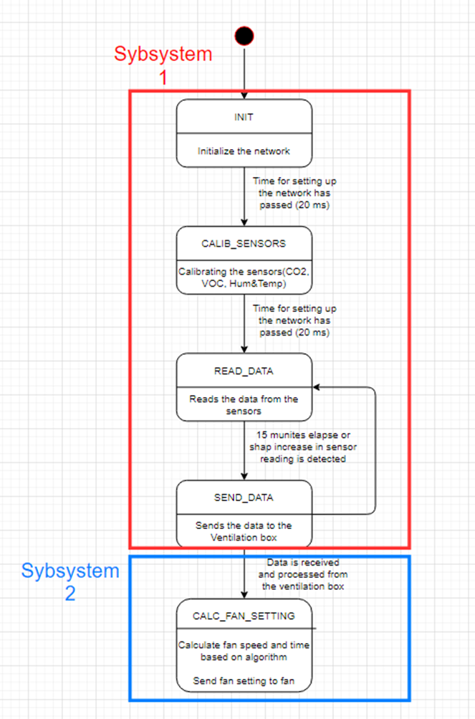

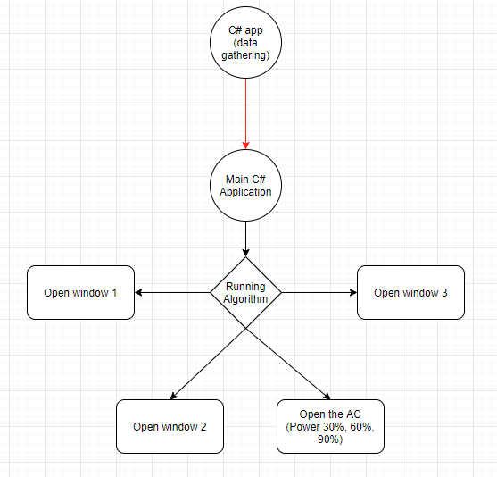Control flow chart:

# Results:

After having successfully finished the project, we have gathered some results to show as proof. We will represent our results using various graphical methods. We continuously send and read data via sensors and the C#-App; this data is then recorded in a text file that acts as a database of our readings. This text file will be essential in demonstrating our readings (and of course our results). We have also made a graphical representation of how our sensor-network looks and the relationship between the network’s members.

Log file results:

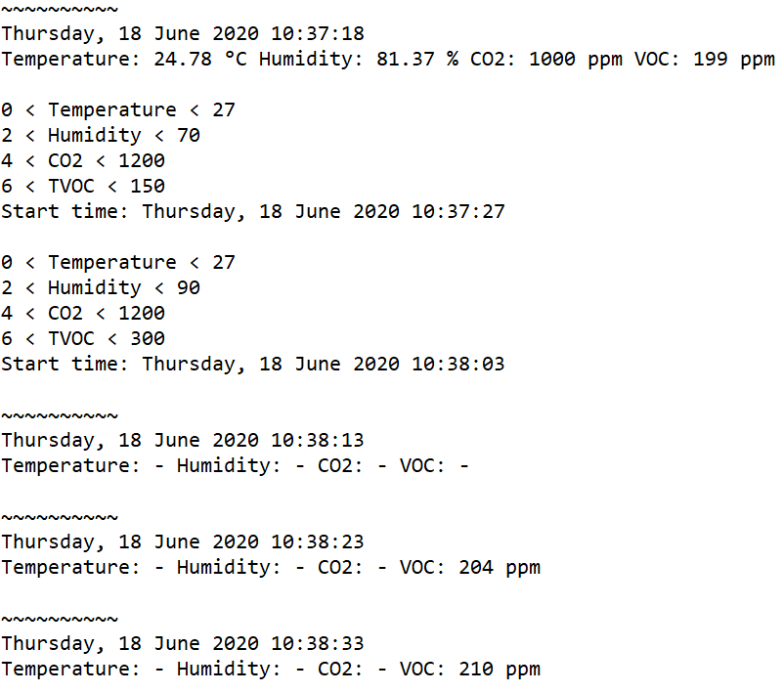

Network Diagram:

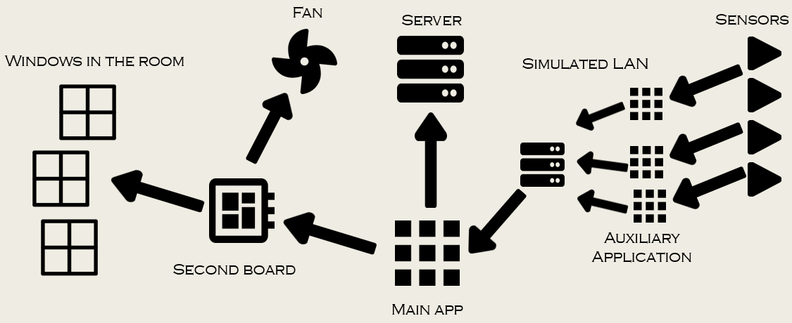

These are our project’s results; clearly showing how everything is connected and what is being read/transmitted within the network.

Our solution meets all requirements, except for the data-transmission being handled by the ZigBee module. So, at the end of our project we are able to declare our solution as more than functional. We can read real-time values (or readings) from each and every sensor, transmit said values via TCP/IP to a remote Application, which in turn transmits the collected data to another group’s server.

# Conclusion:

Overall, this was a very interesting project, that challenged us in multiple ways. We are all happy with the final product, but also have a lot of ideas for future improvements. And while the project was slightly changed due to outside circumstances, it still remained challenging and interesting for all of us.

# Retrospective and recommendations:

Looking back, this project definitely had its ups and downs.

On one hand, the coronavirus pandemic was something that had a negative effect on the process. Not being able to see each other and get all sensors together on a single microcontroller meant that we had to look into communication over the Internet to get each sensor’s readings. This made the task a lot more difficult and problematic, especially considering our level of programming knowledge.

However, this also had its positives in that we had to push ourselves to get familiar with more complex ways of communication, particularly TCP and HTTP, which would definitely come in handy for future projects or assignments.

The COVID situation also affected the way we communicate, resulting in us not being able to meet physically and having to rely on online communication for a large part of the project. However, I think that we quickly adapted to the situation and at the end we were communicating just as effectively digitally as face-to-face.

What we could improve on in future projects or assignments is time management. Although we managed to finish everything on time, there was definitely more work at the start and end of the project rather than in the 6-12-week period. So working on distributing the work more evenly across time would be a big improvement.