Findings TwinCat Software

Robot arm project

Luuk aarts

2023

Table of contents

Introduction 2

Questions 2

Main question 2

Sub questions 2

What 2

Why 2

How 2

What is a PLC? 3

What software is best for the Beckhoff PLC? 3

How to get the software for the Beckhoff PLC? 3

How to connect your device with the Beckhoff PLC? 4

Ethernet IP 4

Windows 4

MacOS 4

How to run code on a Beckhoff PLC? 5

Conclusion 6

Sources 6

# Introduction

This document will contain the research done to get to know the Beckhoff PLC. All research is done via the [DOT framework](https://ictresearchmethods.nl/The_DOT_Framework), the sources will be listed at the end of this file and you will know what software to use, where to find it and how to use it with the Beckhoff PLC at the.

# Questions

The sub questions consist out of smaller parts of the main question and questions that should be answered to understand the main question.

## Main question

* How can you write software on a Beckhoff PLC?

## Sub questions

* What is a PLC?
* What software is best for the Beckhoff PLC?
* How to get the software for the Beckhoff PLC?
* How to connect your device with the Beckhoff PLC?
* How run the code on the Beckhoff PLC?

# What

During the research for this document, I will be using existing documentation and use Beckhoff as main source since we are using their product so their documentation will be most complete. I will also check their claims with other sources so that I can be confident that what Beckhoff stated is indeed true.

# Why

Using a PLC is completely new to me, so to be able to use one, I will have to know more about what it is and how to use it. Computers have all kinds of specific needs or details that must be known before writing any code. For example, does the PLC have built in timers or does it run on multiple treads?

It is safer for the machine and for us to check this before using it.

# How

I will be doing research on already known subjects, so most of my research will be done using the Library method. After searching the answers on all questions, I will check the usability of the information I found using the Field and Lab methods of the DOT framework. The Library research will be done existing documentation and community discussions about the subject.

# What is PLC: programmable logic controllerWhat is a PLC?

A PLC (Programmable Logic Controller) is a PC specially made for the industrial automation of all kinds of processes. I found on multiple sources that the most important difference with a PC is that the PLC is much saver and can almost not crash when in a process. For the industrial automation a very important aspect might indeed be that the process does not stop because of a wrong use of process storage a value that becomes too big.

On a PLC all parameters will be created and set before running the program, this makes it impossible for the program to crash during runtime because of a storage error. A PLC can communicate with the outside world using I/O pins and Ethernet or any other extensions. The PLC can add extensions to its existing format by just adding a new brick to the PLC, this makes it very useful in an industrial area.

**Source¹**

# What software is best for the Beckhoff PLC?

I have been searching for multiple software programs to be used on the Beckhoff PLC. It seems though that TwinCAT is the only available software on the marked, the software is also from Beckhoff and it seems that Beckhoff does not want any other options for their device.   
I thought there might be some jailbreak options but even on that spectrum is no written source. TwinCAT comes out as the best software for the Beckhoff PLC, but meanly because it is the only compatible software on the market wright now.

# How to get the software for the Beckhoff PLC?

TwinCat is an application that will host and form the backbone and software of a PLC. In this case we will use this software because the PLC we are using is made by Beckhoff, the same company that developed TwinCat. And the application does fit within our needs and requirements, one of which is the ability to write the code in Structured text, TwinCat is perfect for the structured text language.

Figure 1, source: https://www.beckhoff.com/en-en/products/automation/twincat/texxxx-twincat-3-engineering/te1000.html

The version of TwinCat we will use is the, TE1000 TwinCAT 3 Engineering, it will integrate into the Visual Studio software on device and download their own platform to use if preferred.

If downloaded properly, the software should now be available to use in combination with the Beckhoff PLC.

**Source²**

# Afbeelding met tekst Automatisch gegenereerde beschrijvingHow to connect your device with the Beckhoff PLC?

While there is not much information about running the TwinCAT software on a virtual machine on a MacBook, there found out by trial and error that there are some problems that showed up.

## Ethernet IP

The TwinCAT application on device will connect with the PLC over ethernet.

What I had not found when searching the documentation about TwinCAT but did see in a video about TwinCAT, was the basic Ethernet rule, both devices should have the same network address. So after a few days of not knowing what was wrong, I found together with Oswald that the solution would be to set a static IP on ‘192.168.3.—’ with a network mask of ‘255.255.255.0’.

After setting the IP the PLC could finally be connected.

**Source³**

## Windows

If the PLC is already known on the device, it will be showed under the <LOCAL> device. It can then be selected as the target and the connection is complete.

If the PLC is new on the device, the Search via Ethernet button can be used to search for the PLC. After detecting the new PLC within the search results the PLC can be selected as the target. The PLC will now be known on this device.

Note: to log in on our PLC we used,

The username: ‘Administrator’.

The password: ‘1’.

I got this password and username from my teacher (client) other devices might have different passwords, but the default info according to Beckhoff is the above Username and Password.

**Source⁴**

## MacOS

When testing the connecting sequence, I had found and checked at multiple sources, it did not work. At least not on my device, the others had no problems at with connecting at all.

The big difference was the Mac with M1 (ARM 64) chip that I tried it on, TwinCAT although not brought to attention very clear, has no support for any other processors then Intel processors yet.

My solution was to use another device while working on TwinCAT.

# How to run code on a Beckhoff PLC?

A new project can be created and will create a work environment for the connected PLC. The PLC can be equipped with external devices which it could use. Those devices will show up on the I/O tab and devices interface. But to start programming the PLC, a PLC must be created in the work environment. Under the tab PLC a new PLC can be created and named, (here Untitled10 Project).

When watching a startup manual, I found the meaning of all created folders in the project. TwinCAT has a pre structured software setup, this makes it more robust for errors while running. Software and parameters are separated to achieve the exact same goal.

* POU's (Program Organizational Unit) -- Program all functions, programs and all general code here.
* GVL's (Global Variable Library) -- set all variables in here.
* DUT's (Data Unit Types) -- create all new structures and types here.

**Source⁵**

In general, the program should work somewhat the same as a Visual Studio project.

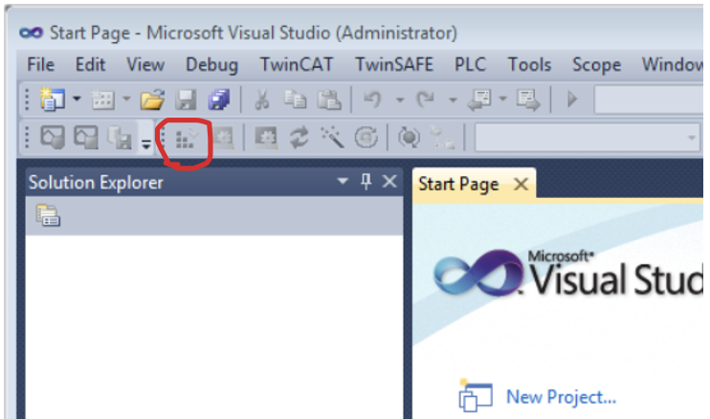

An important addition to this Visual Studio Shell is how to run the code. In this shell it is through the button shown on the right. This will build the software and turn on run mode. Now the go online button and play button will make the program actually run.

# Conclusion

Now I have solved some issues and made some demos I can finally answer the question, how can you write software on a Beckhoff PLC? Most information about TwinCAT could be found on the Beckhoff website, but the video series from Jakob Sagatowski did help a lot in visualizing what the Beckhoff website could only show via documentation.

The conclusion is that, by using TwinCAT it can be quite easy to work with a PLC, it just took me a long time because both on the mac and windows laptop I had some serious problems. Now I have done the research and found the solutions to those problems it was easy to repeat the same process on other devices as well.

**Source⁶**

# Sources

¹ <https://www.unitronicsplc.com/what-is-plc-programmable-logic-controller/>, how does a PLC work?

¹ <https://en.wikipedia.org/wiki/Programmable_logic_controller>, how does a PLC work?

² <https://www.beckhoff.com/en-en/products/automation/twincat/texxxx-twincat-3-engineering/te1000.html>, Link to the TwinCAT software download page.

³ <https://www.youtube.com/watch?v=RrG0LS4c444>, video, how to set static IP for Beckhoff PLC.

⁴<https://infosys.beckhoff.com/english.php?content=../content/1033/sw_os/2019206411.html&id=>, the Default User and Password, Beckhoff

⁵<https://infosys.beckhoff.com/english.php?content=../content/1033/tc3_plc_intro/2530268811.html&id=>, Information about the TwinCAT interface.

⁶ <https://www.youtube.com/playlist?list=PLimaF0nZKYHz3I3kFP4myaAYjmYk1SowO>, the video series about working with TwinCAT, Jakob Sagatowski