**Puente’s Group**

**Members:**

Lois Nikole A. Rojas

Simon Gemuel B. Camua

Ma. Madel L. Moraca

John Angelou S. Gacutan

Justin Dave P. Margin

**Admin Table**

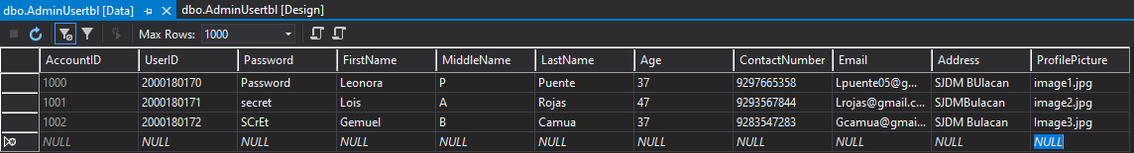

**Student Table**

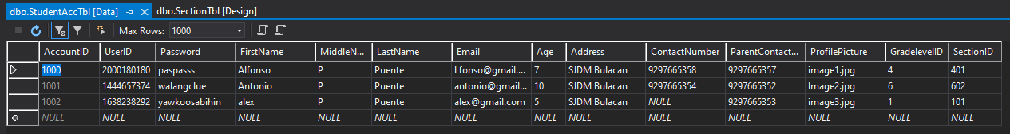

**Teacher Table**

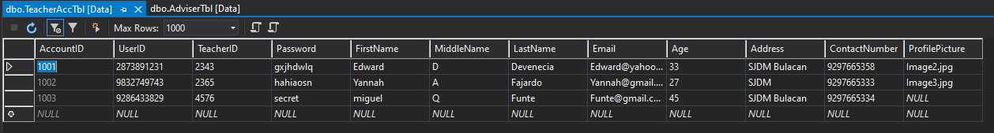

**Registrar Table**

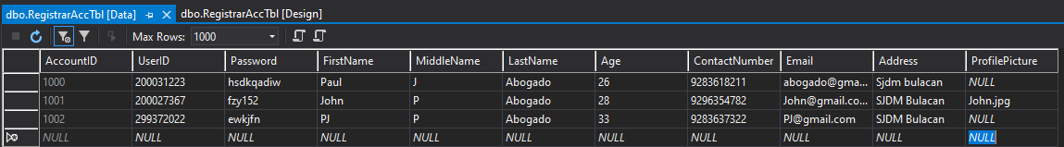

**Grade Level Table**

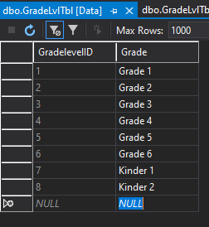

**Subject Table**

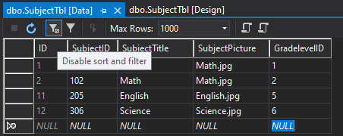

**Module Table**

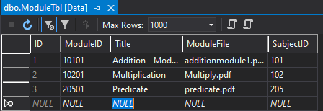

**Section Table**

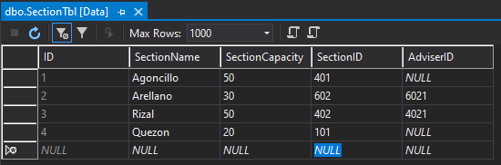

**Adviser Table**

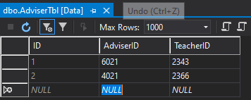

**Schedule Table**

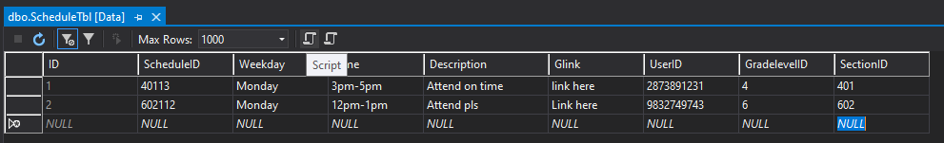

**Report Table**

