# 2. Testcase Design

1. Design the model using terrain tool in Unity

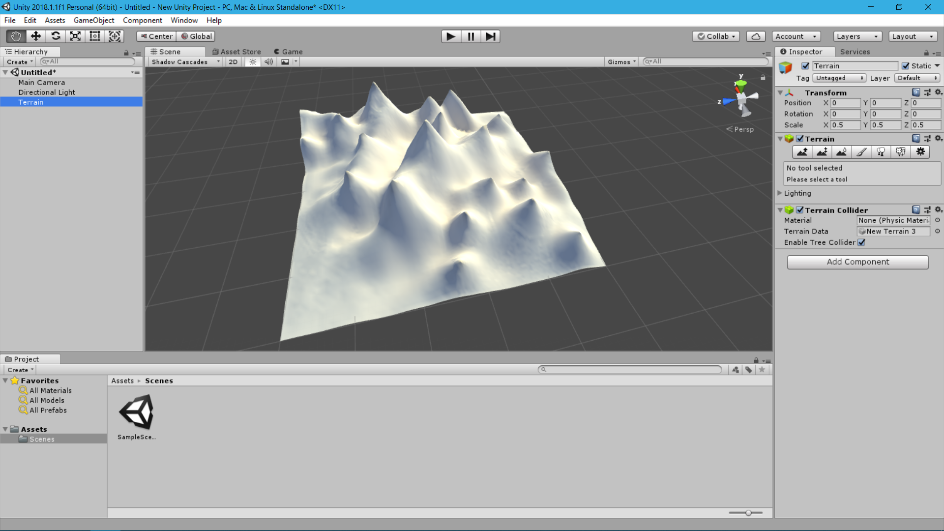

1. Export heightmap as raw image
2. Edit image in Photoshop to amplify the contrast

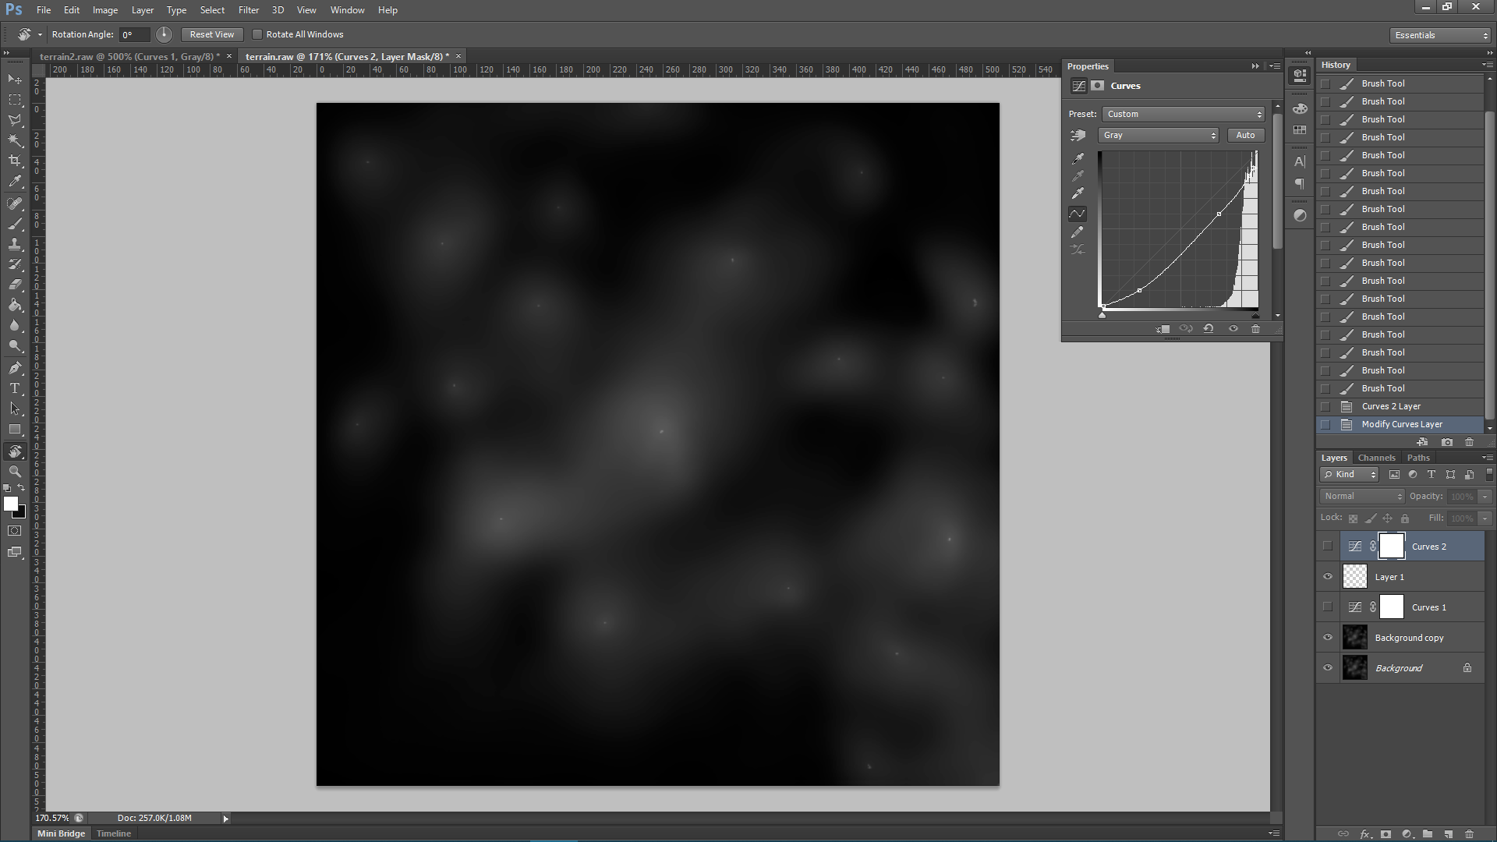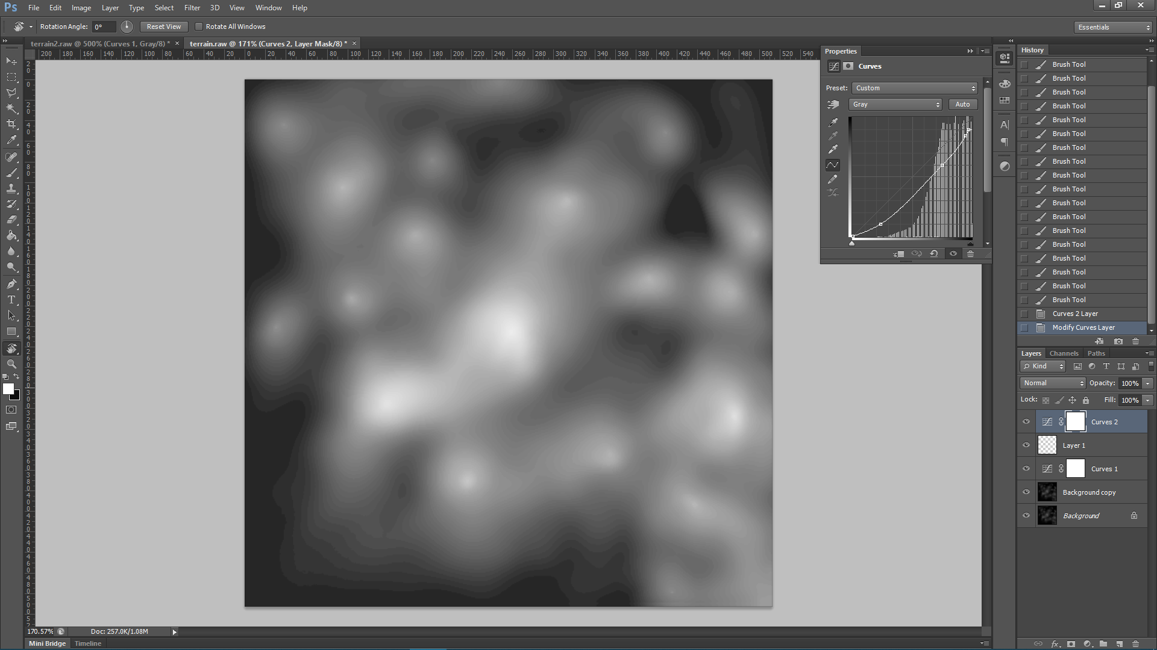

1. Use the website below to turn image into c-array according to its RGB value of each pixel: <https://littlevgl.com/image-to-c-array>

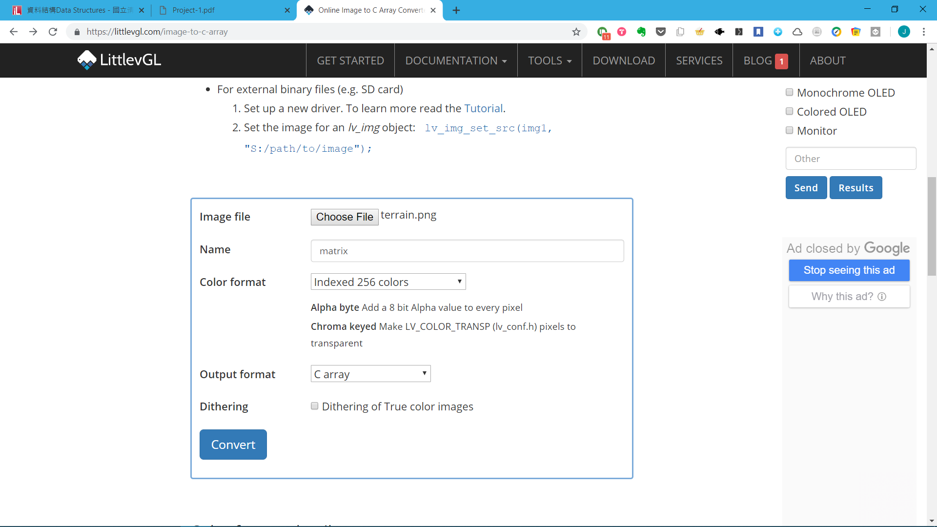

1. Output:

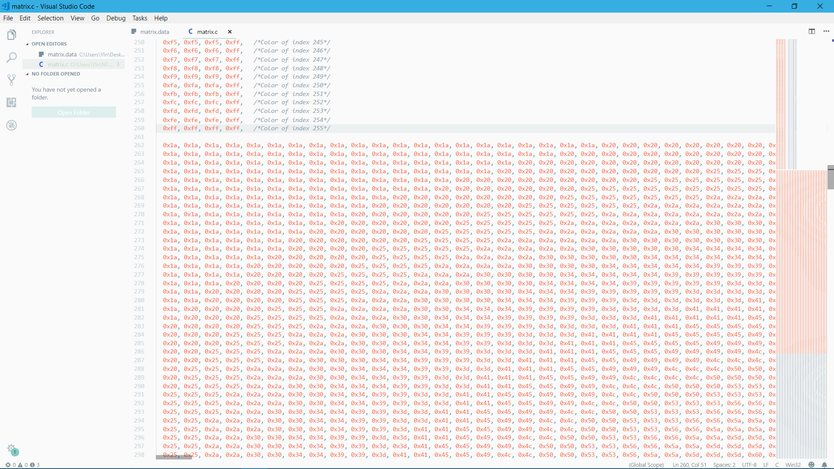

1. Convert in to long integers using replace tool

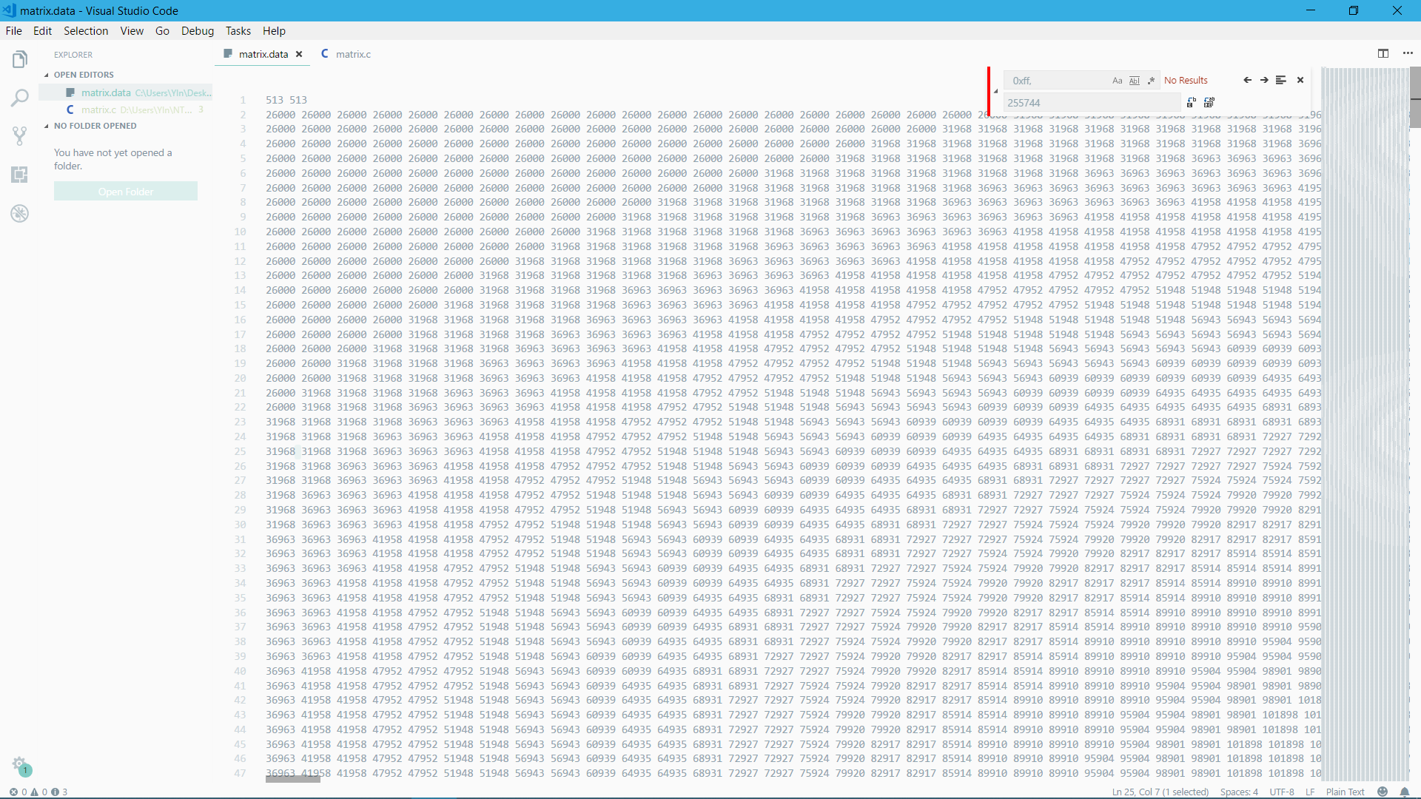

1. Correct the format and save as matrix.data