**Outputs:**

**BowlingCentre.java**

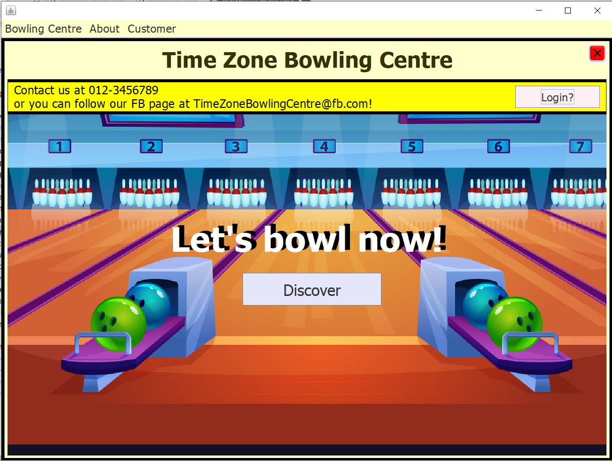

**Marketing.java**

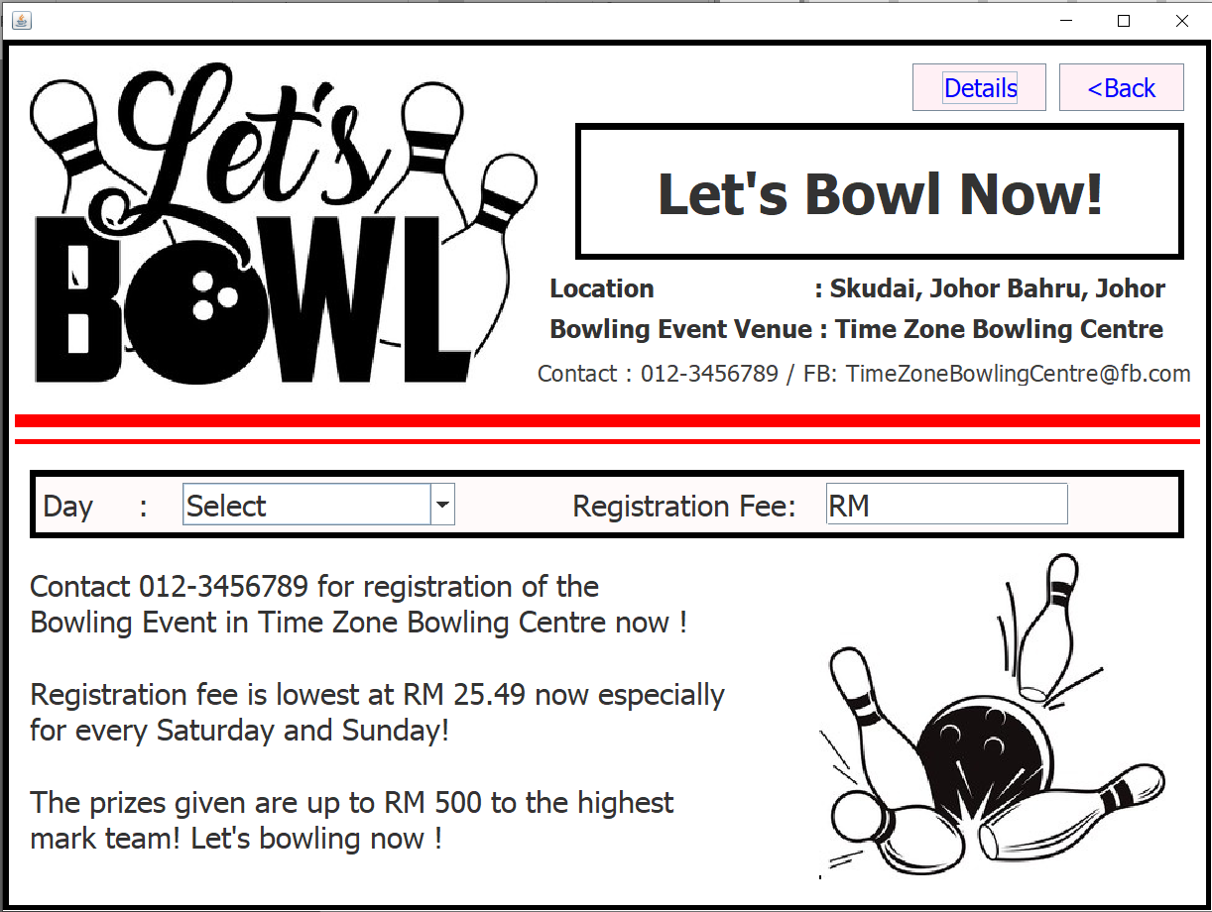

**MarketingDetails.java**

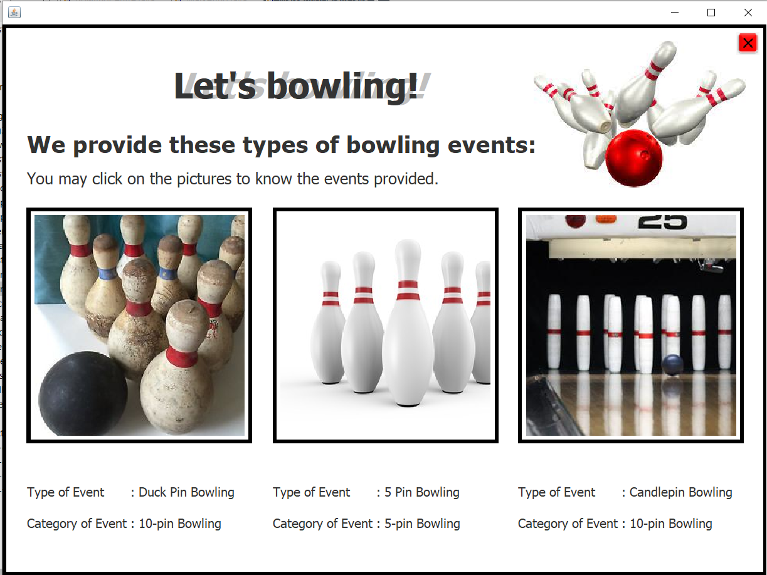

**UserOption.java**

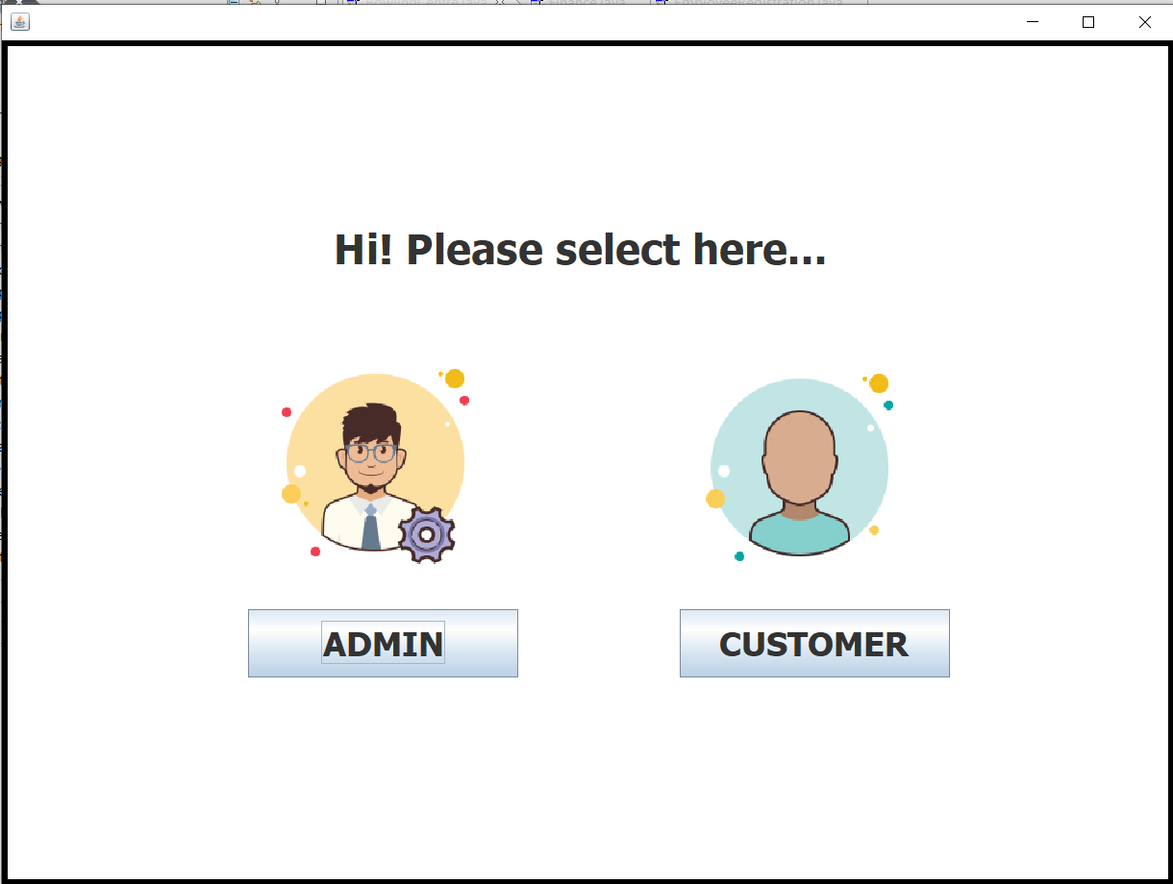

**EmployeeLogin.java**

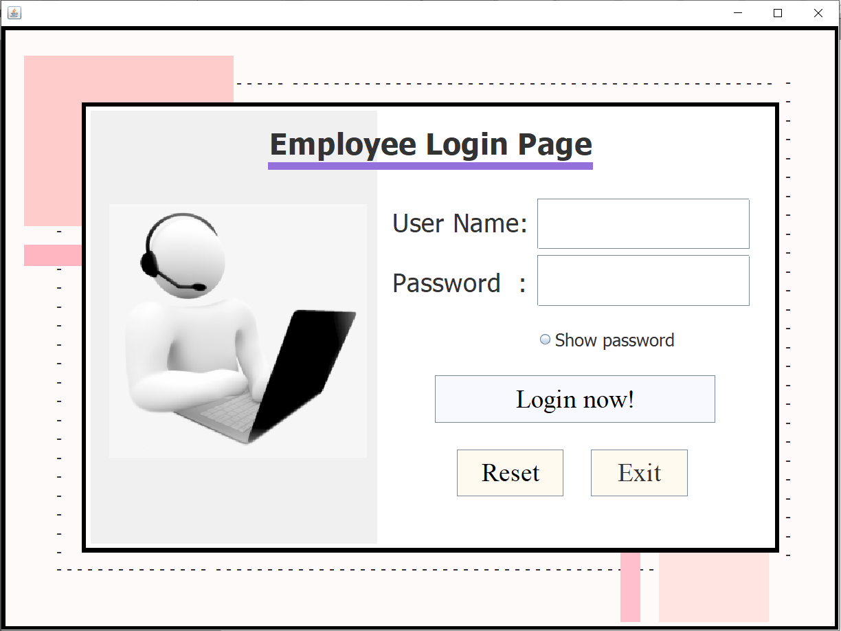

**EmployeeRegistration.java**

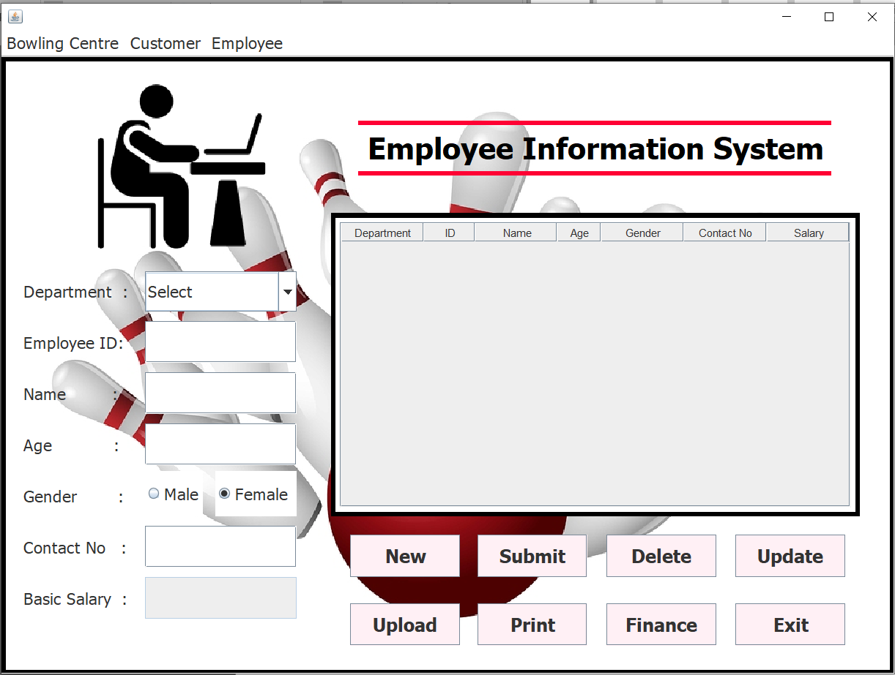

**Finance.java**

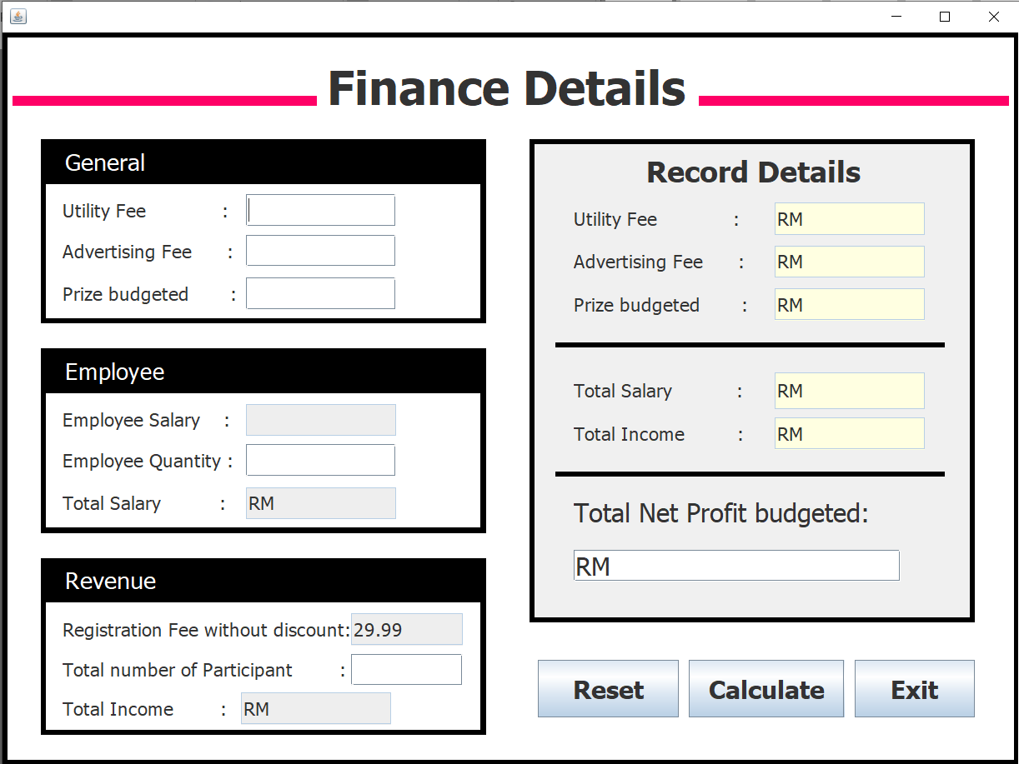

**UpdateEvent.java**

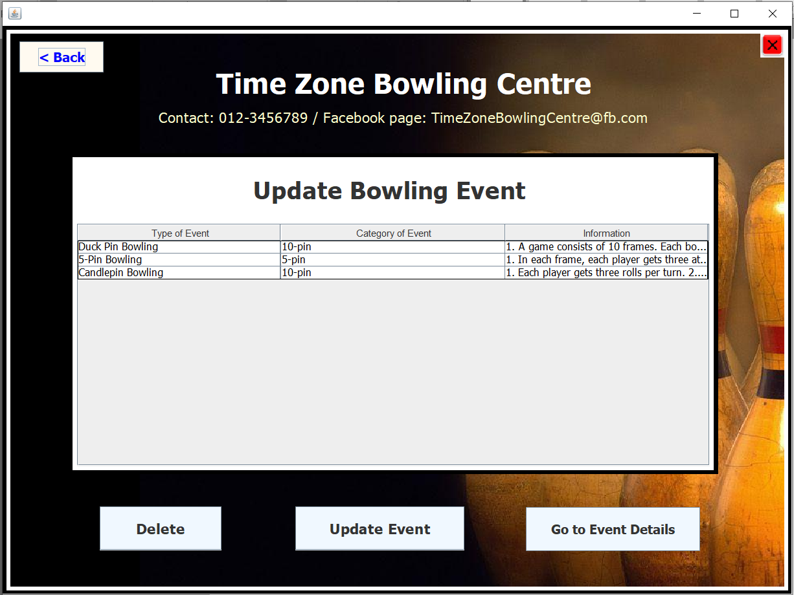

**CustomerLogin.java**

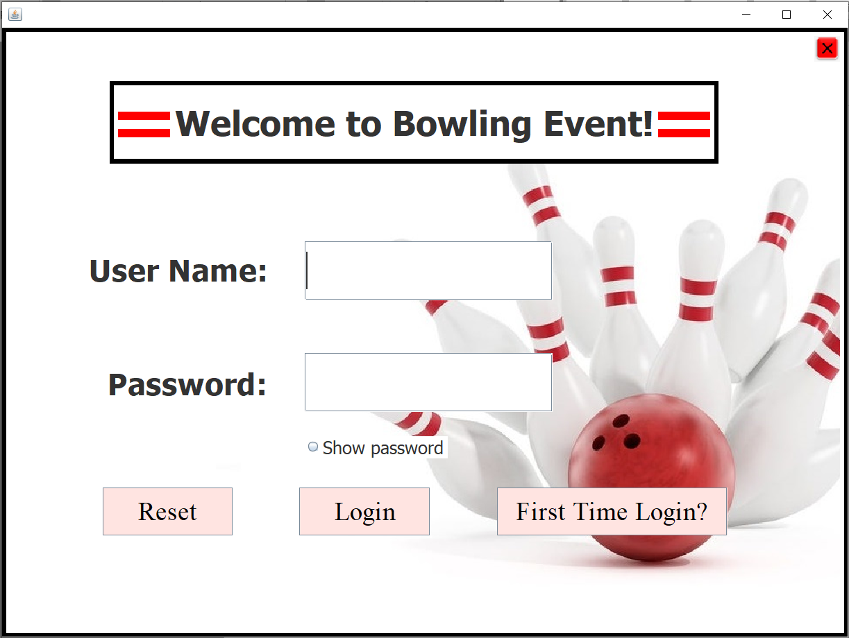

**FirstTimeLogin.java**

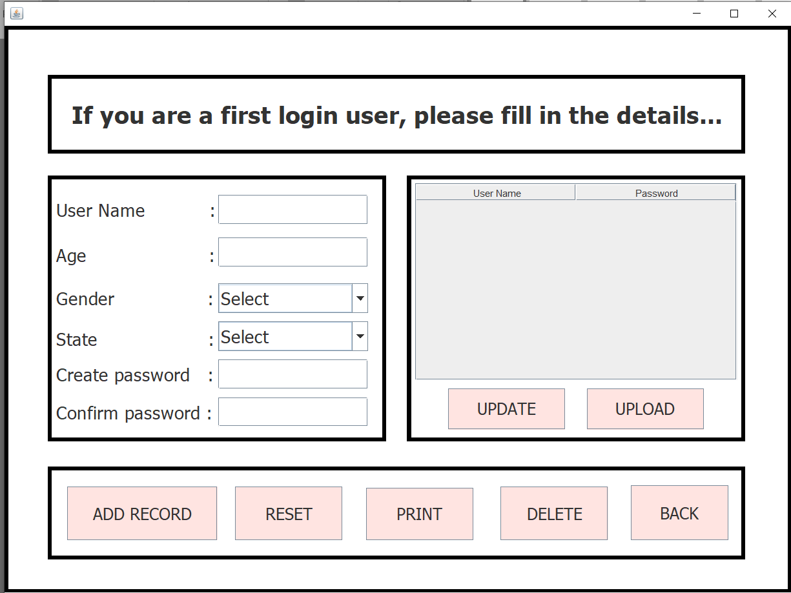

**EventDetails.java**

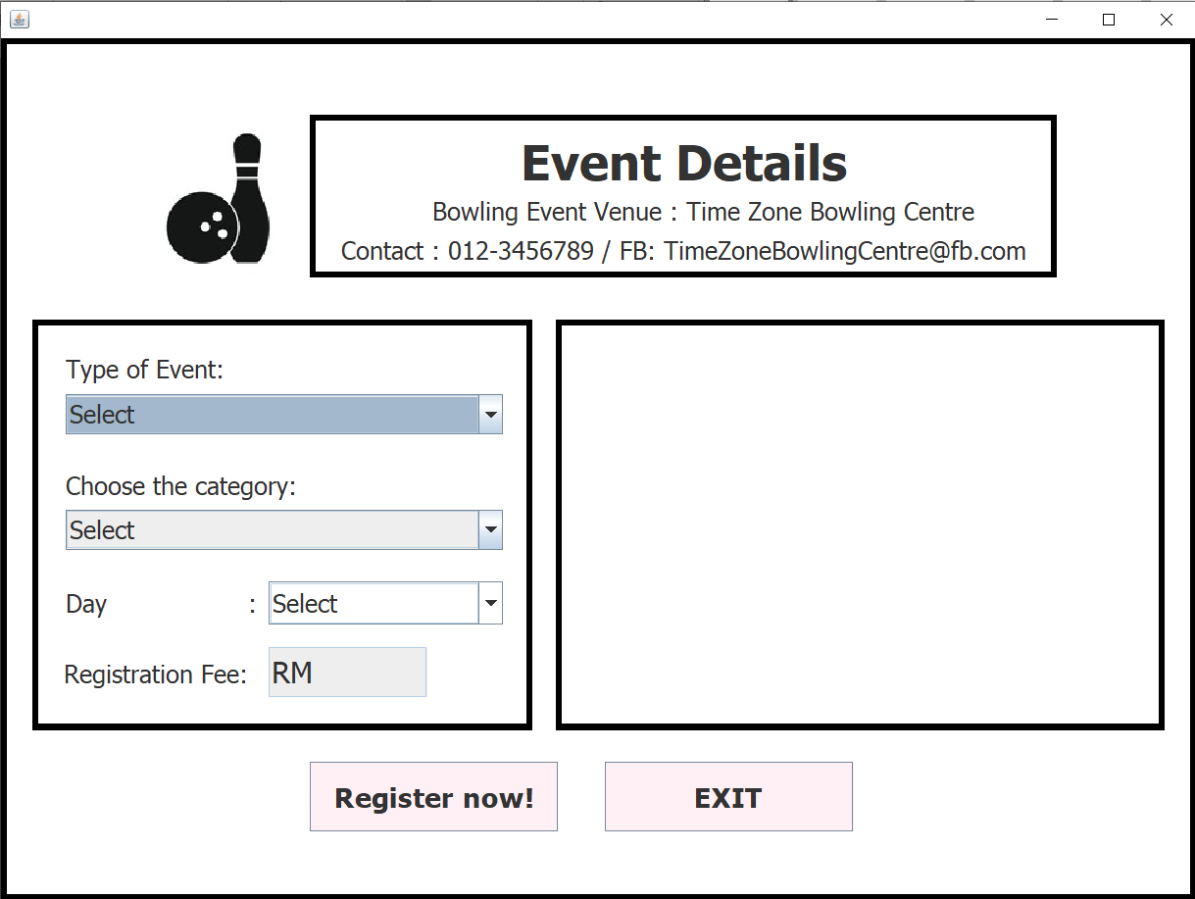

**CustomerRegistration.java**

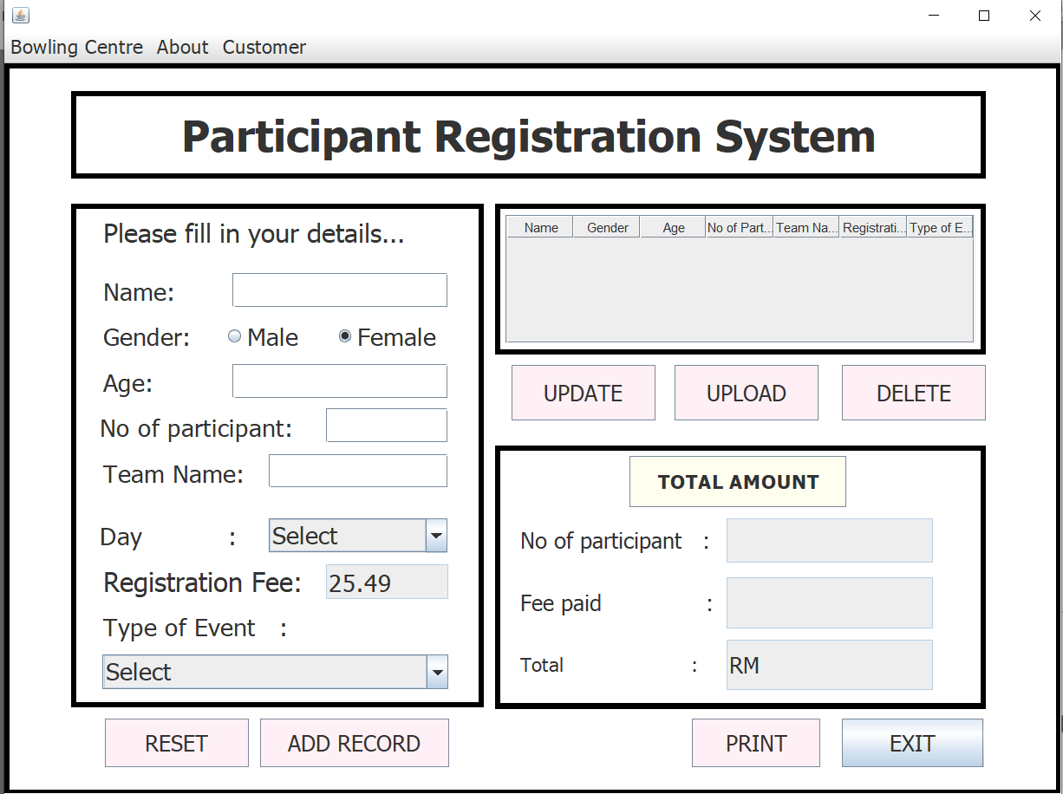

**Output Video Link:**

<https://drive.google.com/file/d/1TwCT6hMY9UdhJwfR7dR4kYXCMSsAhvbp/view?usp=sharing>