**A10: Product**

This artefact contains the presentation of the product developed.

**1. Installation**

Link to the Github realease: <https://github.com/afonsobspinto/lbaw1764/tree/proto>

Docker command:

|  |
| --- |
| docker login DOCKER_USERNAME=ros65536  IMAGE_NAME=lbaw1764 ./upload_image.sh |

**2. Usage**

Url to the product: <http://lbaw1764.lbaw-prod.fe.up.pt/>

**2.1. Administration Credentials**

|  |  |
| --- | --- |
| Email | Password |
| a@a.a | 123456 |

**2.2. User Credentials**

|  |  |  |
| --- | --- | --- |
| Type | Email | Password |
| Authenticated User / Auctioneer / Bidder | [guest@lbaw64.com](mailto:guest123@gmail.com)[1] | 123456 |
| Banned User | Dave.Petterson@dolfijn.dk | 123456 |

**3. Application Help**

Url to our FAQ’s page: <http://lbaw1764.lbaw-prod.fe.up.pt/faq>

**4. Input Validation**

In registration form, several validations are done either on the server side or using HTML validation, by making a request to the server. Some examples are given below:

* Check for email entered by the user:

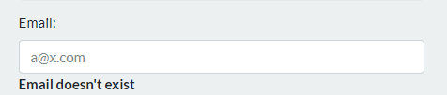

* Check if required fields are filled in:

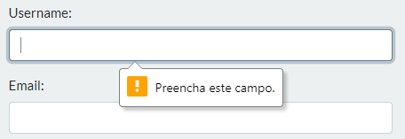

* Check the minimum password size:

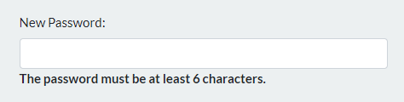

* Verify if the password entered by the user and its confirmation matches:

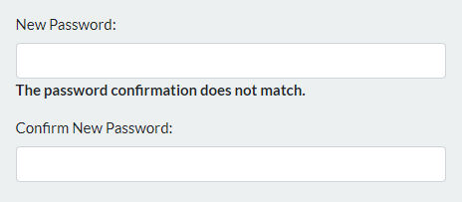

* Verify if the username or the email entered by the user is already registered in the application:

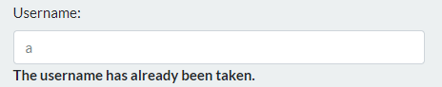

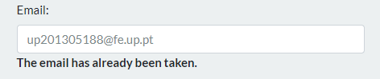

**5. Check Accessibility and Usability**

Accessibility: 18/18

Usability: 27/28

Only the javascript files weren’t minified.

The files are included in: <https://github.com/afonsobspinto/lbaw1764/tree/master/docs>

**6. HTML & CSS Validation**

There were no errors using the CSS and HTML Validator tool.

The CSS validator tool print files are included in: <https://github.com/afonsobspinto/lbaw1764/tree/master/docs/cssValidator>

The HTML validator tool print files are included in: <https://github.com/afonsobspinto/lbaw1764/tree/master/docs/htmlValidator>

**7. Revisions to the Project**

Most of the features previously proposed were implemented, except, due to lack of time, some user stories with low / medium priority, such as:

* Register or log in using external Google Sign-In;
* The integration of the PayPal API was left behind and in order to be able to complete the auction process, the group implemented the messaging system that in the previous specification was assigned low priority. The messaging system is complete since you can create and delete a message and view incoming and outgoing messages. Through the implementation of sockets it is also possible for the user to receive a message and be notified in real time.
* Options for the Auction Winner like Feedback or Ask for Refund;
* Contact Page (This was included in the about page);
* The option for the user to cancel his account;
* Some administrator functionalities like promoting users to admin;
* Some banned user functionalities like appealing to be desban.

**8. Implementation Details**

**8.1. Libraries Used**

Libraries used:

* JQuery - <https://jquery.com/> - We introduced JQuery in our project to deal with some functionalities such as the search bar and error handling. The search bar example:

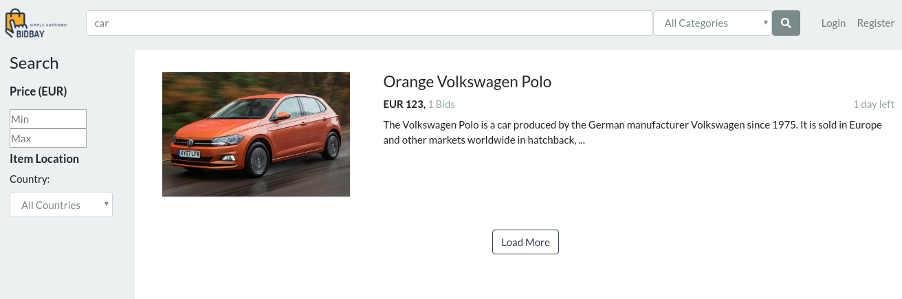

(<http://lbaw1764.lbaw-prod.fe.up.pt/search?search-input=&category=ALL>)

* Less - <http://lesscss.org/> - We implemented Less in CSS

Frameworks used:

* Laravel - <https://laravel.com/> - Our entire website follows the Laravel architectural pattern.
* Bootstrap - <https://getbootstrap.com/> - Our CSS environment is made with Bootstrap. The auction’s carousel in the landing page was made using this framework:

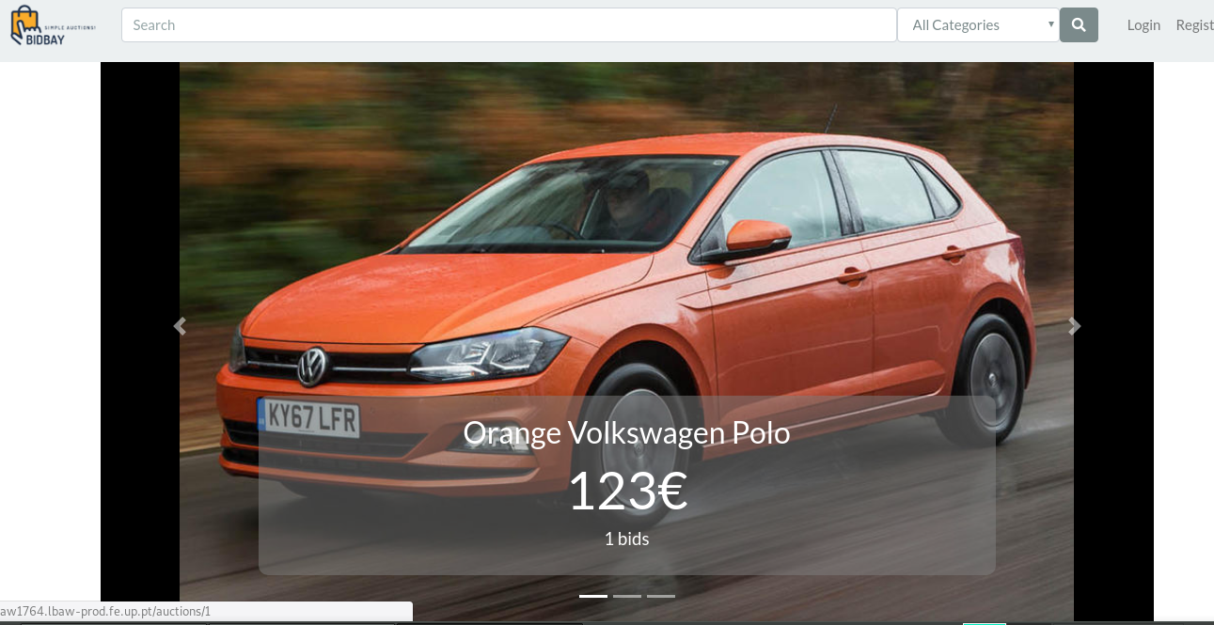

(<http://lbaw1764.lbaw-prod.fe.up.pt/landing_page>)

**8.2. User Stories**

**User**

|  |  |  |  |  |
| --- | --- | --- | --- | --- |
| **Identifier** | **Name** | **Priority** | **Team Members** | **State** |
| US01 | Home page | high | Rostyslav Khoptiy | 100% |
| US02 | Search | high | Rostyslav Khoptiy | 100% |
| US03 | About page | medium | Tomás Oliveira | 100% |
| US04 | FAQ page | medium | Tomás Oliveira | 100% |
| US05 | Contact page | low |  | 0% |

Table 1: User’s User Stories

**Visitor**

|  |  |  |  |  |
| --- | --- | --- | --- | --- |
| **Identifier** | **Name** | **Priority** | **Team Members** | **State** |
| US11 | Log in | high | Rostyslav Khoptiy | 100% |
| US12 | Register | high | Rostyslav Khoptiy | 100% |
| US13 | View profile | medium | Tomás Oliveira | 100% |
| US14 | Log in using Google Sign-In | low |  | 0% |
| US15 | Register using external Google Sign-In | low |  | 0% |

Table 2: Visitor’s User Stories

### **Authenticated User**

|  |  |  |  |  |
| --- | --- | --- | --- | --- |
| **Identifier** | **Name** | **Priority** | **Team Members** | **State** |
| US21 | Email  verification | high | Rostyslav Khoptiy | 100% |
| US22 | Update  account information | high | Tomás Oliveira & Rostyslav Khoptiy | 100% |
| US23 | Update profile information | medium | Tomás Oliveira & Rostyslav Khoptiy | 100% |
| US24 | View profile | medium | Tomás Oliveira | 100% |
| US25 | Cancel account | low | Afonso Pinto | 100% |

Table 3: Authenticated User’s User Stories

### **Banned User**

|  |  |  |  |  |
| --- | --- | --- | --- | --- |
| **Identifier** | **Name** | **Priority** | **Team Members** | **State** |
| US31 | View ban duration | low | Tomás Oliveira | 100% |
| US32 | Appeal ban | low |  |  |

Table 4: Banned User’s User Stories

**Active User**

|  |  |  |  |  |
| --- | --- | --- | --- | --- |
| **Identifier** | **Name** | **Priority** | **Team Members** | **State** |
| US41 | Add Item | high | Afonso Pinto | 100% |
| US42 | Bid | high | Afonso Pinto & Rostyslav Khoptiy & Tomás Oliveira | 100% |
| US43 | Purchase history | high | Afonso Pinto | 100% |
| US44 | Ask Auction Q&A | medium | Tomás Oliveira | 100% |
| US45 | Report auction | medium | Cristiana Ribeiro | 100% |
| US46 | Open chat | low | Cristiana Ribeiro | 100% |
| US47 | Report auction feedback | low | Cristiana Ribeiro | 100% |
| US48 | Report account | low | Cristiana Ribeiro | 100% |

Table 5: Active User’s User Stories

### **Bidder**

|  |  |  |  |  |
| --- | --- | --- | --- | --- |
| **Identifier** | **Name** | **Priority** | **Team Members** | **State** |
| US61 | See the auctions I’m bidding | high | Tomás Oliveira | 100% |
| US62 | Automatic message system | low | Afonso Pinto | 100% |

Table 6: Bidder’s User Stories

### **Auction Winner**

|  |  |  |  |  |
| --- | --- | --- | --- | --- |
| **Identifier** | **Name** | **Priority** | **Team Members** | **State** |
| US71 | Manage payment | high | Afonso Pinto | 100% |
| US72 | Rate Auction | medium |  | 0% |
| US73 | Request refund | medium |  | 0% |
| US74 | Payment using PayPal Express Checkout Integration | low |  | 0% |

Table 7: Auction Winner’s User Stories

### **Auctioneer**

|  |  |  |  |  |
| --- | --- | --- | --- | --- |
| **Identifier** | **Name** | **Priority** | **Team Members** | **State** |
| US81 | Manage payment | high | Afonso Pinto | 100% |
| US82 | Update auction | high | Afonso Pinto & Tomás Oliveira | 100% |
| US83 | Remove auction | high | Rostyslav Khoptiy | 100% |
| US84 | See my auctions | high | Tomás Oliveira | 100% |
| US85 | Answer Auction Q&A | medium | Tomás Oliveira | 100% |
| US86 | Upload item pictures | medium | Rostyslav Khoptiy | 100% |

Table 8: Auctioneer User Stories

**Admin**

|  |  |  |  |  |
| --- | --- | --- | --- | --- |
| **Identifier** | **Name** | **Priority** | **Team Members** | **State** |
| US91 | Remove content | high | Afonso Pinto | 50% |
| US92 | Cancel auctions | high | Afonso Pinto | 100% |
| US93 | Ban accounts | medium |  | 0% |
| US94 | Change ban duration | low |  | 0% |
| US95 | Restore  accounts | low |  | 0% |
| US96 | Promote to Admin | low |  | 0% |
| US97 | View account reports | low | Cristiana Ribeiro | 100% |
| US98 | Vote to demote Admin | low |  | 0% |

Table 9: Admin’s User Stories

**Google Sign-In**

|  |  |  |  |  |
| --- | --- | --- | --- | --- |
| **Identifier** | **Name** | **Priority** | **Team Members** | **State** |
| US101 | Google Sign In API | low |  | 0% |

Table 10: Google Sign-In’s User Stories

**PayPal Express Checkout Integration**

|  |  |  |  |  |
| --- | --- | --- | --- | --- |
| **Identifier** | **Name** | **Priority** | **Team Members** | **State** |
| US111 | Payments API | low |  | 0% |

Table 11: PayPal Express Checkout Integration’s User Stories

GROUP1764, 30/05/2018  
   
Afonso Bernardino da Silva Pinto, up201503316@fe.up.pt  
Cristiana Maria Monteiro Ribeiro, up201305188@fe.up.pt  
Rostyslav Khoptiy, up201506219@fe.up.pt  
Tomás Sousa Oliveira, up201504746@fe.up.pt

1. We use email verification, so we recomend using your own email