**A4: Conceptual Data Model**  
   
**1. Class diagram**  
   
The diagram of Figure 1 presents the main organisational entities, the relationships between them, attributes and their domains, and the multiplicity of relationships for BidBay.

Figure 1: UML conceptual data model for BidBay.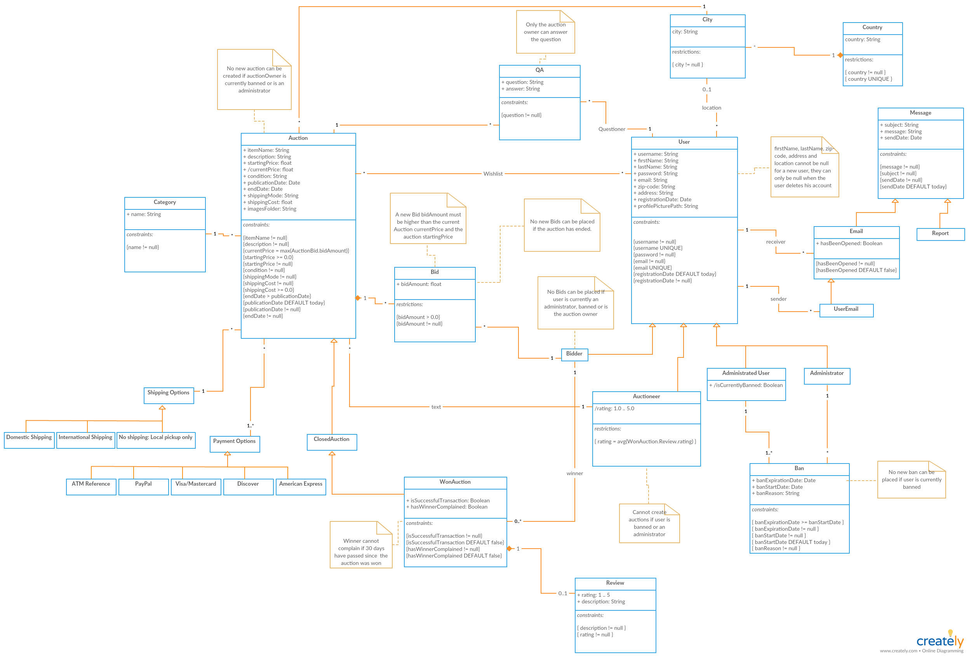

**Revision history**  
   
Changes made to the first submission:

1. Add city and country classes.
2. Rename some classes (Bid, QA, …).
3. Add some rules.
4. Add and change Message subclasses (Report, Email, …).
5. Add Shipping and Payment Options class as well its subclasses.
6. Add and change user subclasses (Administrator, Bidder, …).
7. Update the lines.
8. Add Image path and folder.
9. Change the body of most classes.

GROUP1764, 21/03/2018  
   
Afonso Bernardino da Silva Pinto, up201503316@fe.up.pt  
Cristiana Maria Monteiro Ribeiro, up201305188@fe.up.pt  
Rostyslav Khoptiy, up201506219@fe.up.pt  
Tomás Sousa Oliveira, up201504746@fe.up.pt