**Before Code Optimization:  
  
CPU (High):**

**CPU (Low):**

**Memory (Low):**

**FPS:  
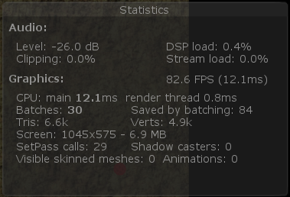**

**After Code Optimization:**

**CPU (High):**

**CPU (Low):**

**Memory (High):**

**Memory (Low):**

**FPS:**

**Code Optimization:**

**1) Common subexpression elimination:**

**(Before)**

**(After)**

**2) Extract Method:**

**(Before)**

**(After)**

**3) Extract Method:**

**(After)**

**4) Extract Method:**

**(Before)**

**

**5) Extract Method:**

**(Before)**

**(After)**

