Core MVP Detailed Wireframes
Design documentation
Team: Team 40 / Team B — Intern Management System
Task: [UX DESIGN] — Core MVP Detailed Wireframes
UX Designer: Faridullah Jabbar Khil
Sprint: Sprint 1 — Design & Bootstrap

1. Purpose
This document explains the detailed wireframes for Team B's Core MVP, built against the Week 2 BA update. That update changed the task-status model and introduced Individual Task Submission as a concept distinct from Weekly Progress — this is not an incremental extension of the Early Wireframes deliverable, it reflects a revised baseline.

2. What changed since Early Wireframes
- Task status is no longer Mentor-selected ("Not Started / In Progress / Submitted"). It is now Assigned (system-set) → In Progress → Completed (Intern-updated), per WA-07 / AC-01.2 / AC-01.3.
- Mentor Task Assignment gains a Due Date field and drops the status selector entirely (WA-08).
- Individual Task Submission is a new, separate function from Weekly Progress (WA-09 / FR-08 / AC-03.2) — not present in the Early Wireframes set at all.
- Requirement codes are renumbered in the new doc (US-01–05, FR-01–18, AC-01.1–05.4, EC-01–18, OR-01–07, WA-01–09). Codes in this document do not correspond to the same codes in the Early Wireframes document.

3. Requirement mapping
Screen | Requirement | Role | State
Intern Workspace | PM direction (not in checklist) | Intern | Happy path
My Tasks | US-02 / FR-05, FR-06 / AC-02.1 | Intern | Happy path
My Tasks — no task assigned | EC-01 / AC-02.2 | Intern | Empty state
Task Detail | US-02, US-03 / FR-07, FR-08 / AC-02.3, AC-02.4 | Intern | Happy path
Weekly Progress | US-04 / FR-12–14 / AC-04.1 | Intern | Happy path
Assign task | US-01 / FR-01–04 / AC-01.1 | Mentor | Happy path
Review progress | US-05 / FR-16–18 / AC-05.1 | Mentor | Happy path
Review progress — no submission | EC-09 / AC-05.2 | Mentor | Empty state

4. Screens and annotated interactions

4.1 Intern Workspace
- Hub linking to My Tasks and Weekly Progress — requested directly by the PM (Discord), not a named checklist item; page structure itself is a UX decision
- Annotated as assuming the Applicant-to-Intern transition is already complete (EC-16, EC-17) — that gating is a cross-team/Team A concern, not designed on this screen

4.2 My Tasks — US-02 / FR-05, FR-06 / AC-02.1 (Intern)
- Lists assigned tasks with title, due date, and status badge
- Footnote ties the screen to AC-02.6 (access restricted to the signed-in intern's own tasks)

4.3 My Tasks — no task assigned — EC-01 / AC-02.2 (Intern)
- Dashed empty-state container replaces the list

4.4 Task Detail — US-02, US-03 / FR-07, FR-08 / AC-02.3, AC-02.4 (Intern)
- Status control is forward-only: the button label changes based on current status (“Start task” → In Progress, “Mark completed” → Completed), so an invalid status value (EC-05) cannot be entered through the UI at all
- Task Submission is a collapsible section on this same screen, not a separate page — kept generic (no labeled fields) because content is unconfirmed (OR-03 / EC-07 / AC-03.5)
- Annotated with the remaining open items directly relevant to this screen: editing an existing submission (OR-04 / EC-12) and the unclear relationship between task status and submission (OR-05 / EC-13)

4.5 Weekly Progress — US-04 / FR-12–14 / AC-04.1 (Intern)
- Lives at the Workspace level, not nested inside a task — this is what makes it “separate” per FR-14 / WA-09, not just a caption saying so
- All three fields (Accomplishments, Blockers, Next Steps) marked required — see Section 6 for why this differs from the Early Wireframes version
- Annotated with the open duplicate/edit question (OR-01, OR-02 / EC-10, EC-11)

4.6 Assign task — US-01 / FR-01–04 / AC-01.1 (Mentor)
- Fields: Task Title, Description, Due Date, Assigned Intern — per WA-08
- No status field — annotated that the system sets Assigned automatically (AC-01.2, AC-01.3) and that this screen assumes an existing Mentor–Intern relationship (WA-04), since mentor assignment itself stays out of Core MVP

4.7 Review progress — US-05 / FR-16–18 / AC-05.1 (Mentor)
- Read-only, per-intern, unchanged in spirit from the Early Wireframes version

4.8 Review progress — no submission — EC-09 / AC-05.2 (Mentor)
- Same dashed empty-state pattern as 4.3, applied to the Mentor side

4.9 Shared key states
- Validation error — EC-02, EC-05, EC-08 / AC-01.5, AC-02.5, AC-04.2
- Access denied — EC-03, EC-04, EC-06 / AC-01.6, AC-02.6, AC-03.3, AC-05.3, AC-05.4
- Empty state — EC-01, EC-09 (also shown as real screens — see 4.3 and 4.8)
- Success — AC-01.1, AC-03.1, AC-04.1

5. Design constraints considered

Screen size
Desktop web, consistent with the Early Wireframes deliverable and the BA's target usage.

Accessibility
Required fields marked with both an asterisk and (in build) an accessible label. Every state pairs an icon/border treatment with a text label rather than color alone.

Existing design system / shared IMS direction
Follows the same grayscale wireframe convention as the Early Wireframes deliverable. Per the PM's Discord direction, the landing page, login, navigation, and account/profile experience are shared touchpoints with Team A and are explicitly not designed in this file — see Section 7.

6. Working assumptions incorporated
Every screen is annotated with the specific WA/OR/EC code it depends on, rather than treating the BA's working assumptions as implicit. Two points worth flagging explicitly:
- OR-03 (Task Submission content): the wireframe intentionally shows no labeled fields for this function. This is not an oversight — AC-03.5 specifically instructs against introducing unsupported fields as though confirmed.
- Weekly Progress fields: the original BA doc marked Blockers as optional. The Week 2 update (FR-13, WA-06) lists all three fields together as “minimum content” with no field marked optional. This wireframe follows the Week 2 wording literally (all three required) — flagged here as an open question for the BA to confirm whether the optional-Blockers distinction was meant to carry over or was intentionally dropped.

7. Explicitly not in this file
- Register, Application, Application Status — Team A's scope (BA transition doc, Section 9 ownership table)
- Mentor-assignment UI (who becomes whose mentor) — stays outside Core MVP per WA-04
- The Applicant-to-Intern transition screen itself — shared touchpoint requiring coordination with Team A UX (Wyatt), not a Team B-only design decision

8. Wireframe evidence
Nine screens, built in Figma Make. Insert one screenshot per slot below, matching each screen's frame label exactly — this makes it easy for a reviewer to check the doc against the live file. The interactive parts (the status control actually advancing, the Task Submission section expanding) won't show in a static image, so a short note is included where that matters.
Figure 1 — Intern Workspace
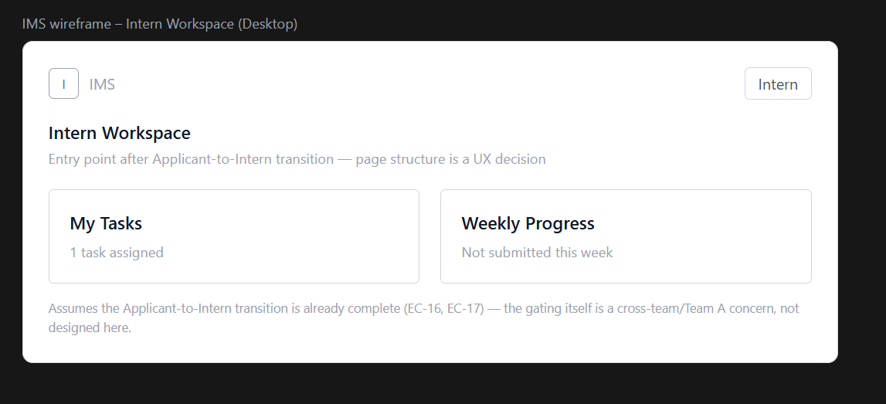

Figure 2 — My Tasks
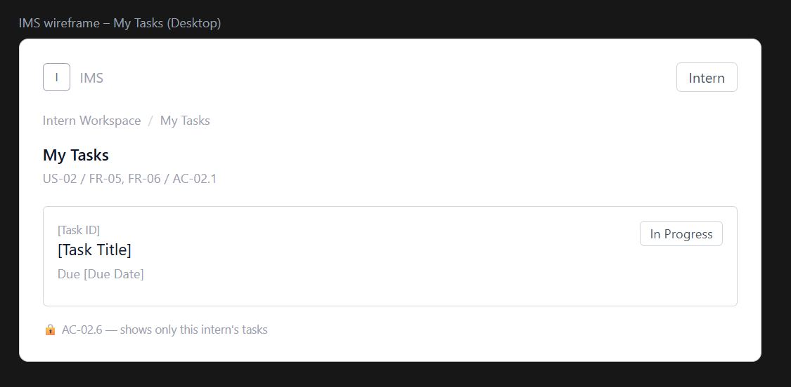
Figure 3 — My Tasks — no task assigned
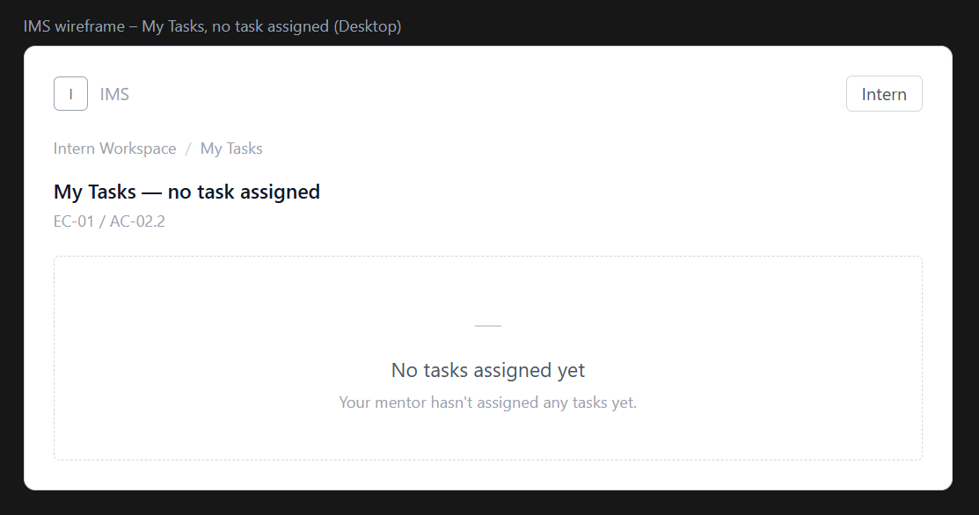

Figure 4 — Task Detail
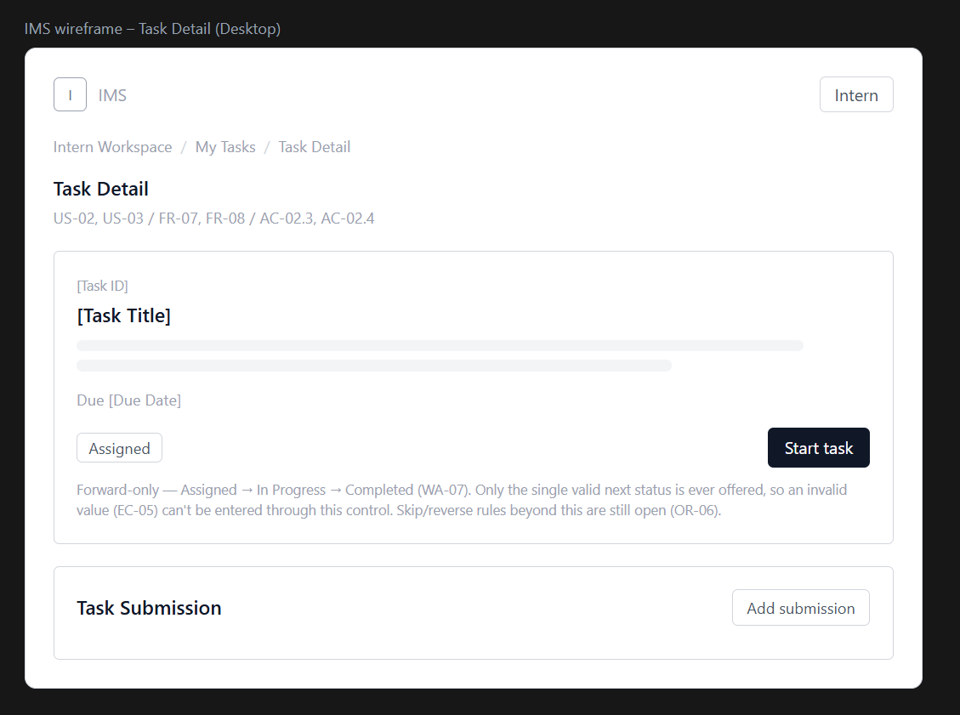
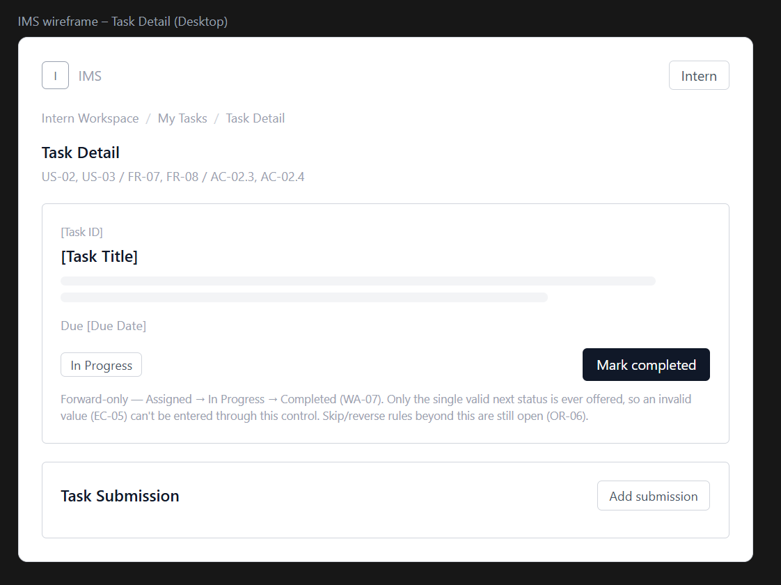
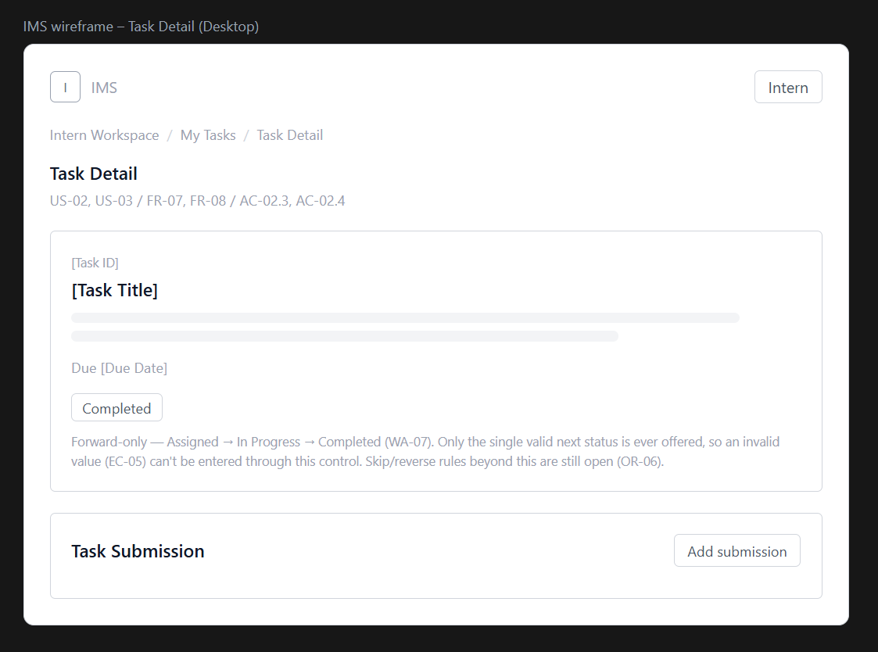

Figure 5 — Weekly Progress
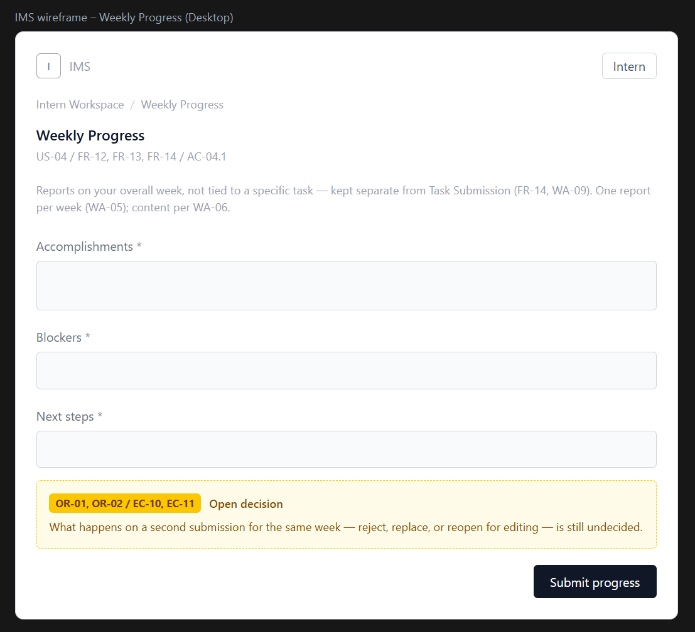

Figure 6 — Assign task
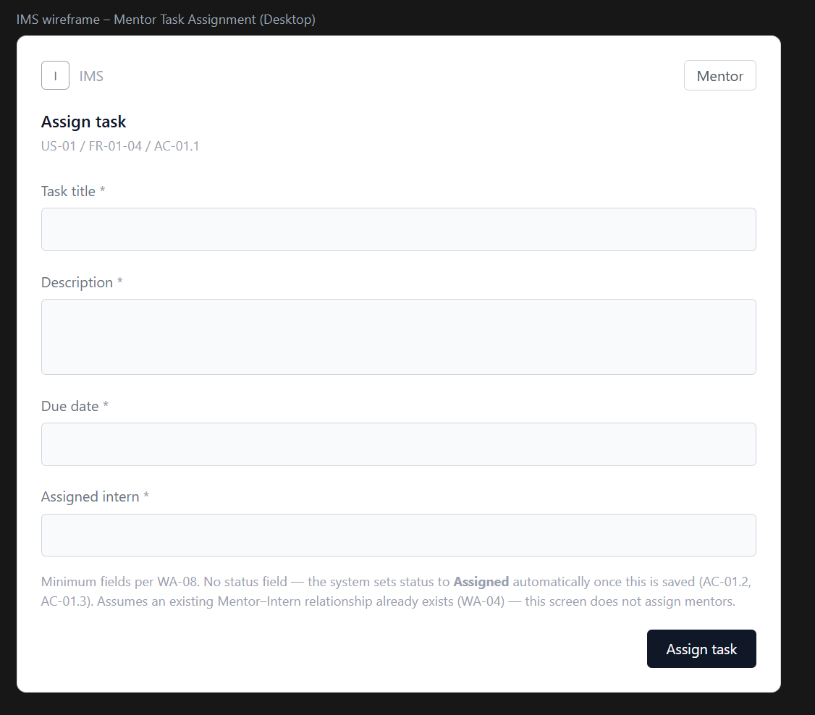

Figure 7 — Review progress
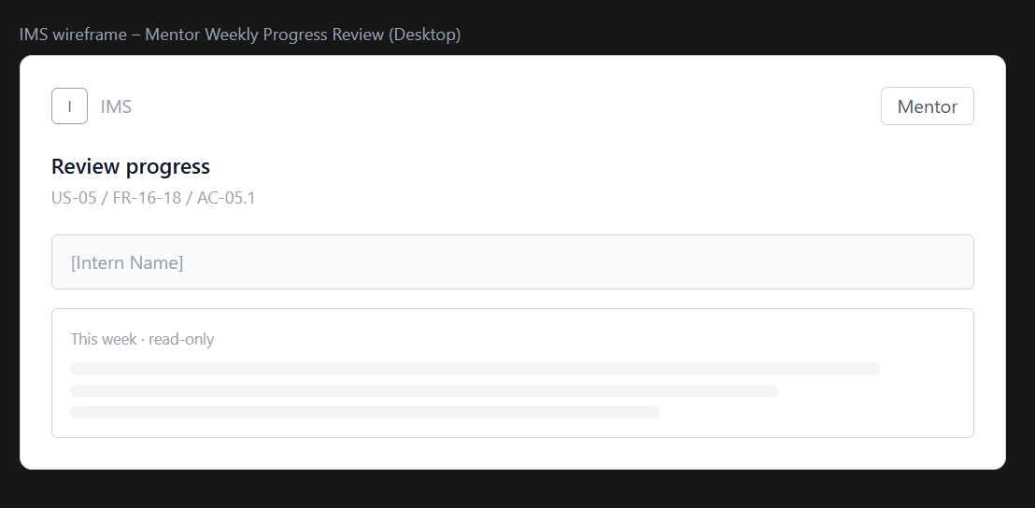
Figure 8 — Review progress — no submission
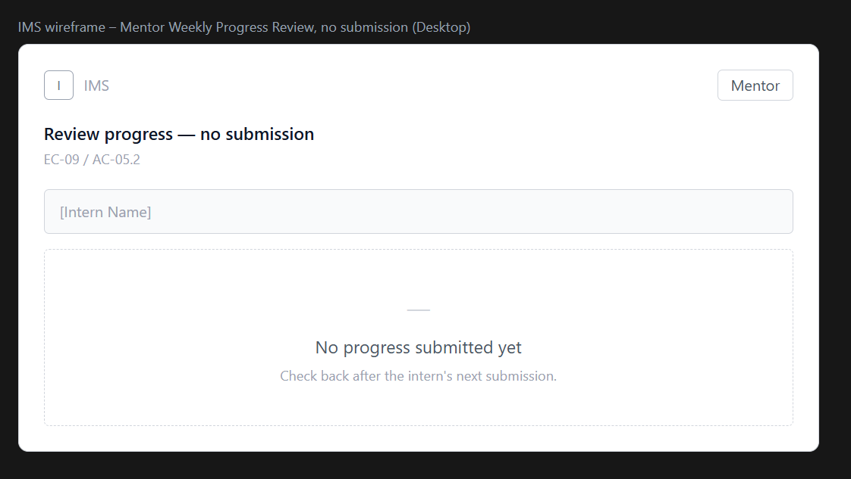

Figure 9 — Legend
