Core MVP — UX Evidence & Demo Handoff
Sprint 2 Playback — Team 40 / Team B (Intern Management System for Social Enterprise Workforce Development)
Prepared by: Faridullah Jabbar Khil (s4020393) — UX
Task: [SPRINT PLAYBACK] – Core MVP UX Evidence & Demo Handoff · Sprint 2 Playback
Purpose: give the PM presentation-ready evidence of the progression from approved design to implemented Core MVP, with fallback visual evidence in case the live demo is unavailable.

1. Purpose & Scope
PM task description
“Prepare the visual and UX evidence required for the Sprint 2 Playback so the PM can clearly demonstrate the progression from approved design and client feedback to the implemented Core MVP. This is not functional acceptance testing. Prepare presentation-ready evidence from the approved Figma/prototype and current implementation, including fallback visual evidence if the live demo becomes unavailable. Sprint 2 Playback requires actual working achievement to be shown rather than only described.”

The design side of every comparison below is the refined Core MVP prototype (App.tsx, v5) following the Final UI & Interaction Polish task — this is also what the team's Figma Make file reflects, since no changes were made to it after that polish pass. The implementation side is DEV's current deployed build (Vercel), captured live and logged in as the relevant role.

2. Design → Implementation Comparisons
Four screens, chosen because they cover both roles and carry the Sprint 2 client-requested changes (Section 3).

2.1 Intern — My Tasks
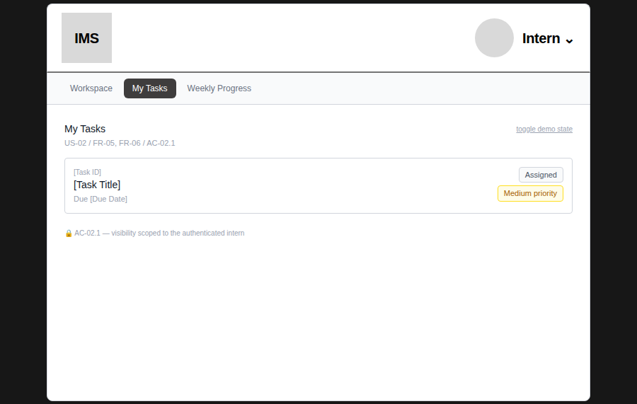  Design (prototype) — single placeholder task, illustrative status/priority colours | 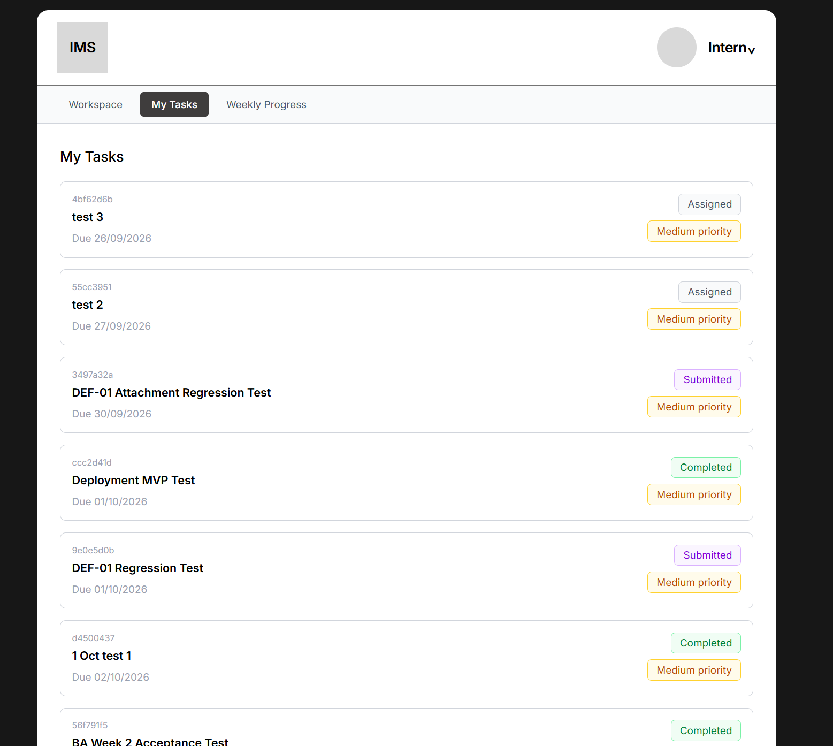  Implementation — real task list, status/priority colours and layout match the approved design

2.2 Intern — Task Detail
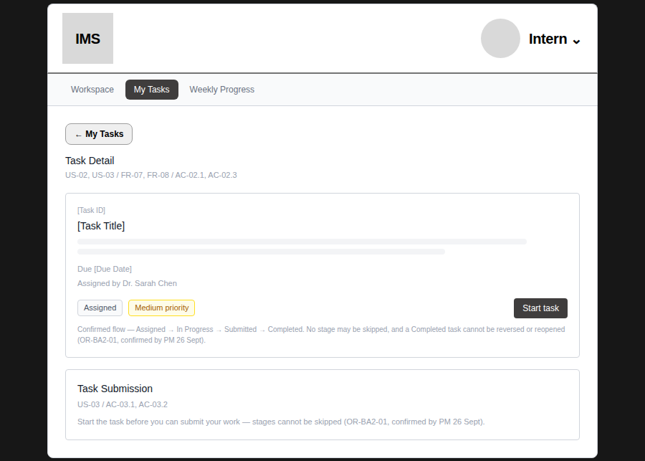  Design (prototype) — placeholder task, confirmed status-lifecycle flow shown as a note | 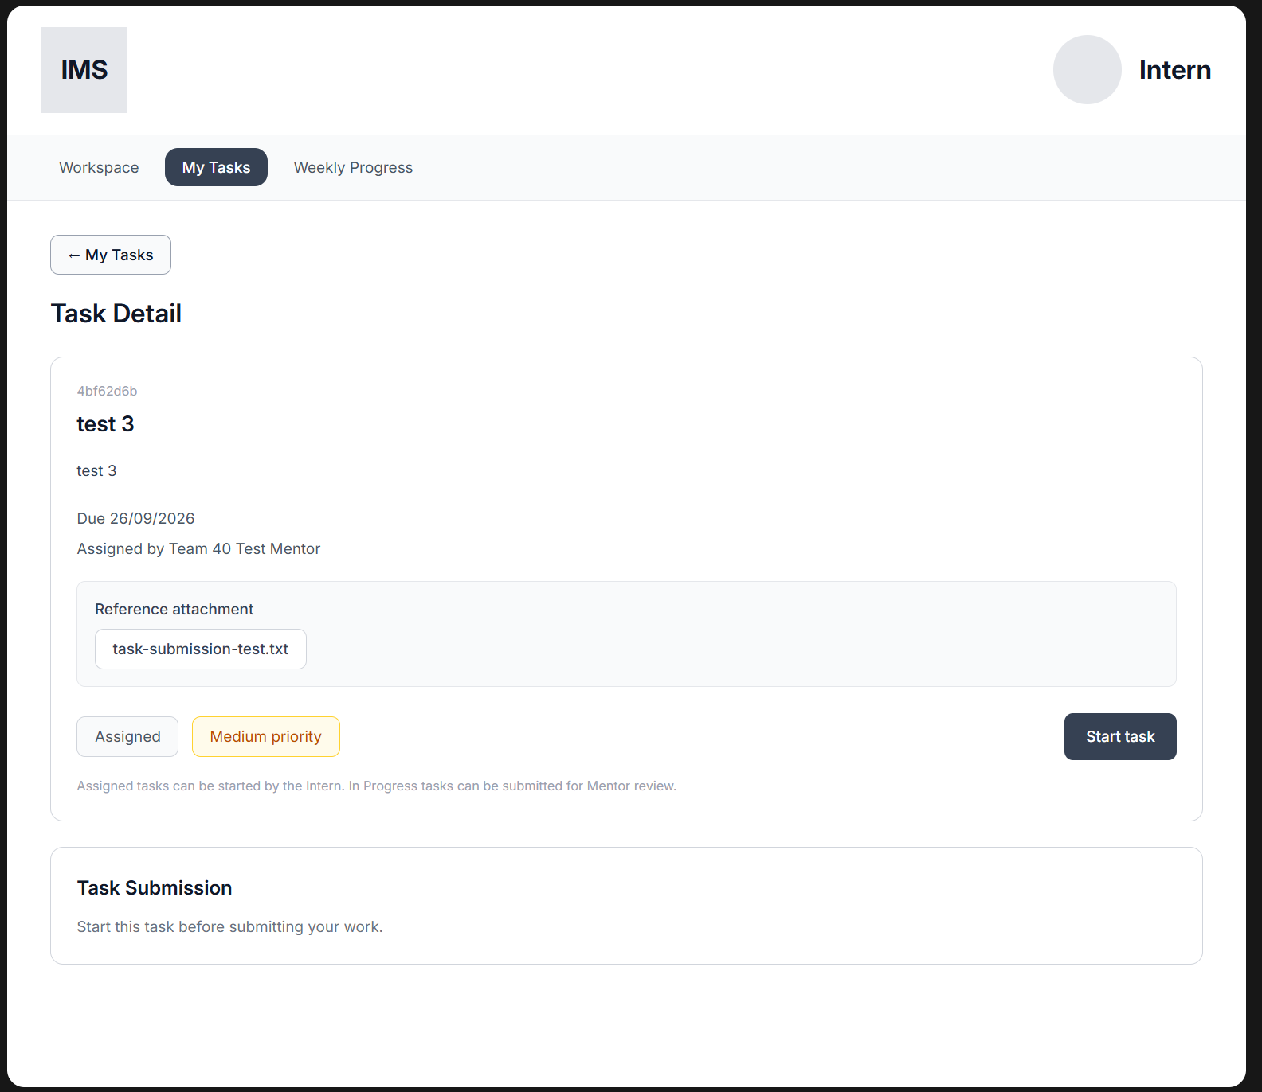  Implementation — real task, reference attachment visible to the Intern (see Section 4)

2.3 Intern — Weekly Progress
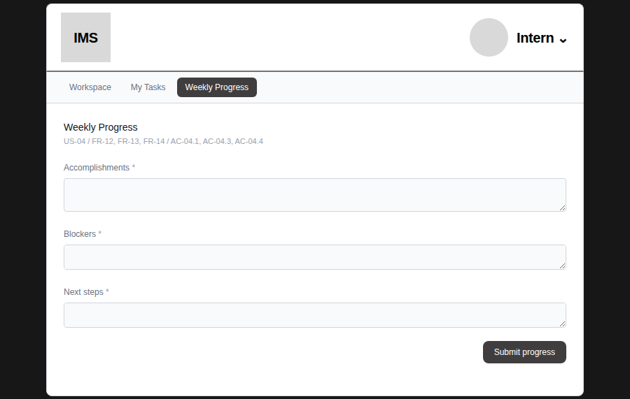  Design (prototype) — empty form, three required fields | 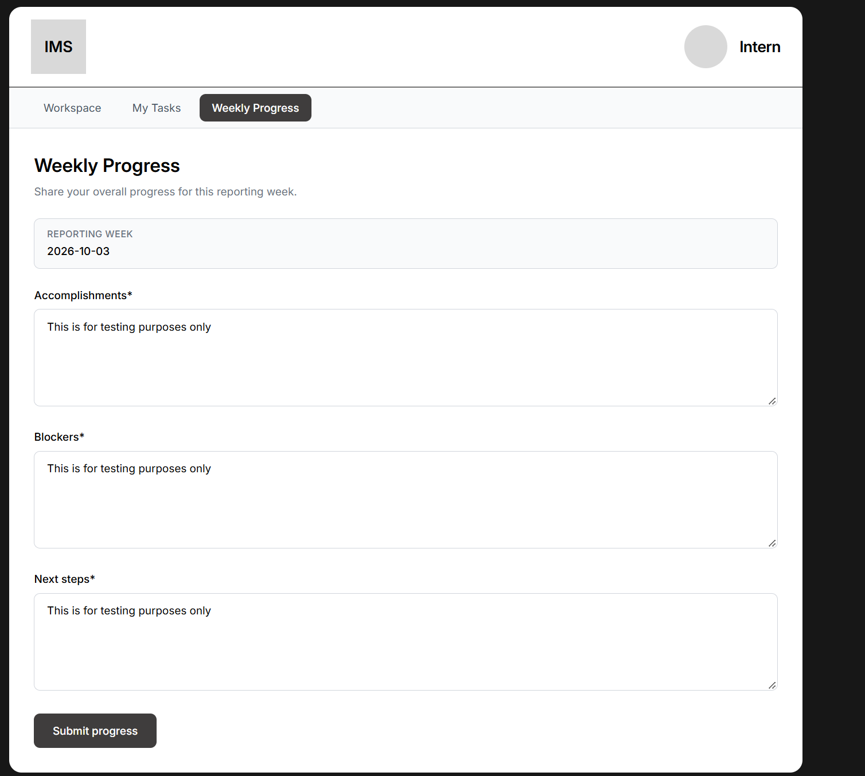  Implementation — same three fields, submitted with real content

2.4 Mentor — Assign Task
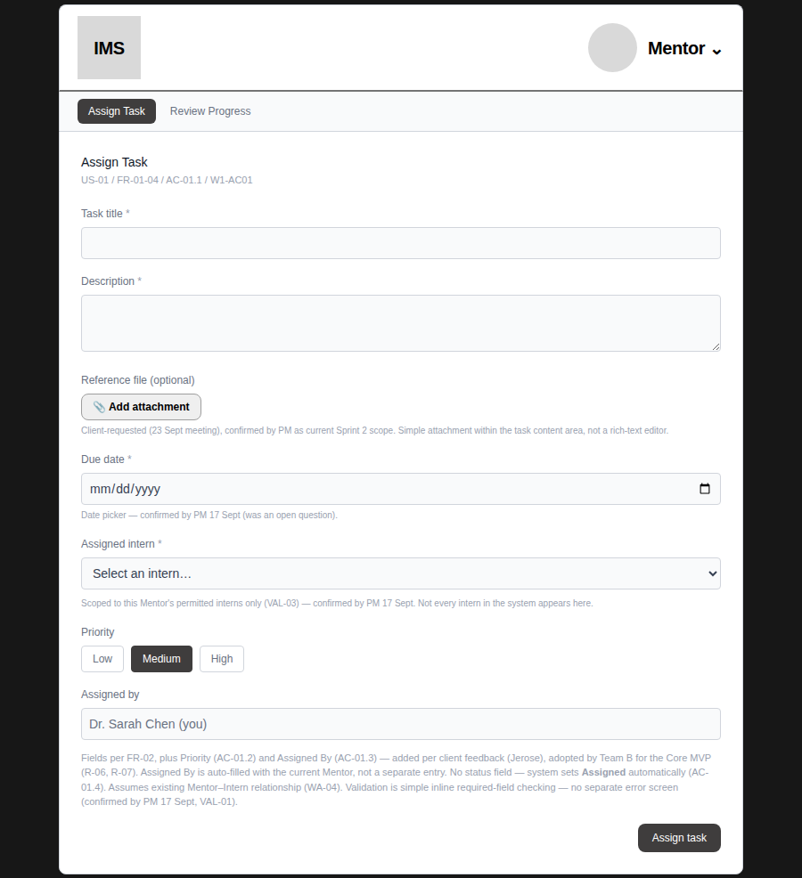  Design (prototype) — empty form with field-level requirement annotations | 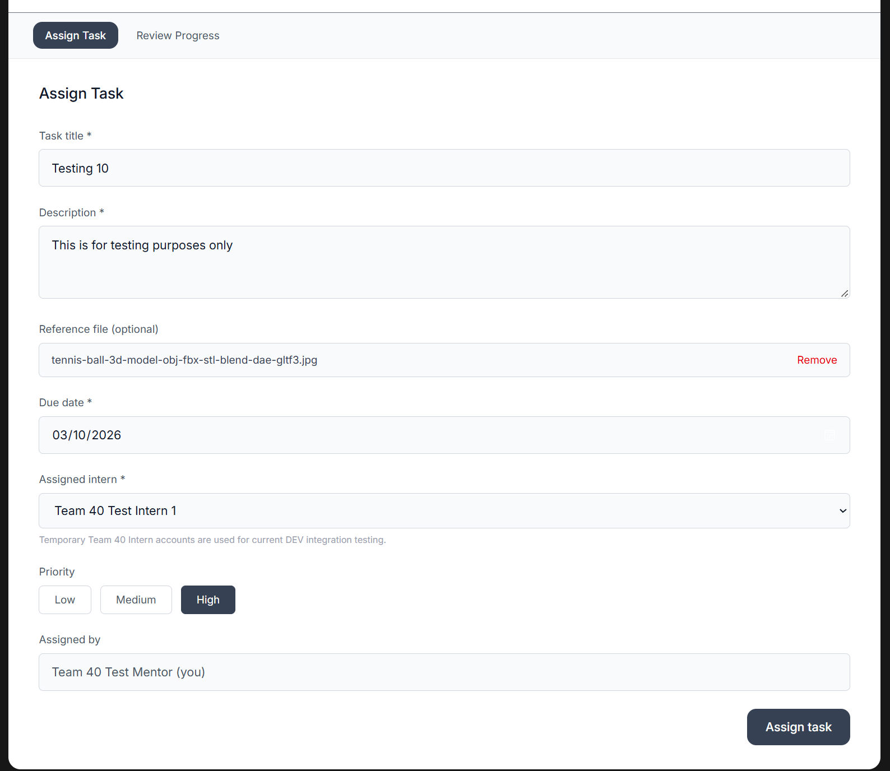  Implementation — same fields, filled and submitted: title, description, reference file, due date, assigned Intern, priority, assigned-by

3. Client-Feedback-Driven Changes
These three fields on Assign Task were added specifically in response to client feedback from the 23 September Team A/B meeting, confirmed in scope by the PM, and carried into the approved design before DEV built them. All three are visible, working, and in the correct place in the implementation comparison above (2.4).
- Reference file attachment — client-requested (23 Sept meeting), confirmed by PM as current Sprint 2 scope. A simple attachment within the task content area, not a rich-text editor — matches what was agreed, not an over-built version of it.
- Priority field — added per client feedback (Jerose), adopted by Team B for the Core MVP.
- Assigned By field — auto-filled with the current Mentor rather than a separate entry field, consistent with the system's existing Mentor–Intern relationship (WA-04).
The Mentor reference attachment is also visible to the Intern on their own Task Detail screen (2.2) — DEV correctly carried the attachment through to the Intern's side of the flow, which the original design annotation implied but didn't explicitly mock as a separate screen.

4. Intern / Mentor Summary
Intern experience: a scoped, single-purpose workspace — My Tasks (visibility limited to their own assigned work, AC-02.1), Task Detail with the confirmed forward-only status lifecycle (Assigned → In Progress → Submitted → Completed, no skipping or reversal), and a once-per-week Weekly Progress form that locks after submission.
Mentor experience: Assign Task carries the three client-requested fields above, scoped to that Mentor's permitted Interns only (VAL-03). Review Progress lets the Mentor review a Task Submission and mark it Completed, and review Weekly Progress per Intern — all confirmed, unchanged by this evidence task.

5. Lifecycle States (Fallback Evidence)
Captured on the design side across the full confirmed status lifecycle, so the PM has a fallback if the live DEV demo can't show every transition in the room. DEV's current build only has an Assigned-state task on record at time of capture (2.2, repeated below for a complete set); these design-side states show the same lifecycle the implementation already enforces, verified earlier this sprint by running the prototype end-to-end with no console or page errors.
Assigned — Intern view, starting state (matches DEV, Section 2.2)
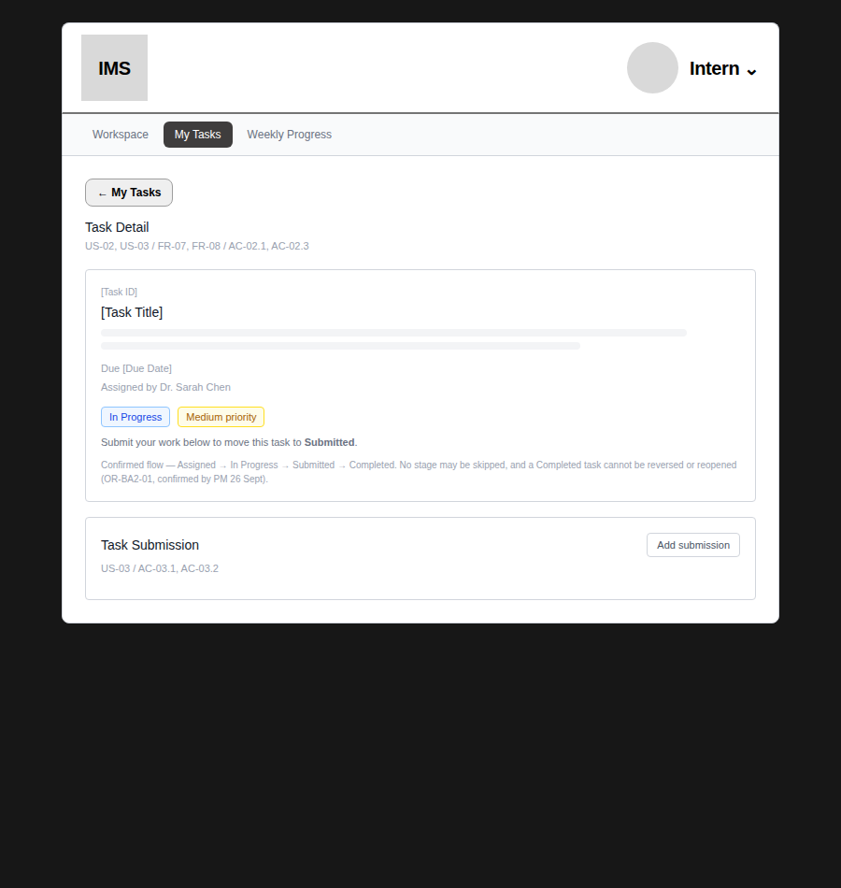
In Progress — Intern view, after “Start task”
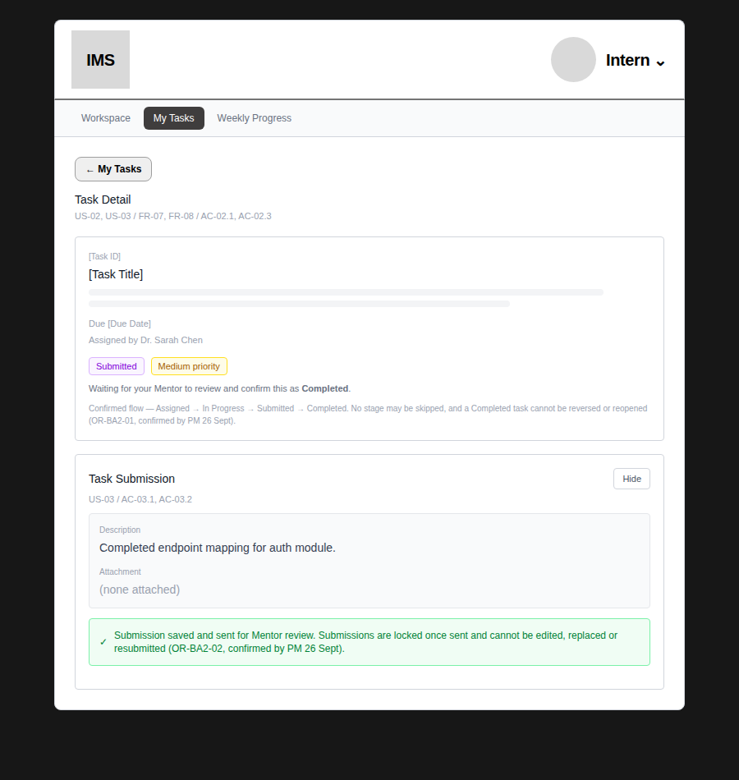
Submitted — Intern view, after completing the Task Submission form
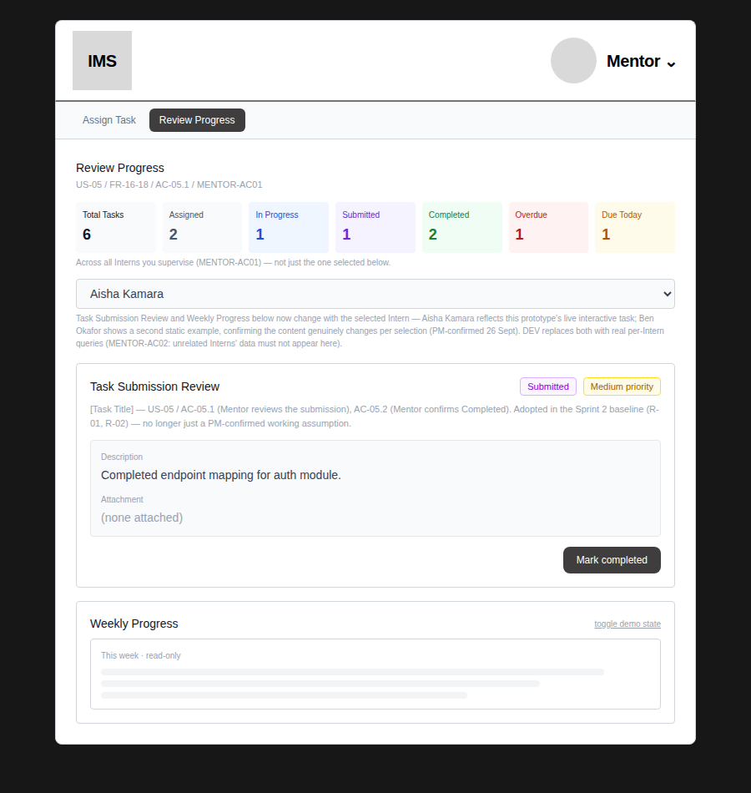
Submitted — Mentor's Review Progress view, ready to confirm Completed
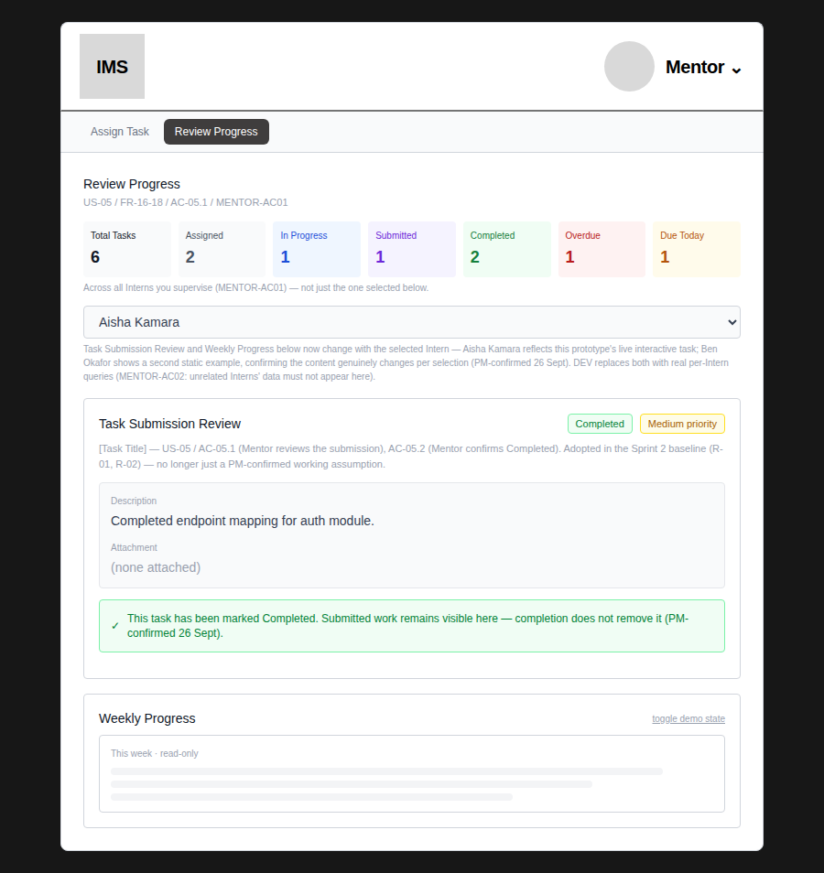
Completed — Mentor view, after “Mark completed”; submitted work stays visible

6. Fallback Demo Evidence & Figma
Figma link
Mentor task Assignment prototype – Figma Make

This document itself is the fallback visual evidence required by the task: every comparison above is a real screenshot, not a mock-up, of both the approved design and DEV's live implementation, captured in the relevant logged-in role. If the live demo environment is unavailable during Playback, the PM can present directly from Section 2.

7. Handoff Summary
Confirmed
Four design→implementation comparisons captured and verified against the current DEV deployment. All three client-feedback-driven changes (Section 3) are implemented, visible, and in the correct place. Fallback lifecycle evidence (Section 5) is ready in case the live demo is unavailable.

Open before Playback
Figma Make link needs to be pasted into Section 6. DEV's live record only shows an Assigned-state task at time of capture — if the PM wants a live Submitted/Completed transition in the room, that needs a quick DEV-side run-through before rehearsal, otherwise present from the Section 5 fallback evidence instead.

Files: App.tsx (v5) — core-mvp-prototype; DEV screenshots captured live from the Vercel deployment, logged in as Mentor/Intern. Handed off to PM ahead of Sprint 2 Playback rehearsal.

