Intern Management System — User Guide
Applicant-to-Intern transition, Intern workflow and Mentor workflow — Team 40 / Team B
Prepared by: Faridullah Jabbar Khil (s4020393) — UX
Task: [UX HANDOVER] – Final User Guidance & Role-Based Workflow Documentation · Sprint 3 · due 26/10/2026
Source of truth: the deployed system (screens captured in October 2026) and DEV’s final code

1. About This Guide
Who this guide is for
People using the final integrated system: Applicants who may become Interns, Interns doing their work, and Mentors assigning and reviewing it. It explains where each person arrives after signing in, and the main steps for tasks and Weekly Progress, in the words the system itself uses.

The guide uses the screens and labels of the deployed system. Where a step has a screenshot, the screenshot comes from the deployed system and its capture date is in the caption. Steps without a screenshot follow the final code and use the same labels. No part of this guide describes a feature that is not in the system.

2. How Roles and Navigation Work
There is one account for everyone. You sign in with the same email and password whatever your role, and the system takes you to the right place from your role.
Role | Where you land after signing in | What you do there
Applicant | The application form (/application) | Apply for the internship in four steps.
Intern | Intern Workspace (/intern/workspace) | See your tasks, start and submit them, and send Weekly Progress.
Mentor | Assign Task (/mentor/tasks/assign) | Assign tasks, review submissions and read Weekly Progress.
Admin | Applications (/admin/applications) | Screen applications and promote accepted candidates to Intern.

Moving around
- Interns have three tabs along the top: Workspace, My Tasks and Weekly Progress. The same tabs appear on every Intern page.
- Mentors have two tabs: Assign Task and Review Progress.
- Your name appears at the top right of every page.

If you open a page that belongs to another role
You will see “You cannot access this page”, with a button that takes you back to your own workspace. This is expected, for example if an Intern opens a Mentor link. Nothing is wrong with your account.
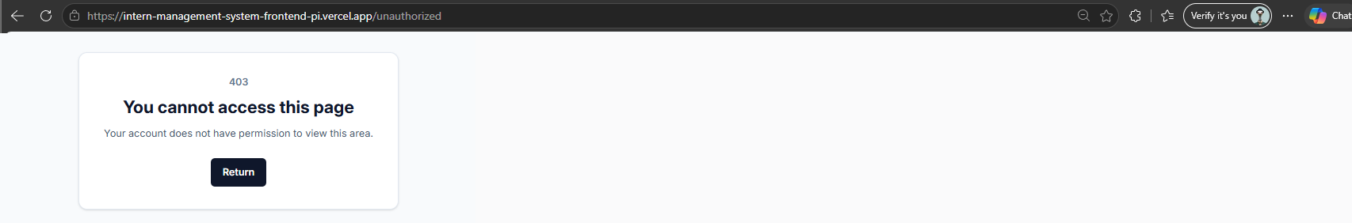
Fig. 1 — The access screen (captured 11 October)

3. From Applicant to Intern
One account follows you from your application to your internship.
- Step 1 — Create your account. Choose Create account and enter your full name, email address and password. You go straight to the application form.
- Step 2 — Complete the application. The form has four steps: Personal Info, Application Details, Documents, and Review & Submit.
- Step 3 — Wait for the decision. Administrators review applications and mark them Submitted, Reviewing, Accepted or Rejected.
- Step 4 — Promotion. When an application is Accepted, an administrator promotes the candidate to Intern. The system warns that this “changes the candidate’s account role to Intern and locks their application profile”.
- Step 5 — Sign in as an Intern. Use the same email and password. You arrive in the Intern Workspace automatically; there is no separate sign-in for Interns.

What you see first as an Intern
You go straight to the Intern Workspace. Until your Mentor assigns your first task, My Tasks says “You currently have no assigned tasks.” New tasks appear in My Tasks as soon as they are assigned.

4. Guide for Interns

4.1 Your workspace
The Workspace tab is your home page. Seven counters show Total Tasks, Assigned, In Progress, Submitted, Completed, Overdue and Due Today. Below them, the My Tasks tile opens your task list, and the Weekly Progress tile shows whether you have submitted this week.
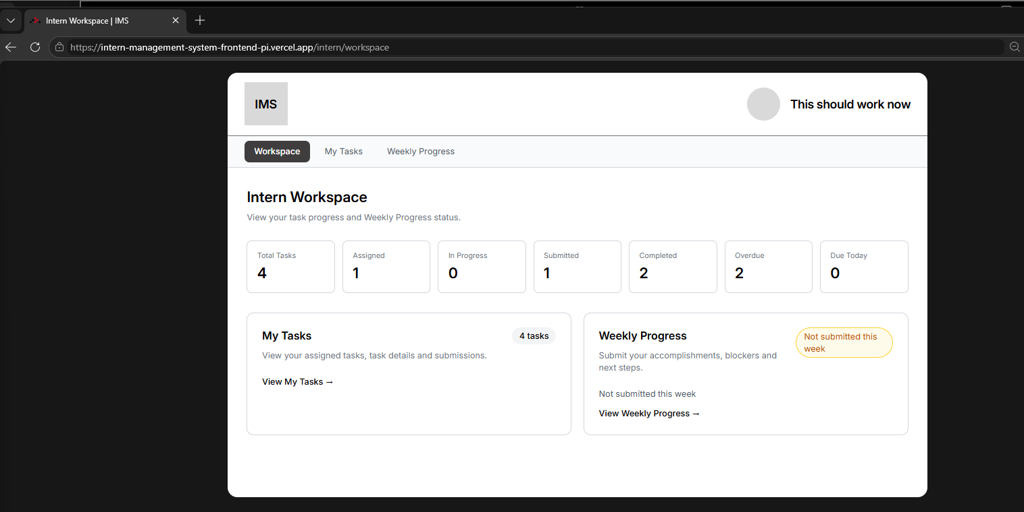
Fig. 2 — Intern Workspace (captured 18 October)

4.2 My Tasks
My Tasks lists every task assigned to you. Each card shows the task name, its due date, its status and its priority. Select a card to open the task.
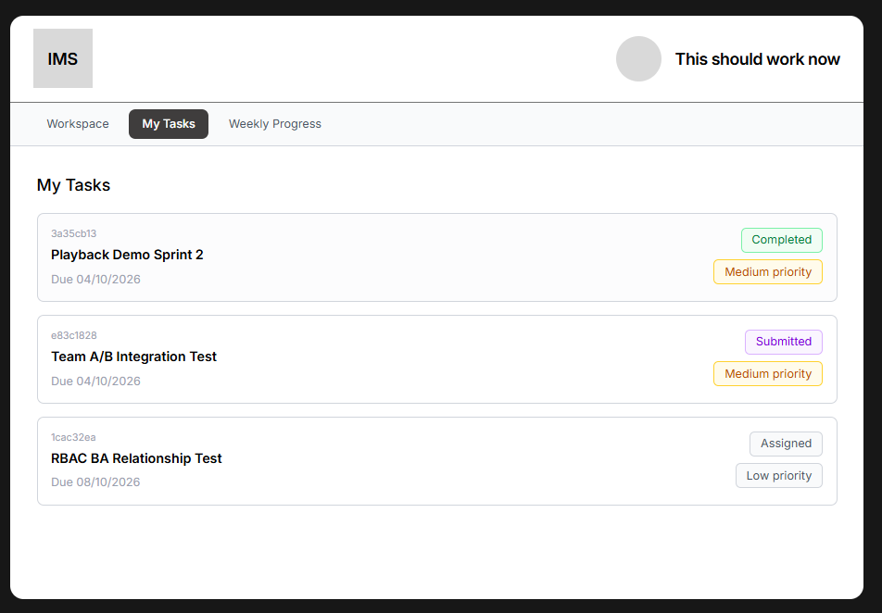
Fig. 3 — My Tasks (captured 10 October)

4.3 Working on a task
A task moves through four statuses. Each one is shown as a label on the task.
Status | What it means | Who moves it forward
Assigned | The Mentor has given you the task. You have not started it. | You, with Start task
In Progress | You have started the task and are working on it. | You, with Submit task
Submitted | You sent your work for review. | Your Mentor, with Mark completed
Completed | Your Mentor has reviewed and completed the task. | Final

- Step 1 — Open the task from My Tasks. Task Detail shows the title, description, due date, who assigned it, its status and its priority. Any reference attachment appears here too.
- Step 2 — Select Start task. The status changes from Assigned to In Progress. Until you start, the Task Submission section says “Start this task before submitting your work.”
- Step 3 — Complete your work, then fill in the Task Submission form. Submission description is required. Attach file is optional.
- Step 4 — Select Submit task. The status changes to Submitted and the page confirms “This task has been submitted for Mentor review.”
- Step 5 — Wait for your Mentor. When they mark the task Completed, the page shows “This task has been marked Completed.”
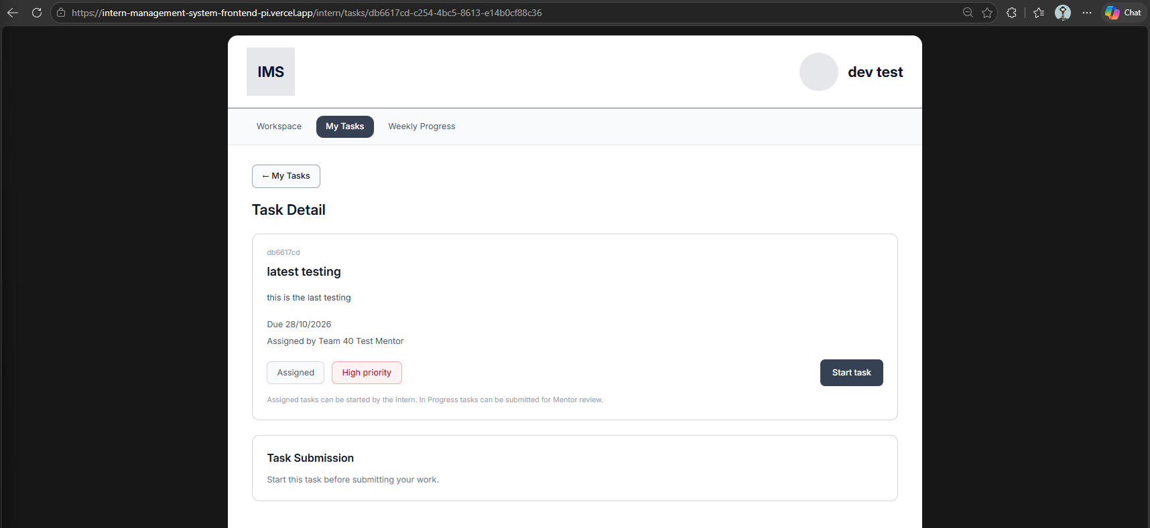
Fig. 4 — Task Detail for an Assigned task, with Start task (captured 26 October)
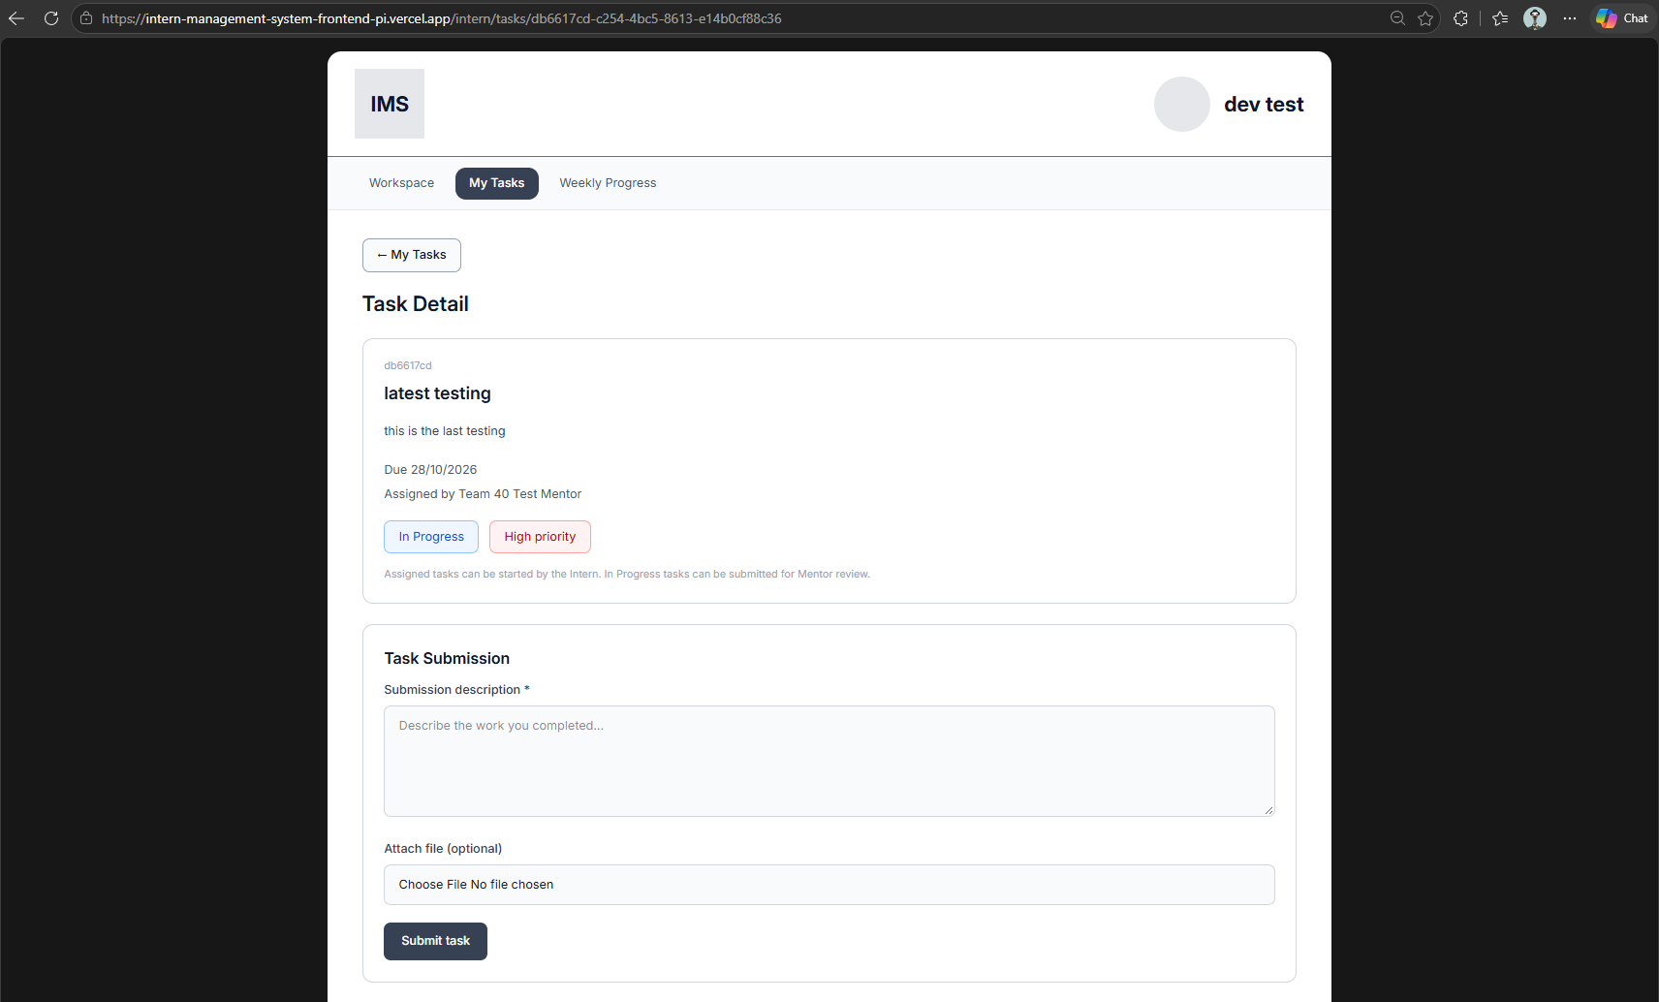
Fig. 5 — Task Detail for an In Progress task, with the Task Submission form (captured 26 October)

4.4 Weekly Progress
Once a week, send your Mentor a short progress report from the Weekly Progress tab.
- Step 1 — Open the Weekly Progress tab. The reporting week is shown at the top.
- Step 2 — Fill in Accomplishments (“What did you accomplish this week?”), Blockers (“What blockers or challenges did you face?”) and Next steps (“What will you work on next?”). All three are required.
- Step 3 — Select Submit progress.
Only one submission per week is allowed. After you submit, the form is locked and the page says “This week’s progress was already submitted.” On the Workspace tab, the Weekly Progress tile changes from “Not submitted this week” to “Submitted this week”.
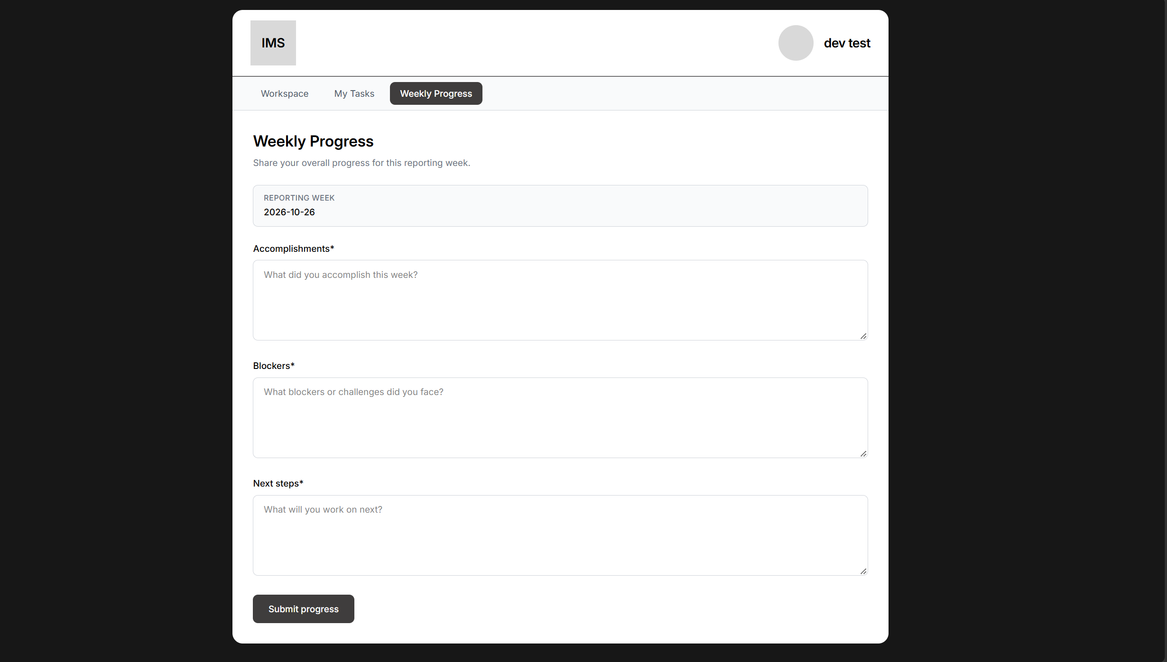
Fig. 6 — Weekly Progress form (captured 26 October)

5. Guide for Mentors

5.1 Assigning a task
After signing in you land on the Assign Task tab. Fill in the form to give an Intern a new task.
- Task title and Description are required.
- Reference file is optional. Select Add attachment to include one.
- Due date is required.
- Assigned intern is required. Choose the Intern from the list.
- Priority is Low, Medium or High. Medium is selected by default.
- Assigned by shows your own name automatically. You cannot change it.
Select Assign task. The page confirms the task was assigned to the Intern with its priority, and the task appears in that Intern’s My Tasks with the status Assigned.
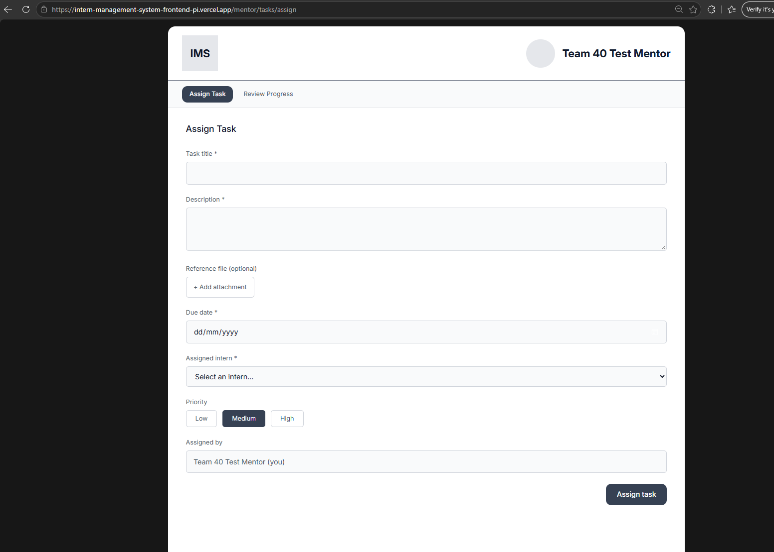
Fig. 7 — Assign Task form (captured 11 October)

5.2 Reviewing progress
The Review Progress tab is where you follow your Interns’ work.
- Summary cards at the top show Total Tasks, Assigned, In Progress, Submitted, Completed, Overdue and Due Today.
- Choose an Intern from the list to see that Intern’s work. If no Interns are available the list says “No Intern available”.
- Task Submission Review lists the Intern’s tasks. Each card shows the status and priority, the Due date, when it was Submitted, the Task Description, the Intern’s Description of their work, and the Attachment (or “No attachment provided.”).
- Select Mark completed to finish a Submitted task. The task shows “This task has been marked Completed.” and the Intern sees Completed on their side.
- Weekly Progress, lower on the same page, shows the selected Intern’s submitted reports. If there is none it says “No progress submitted yet. Check back after the Intern’s next submission.”
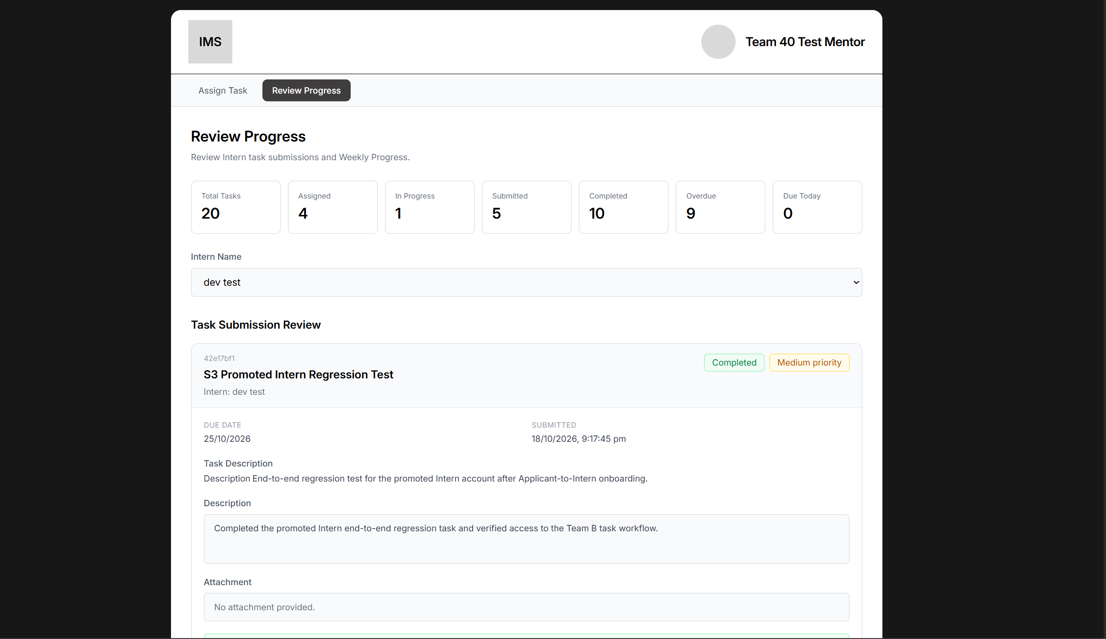
Fig. 8 — Review Progress with summary cards, Intern list and Task Submission Review (captured 26 October)
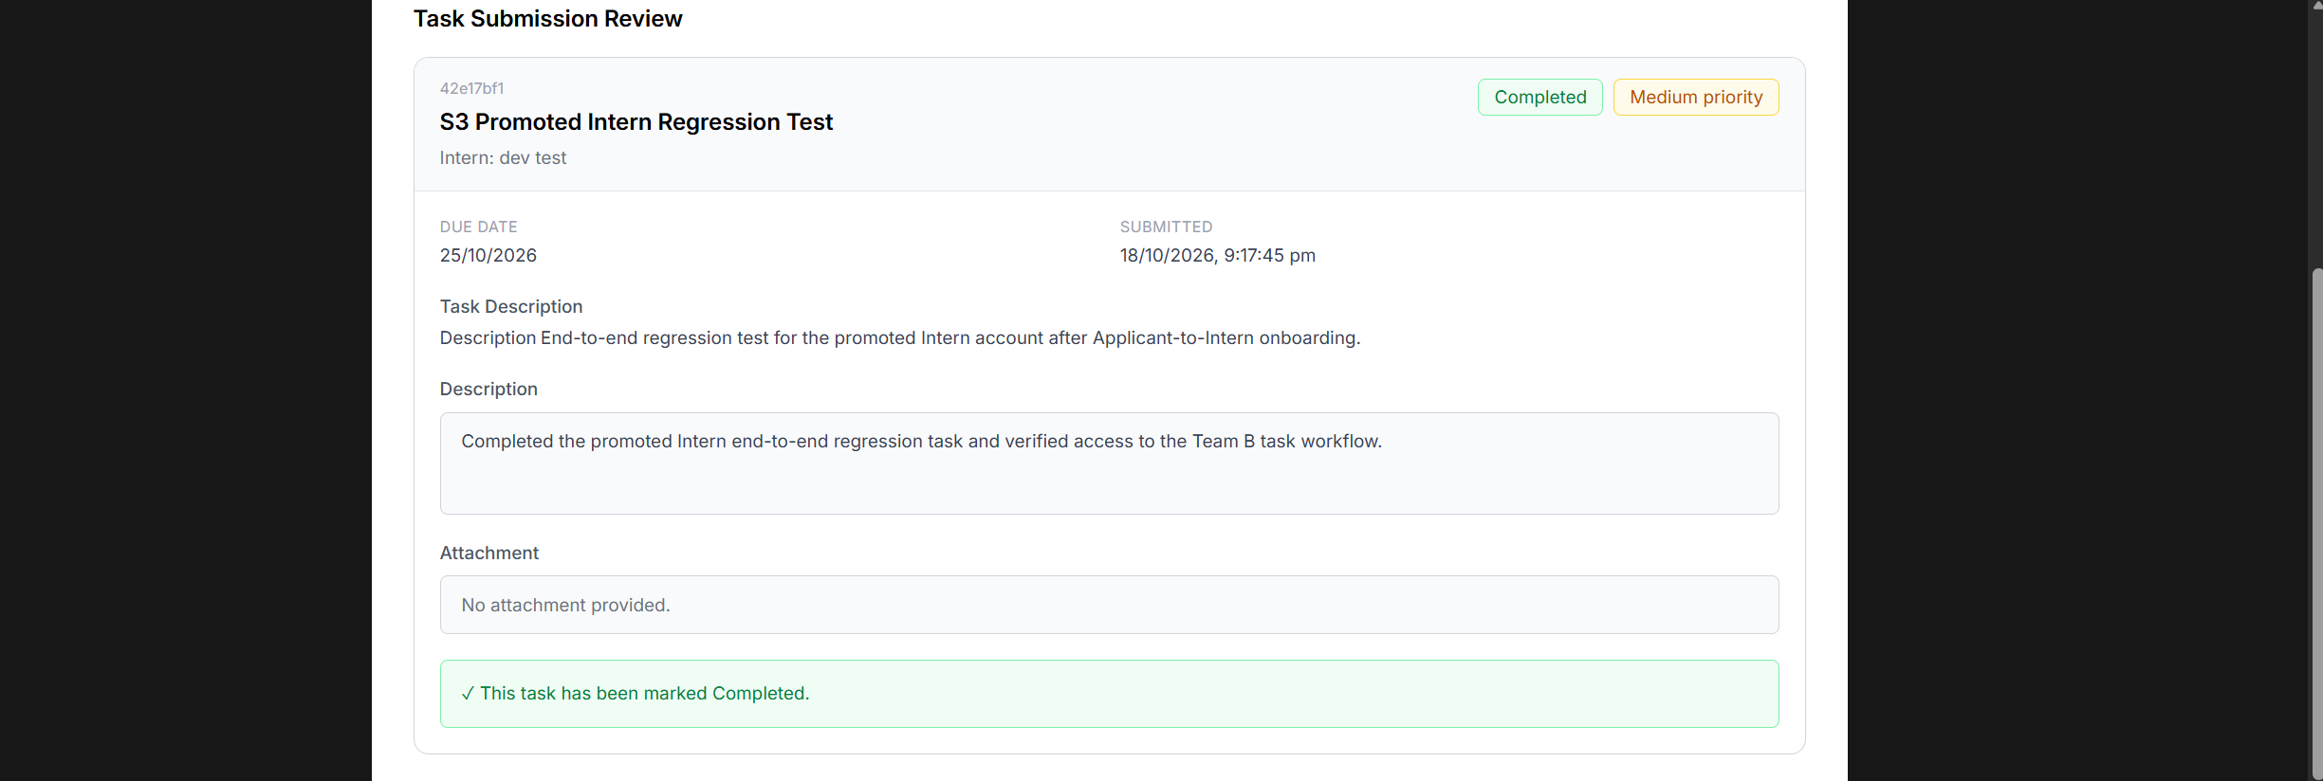
Fig. 9 — A Completed task in Task Submission Review (captured 26 October)

6. Terms Used in the System
Term | Meaning
Workspace | Your home page: task counts plus the My Tasks and Weekly Progress tiles.
My Tasks | The list of tasks assigned to you. Each card shows the title, due date, status and priority.
Task Detail | One task in full, with its status and, once started, the Task Submission form.
Weekly Progress | A short report you send once each week: Accomplishments, Blockers and Next steps.
Review Progress | The Mentor’s page for reading submitted tasks and Weekly Progress.
Overdue | Tasks past their due date that are not Completed.
Due Today | Tasks due today that are not Completed.
Priority | Low, Medium or High, set by the Mentor when assigning the task.

7. Common Questions
- “I see ‘You cannot access this page’.” You opened a page that belongs to another role. Use the button on that screen to return to your own workspace.
- “My Tasks is empty.” You have no assigned tasks yet. Your Mentor assigns them, and they appear as soon as they are assigned.
- “I cannot submit my task.” Start the task first. The submission form only appears once the task is In Progress.
- “I cannot send Weekly Progress again.” Only one submission per week is allowed. The form unlocks for the next reporting week.
- “I was accepted but I still see the application form.” Your promotion to Intern has not been applied yet. Ask the administrator to confirm it, then sign in again.

8. Notes for the PM
To confirm before this guide is published
Signing out: the final code adds an account menu with Sign out to the Intern and Mentor headers, but the deployed screens captured for this guide do not show it yet, so the guide does not describe signing out. Screenshots: Task Detail, Weekly Progress and Review Progress were captured on the deployed system on 26 October. The Weekly Progress section of Review Progress and the Mark completed button are described from the final code.

