UX Final Handover Package — Interface Evidence
Evidence register and client handover for the Intern and Mentor workflows — Team 40 / Team B
Prepared by: Faridullah Jabbar Khil (s4020393) — UX
Task: [UX HANDOVER] – Final Interface Evidence & Client Handover Package · Sprint 3 · due 28/10/2026
Deployed system: https://intern-management-system-frontend-pi.vercel.app

1. What This Package Is
Purpose
One place that lets the client, or a future team, understand the main role-based workflows without the project team explaining them. It lists the UX documents, shows the final interface evidence behind them, and says what is open at handover.

UX documents in the package
All files are in documents/team-b/UX/ in the docs repository.
File | What it is for
IMS-User-Guide-Role-Based-Workflows.docx | The main document for the client and any future team. Plain-language guide to the roles, the Applicant-to-Intern transition, and the Intern and Mentor workflows.
Team-AB-Role-Entry-Workspace-UX-Review-Updated.docx | Review of how each role enters the system and what it sees first, checked on the deployed site.
Integrated-Workspace-Navigation-Role-State-UX-Review.docx | Review of navigation and role states across the integrated workspace, including the access screen.
Applicant-to-Intern-Onboarding-UX-Review.docx | Review of what an accepted applicant sees when they become an Intern.
Intern-Workspace-Entry-Navigation-Consistency-UX-Handoff.docx | Final consistency check of the Intern workspace pages, with what remains.
This package (evidence register) | Index of the screenshots and the checks behind the guide, plus what is open at handover.

Start with the User Guide. The other documents are the reviews behind it.

2. The System at a Glance

Who lands where
One account serves every role. After signing in, the system opens the page for the person’s role.
Role | Lands on | What is there
Applicant | /application | Four-step application: Personal Info, Application Details, Documents, Review & Submit.
Intern | /intern/workspace | Tabs: Workspace, My Tasks, Weekly Progress.
Mentor | /mentor/tasks/assign | Tabs: Assign Task, Review Progress.
Admin | /admin/applications | Screens applications and promotes accepted candidates to Intern.

The four main flows
Flow | Steps
Applicant to Intern | Applicant applies → Admin screens (Submitted, Reviewing, Accepted, Rejected) → Admin promotes → same email and password now opens the Intern Workspace.
Task | Mentor assigns (Assign Task) → Intern opens it in My Tasks → Start task (In Progress) → Task Submission form, Submit task (Submitted) → Mentor opens Review Progress, Mark completed (Completed).
Weekly Progress | Intern completes Accomplishments, Blockers and Next steps once a week (Submit progress) → Mentor reads it under Review Progress.
Wrong role page | Any role opening another role’s page sees “You cannot access this page” with a button back to its own workspace.

3. Final Interface Evidence
Nine screens from the deployed system cover the Intern and Mentor workflows. The sheet below shows all of them; the table gives the role, location and capture date for each.
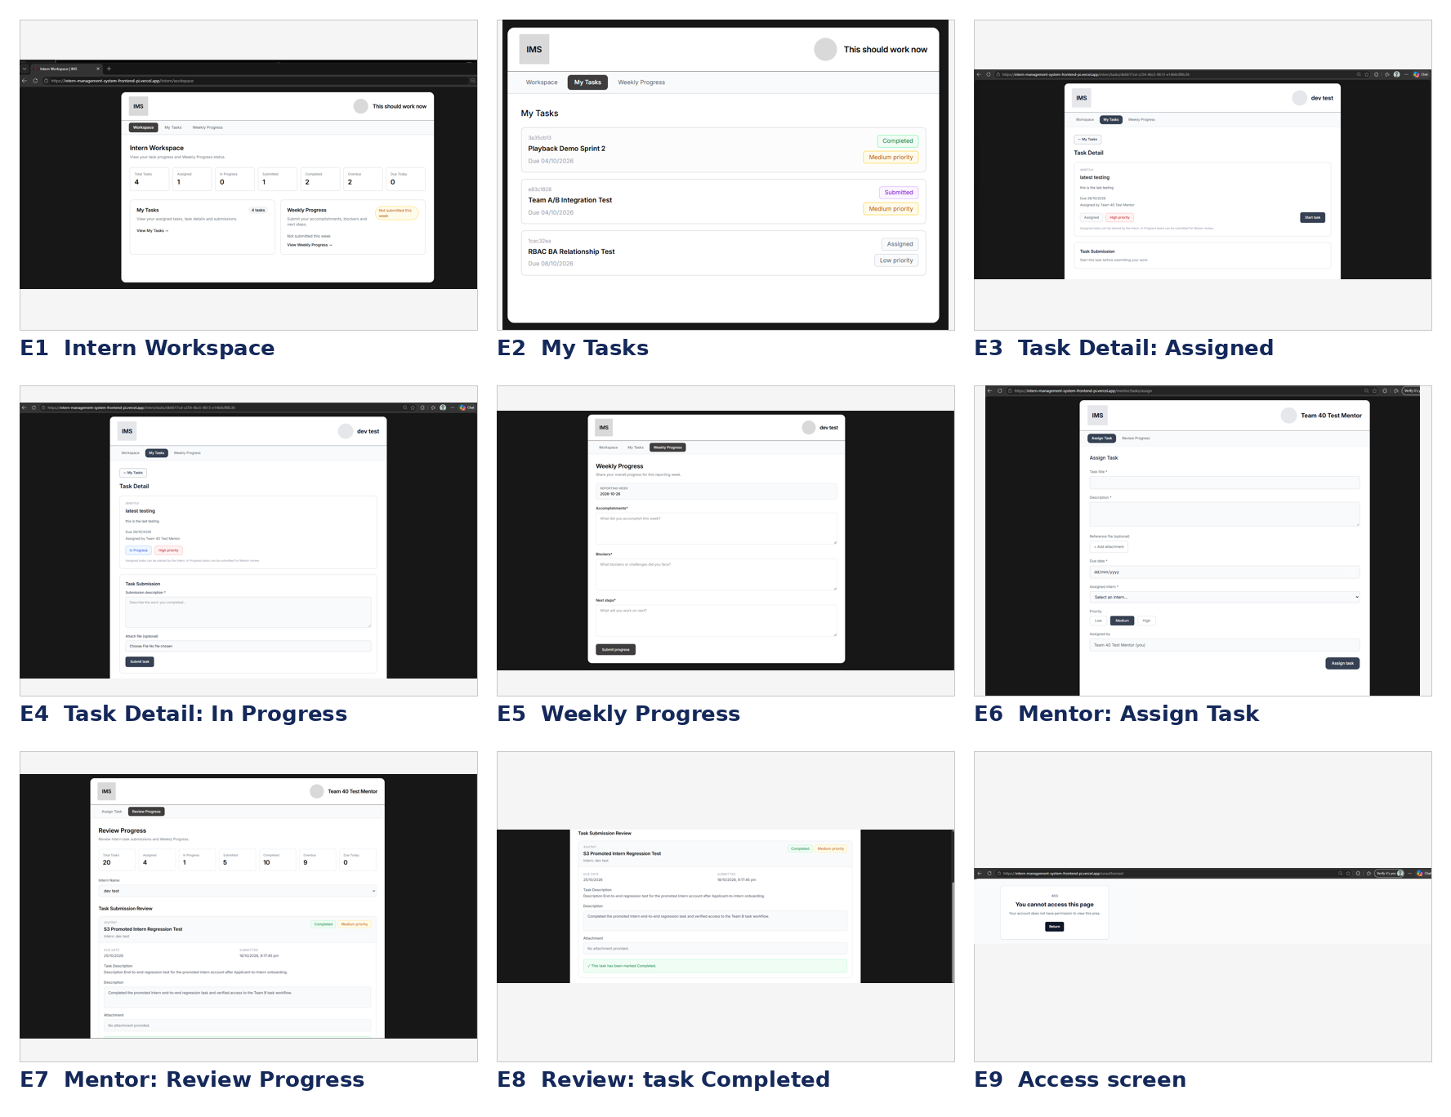
Fig. 1 — Evidence sheet E1 to E9 (deployed system)
ID | Screen | Role | Where | Captured | Used in
E1 | Intern Workspace | Intern | Workspace tab | 18 Oct | Guide, Fig. 2
E2 | My Tasks | Intern | My Tasks tab | 10 Oct | Guide, Fig. 3
E3 | Task Detail, Assigned | Intern | My Tasks, open a task | 26 Oct | Guide, Fig. 4
E4 | Task Detail, In Progress | Intern | My Tasks, open a task | 26 Oct | Guide, Fig. 5
E5 | Weekly Progress | Intern | Weekly Progress tab | 26 Oct | Guide, Fig. 6
E6 | Assign Task | Mentor | Assign Task tab | 11 Oct | Guide, Fig. 7
E7 | Review Progress | Mentor | Review Progress tab | 26 Oct | Guide, Fig. 8
E8 | Review Progress, task Completed | Mentor | Review Progress tab | 26 Oct | Guide, Fig. 9
E9 | Access screen | Mentor | Intern page opened as Mentor | 11 Oct | Guide, Fig. 1

Full-size versions of every screen are in the User Guide. Browser tab strips were removed from the images because they showed personal tabs.

4. Terminology Checked Against the Deployed System
Each label used in the User Guide was compared with the deployed screens listed below.
Item | Wording used | Checked on
Tab labels | Workspace, My Tasks, Weekly Progress (Intern); Assign Task, Review Progress (Mentor) | Seen on screen, E1 to E8
Task statuses | Assigned, In Progress, Submitted, Completed | Seen on screen, E2 to E4, E8
Priority | Low, Medium, High, shown as “Medium priority” | Seen on screen, E2, E8
Task Submission | Submission description (required), Attach file (optional), Submit task | Seen on screen, E4
Weekly Progress fields | Accomplishments, Blockers, Next steps, Submit progress | Seen on screen, E5
Review Progress | Total Tasks, Assigned, In Progress, Submitted, Completed, Overdue, Due Today; Intern Name; Task Submission Review | Seen on screen, E7
Access message | “You cannot access this page” | Seen on screen, E9
Assign Task fields | Task title, Description, Due date, Assigned intern, Priority, Assigned by | Seen on screen, E6

No wording in the guide differs from the deployed system for these items.

5. Open at Handover
These are the items a reader of the package should know about. None of them stops the Intern or Mentor workflows from working.
Item | Detail | Owner
Sign out | The Intern and Mentor headers show a name only. The account menu with Sign out is built in DEV’s PR #22 but was not in the code on the main branch when this package was prepared, so the guide does not describe signing out. | DEV / PM
Welcome notice for a new Intern | A newly promoted Intern goes straight to the workspace with no notice that the account has changed. The guide explains this in words. | With DEV
Small visual differences | The My Tasks title is smaller than on the other Intern pages, the Task Detail tab bar has a different shape, and the My Tasks tile reads “1 tasks”. Polish only; nothing blocks use. | Optional

6. Handoff Checklist for the PM
- Update evidence to the final deployed UI: E1 to E9 show the final deployed system.
- Finalise Intern workflow guidance: User Guide, section 4.
- Finalise Mentor workflow guidance: User Guide, section 5.
- Check role and navigation guidance: User Guide, section 2, and section 2 of this package.
- Organise final screenshots and UX evidence: section 3 and the evidence table in this package.
- Hand the package to the PM: the five UX documents and this package are ready for final consolidation.

