Core MVP Early Wireframes
Design documentation
Team: Team 40 / Team B — Intern Management System
Task: [UX DESIGN] — Core MVP Early Wireframes
UX Designer: Faridullah Jabbar Khil
Sprint: Sprint 1 — Design & Bootstrap
Source requirements: Team40_TeamB_BA_Requirements_Shakthijhaa_S4065078.docx

1. Purpose
This document explains the low-fidelity wireframes produced for Team B's Core MVP: Intern Task & Progress Management. It maps each screen to the specific BA requirement it satisfies, explains the interactions and states represented, notes the design constraints considered, and records how the wireframes changed after a self-review against the BA document.

2. Requirement mapping
Every screen corresponds to a named deliverable in D-03 (“Development depends on UX defining the minimum interaction and screen design required for…”), plus the edge-case states required by NFR-05 and EC-01/EC-02.
Screen | Requirement | Role | State
Assign task | FR-02 / AC-01 | Mentor | Happy path
My tasks | FR-04 / AC-02 | Intern | Happy path
My tasks — no task assigned | EC-01 / AC-02.2 | Intern | Empty state
Submit weekly progress | FR-05 / FR-06 / AC-03 | Intern | Happy path
Review progress | FR-07 / AC-04 | Mentor | Happy path
Review progress — no submission | EC-02 / AC-04.2 | Mentor | Empty state

3. Screens and annotated interactions

3.1 Assign task — FR-02 / AC-01 (Mentor)
- Assign to intern (select, required) — must resolve to an existing Mentor–Intern relationship per BR-06/A-01, not a free-text field
- Task title and Description (required) — fields left undefined by the BA doc (US-01 BA Note); marked required as the working assumption pending EC-09 sign-off
- Initial status — three-option toggle representing the working EC-09 proposal (Not Started / In Progress / Submitted); flagged in the flow-definition doc as still open with the BA
- Primary action —0 “Assign task” commits the record (AC-01.1)

3.2 My tasks — FR-04 / AC-02 (Intern)
- Task card shows ID, title, and status badge — satisfies AC-01.2 (“saved task information and basic task status shall be available”)
- Footnote annotation ties the screen to EC-05 (data isolation) — explicitly states the list is scoped to the signed-in intern only

3.3 My tasks — no task assigned — EC-01 / AC-02.2 (Intern)
- Dashed empty-state container replaces the task card when no assignment exists
- Added in revision 2 (see Section 5) so this state is an actual screen, not only a legend reference

3.4 Submit weekly progress — FR-05 / FR-06 / AC-03 (Intern)
- Accomplishments and Next steps marked required; Blockers marked optional — working assumption for EC-04, pending field confirmation with the BA
- Primary action — “Submit progress” commits the record and links it to the relevant task (AC-03.1)

3.5 Review progress — FR-07 / AC-04 (Mentor)
- Intern selector scopes the review to one intern at a time
- Progress card is read-only — annotated to make clear this screen intentionally excludes a feedback/comment field, since Mentor feedback is FR-11 (Could Have, out of Core MVP scope per BR-10)

3.6 Review progress — no submission — EC-02 / AC-04.2 (Mentor)
- Same dashed empty-state pattern as 3.3, applied to the Mentor side
- Added in revision 2 alongside 3.3

3.7 Shared key states
- Validation error — EC-04 / AC-03.3
- Access denied — EC-03 / AC-01.3, AC-02.3, AC-04.3 (role-based restriction, FR-09)
- Empty state — EC-01, EC-02 / AC-02.2, AC-04.2 (also shown as real screens — see 3.3 and 3.6)
- Success — AC-01.1, AC-03.1

4. Design constraints considered

Screen size
Designed for desktop web, matching the BA's target usage (no mobile requirement stated in scope). Fields stack in a single column within each card so the layout degrades gracefully on a narrower viewport without hidden or clipped content.

Accessibility
Required fields are marked with both an asterisk and would carry an accessible label in build, not color alone. Every key state (validation error, access denied, empty, success) pairs an icon and a text label with its border/fill treatment, so the state is not conveyed by color alone — consistent with the spirit of NFR-01's instruction not to rely solely on hiding or a single visual cue for access control, applied here to state legibility generally.

Existing design system
The wireframes follow the grayscale, numbered-step-rail convention already established as the team's low-fidelity format, rather than introducing a new visual language for this deliverable.

5. Iteration history
The wireframes went through one revision after a self-review against the BA requirements document, in addition to the original build.

Revision 1 — initial pass
- Four core screens built: Assign task, My tasks, Submit weekly progress, Review progress
- One shared legend covering validation, access-denied, empty, and success states in the abstract

Revision 2 — after BA cross-check
- Corrected the legend's requirement reference: AC-03.3 was incorrectly grouped under “access denied” — in the BA doc, AC-03.3 is the validation criterion for weekly progress, not a role-denial criterion. Access denial for that screen falls under the general FR-09 instead
- Added two explicit empty-state screens (3.3 and 3.6) so AC-02.2 and AC-04.2 are demonstrated as real screens rather than only referenced abstractly in the shared legend

6. Wireframe evidence

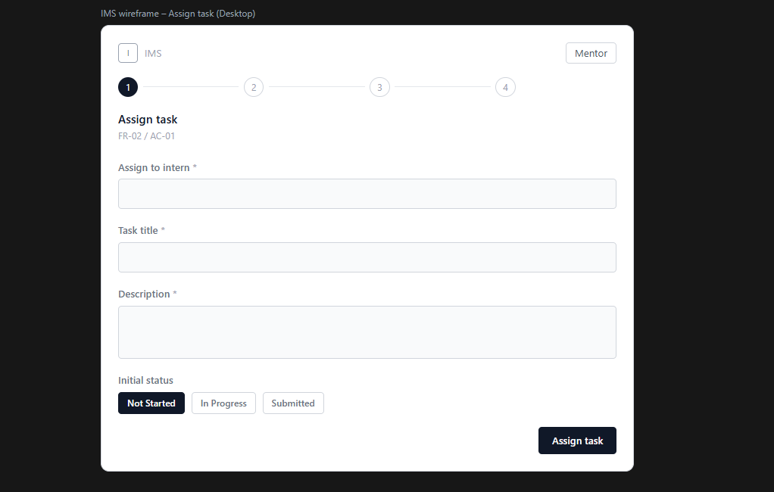
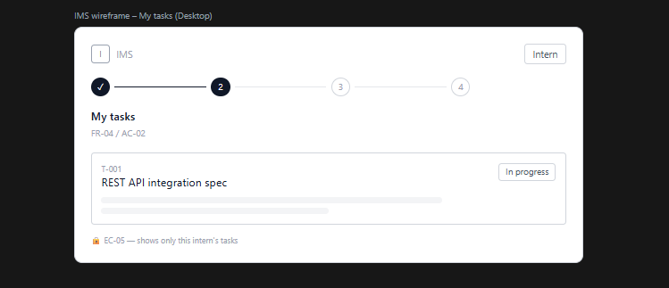
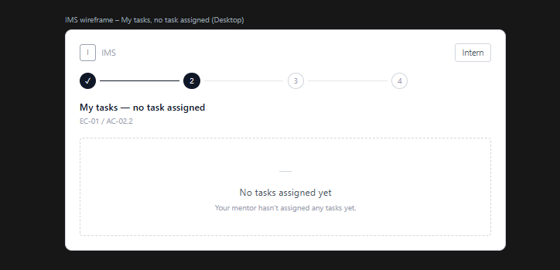
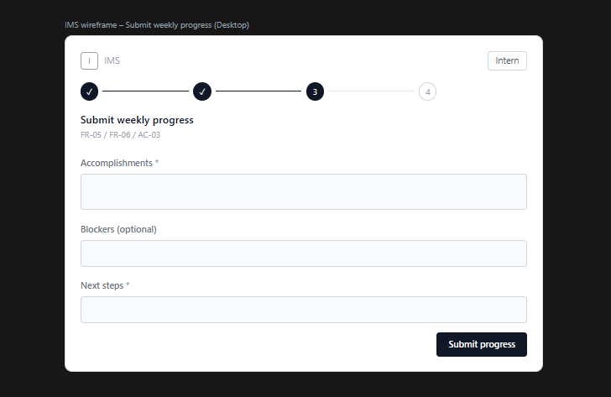
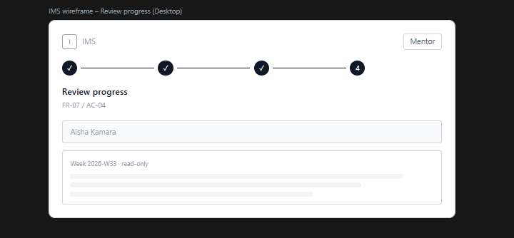
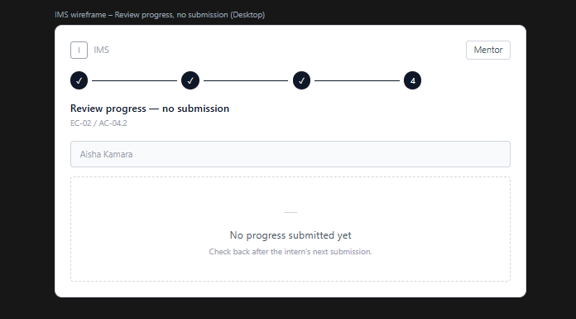
Figure 1 — Assign task, My tasks, Submit weekly progress, Review progress (Figma Make render)
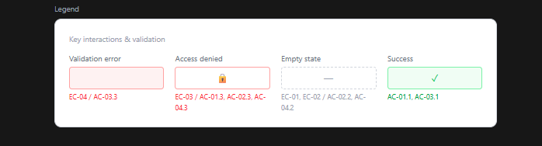
Figure 2 — Shared key-states legend, prior to the Revision 2 correction described in Section 5

