Team A/B Role Entry & Workspace — UX Review
Sprint 3 Week 1 — Team 40 / Team B (Intern Management System for Social Enterprise Workforce Development)
Prepared by: Faridullah Jabbar Khil (s4020393) — UX
Task: [UX INTEGRATION] – Applicant, Intern & Mentor Entry-Flow Review · Sprint 3 Week 1 · due 10/10/2026
Review type: pre-implementation review, based on the existing prototype (App.tsx v5) and the DEV screens available
Inputs: PM alignment document “Team A/B Role Routing & Workspace Alignment” (9 October 2026); BA “Role-Based Routing Requirements & Acceptance Criteria” (Sprint 3 Week 1)

1. Purpose & Scope
PM handoff note for this task
“UX (Farid) — Review the Applicant, Intern and Mentor entry flows based on the confirmed Team A/B routing approach. Identify any navigation, role-state or workspace inconsistencies and provide UX recommendations for the integrated user experience.”

This is a pre-implementation review. It checks the confirmed routing contract (Applicant → Team A workspace, Intern → Team B Intern workspace, Mentor → Team B Mentor workspace, all from shared_accounts.role) and the BA rules and acceptance criteria built on it (RR-01 to RR-10, AR-01 to AR-08, AC-RR01 to AC-RR12) against the existing Core MVP prototype (App.tsx v5), which was run in a browser with no console or page errors, and against the DEV screens available, which are the 3 October screenshots. Every recommendation changes behaviour, wording or presentation of data that already exists; none adds business functionality.
What this review is and is not
This is a pre-implementation review based on the existing prototype and available screens; DEV’s role-based routing was not reviewed in the deployed build. Each finding therefore carries a check to confirm once the routing is deployed. Team A’s Applicant screens were not reviewed; only the point where they hand off to Team B was.

2. Summary
Already consistent — no change needed
Same header shell as Team A (logo box, avatar and divider values taken from Team A’s Figma file). Each role sees only its own navigation. My Tasks stays highlighted on Task Detail. Status colours match across Workspace, My Tasks, Task Detail and Review Progress. A visible Access denied state exists.

Needs correction — 3 items, all High
Role switching must not survive into the product (01), the access screen needs a way out and a version for an unknown role (02), and the post-login redirect must respect the resolved role (03). Full table in Section 4; how each relates to the BA criteria is in Section 5. Four smaller observations are deferred (Section 6).

Coverage of the PM handoff note
- Review the Applicant, Intern and Mentor entry flows against the confirmed routing approach → Section 3 and findings 01–03.
- Identify navigation, role-state or workspace inconsistencies → Section 4, findings 01–03.
- Provide UX recommendations for the integrated experience → Sections 4 and 7.

3. Entry Flow Review

3.1 Applicant
Applicants land in Team A’s workspace, which Team A owns (BA RR-02, AC-RR01). The only UX requirements at the seam are a shared header shell (already aligned) and that no Team B screen is ever visible to an Applicant, which findings 01–03 cover. Team A’s Applicant screens themselves were not reviewed.

3.2 Intern
Entry is the Intern Workspace: summary cards plus My Tasks and Weekly Progress tiles, with the tabs Workspace | My Tasks | Weekly Progress. Navigation and state are consistent and need no correction; one optional polish item is deferred (Section 6).

3.3 Mentor
Entry is the Assign Task form, with the tabs Assign Task | Review Progress. Navigation is consistent and needs no correction; the landing differs from the Intern pattern, which the BA criteria accept (AC-RR06), so it is deferred (Section 6).
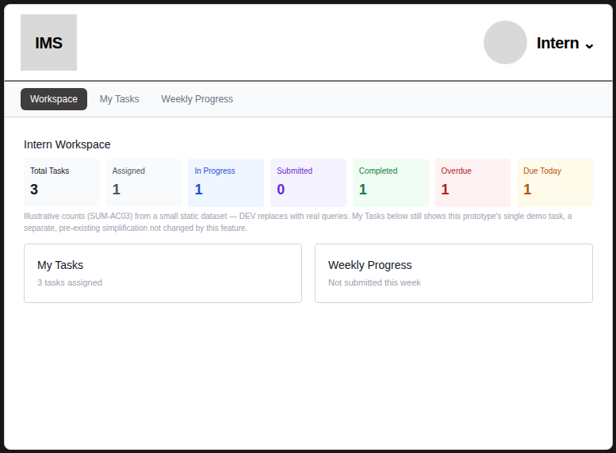  Fig. 1 — Intern landing: titled workspace with summary cards | 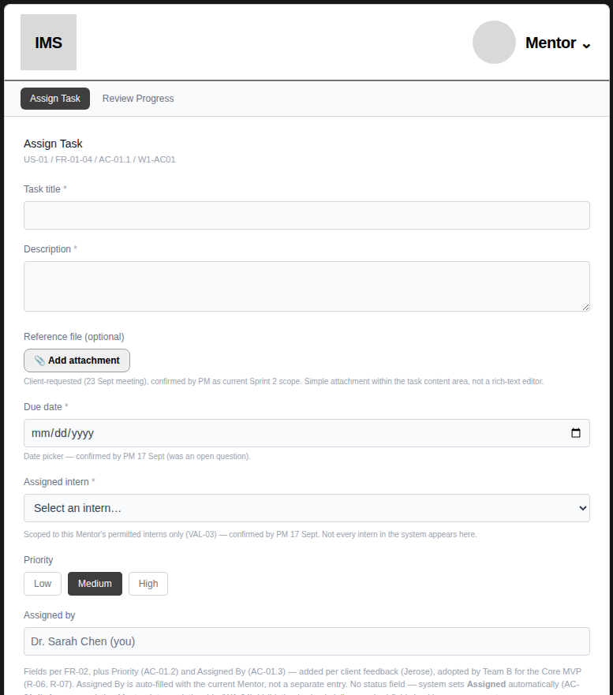  Fig. 2 — Mentor landing: straight onto the Assign Task form

4. Findings & Prioritised Correction Handoff
Three corrections, in the order DEV should apply them. Each Check names the BA criteria it supports; Section 5 shows how the two documents relate.
# | Priority | Finding & evidence | Correction for DEV | Check (BA / UX)
01 | High | Manual “Switch role” control  The prototype account menu lets the user switch between Intern and Mentor. It sits above the “Prototype tools — not in final product” label, so it is not marked for removal (Fig. 3). In the product it would be a normal-flow path into the other role’s workspace (BA AR-04, AR-05). | Do not carry it into the integrated build. Resolve the role only from shared_accounts.role after login; no control in the UI changes a user’s role or workspace. | Signed in as Intern, no control opens the Mentor workspace, and the reverse. BA: RR-01, AC-RR07, AC-RR08.
02 | High | Access denied is a dead end, and there is no screen for an unknown role  The wrong-role screen shows a lock and “You are previewing as a Mentor” (prototype wording) with no way out; the user’s own tab still looks active. The prototype has no screen at all for an account whose role cannot be resolved. The BA rules allow a redirect or a safe access state (AR-06) and leave the unknown-role screen to DEV/UX (RR-09, IC-02), so both are UX decisions. | Build one reusable safe access screen with two messages. Wrong role: “This area is for Mentors. You’re signed in as an Intern.” with a primary button “Go to my workspace” (for an Applicant, the Team A workspace). Unknown role: “We couldn’t find a workspace for your account” with Sign out. Never default to Applicant, Intern or Mentor. The frontend guard is navigation only; the API denial stays. | Intern opens a Mentor URL: sees the notice and button, and the button lands in the Intern workspace. Account with a missing or unexpected role sees only the neutral screen: no role navigation, no data. API still denies the data. BA: AR-06, AR-08, AC-RR02, AC-RR07, AC-RR10, AC-RR11.
03 | High | Redirect to the previous URL after login  Ilya reports login redirects to the previously requested URL or the application page (PM document §3). A user promoted from Applicant to Intern may hold an old Applicant URL, and BA RR-06 and RR-08 forbid it overriding the new role. | Resolve the role first. Honour the previous URL only if it belongs to the resolved role’s workspace; otherwise go to that role’s home. An Intern is never sent to an Applicant page. | Promoted account with a stale Applicant URL signs in and lands in the Intern workspace. BA: AC-RR05, AC-RR09.

Supporting evidence
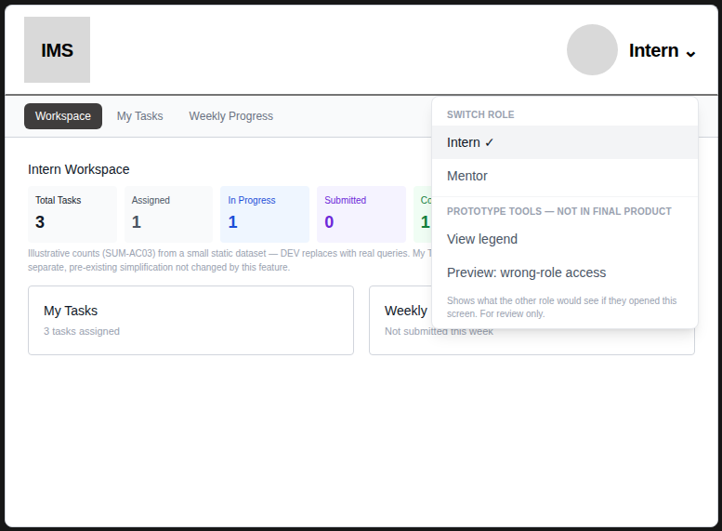
Fig. 3 — “Switch role” sits outside the prototype-tools label

5. Alignment with the BA Acceptance Criteria
The BA baseline was read alongside this review and the two do not contradict each other. Two findings enforce BA rules at the interface (01, 03) and one makes the decisions the BA document leaves to UX (02: the wrong-role response and the unknown-role screen).
UX finding | BA reference | How the two relate
01 Switch role | RR-01, AR-04, AR-05, AC-RR07, AC-RR08 | Enforces the BA rules at the interface: no UI path into the other role’s workspace.
02 Safe access screen | AR-06, AR-08, RR-09, IC-02, AC-RR02, AC-RR07, AC-RR10, AC-RR11 | UX decision: the BA allows a redirect or a safe access state and leaves the unknown-role screen to DEV/UX; this defines both as one screen.
03 Previous URL | RR-06, RR-08, AR-03, AR-07, AC-RR05, AC-RR09 | Enforces the BA rules; the same behaviour described in interface terms.

The remaining BA criteria are routing, API and data rules (for example AC-RR01, AC-RR04, AC-RR11 and AC-RR12) that need no interface change from UX.

6. Open Items and Deferred Observations

Open items needing an owner
- Exact destination paths — the BA accepts on the correct role-owned destination, not a URL string (IC-01). Only /mentor/tasks/assign and /intern/weekly-progress are confirmed from the deployed build; the Intern home and Applicant home paths are not. Owner: DEV with Ilya.
- Role refresh when an account is promoted between sessions. The BA leaves token and session mechanics to DEV (IC-04); the UX recommendation is to re-resolve the role at every sign-in (finding 03). Owner: DEV with Ilya.
- Review workflow for changes to the shared AuthPage.tsx. Owner: PM with Team A.
- Map the Check column to AC-RR01 to AC-RR12. The check for finding 02 adds interface-level evidence the BA criteria do not spell out. Owner: BA (Shakthijhaa).

Deferred — no action requested this sprint
Noted during the review. None is needed for final Core MVP integration, and no BA criterion depends on them.
- Sign out: worth a one-minute check that the shared header already provides it; not part of this handoff.
- First-arrival state: a newly promoted Intern with no tasks would see an empty-looking Workspace; polish only.
- Header identity: the top bar shows only the role (“Intern”, “Mentor”), not the user’s name; polish only.
- Mentor landing: a Mentor lands directly on Assign Task rather than a titled home; accepted by BA AC-RR06 (any Mentor-owned destination).

7. Handoff to DEV
For DEV (Chan)
Apply findings 01 to 03 in order. The scope is deliberately small: 01 is a removal, 02 is one reusable screen with two messages, and 03 is a condition on the existing redirect. Finding 03, and the unknown-role case of 02, sit in the existing AuthPage.tsx login flow, so coordinate them with Ilya. Use the BA criteria (AC-RR01 to AC-RR12) alongside this document; where they differ in detail, the BA business rules stand and this review adds interface decisions. Keep the shared authentication foundation and existing Team B Core MVP behaviour unchanged. BA validates the result against the deployed build.

Files: this document; prototype App.tsx v5 (unchanged by this review).

