Admin User Manual & QA Handover
Final handover support document

Team | Team 39 - Intern and Management System - Team A | Role | Business Analyst - Abdifatah Hashi
Sprint | Sprint 3 Week 3 | Period | 19-25 October 2026

1. Purpose
This document provides a short administrator guide, records the main UAT evidence already completed by the BA, lists known edge cases, and gives troubleshooting notes for the final project handover.

2. Administrator Quick Guide

2.1 Sign in and open the Admin Portal
- Open the deployed Intern Management System and go to the sign-in page.
- Sign in using an authorised Admin account. Do not store test passwords in project documents or screenshots.
- After a successful login, the system should redirect the Admin user to the Admin Portal.
- Open Candidate Screening / Applications to review submitted candidate applications.

2.2 Review and update a candidate
- Locate the candidate using the application list, search, or available filters.
- Open the candidate record and review the application details and uploaded resume.
- Use the status control to update the candidate to the required recruitment state. The final workflow supports changing a candidate to Accepted before promotion.
- Confirm the status change when prompted. The application list should refresh and keep the updated state.
- For an Accepted candidate, use the available promotion action when the workflow requires the user to become an Intern.

2.3 Client-requested applicant fields
The final data update added the following mandatory applicant fields to the shared data model and application workflow:
Field | Operational expectation
Country | Applicant provides their current country. The value should be captured and displayed consistently.
Date of birth | Applicant provides a valid date of birth using the supported date input/validation.
LinkedIn URL | Applicant provides a LinkedIn profile URL and the value is stored with the application/profile data.

3. UAT Evidence Summary
The following results are based on BA testing completed in the earlier Sprint 3 UAT tasks and supporting team implementation/test evidence. A final regression run is recorded separately before the showcase.
Area | Result | Evidence / note
Admin authentication and redirection | PASS | Final BA regression on 25 October 2026 confirmed authorised Admin sign-in and redirection into the Admin Portal.
Restricted access / role permissions | PASS (previous UAT) | Earlier permissions UAT verified that non-admin and unauthenticated access is restricted. No regression affecting the authorised Admin route was observed in the final run.
Candidate status change to Accepted | PASS | Controlled test candidate “BA Routing Test Applicant” was changed from Reviewing to Accepted. Accepted remained visible after the page was refreshed.
Updated client fields and validation | PASS | The public application displays Country, Date of Birth and LinkedIn Profile URL as required fields. Required-field validation was triggered successfully, and the stored candidate profile displays these fields.
Server-side search and filtering | PASS | Searching for “BA Routing Test Applicant” returned the correct candidate record. Returning to the full candidate list also worked without a blocking error.
Mobile layout | Known limitation | Mobile presentation was previously reported as functional but less polished than desktop. This did not block the desktop regression path used for the final handover.
Email / NDA automation | Descoped / non-blocking | Email/NDA automation is outside the final core workflow. No email/NDA step interrupted or blocked the tested recruitment flow.

4. Known Edge Cases
- If a user is not authorised for an Admin route, access should be denied rather than displaying Admin content.
- If a candidate status update request fails, the previous state should remain visible and the user should receive a clear error instead of a silent failure.
- Empty or unmatched search/filter combinations should return no matching records without breaking the page.
- The mobile layout is functional but may not have the same level of polish as the desktop layout.
- Descoped email/NDA features should not block the core recruitment and handoff flow.

5. Troubleshooting FAQ
Admin signs in but cannot see the Admin Portal
Confirm the account has the Admin role in the shared account data. Sign out and sign in again. If the role is correct and the redirect still fails, log it as a routing defect.
Candidate status does not update
Retry once and confirm the candidate/application is still available. If the old status remains, record the candidate ID, time, action attempted, and visible error for the developer.
Search returns no result
Clear filters, confirm the spelling/value, then retry using one field at a time. An empty result is valid when nothing matches.
Updated client field is missing
Confirm the deployed frontend and backend are using the latest version. Record which field is missing and whether the value exists in the candidate record.
Promotion action is unavailable
Confirm the candidate has reached the Accepted state first. Promotion should only be available at the correct stage of the workflow.
A page looks poor on a phone/tablet
Record the device/browser and screenshot. The final version is functional on mobile, but mobile presentation is a known polish limitation.

6. Handover Note
The final BA regression run was completed on 25 October 2026. The public application, required-field validation, Admin login/redirection, Candidate Screening, candidate status update to Accepted, and search/filtering all worked without a high-priority blocking defect. Email/NDA automation remains descoped and did not interrupt the core flow. This document is ready to be included in the final handover package together with the completed regression test log.

7. Final Screenshot Evidence
The screenshots below were captured from the deployed system during the final BA regression run on 25 October 2026. Only evidence needed to support the handover and regression results is included.
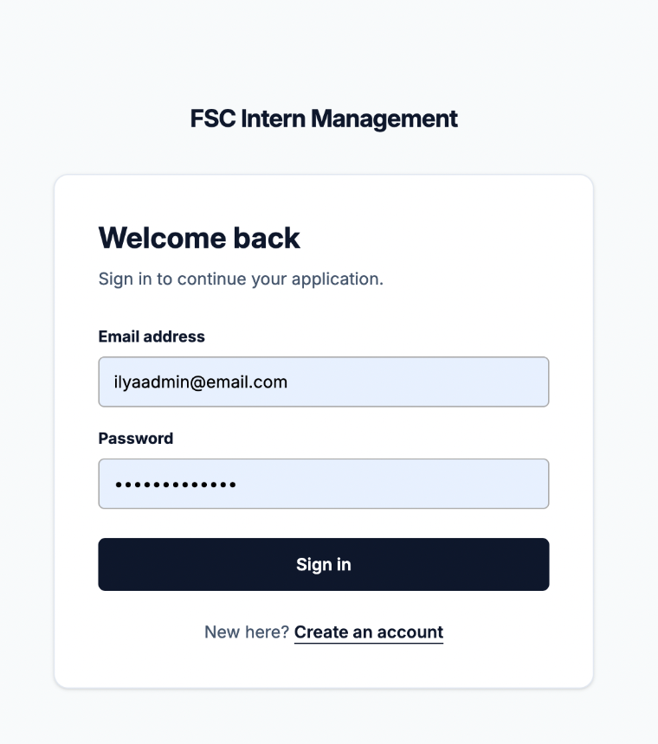
Figure 1. Admin sign-in page used for the final authentication check.

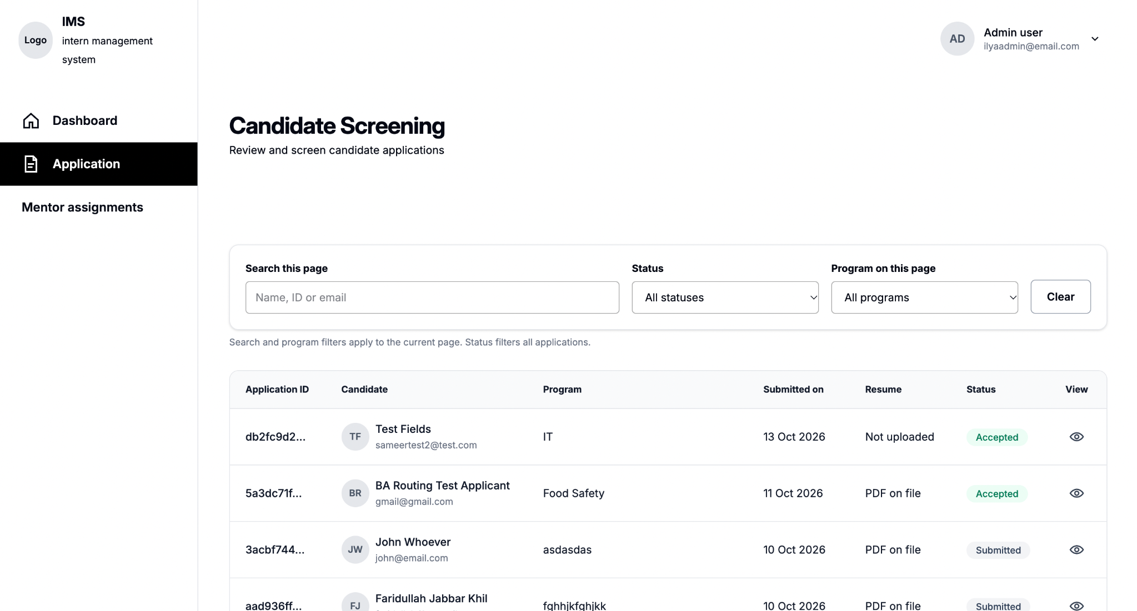
Figure 2. Candidate Screening loaded after successful Admin sign-in, confirming the Admin Portal route and candidate list.

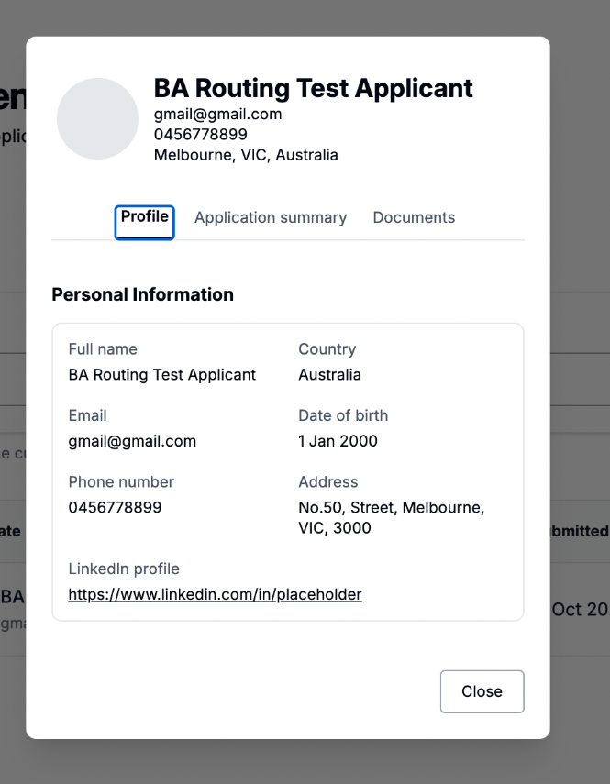
Figure 3. Candidate profile showing the stored Country, Date of Birth and LinkedIn profile fields.

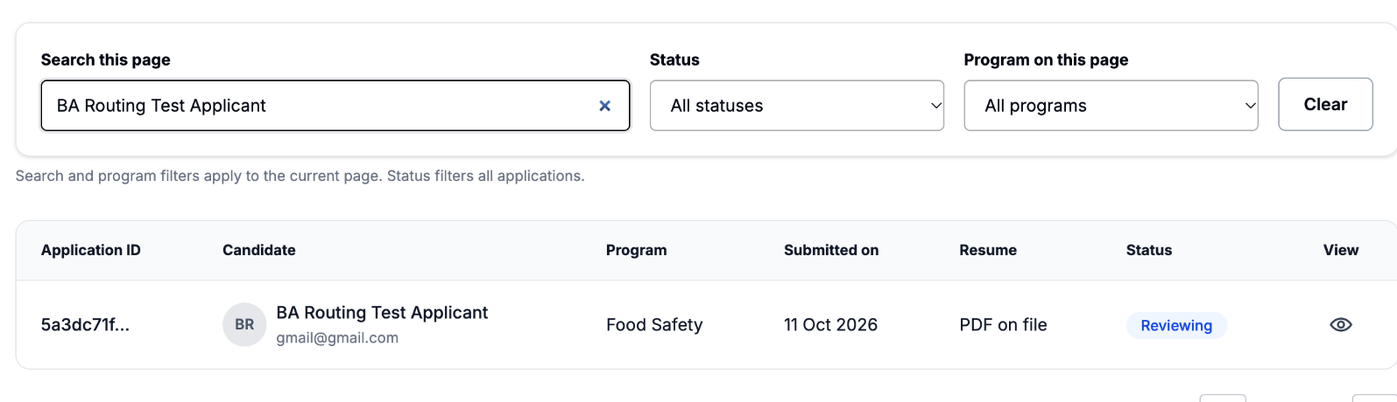
Figure 4. Search/filter evidence: “BA Routing Test Applicant” returned the expected candidate.

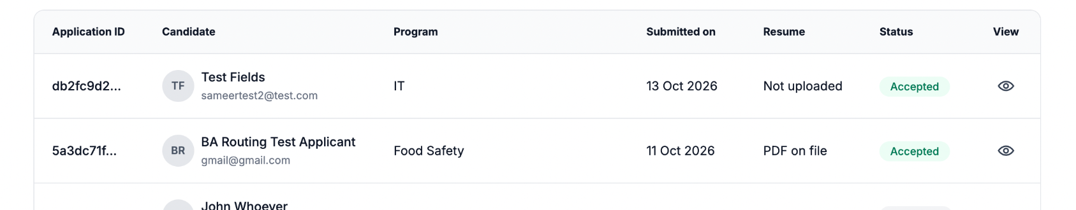
Figure 5. Status persistence evidence: the controlled test candidate still shows Accepted after refresh.

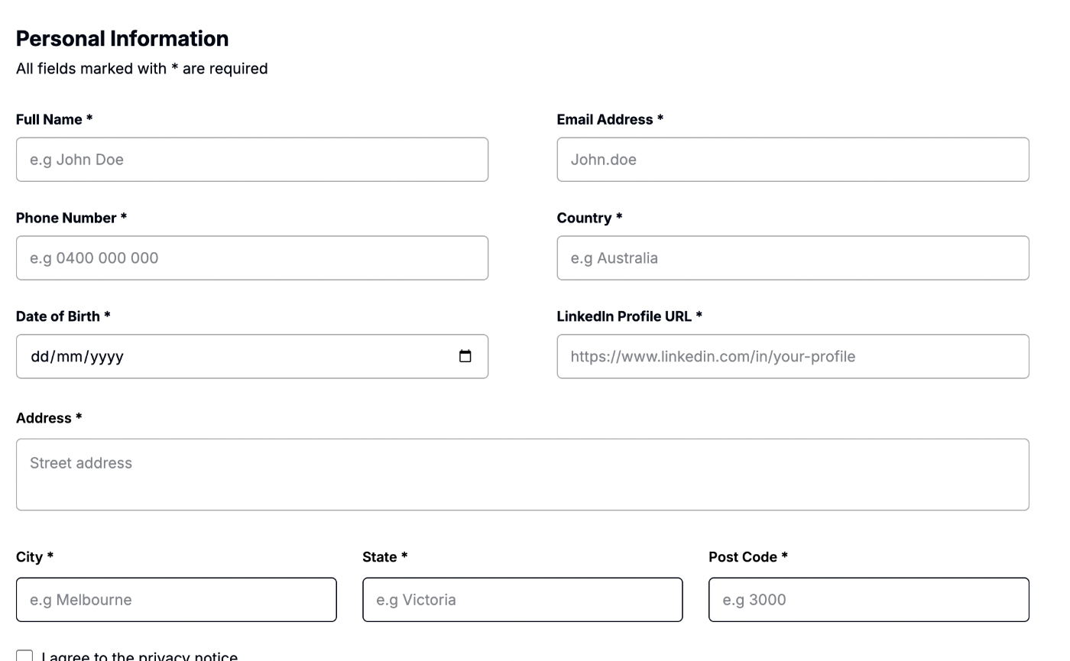
Figure 6. Public application Personal Information step showing Country, Date of Birth and LinkedIn Profile URL as required fields.

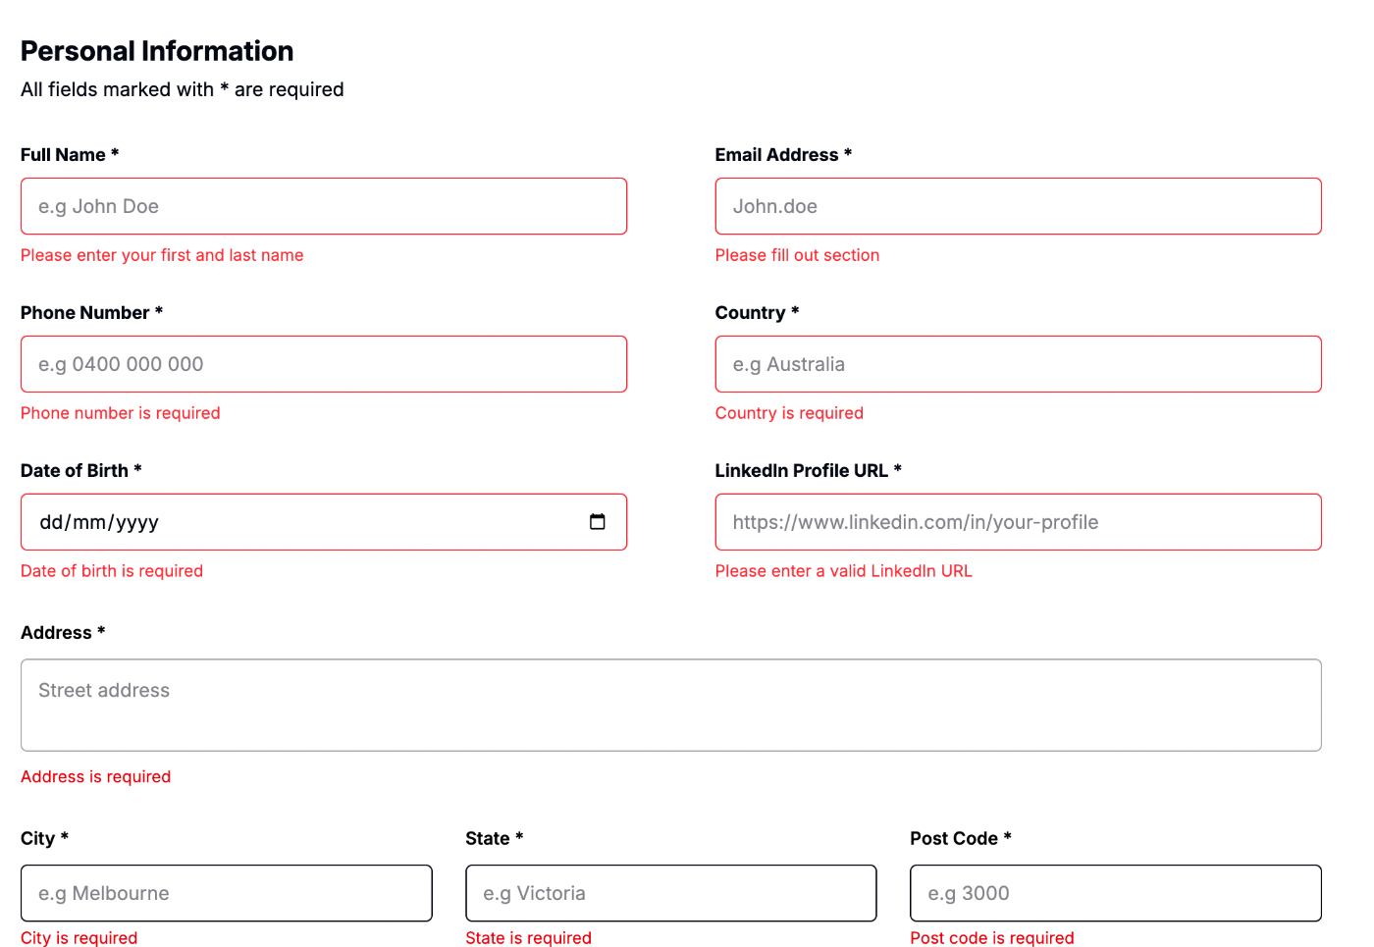
Figure 7. Required-field validation messages displayed after attempting to continue with mandatory fields blank.

8. Final Handover Status
Final regression outcome: PASS
High-priority blocking defects: None found during the final BA regression run.
Known non-blocking item: Mobile layout remains a presentation-polish limitation noted previously; it does not block the desktop showcase flow.
Handover status: Ready for final submission and client showcase.

