End-to-End Regression Test Log
Final BA regression test before client showcase

Team | Team 39 - Intern and Management System - Team A | Role | Business Analyst - Abdifatah Hashi
Sprint | Sprint 3 Week 3 | Period | 19-25 October 2026

1. Objective
Execute a final regression check across the core recruitment workflow so that recent frontend, backend, validation, search and routing changes have not broken previously working functionality.

2. Core Regression Path
Public Application -> Admin Login -> Admin Portal Redirection -> Candidate Status Change to Accepted -> Search / Filtering

3. Final Test Execution Matrix
ID | Test | Action | Expected result | Final result
R01 | Public application loads | Open the public application page. | Form loads and required fields are visible. | PASS
R02 | Required-field validation | Leave a mandatory field blank and continue/submit. | Clear validation message appears and submission is prevented. | PASS
R03 | Client-requested fields | Check Country, Date of Birth and LinkedIn URL. | All three fields appear and accept valid input. | PASS
R04 | Admin login | Sign in using an authorised Admin account. | Authentication succeeds. | PASS
R05 | Admin redirect | Complete Admin sign-in. | User is automatically sent to the Admin Portal. | PASS
R06 | Candidate screening | Open the applications/candidate screening page. | Candidate records load without a blocking error. | PASS
R07 | Status change | Change a test candidate from its current review state to Accepted and confirm. | New Accepted state is saved and remains visible after refresh. | PASS
R08 | Search / filtering | Search by a known candidate name, confirm the matching result, then return to the full candidate list. | Correct matching candidate appears and the normal list can be restored without a blocking error. | PASS
R09 | Descoped features | Confirm the core workflow does not depend on the descoped email/NDA functionality. | The recruitment path works without an email/NDA step or blocker. | PASS (DESCOPED)
R10 | Regression blocker check | Complete the final core path across public application, Admin access, screening, status update and search. | No high-priority blocker prevents the final demo/handover journey. | PASS

4. Previously Verified Baseline
These items passed earlier UAT and provide the baseline for the final regression run:
- Admin role authentication and protected-route behaviour.
- Admin redirection to the Admin Portal.
- Candidate status-change workflow to Accepted.
- Updated client-requested fields and required-field validation.
- Server-side search/filtering tested by the development team.

5. Defect Log
Defect | Severity | Status | Notes
No high-priority defect found | - | Closed | Final BA regression completed without a reproducible blocking defect. Existing mobile-layout polish limitation remains non-blocking.

6. Final Sign-off
Final regression outcome: PASS
The deployed system completed the tested core regression path without a high-priority blocking defect. The controlled candidate status change persisted after refresh, and the main search/filter path remained operational.

7. Final Test Record
Date/time tested | 25 October 2026, approximately 3:33-3:52 pm AEDT
Environment | Current deployed Team 39 Intern Management System frontend
Tester | Abdifatah Hashi - Business Analyst
Overall result | PASS
High-priority blocker found | No
Known non-blocking issue | Mobile layout polish limitation previously noted; desktop showcase path is functional
Developer/PM notified | Not required for a blocker; no high-priority defect was found

8. Evidence Mapping
Test ID | Result | Evidence | Final observation
R01 | PASS | Figure 1 | Public application Personal Information step loaded.
R02 | PASS | Figure 2 | Required-field errors were displayed and progression was blocked.
R03 | PASS | Figures 1 and 5 | Country, Date of Birth and LinkedIn fields are present; stored values are visible in the candidate profile.
R04-R06 | PASS | Figures 3 and 4 | Authorised Admin sign-in succeeded and Candidate Screening loaded.
R07 | PASS | Figure 7 | BA Routing Test Applicant remained Accepted after refresh.
R08 | PASS | Figure 6 | Searching by the known candidate name returned the expected record.
R09 | PASS (DESCOPED) | Core-flow screenshots | The tested recruitment path did not require an email/NDA step and was not blocked by descoped functionality.
R10 | PASS | Figures 1-7 | No high-priority blocker prevented completion of the final tested core path.

9. Embedded Evidence
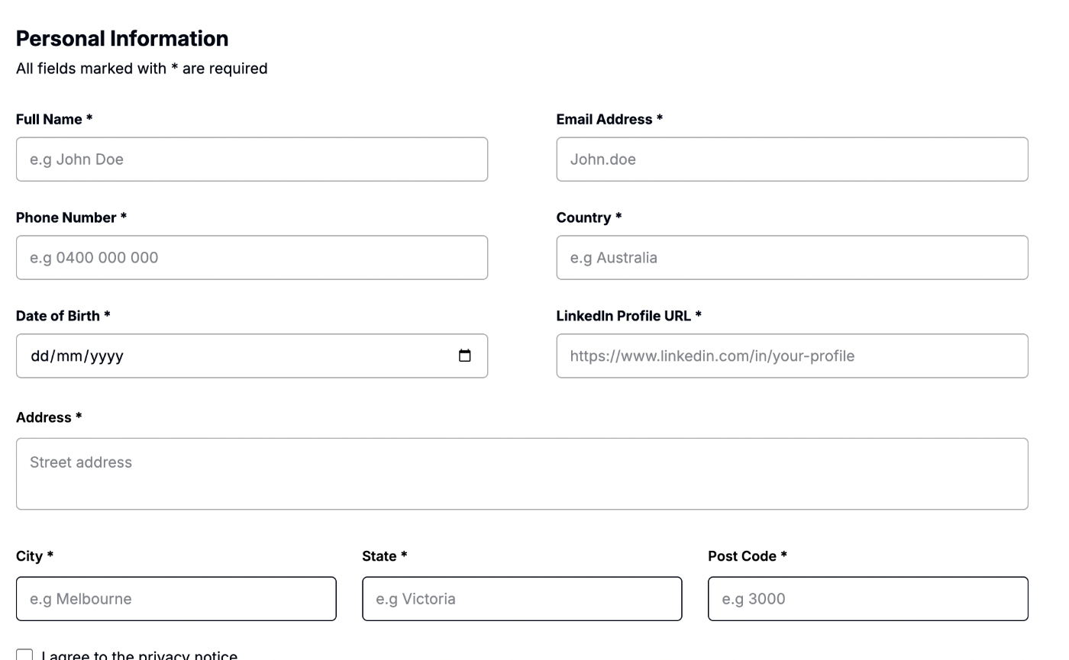
Figure 1. Public application with required Personal Information fields visible.

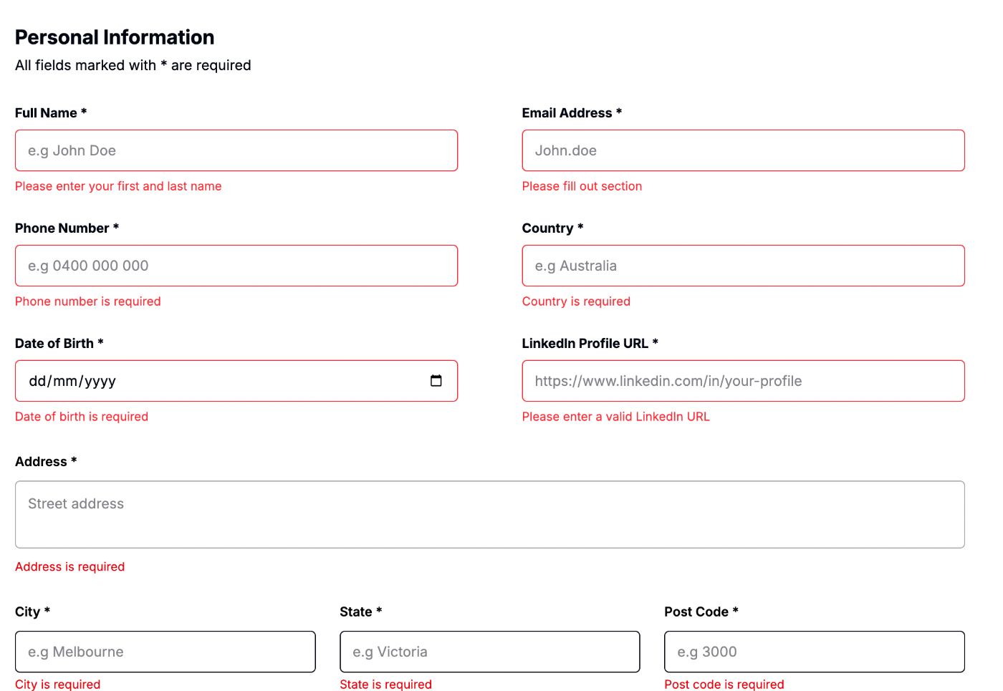
Figure 2. Required-field validation messages after attempting to continue with mandatory fields blank.

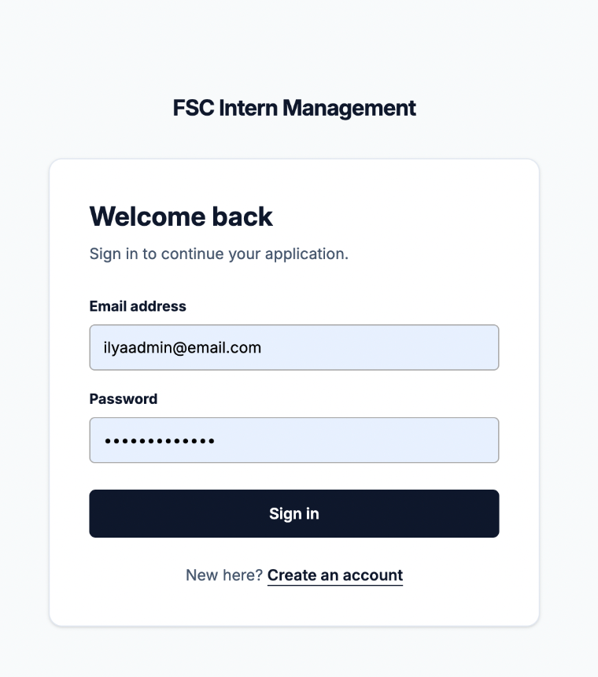
Figure 3. Admin sign-in page used in the final authentication check.

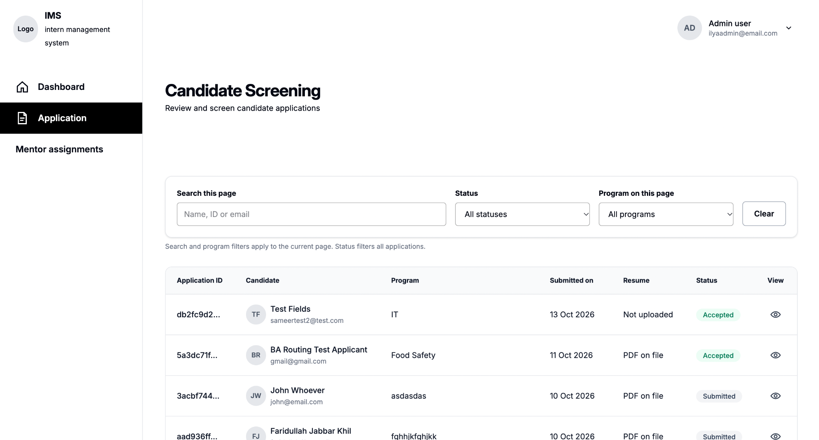
Figure 4. Candidate Screening loaded after successful Admin sign-in.

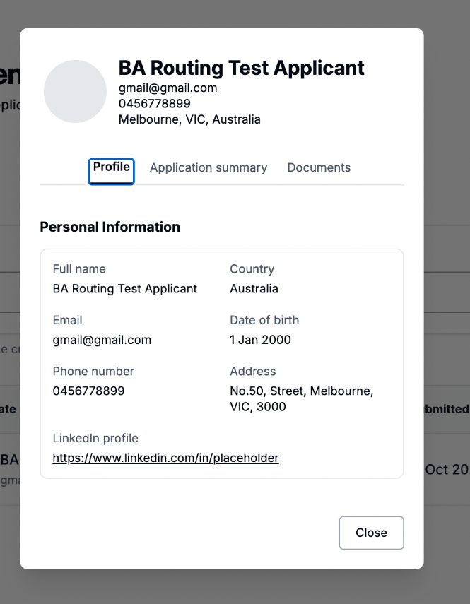
Figure 5. Stored Country, Date of Birth and LinkedIn profile values displayed in the candidate record.

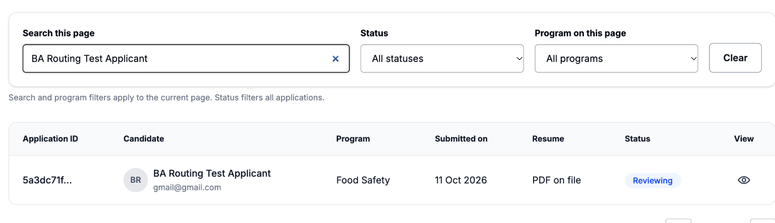
Figure 6. Search returned the expected “BA Routing Test Applicant” record.

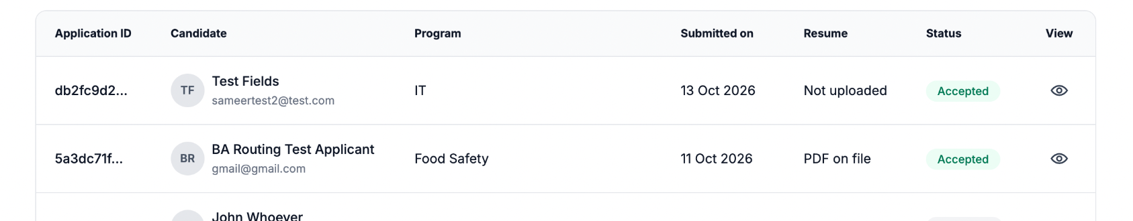
Figure 7. The controlled candidate remained Accepted after refresh, confirming persistence.

10. Handover Note
The final BA regression test is complete. The regression outcome is PASS, no high-priority blocking defect was found, and the evidence in this log can be included in the final handover package and Planner task completion record.

