Intern Workspace Entry & Navigation Consistency — Final UX Handoff
Sprint 3 — Team 40 / Team B (Intern Management System for Social Enterprise Workforce Development)
Prepared by: Faridullah Jabbar Khil (s4020393) — UX
Task: [ONBOARDING UX REFINEMENT] – Intern Workspace Entry & Navigation Consistency · Sprint 3 · due 18/10/2026
Review type: post-implementation review of the promoted Intern’s first-use experience: live Intern workspace (two Intern accounts, 18 October 2026) and DEV’s code (PRs #21, #22 and #25)
Inputs: PM task description; earlier UX reviews “Team A/B Role Entry & Workspace”, “Integrated Workspace Navigation & Role-State Polish” and “Applicant-to-Intern Onboarding”

1. Purpose & Scope
PM task description
“Review the promoted Intern’s first-use experience across the integrated Team B workspace. Check that page entry, role-state presentation, navigation, account menu and existing Task/Progress interfaces remain consistent after onboarding. Consolidate the final UX findings and provide a focused handoff for any required corrections before final acceptance.”

This is the last of the onboarding reviews. It checks the Intern workspace as a promoted Intern would meet it, compares the four Intern pages with each other, and pulls the open UX items from the three reviews into one handoff (Section 5). The review does not add business functionality.
What this review is and is not
Seen on screen: the live Intern Workspace, with two Intern accounts, and a My Tasks screen captured on 10 October. Checked in code only: Task Detail, Weekly Progress and the account menu, because the live site does not yet show the account menu. The empty first-arrival screen was not captured, because both Intern accounts already have tasks. Applicant screens were not reviewed.

2. Summary
Already consistent — no change needed
The same header, name display, tab labels, status wording and priority wording run through all four Intern pages. Sign-in lands every promoted Intern in the Intern workspace, and wrong-role access is handled by DEV’s access screen.

Result — no new corrections required
This review adds nothing new that needs correcting in the Intern workspace. Two cosmetic observations are noted as polish only (Section 6). The two items still open from the earlier onboarding review were already handed to DEV in that review and are listed in Section 5 for completeness.

3. First-Use Review

3.1 Workspace landing
A promoted Intern lands on /intern/workspace, titled Intern Workspace, with seven summary counters and the My Tasks and Weekly Progress tiles (Fig. 1, Fig. 2). The layout is clear and each tile leads to the right page. For a brand-new Intern with no tasks, the missing welcome guidance is already recorded in the onboarding review.

3.2 Account and role presentation
The header shows the Intern’s name, and the same header appears on every Intern page. DEV’s PR #22 turns the name and avatar into an account menu with Sign out; on the live site the header still shows an empty avatar and a plain name (Fig. 1, Fig. 2), so that menu still needs deploying. The role is shown through the page titles and navigation rather than a label, which is enough for this sprint.

3.3 Task and Progress navigation
Navigation is the same on all four pages: Workspace | My Tasks | Weekly Progress. Task Detail keeps My Tasks highlighted and has a “← My Tasks” button back to the list, which works well. The small differences in style between pages are noted as polish in Section 6.
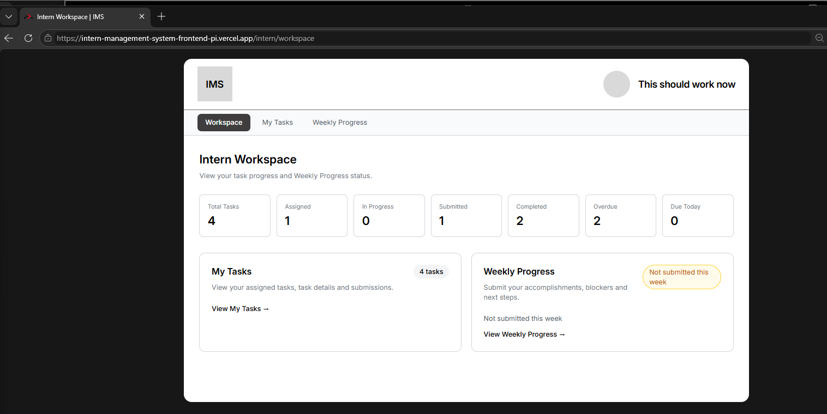
Fig. 1 — Live Intern workspace
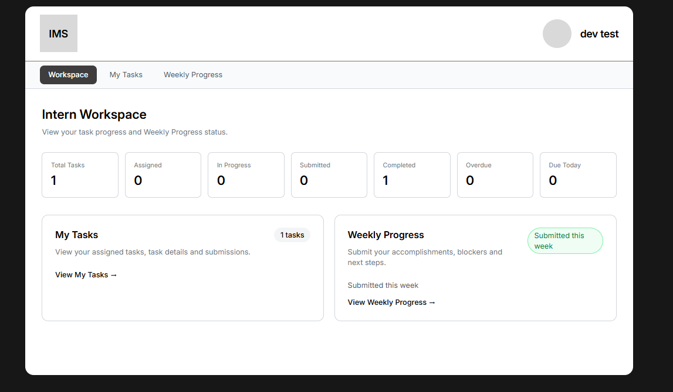
Fig. 2 — Second Intern account: “1 tasks” on the My Tasks tile

4. Consistency with the Existing UX
Element | Result | Detail
Header and name | Consistent | All four Intern pages use the same header with the person’s name and the same account menu component.
Tab labels and order | Consistent | Workspace | My Tasks | Weekly Progress on every page. My Tasks stays highlighted on Task Detail, which is correct.
Page title style | Differs | Workspace, Task Detail and Weekly Progress use a large bold title; My Tasks uses a smaller, lighter one (Fig. 3).
Tab bar style | Differs | Task Detail uses a different tab shape, colour and spacing from the other three pages.
Status and priority wording | Consistent | Assigned, In Progress, Submitted, Completed and Low, Medium, High are used the same way on the workspace, task list and task detail.
Empty and loading wording | Consistent | Each page has its own plain message, for example “You currently have no assigned tasks.”

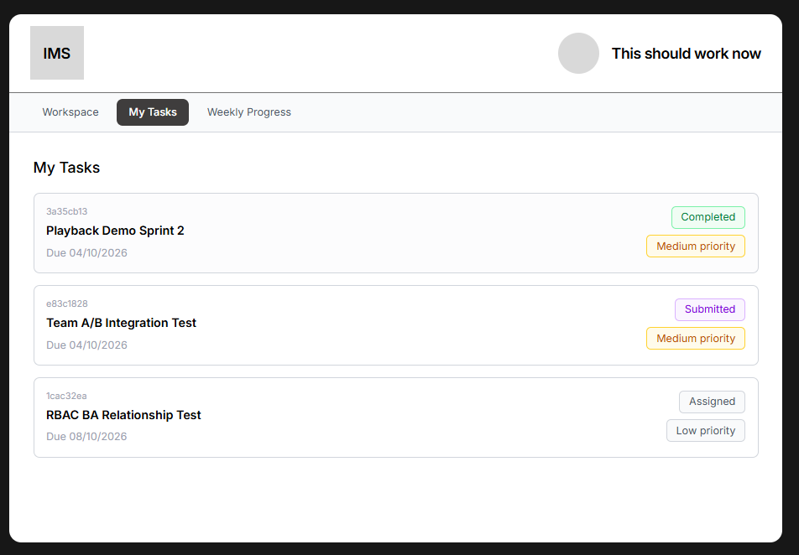
Fig. 3 — My Tasks (captured 10 October): smaller, lighter title than Fig. 1

5. Result and Final UX Handoff
The review found no new correction to add. The only items still open are the two from the onboarding review, which were already handed to DEV there and are repeated here so the final handoff is in one place.
Open item | Priority | Source | Status
Welcome notice for a newly accepted Intern with no tasks | High | Onboarding review, finding 01 | Already with DEV
Sign out account menu on the live site | High | Onboarding review, finding 02 | Built in PR #22, to be deployed

6. Open Items and Deferred Observations

Open items needing an owner
- Final check on the deployed build against the two items above. Owner: BA (Shakthijhaa).
- Acceptance email: whether an email tells a newly accepted Applicant to sign in with the same email and password. Owner: PM with Team A.

Deferred — polish only, no action requested this sprint
Noted during the review. No BA criterion depends on them.
- Page frame: the My Tasks title is smaller and lighter than the titles on the other Intern pages (Fig. 3 against Fig. 1), and the Task Detail tab bar has a slightly different shape and spacing from the other three.
- Workspace wording: the My Tasks tile reads “1 tasks” when there is one task (Fig. 2), and the Weekly Progress tile states the same status twice.

7. Handoff to DEV
For DEV (Chan) and BA
No new action comes from this review. The two items in Section 5 stay with DEV as already recorded in the onboarding review. Keep the shared authentication foundation and existing Team B Core MVP behaviour unchanged. BA validates the deployed build before final acceptance.

Files: this document; the three earlier UX reviews listed above.

