On mobile the top navigation of the application gets squished together.
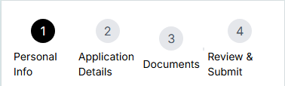
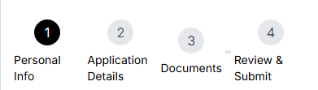
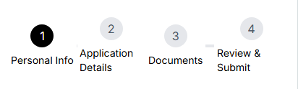
Add the ability to remove an uploaded file in case a user needs to change the file uploaded.
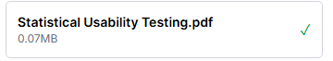
Contents of page all get cut off and navigation doesn’t collapse into a burger menu
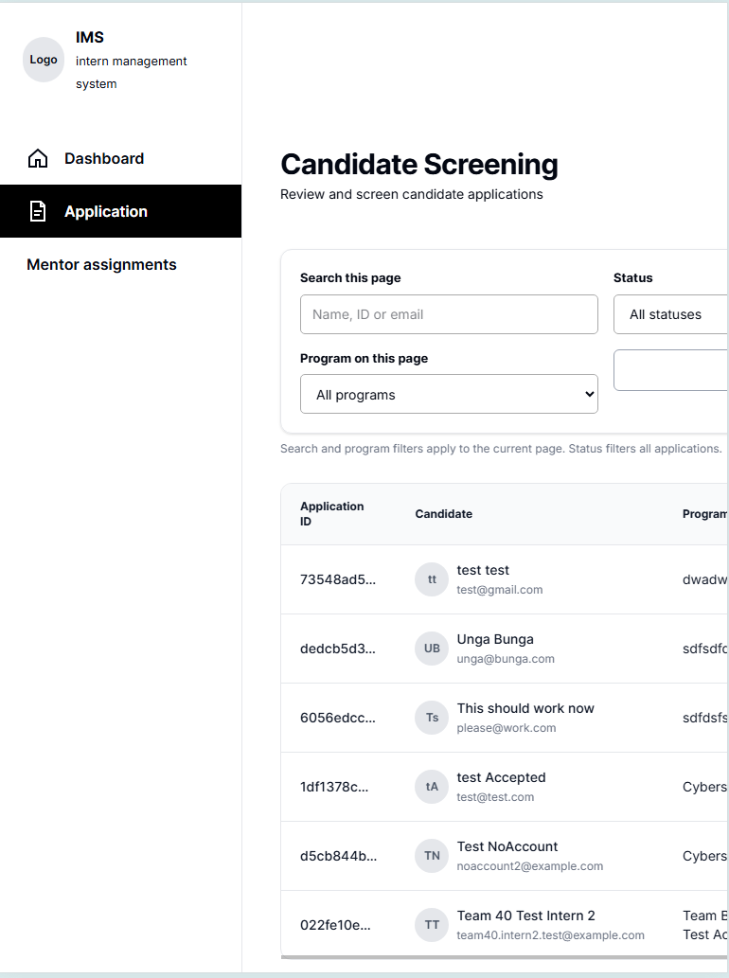
Issues persist even in landscape view
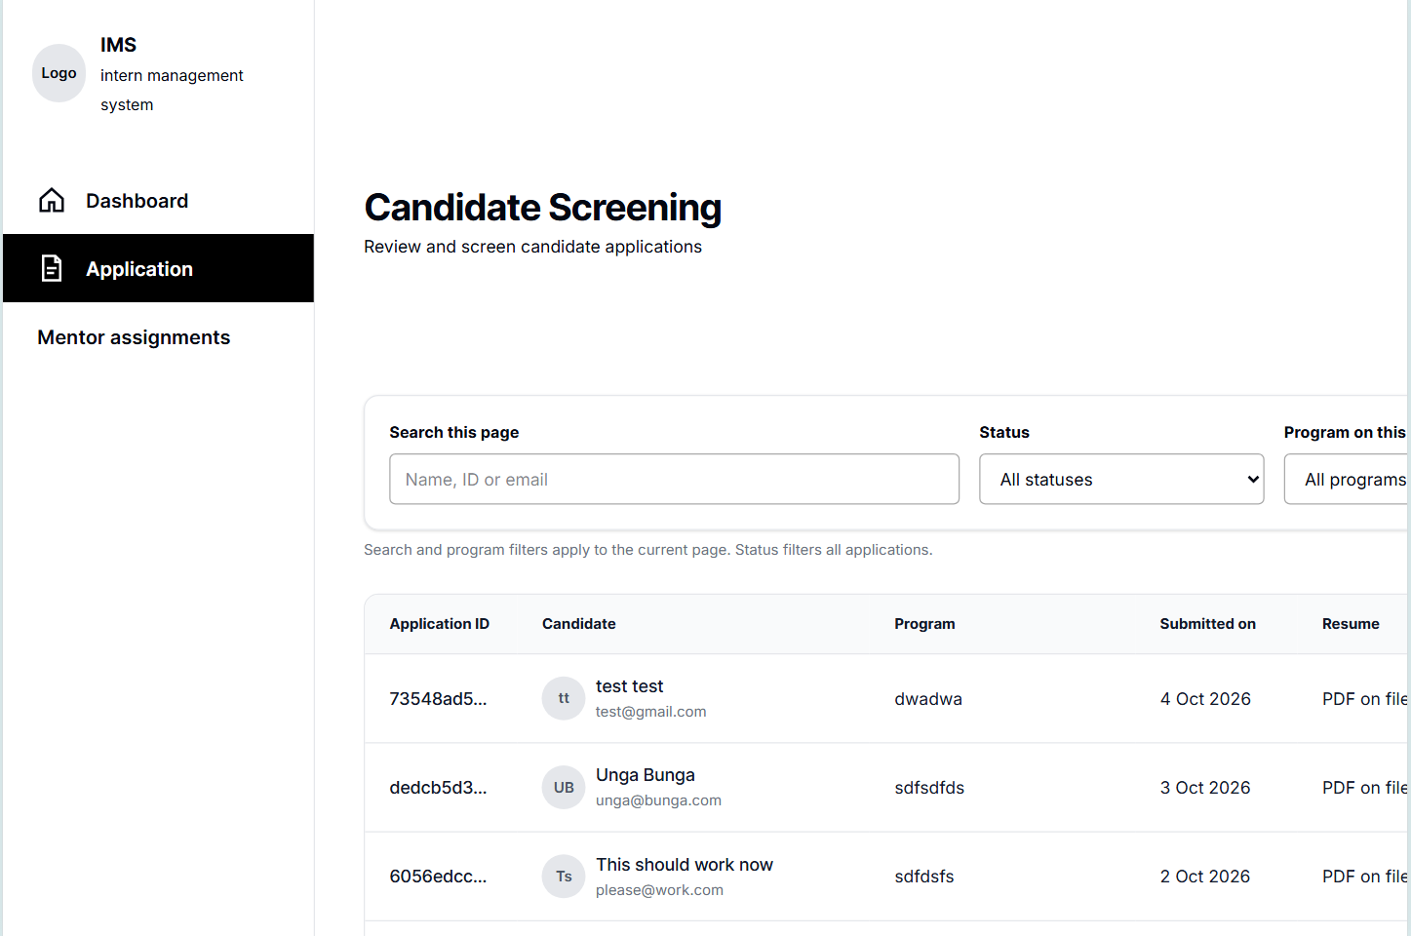

Modals and navigations work but is hard to navigate around due to layout errors caused by tablet view.
