Core MVP User Flow Definition
Evidence of work
Team: Team 40 / Team B — Intern Management System
Task: [UX DESIGN] — Core MVP User Flow Definition
UX Designer: Faridullah Jabbar Khil (S4020393)
Sprint: Sprint 1 — Design & Bootstrap

1. Scope
This document records the role-specific user flows for the four required checklist items, plus how they connect into one end-to-end Core MVP workflow. The wireframe screens shown in Section 3 are the visual evidence for each step below.

2. Flows

2.1 Mentor assigns task — FR-02 / AC-01
- Mentor opens Assign Task
- Role check — not Mentor? Deny, show restricted-action message (EC-03 / AC-01.3)
- Mentor selects an intern from the existing Mentor–Intern relationship and enters task details
- Submit → task saved and linked to the intern (AC-01.1) → confirmation shown
Evidence: Assign task screen (Figure 1).

2.2 Intern views task — FR-04 / AC-02
- Intern opens My Tasks
- Role check — not Intern? Deny (AC-02.3)
- Does the intern have an assigned task? No → no-assignment state (EC-01 / AC-02.2). Yes → task and status displayed (AC-02.1)
Evidence: My tasks, and My tasks — no task assigned (Figure 1).

2.3 Intern submits weekly progress — FR-05 / FR-06 / AC-03
- Intern opens Submit Progress on their assigned task
- Intern completes Accomplishments, Blockers (optional), Next steps
- Submit → required fields complete? No → validation error, nothing saved (EC-04 / AC-03.3). Yes → progress saved and linked to intern + task (AC-03.1) → confirmation shown
Evidence: Submit weekly progress screen (Figure 1).

2.4 Mentor reviews progress — FR-07 / AC-04
- Mentor opens Review Progress, selects an intern
- Role check — not Mentor? Deny (AC-04.3)
- Has that intern submitted progress? No → no-submission state (EC-02 / AC-04.2). Yes → progress displayed, read-only (AC-04.1)
Evidence: Review progress, and Review progress — no submission (Figure 1).

3. Connected end-to-end workflow
The four flows chain in sequence — Mentor assigns task → Intern views task → Intern submits progress → Mentor reviews progress — matching the Core MVP workflow defined in the BA document (Section 3). The wireframe set uses a shared numbered step-rail across all screens so each one's position in the sequence is visible on the screen itself, not only in this document.
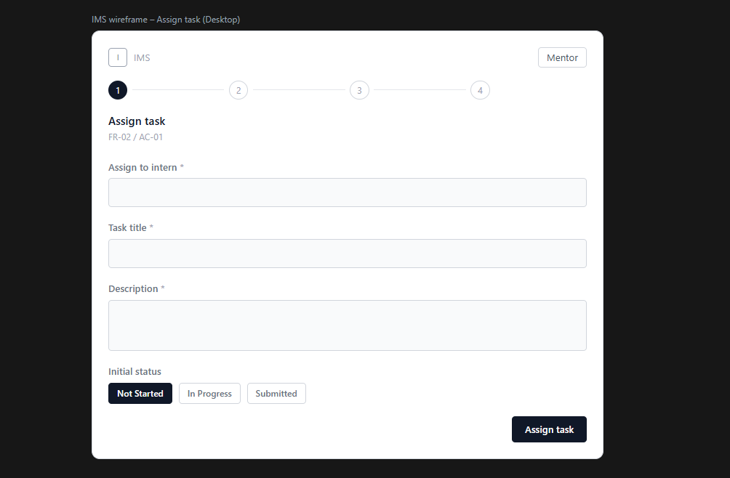
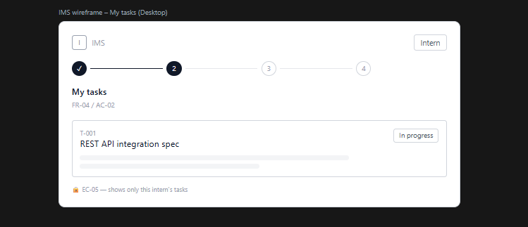
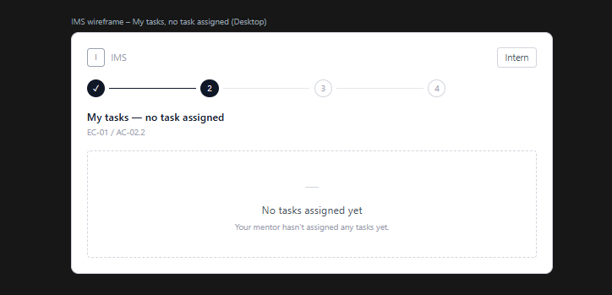
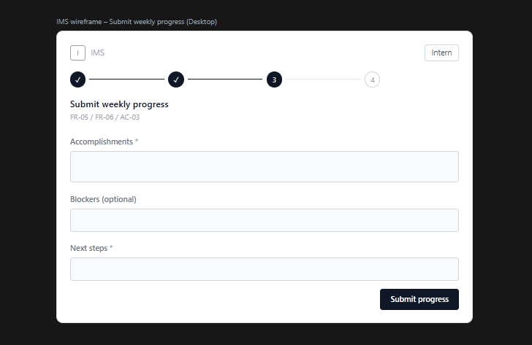
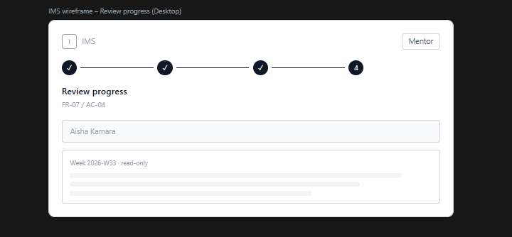
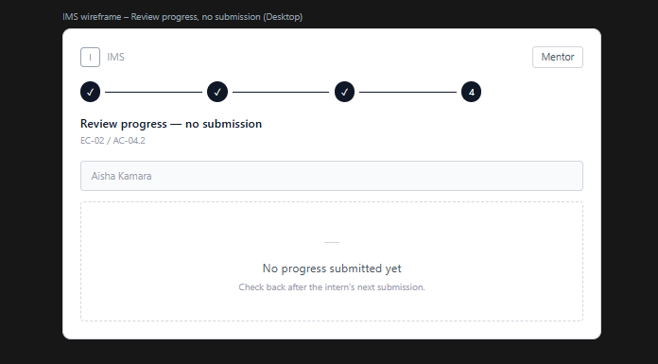
Figure 1 — Wireframe evidence for all four flows (Figma Make render)
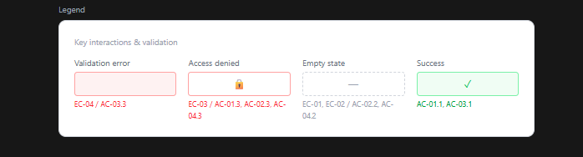
Figure 2 — Shared key-states legend, prior to the Revision 2 correction described in Section 5

