Team A/B Role Entry & Workspace — UX Review
Sprint 3 Week 1 — Team 40 / Team B (Intern Management System for Social Enterprise Workforce Development)
Prepared by: Faridullah Jabbar Khil (s4020393) — UX
Task: [UX INTEGRATION] – Applicant, Intern & Mentor Entry-Flow Review · Sprint 3 Week 1 · due 10/10/2026
Review type: based on the deployed build as at 10 October 2026 (Intern and Mentor test accounts) and the existing prototype (App.tsx v5); recommendations are not yet implemented
Inputs: PM alignment document “Team A/B Role Routing & Workspace Alignment” (9 October 2026); BA “Role-Based Routing Requirements & Acceptance Criteria” (Sprint 3 Week 1)

1. Purpose & Scope
PM handoff note for this task
“UX (Farid) — Review the Applicant, Intern and Mentor entry flows based on the confirmed Team A/B routing approach. Identify any navigation, role-state or workspace inconsistencies and provide UX recommendations for the integrated user experience.”

This review checks the confirmed routing contract (Applicant → Team A workspace, Intern → Team B Intern workspace, Mentor → Team B Mentor workspace, all from shared_accounts.role) and the BA rules and acceptance criteria built on it (RR-01 to RR-10, AR-01 to AR-08, AC-RR01 to AC-RR12). Evidence comes from the deployed site, signed in once as an Intern and once as a Mentor, with the Core MVP prototype (App.tsx v5) as the design reference. Every recommendation changes behaviour, wording or presentation of data that already exists; none adds business functionality.
What this review is and is not
The UX recommendations in this document are not yet implemented, so each finding carries a check to repeat once DEV has changed the build. Only the two test accounts above were used, so Applicant sign-in was not tested; Team A’s Applicant screens were not reviewed beyond the point where they appear after login.

2. Summary
Already consistent — no change needed
Same header shell as Team A (logo box, avatar and divider). The header shows the signed-in name, or the role when no name is set. Each role sees its own tabs. Task status and priority labels are consistent. The API refuses wrong-role data correctly.

Needs correction — 2 items, both High
A user who opens the other role’s URL sees that role’s workspace with an error on it instead of an access screen (01), and an Intern login lands on the applicant form instead of the Intern workspace (02). Full table in Section 4; how each relates to the BA criteria is in Section 5. Smaller observations are in Section 6.

Coverage of the PM handoff note
- Review the Applicant, Intern and Mentor entry flows against the confirmed routing approach → Section 3 and findings 01–02.
- Identify navigation, role-state or workspace inconsistencies → Section 4, findings 01–02.
- Provide UX recommendations for the integrated experience → Sections 4 and 7.

3. Entry Flow Review

3.1 Applicant
Applicants land in Team A’s workspace, which Team A owns (BA RR-02, AC-RR01). The UX requirements at the seam are a shared header shell (already aligned) and that no Team B screen is visible to an Applicant, which findings 01–02 cover. Fig. 1 shows the Team A applicant form that the Intern account wrongly received (finding 02).

3.2 Intern
Expected entry is the Intern workspace, with the tabs Workspace | My Tasks | Weekly Progress. Once inside, navigation and status labels are consistent and need no correction. The problem is getting there: the Intern test account was sent to the applicant form first (finding 02).

3.3 Mentor
The Mentor test account lands on the Assign Task form at /mentor/tasks/assign, with the tabs Assign Task | Review Progress (Fig. 2). This works as intended and the BA criteria accept any Mentor-owned destination (AC-RR06).
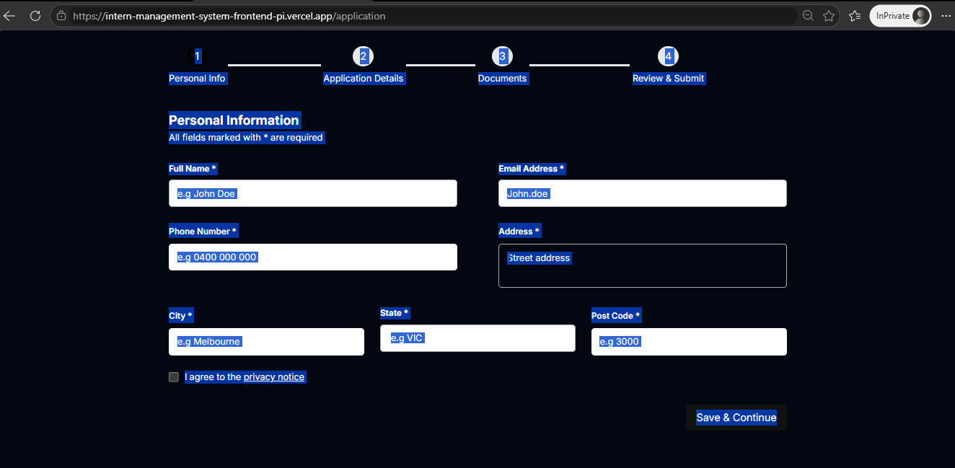
Fig. 1 — Intern login lands on /application (finding 02)
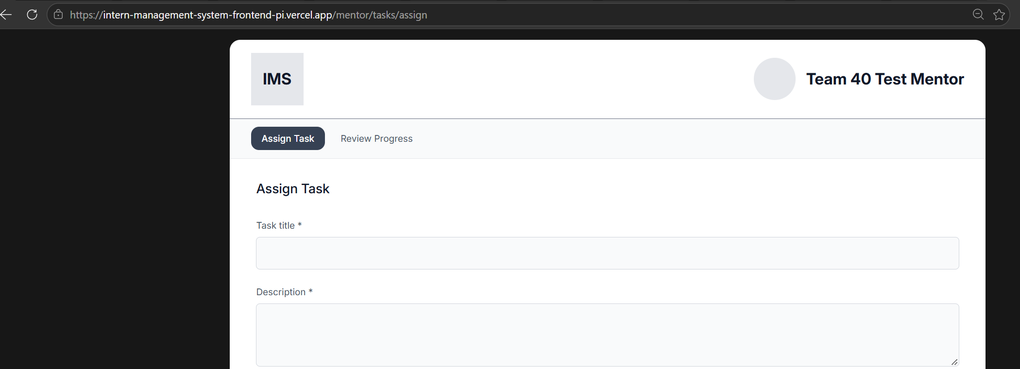
Fig. 2 — Mentor login lands in the Mentor workspace

4. Findings & Prioritised Correction Handoff
Two corrections, in the order DEV should apply them. Each Check names the BA criteria it supports; Section 5 shows how the two documents relate.
# | Priority | Finding & evidence | Correction for DEV | Check (BA / UX)
01 | High | Wrong-role URL shows the other role’s workspace, with no access screen  On the deployed build, a Mentor who opens an Intern URL (/intern/weekly-progress) sees the full Intern workspace: Intern header, Workspace | My Tasks | Weekly Progress tabs and the whole form, with only a red line “The signed-in account is not an Intern.” (Fig. 3). An Intern who opens /mentor/tasks/assign sees the Mentor workspace with a half-broken form (“No Intern accounts available”, “Mentor account unavailable”, a greyed button) and “Insufficient Permissions” (Fig. 4). The API refuses correctly, but the screen does not. There is also no defined screen for an account whose role cannot be resolved (BA RR-09, IC-02). | Build one reusable safe access screen with no role navigation and no form. Wrong role: “This area is for Mentors. You’re signed in as an Intern.” with a primary button “Go to my workspace” (for an Applicant, the Team A workspace). Unknown role: “We couldn’t find a workspace for your account” with Sign out. Never default to Applicant, Intern or Mentor. The frontend guard is navigation only; the API denial stays. | Mentor opens /intern/weekly-progress and Intern opens /mentor/tasks/assign: each sees only the access screen, and the button lands in their own workspace. Account with a missing or unexpected role sees only the neutral screen. API still denies the data. BA: AR-06, AR-08, RR-09, IC-02, AC-RR02, AC-RR07, AC-RR10, AC-RR11.
02 | High | Intern login lands on the applicant form  Logging in with the Intern test account landed on /application, the Team A applicant form (Personal Information, step 1 of 4), not the Intern workspace (Fig. 1). This matches Ilya’s report that login redirects to the previous URL or the application page (PM document §3). It breaks the routing contract (shared_accounts.role decides the workspace; BA RR-06, RR-08). | Resolve the role first, then route: Intern to the Intern workspace, Mentor to the Mentor workspace, Applicant to Team A. Honour a previously requested URL only if it belongs to the resolved role’s workspace; otherwise use that role’s home. An Intern is never sent to an Applicant page. | Intern signs in and lands in the Intern workspace; Mentor lands in the Mentor workspace (Fig. 2 shows the expected result). A stale /application URL does not override the role. BA: AR-03, AR-07, AC-RR05, AC-RR09.

Supporting evidence for finding 01
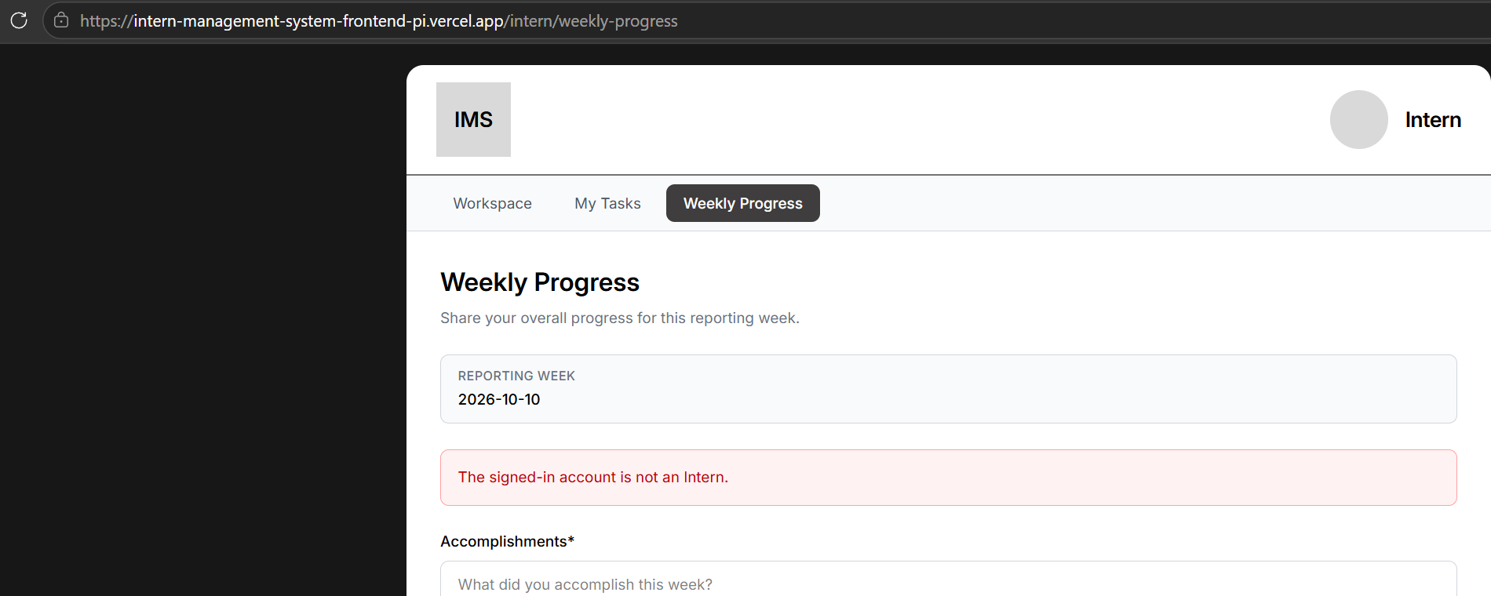
Fig. 3 — Mentor on /intern/weekly-progress: Intern workspace with an error line
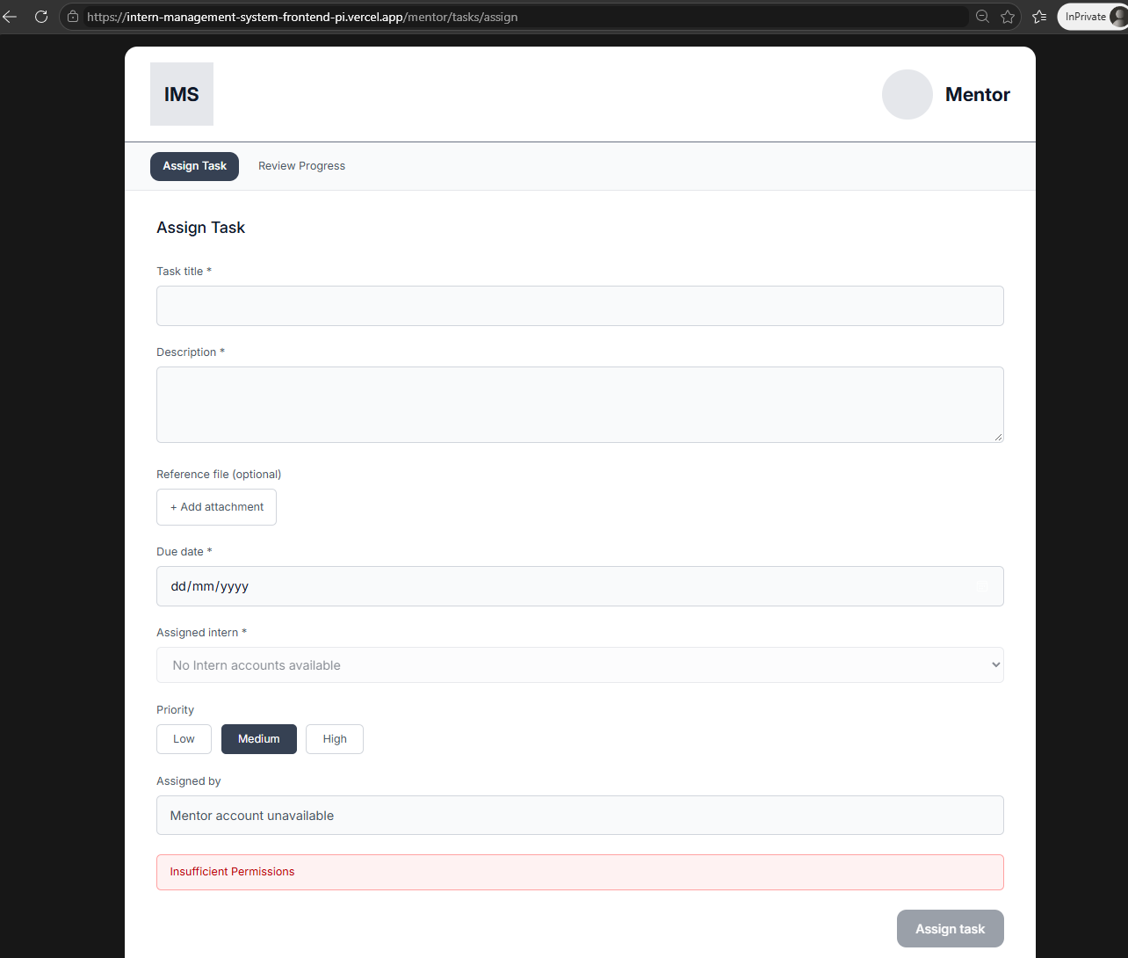
Fig. 4 — Intern on /mentor/tasks/assign: Mentor form with “Insufficient Permissions”

5. Alignment with the BA Acceptance Criteria
The BA baseline was read alongside this review and the two do not contradict each other. Finding 02 enforces BA rules at the interface; finding 01 enforces AR-06 and also makes the decisions the BA document leaves to UX (the wrong-role response and the unknown-role screen).
UX finding | BA reference | How the two relate
01 Safe access screen | AR-06, AR-08, RR-09, IC-02, AC-RR02, AC-RR07, AC-RR10, AC-RR11 | Enforces AR-06 and AC-RR07 at the interface, and makes the decisions the BA document leaves to DEV/UX (the wrong-role response and the unknown-role screen) as one screen.
02 Landing after login | RR-06, RR-08, AR-03, AR-07, AC-RR05, AC-RR09 | Enforces the BA rules; the same behaviour described in interface terms.

The remaining BA criteria are routing, API and data rules (for example AC-RR01, AC-RR04, AC-RR11 and AC-RR12) that need no interface change from UX.

6. Open Items and Deferred Observations

Open items needing an owner
- Exact destination paths — the BA accepts on the correct role-owned destination, not a URL string (IC-01). Only /mentor/tasks/assign and /intern/weekly-progress are confirmed; the Intern home and Applicant home paths are not. Owner: DEV with Ilya.
- Role refresh when an account is promoted between sessions. The BA leaves token and session mechanics to DEV (IC-04); the UX recommendation is to re-resolve the role at every sign-in (finding 02). Owner: DEV with Ilya.
- Review workflow for changes to the shared AuthPage.tsx. Owner: PM with Team A.
- Map the Check column to AC-RR01 to AC-RR12. The check for finding 01 adds interface-level evidence the BA criteria do not spell out. Owner: BA (Shakthijhaa).

Deferred — no action requested this sprint
Noted during the review. None is needed for final Core MVP integration, and no BA criterion depends on them.
- Switch role: the prototype’s account menu has a “Switch role” control. A role switch was not visible on the deployed header, but the account menu was not opened. It must not be carried into the integrated build.
- Sign out: worth a one-minute check that the shared header provides it; not part of this handoff.
- First-arrival state: a newly promoted Intern with no tasks would see an empty-looking Workspace; polish only.
- Display name: some test accounts show the role (“Intern”) in the header instead of a name; likely test data.

7. Handoff to DEV
For DEV (Chan)
Apply findings 01 and 02 in order. The scope is deliberately small: 01 is one reusable screen with two messages, and 02 is a condition on the existing post-login redirect. Finding 02, and the unknown-role case of 01, sit in the existing AuthPage.tsx login flow, so coordinate them with Ilya. Use the BA criteria (AC-RR01 to AC-RR12) alongside this document; where they differ in detail, the BA business rules stand and this review adds interface decisions. Keep the shared authentication foundation and existing Team B Core MVP behaviour unchanged. BA validates the result against the deployed build.

Files: this document; prototype App.tsx v5 (unchanged by this review).

