Mentor Task Assignment — Developer Handoff
UX implementation reference for Sprint 2
Team: Team 40B — Intern Management System
Task: [UX IMPLEMENTATION] — Mentor Task Assignment Developer Handoff
UX Designer: Faridullah Jabbar Khil
Sprint: Sprint 2
Sources: Approved Sprint 1 prototype (core-mvp-prototype); Team40_TeamB_Requirements_Refinement_Sprint2_Handoff (BA, 12 Sept); Shared IMS Design Alignment doc
Purpose
This document extracts the Mentor Task Assignment screen from the approved prototype into a concise developer reference — exact field order, interaction behaviour, and visual values — so DEV can implement Sprint 2 without re-deriving decisions already made. No redesign is included beyond two small citation/consistency corrections caught while preparing this handoff (documented in Section 6).
1. Screen and field order
Screen: “Assign task” (Mentor role, Assign Task tab). Fields appear in this exact top-to-bottom order:
# | Field | Type | Required | Source
1 | Task title | Text input | Yes | FR-02
2 | Description | Textarea | Yes | FR-02
3 | Due date | Text input | Yes | FR-02
4 | Assigned intern | Dropdown (select) | Yes | FR-02
5 | Priority | 3-way pill selector | No — defaults to Medium | AC-01.2, R-06
6 | Assigned by | Read-only display, not an input | N/A — system-derived | AC-01.3, R-07

Status is not a field on this screen — it is system-set to Assigned on save (AC-01.4).
⚠ OPEN QUESTION — the “Assigned intern” dropdown must be scoped to only the interns that have a valid, permitted relationship with the current Mentor — not every intern in the system. This is required by AC-01.1 (“access to a permitted Intern”) and AC-01.5 (assignment is denied if the Intern is outside the permitted relationship). The prototype's dropdown is a static mock list and does not demonstrate this filtering — DEV must apply it at the query level. Note: Team B does not create the Mentor–Intern relationship itself (Section 5.6 of the BA handoff); it only needs to filter against whatever relationship data already exists.
⚠ OPEN QUESTION — Due Date's input type and format are not specified anywhere — not in the BA handoff, not in the prototype (which shows an empty placeholder box, not a working date picker). Confirm with BA/UX whether this should be a native date picker, a formatted text field, and what format (e.g. DD/MM/YYYY) before implementing, rather than assuming.
Figure 1 — Assign Task — empty state, full field order
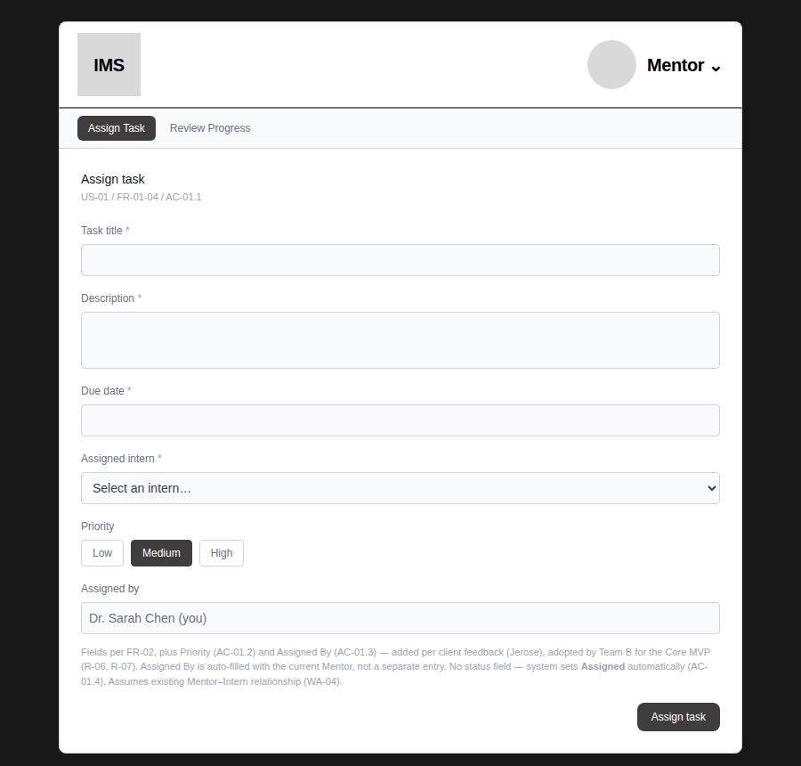
2. Priority interaction and values
- Values: exactly Low, Medium, High — no other values (AC-01.2, R-06).
- Interaction: 3-way single-select pill group, not a dropdown. Default selection is Medium.
- Selected state: fill #3f3d3d, white text, border #3f3d3d, 4px corner radius (Tailwind rounded), 8px/6px padding (px-3 py-1.5).
- Unselected state: white fill, gray-300 border, gray-500 text.
- Once set, Priority is stored and displayed everywhere the task appears — My Tasks, Task Detail, and the Mentor's Task Submission Review — not just on this form.
- Display treatment elsewhere: a color-coded badge reading “{value} priority” — Low: gray border/text; Medium: amber border/text on amber-50 fill; High: red border/text on red-50 fill.
3. Assigned By / Mentor display and auto-population
- This is a read-only display, never a selectable input — there is nothing for the Mentor to choose, since they are obviously the one assigning the task (AC-01.3, R-07).
- On the Assign Task form itself: shown in a disabled-style field with the pattern “{Mentor name} (you)” — e.g. “Dr. Sarah Chen (you)”.
- On Task Detail (Intern's view) and Task Submission Review (Mentor's view): shown as plain text “Assigned by {Mentor name}”, without the “(you)” suffix, since the viewer is not necessarily that Mentor.
- Backend implication: this value must be derived from the authenticated session at save time, not accepted as client-submitted input — otherwise a Mentor could misattribute a task to someone else.
4. Validation, empty/error, and successful-submit states
Successful submit — confirmed and screenshot-tested:
Figure 2 — Assign Task — filled, High priority selected
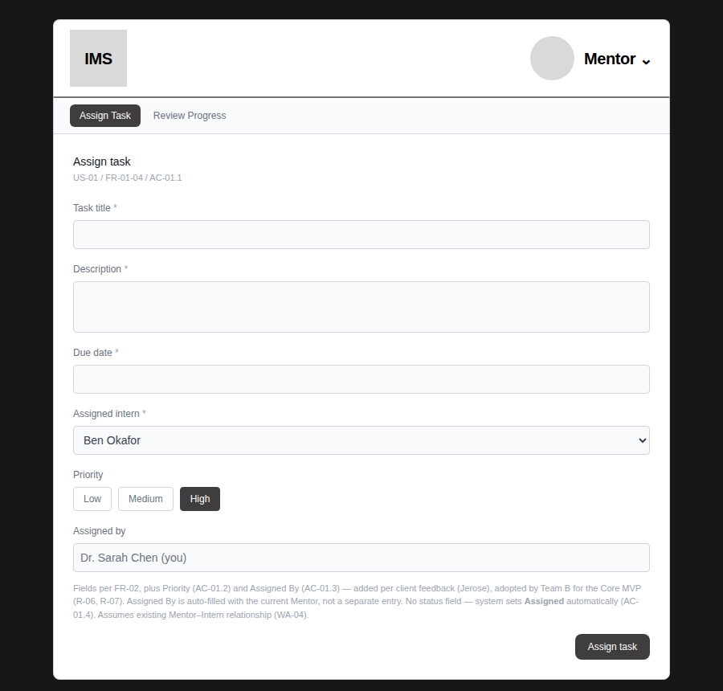
Figure 3 — Assign Task — success confirmation naming intern and priority
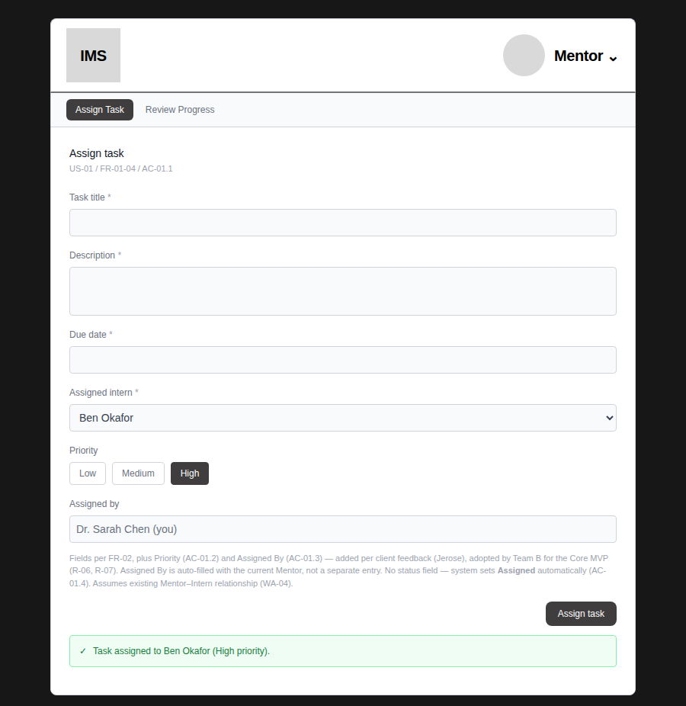
⚠ OPEN QUESTION — the prototype does not currently show a live validation-error state on this specific screen (e.g. submitting with Task title empty). The pattern to use is already established elsewhere in the prototype — red border, red helper text below the field, referenced in the shared Legend as EC-02/EC-05/EC-08 with AC-04.2 (the same required-field validation rule used on Weekly Progress). Apply that same treatment here rather than inventing a new one; flag to BA/UX if a different treatment is intended for this form specifically.
5. Navigation back to Mentor task view after creation
Current prototype behaviour: after a successful assignment, the Mentor stays on the same Assign Task screen — the form values remain filled in, and the success banner appears below the button. There is no automatic navigation away.
⚠ OPEN QUESTION — the current prototype has no “Mentor task view” (a list of tasks a Mentor has assigned) at all — only Assign Task and Review Progress exist on the Mentor side. This checklist item implies such a screen should exist to navigate back to. Before implementing navigation, confirm with BA/PM whether: (a) staying on the Assign Task form is the intended behaviour for rapid multi-task assignment, or (b) a new Mentor task-list screen is expected and simply hasn't been designed yet. Do not build a new screen speculatively — raise this gap first, per the BA handoff's own instruction not to add UI for unconfirmed behaviour.
6. Measurements, labels, and components needed by DEV
Shared header (matches Team A's actual Figma values, verified via the Figma MCP connector — not estimated):
Element | Value
Logo box | 71×71px, #d9d9d9 fill, square corners (no border-radius)
Avatar circle | 55px diameter, #d9d9d9 fill
Header text (logo label, role label) | 20px, Inter Semibold, #000000, -0.4px letter-spacing
Header bottom border | 2px solid #747474
Primary button (Assign task, Start task, Priority-selected, active nav tab) | #3f3d3d fill, white text, 8px corner radius
Secondary button (Back-style) | #efefef fill, 1px #9e9e9e border, black bold text, 8px corner radius
Field labels | 12px (text-xs), #6b7280 (gray-500)
Text/textarea inputs | 1px #d1d5db (gray-300) border, #f9fafb (gray-50) fill, rounded

Note: two small color inconsistencies were caught and corrected while preparing this handoff — the “Start task” status button and the Priority pill's selected state were still using a plain Tailwind gray (#111827) instead of the Team A-matched #3f3d3d. Both are now fixed and verified pixel-for-pixel identical to the primary button (RGB 63, 61, 61 confirmed by direct pixel sample, not just visual comparison).
Figure 4 — “Start task” button — confirmed using the same #3f3d3d as every other primary action
