Remaining Core MVP — Developer Handoff
Task Submission, Mentor Review/Completion, and Weekly Progress
Team: Team 40 / Team B — Intern Management System
Task: [UX IMPLEMENTATION] — Remaining Core MVP Developer Handoff
UX Designer: Faridullah Jabbar Khil
Sprint: Sprint 2 — Week 2
Sources: Approved Sprint 1 prototype (core-mvp-prototype); Sprint 1 Close-Out Requirements Refinement & Sprint 2 Handoff (BA, 12 Sept)
Purpose
This handoff covers the four remaining confirmed Core MVP screens/states not covered by the Week 1 handoff: Intern Task Submission, Mentor Submission Review, the Completed state, and Weekly Progress. Per the task's scope, this reuses the approved Sprint 1 prototype and only resolves implementation-critical details — it does not redesign anything already approved.
Two real implementation gaps were found and fixed while preparing this handoff, not just documented — both are extensions of an already-approved pattern (Section 4), not new design. One additional usability observation was identified but deliberately left unimplemented, since it wasn't a blocker — see Section 3.
1. Task Submission — implementation states
Screen: Task Detail (Intern role), Task Submission panel. States, in the order an Intern encounters them:
State | Trigger | What's shown
Collapsed | Default | Just the “Task Submission” header and an “Add submission” button
Open, empty | “Add submission” clicked | Description textarea (empty) + Attach file button + Submit
Open, validation error | Submit clicked with empty Description | Red border on Description + “Description is required.” below it — no state change, task stays In Progress
Open, success | Submit clicked with Description filled | Green success banner; task status becomes Submitted

Figure 1 — Task Submission — open, empty
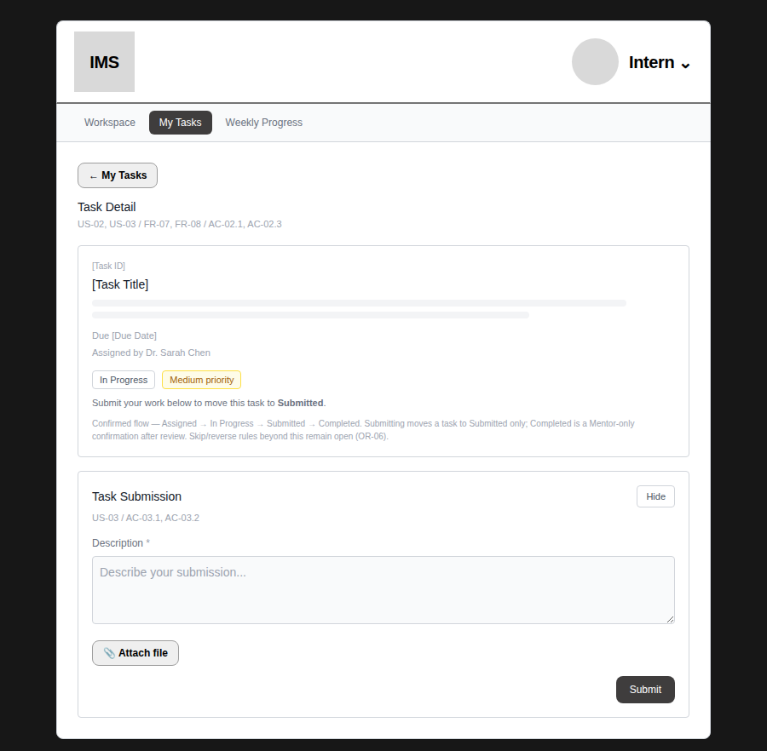
Figure 2 — Task Submission — validation error on empty submit
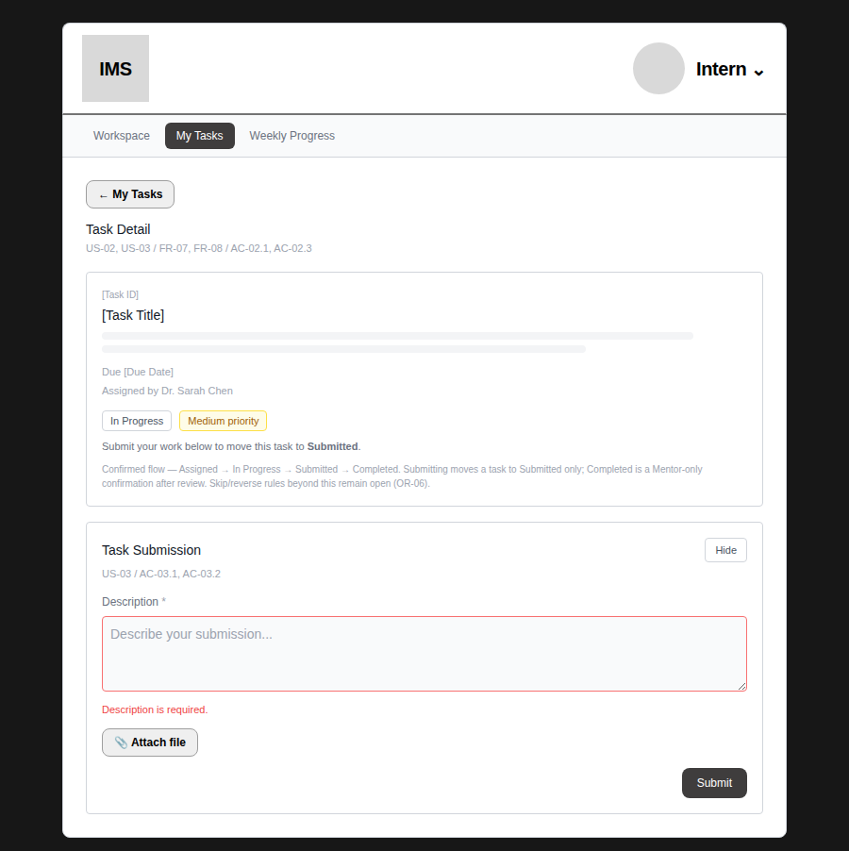
Figure 3 — Task Submission — success, status now Submitted
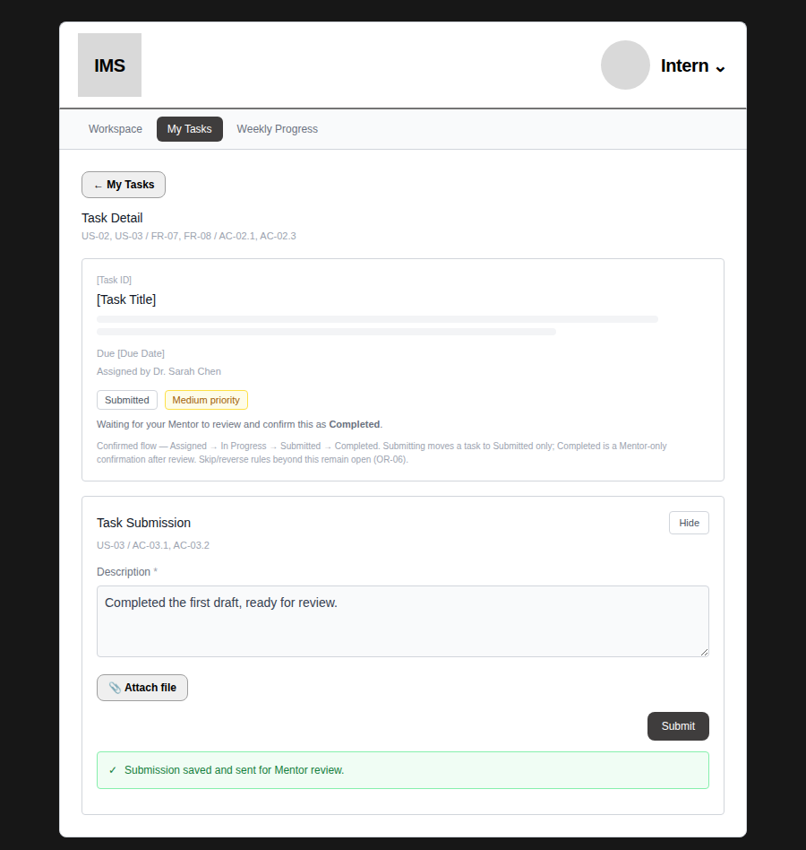
2. Description input and file attachment interaction
CONFIRMED — Description is a required, free-text textarea (US-03, AC-03.1). No character limit specified by BA — use a reasonable default if DEV needs one.
CONFIRMED — “Attach file” is a real file picker — clicking it opens the browser's native file selection dialog, and the Intern chooses a file from their own local machine. The prototype now demonstrates this directly (not a mocked filename): the styled button triggers a hidden native file input, and the actual selected file's name is displayed next to the button. DEV can wire this to real upload handling using the same trigger pattern. Attachment remains optional — Description is the only field with a required asterisk.
Figure 4 — Task Submission — real file selected via the native picker
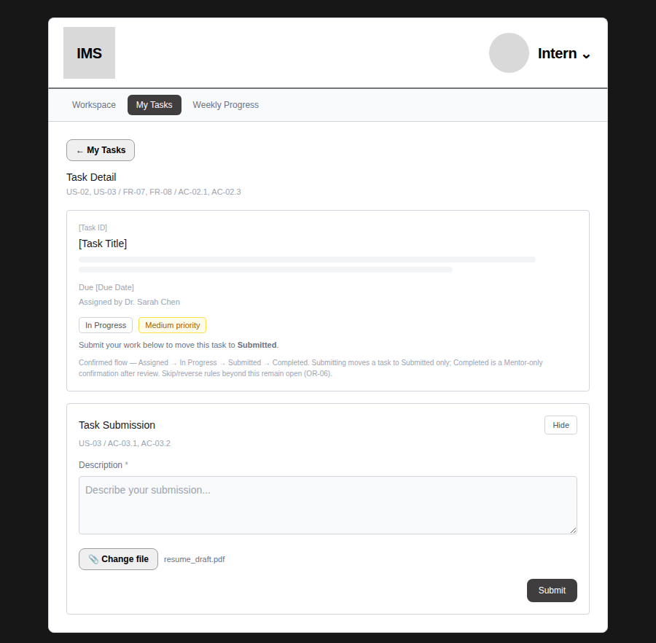
“resume_draft.pdf” is an actual file selected through the browser's file dialog, not a hardcoded placeholder.
3. Submitted and Completed status presentation
CONFIRMED — both statuses use the same StatusBadge treatment as Assigned/In Progress — plain text in a bordered pill, no colour coding by status (only Priority is colour-coded).
CONFIRMED — on Task Detail (Intern view), Submitted shows “Waiting for your Mentor to review and confirm this as Completed” — no further action available to the Intern (AC-02.3, no self-completion).
CONFIRMED — on Review Progress (Mentor view), Completed shows a plain confirmation banner — this matches the approved Sprint 1 prototype exactly, unchanged.
Observation (not implemented, not a blocker — recommendation only): once a task is Completed, the submitted Description/Attachment are no longer visible anywhere on this screen, only the confirmation banner. This may be worth revisiting so the Mentor (or anyone reviewing later) can still see what was submitted after completion — but the current approved behaviour is not broken and works as originally designed, so this has been left as-is per this task's scope (reuse the approved prototype, don't redesign without a confirmed blocker). Recommend raising with BA/PM as a possible item for the next task rather than deciding it here.
Figure 5 — Review Progress — not yet submitted
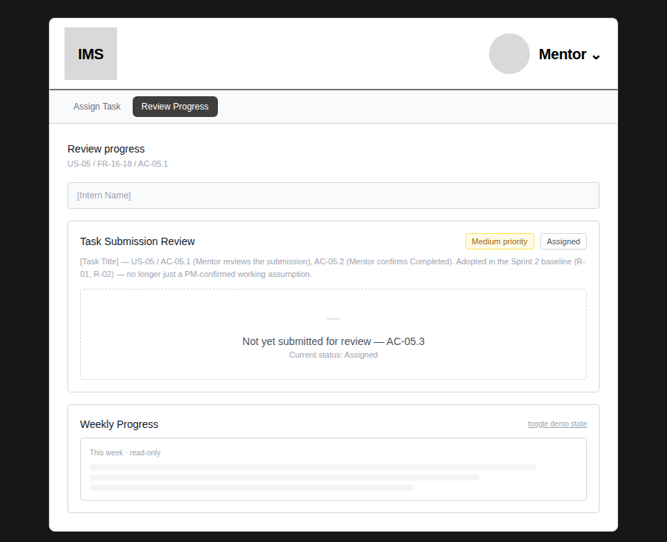
Figure 6 — Review Progress — Submitted, real content visible
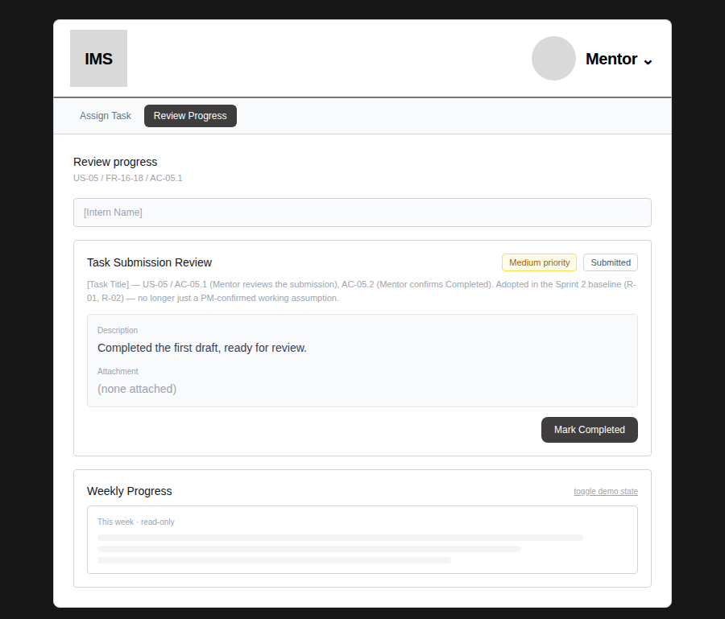
Figure 7 — Review Progress — Completed, matches approved prototype
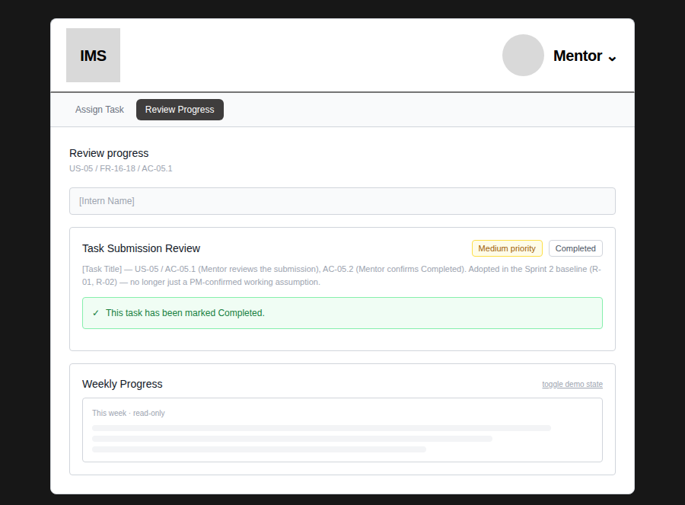
4. Implementation/design mismatches found and fixed
FIXED IN THIS HANDOFF — Weekly Progress's three fields (Accomplishments, Blockers, Next steps) had no real value tracking or validation at all — they were decorative placeholder boxes, despite being marked required and despite AC-04.2 explicitly requiring validation feedback when required fields are missing. Clicking Submit always succeeded regardless of content. Fixed: all three are now real controlled inputs with inline validation matching the pattern already established for Assign Task (red border + message per field, no separate error screen). Re-tested: confirmed an empty submit shows all 3 errors and does not lock the week; a valid submit locks correctly.
FIXED IN THIS HANDOFF — Task Submission's Description field was marked required but was never actually validated — clicking Submit with an empty Description always succeeded and advanced the task to Submitted. Fixed to match the same inline-validation pattern. Re-tested: confirmed an empty submit shows the error and does not change task status; a valid submit works as before.
Both fixes are extensions of an already-approved pattern (Assign Task's confirmed validation), not new design — consistent with this task's scope to resolve implementation-critical gaps only.
STILL OPEN (BA) — OR-06 (status skip/reverse rules) remains open — nothing in this handoff addresses whether a Mentor can revert a Completed task, or whether stages can be skipped. Do not build either without separate confirmation.
STILL OPEN (BA) — OR-H02 (can an Intern edit a Task Submission after submitting) remains open. The prototype does not disable the Submit button or the form after a successful submission — this is deliberate, not an oversight, since disabling it would itself be assuming an answer to an unconfirmed question. Do not add either behaviour (allowing or blocking edits) without BA confirmation.
STILL OPEN (BA) — Linking Weekly Progress to the Intern's assigned tasks for the same period (the client's second suggestion via Jerose) remains deferred to Sprint 3 per the existing team decision — not part of this handoff's scope.
5. Validation, success, and error behaviour — summary
Screen | Required fields | Validation | Success feedback
Task Submission | Description | Inline, red border + message (fixed in this handoff) | Green banner, status → Submitted
Weekly Progress | Accomplishments, Blockers, Next steps | Inline, red border + message per field (fixed in this handoff) | Green banner, form replaced (locked for the week)
Mark Completed (Mentor) | None — single-click action | N/A | Green banner, content stays visible (fixed in this handoff)

Figure 8 — Weekly Progress — validation errors on empty submit
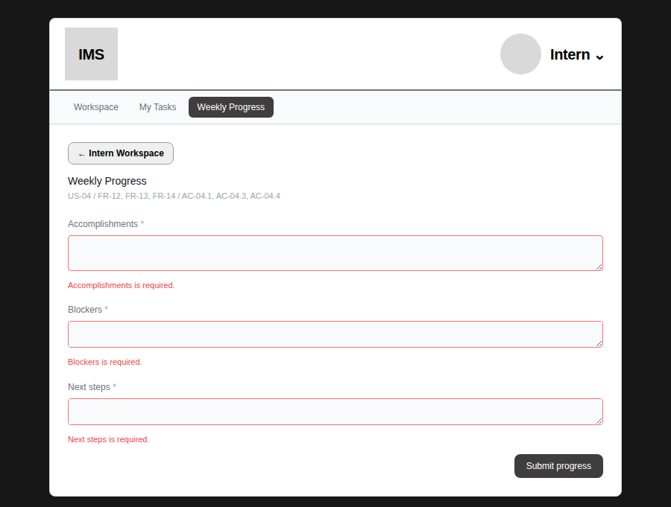
Figure 9 — Weekly Progress — locked after valid submit
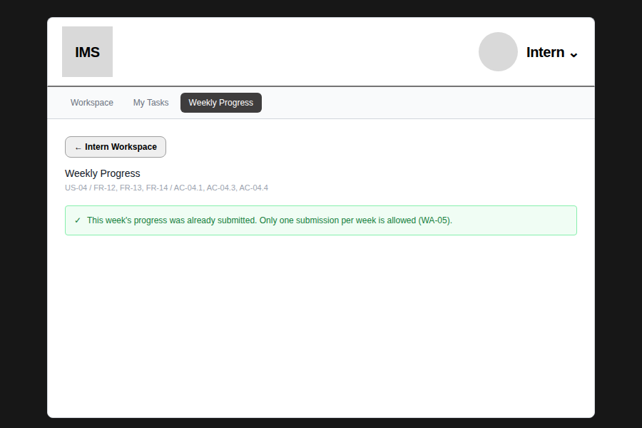
6. DEV-ready labels, components, and navigation guidance
Element | Value
Inline validation error | 1px #f87171 (red-400) border on the field; 11px #ef4444 (red-500) text below it — same pattern across every form in the app
Success banner | Green border/background (#bbf7d0-ish / green-50), green-700 text, checkmark prefix
Primary button (Submit, Submit progress, Mark Completed) | #3f3d3d fill, white text, 8px corner radius — same as every other primary action
Secondary button (Attach file) | #efefef fill, 1px #9e9e9e border, black bold text, 8px corner radius
Status/Priority badges | Plain bordered pill for status; colour-coded pill for priority (Low: gray, Medium: amber, High: red) — unchanged from Week 1 handoff

Navigation: no new screens or nav changes in this handoff. Task Submission and Review Progress sit within their existing screens (Task Detail, Review Progress) exactly as in the approved prototype.
Terminology: field labels (“Description”, “Accomplishments”, “Blockers”, “Next steps”) and button labels (“Submit”, “Submit progress”, “Mark Completed”) are unchanged from the approved prototype — use them verbatim.
Change log
- This handoff (20 Sept): covers Task Submission, Mentor Review/Completion, and Weekly Progress. Fixed 2 implementation gaps (Weekly Progress validation, Task Submission validation) and upgraded Attach file from a UI mock to a real native file picker, per confirmed direction that DEV will let the Intern choose a local file. One usability observation (Completed-state content visibility) was identified but deliberately left as the original approved design, since it wasn't a blocker — recorded as a recommendation rather than implemented. All changes re-tested before documenting them.

