The navigation of the application pages are disconnected and the colours aren’t accurate
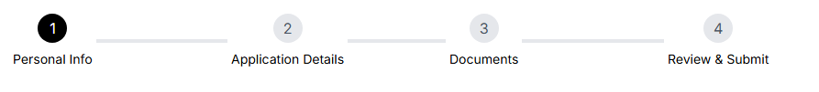
Figma for reference:
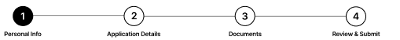

If possible format text box to automatically correct to phone number format
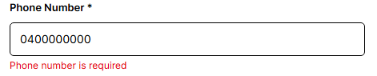
Example:
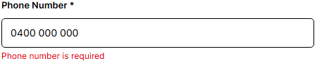
In the navigation after a step has been completed the number should change to a tick
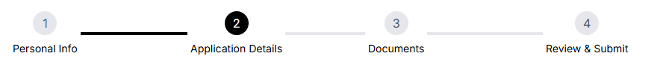
Figma example:

Internship program should be a dropdown filled with available programs to apply to
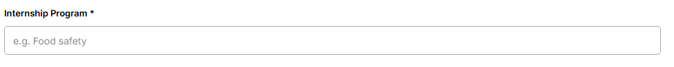
Example:
Document upload should also allow docx files to be uploaded
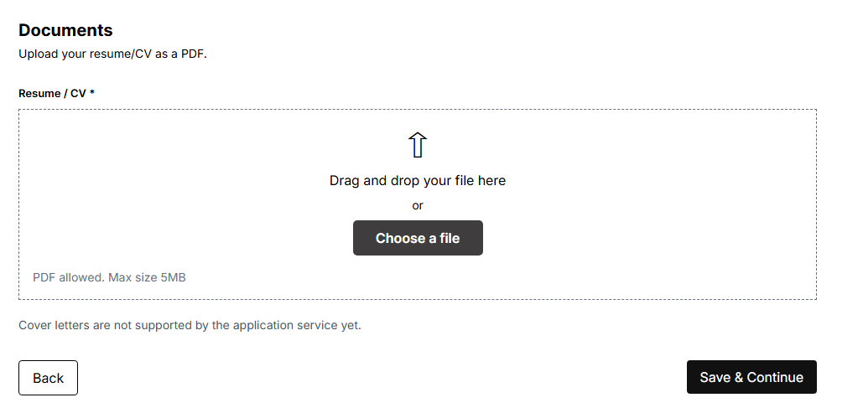
Example:
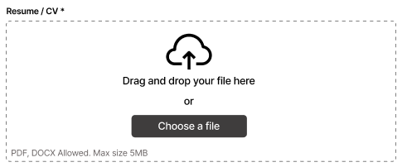

Notes:
some links are not yet functional like the terms and conditions and submitting the application brings up an error. This may be due to not being fully implemented yet so we it will be checked again later.

Page is also hard to comprehend when user is using dark mode.

