Client Feedback & Core MVP UX Re-alignment
Post-23 September client meeting — UX handoff for confirmed Sprint 2 changes
Team: Team 40 / Team B — Intern Management System
Task: [CLIENT VALIDATION] — Client Feedback & Core MVP Requirements Re-alignment
UX Designer: Faridullah Jabbar Khil
Sprint: Sprint 2 — Week 2
Revision: v2 — incorporates PM revision request (Jianqi Lu, 26 Sept) before approval
Prototype link (Figma Make): Mentor task Assignment prototype – Figma Make
Inputs reviewed: PM Client Feedback Consolidation & Action Summary (Jianqi Lu, 26 Sept); BA Client Feedback & Core MVP Requirements Re-alignment (Shakthijhaa Sivagnanam, 26 Sept); existing approved UX baseline
Not reviewed: 23 September Client Meeting Minutes were not provided for this task and were not available at time of writing — this handoff relies on the PM and BA documents' own summaries of that meeting
Purpose
This handoff assesses the UX impact of client feedback from the 23 September Team A/B meeting, as consolidated by PM and formally re-aligned by BA, against the existing approved Core MVP. Per task scope, only items confirmed through the PM/BA re-alignment are implemented here — nothing is introduced from raw client comments directly, and unaffected parts of the approved baseline are left untouched.
1–2. Inputs reviewed and classification
Client feedback item | BA classification | UX action
Mentor task reference attachment | CHANGED — current Sprint | Must Implement — Section 3
Compact Task Progress/Status summary | CHANGED — current Sprint | Must Implement — Section 4
Mentor visibility across multiple Interns | CLARIFIED (workflow/data-scope) | Must Implement — Section 5
Task Submission purpose (final vs. draft) | CLARIFIED / UNCHANGED | No Change — already correct
Weekly Progress ↔ assigned-task linkage | DEFERRED — Sprint 3 / future | No Change — out of scope

The client's provided summary-card image (Total Tasks, Pending, In Progress, Completed, Overdue, Due Today) was treated as a visual reference only, per BA direction — the BA's own metric definitions (Section 4 below) are what was actually built, including one metric the client's example omitted (Submitted).
3. Mentor Task Reference Attachment
Implemented as a real, functional file attachment — not a UI mock. Verified against all 5 BA acceptance statements (ATT-AC01–05):
VERIFIED — ATT-AC01 — Add attachment control is available within the task content/description area on Assign Task (positioned directly under Description, per BA/PM direction to keep it simple, not a rich-text editor).
VERIFIED — ATT-AC02 — tested explicitly: a task can be assigned successfully with no reference file selected.
VERIFIED — ATT-AC03 — a file selected during assignment is associated with that task and available to the assigned Intern (uses the browser's real File API, not a placeholder string).
VERIFIED — ATT-AC04 — on Intern Task Detail, the file is identifiable by name, with working Preview and Download links (real blob URLs, confirmed by test, not mock hrefs).
VERIFIED — ATT-AC05 — tested explicitly: attached a different file at Task Submission stage and confirmed the Mentor's reference file remained unaffected and visually distinct from the Intern's own submission attachment.
Figure 1 — Assign Task — Reference file control, positioned under Description
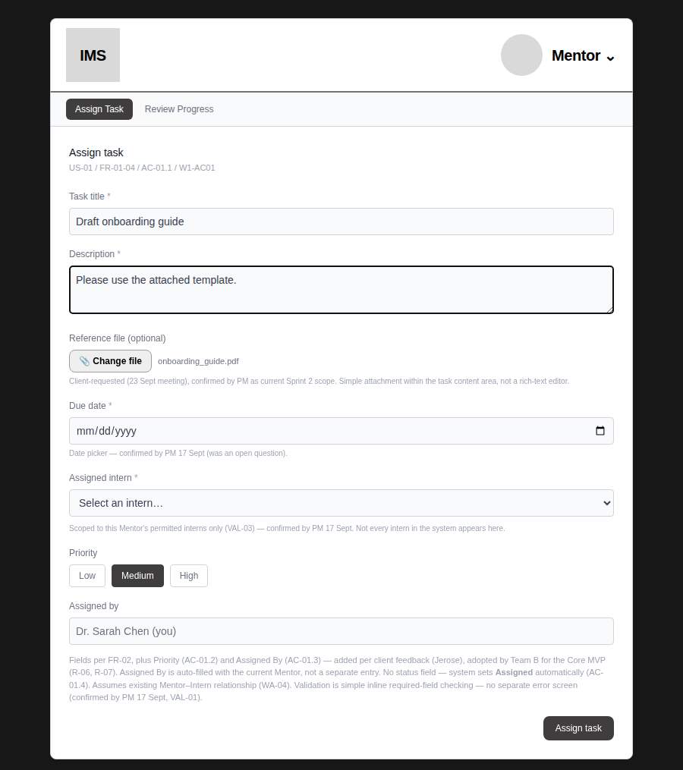
Figure 2 — Task Detail — Intern sees the Mentor's reference file, with working Preview/Download
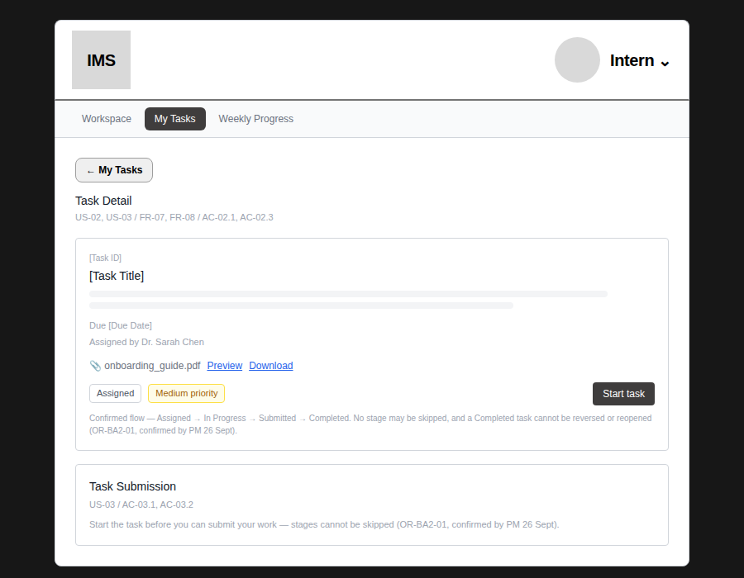
Figure 3 — Task Detail — ATT-AC05 verified: Mentor's reference file and the Intern's own submission attachment are distinct and both correctly visible
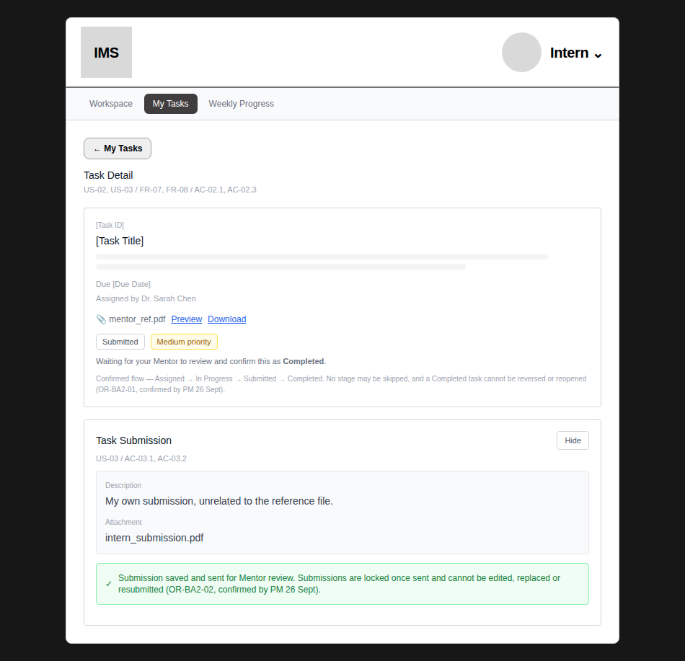
mentor_ref.pdf (top, from Assign Task) and intern_submission.pdf (bottom, from Task Submission) are two different files, confirmed not to interfere with each other.
3.1 Confirmed lifecycle business rules (PM revision, 26 Sept)
Two previously open BA items are now closed by explicit PM confirmation and implemented:
VERIFIED — OR-BA2-01 — the lifecycle is strictly Assigned → In Progress → Submitted → Completed. No stage may be skipped, and a Completed task cannot be reversed or reopened. The prototype already had no mechanism to skip or reverse stages; the on-screen citation is updated from “open” to confirmed.
VERIFIED — OR-BA2-02 — once an Intern successfully submits, the submission is locked and cannot be edited, replaced or resubmitted. Newly implemented: after a valid submission, the editable form is replaced with a read-only view of the submitted Description and Attachment — no Change file button, no editable textarea, no way to resubmit.
A genuine gap was caught on a deeper re-check of this exact requirement, not assumed correct from the first pass:
VERIFIED — Gap found and fixed — the Task Submission section was reachable and usable even while the task was still Assigned, before the Intern had clicked Start task. This meant a task could jump directly from Assigned to Submitted, skipping In Progress entirely — a direct violation of OR-BA2-01's “no stage may be skipped.” Fixed: Task Submission is now gated to only become available once the task is In Progress; while Assigned, a message explains why, citing OR-BA2-01.
VERIFIED — Gap found and fixed — the initial lock implementation only prevented editing within the same view. Testing actual navigation (leaving Task Detail and returning, or switching role and back) revealed the lock was silently undone — the editable form reappeared with the original text still in it, ready to be resubmitted. Root cause: a shared reset function was clearing the locked flag on every navigation. Fixed and re-tested across three separate navigation paths (collapse/expand, leaving and returning to Task Detail, and a full role switch) — the lock now holds in all three.
Figure 4 — Task Submission — gated while Assigned, cannot be skipped to (OR-BA2-01)
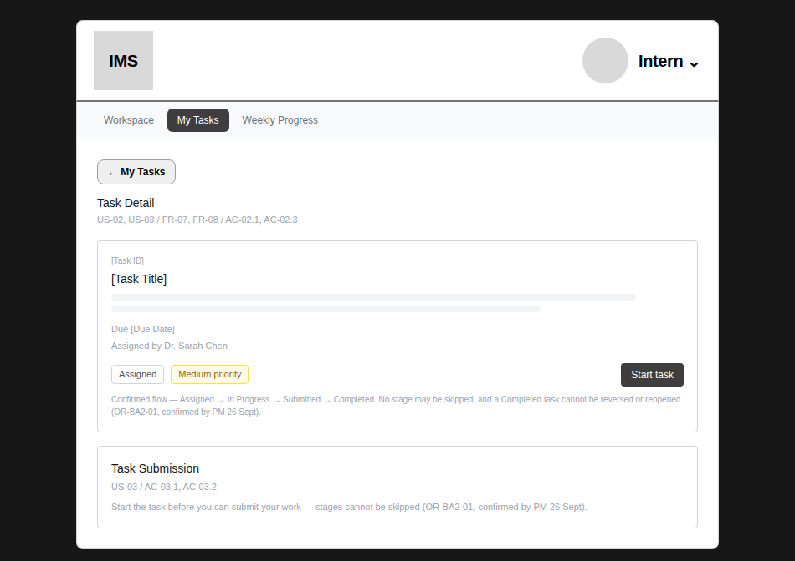
Figure 5 — Task Submission — confirmed still locked after leaving and returning to Task Detail (OR-BA2-02)
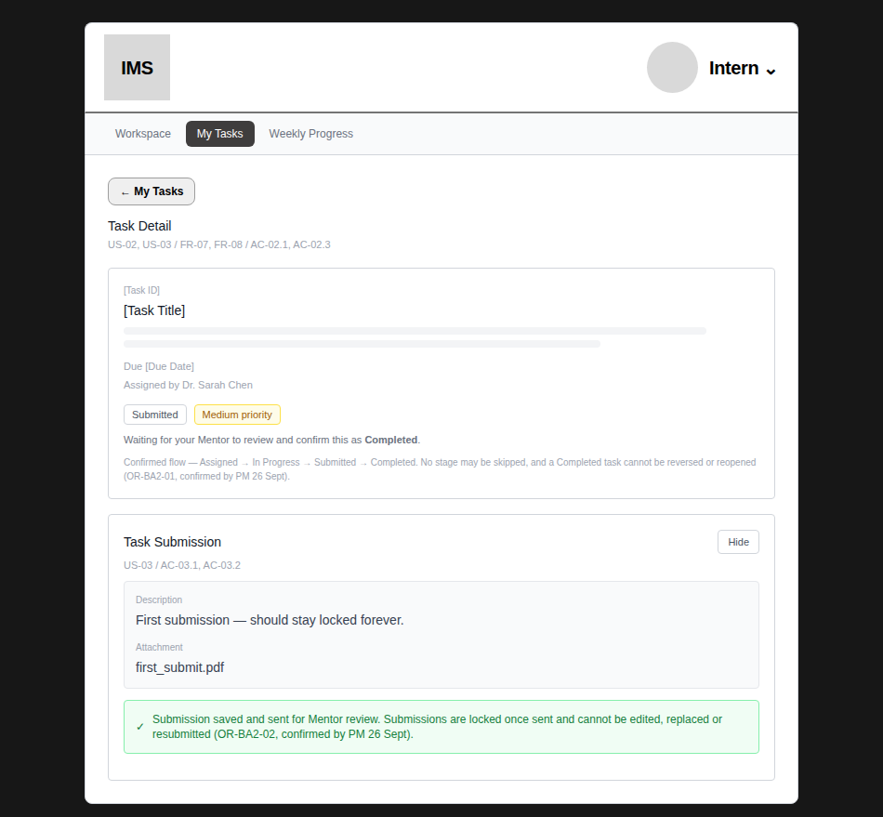
Figure 6 — Task Submission — locked and read-only immediately after a valid submission (OR-BA2-02)
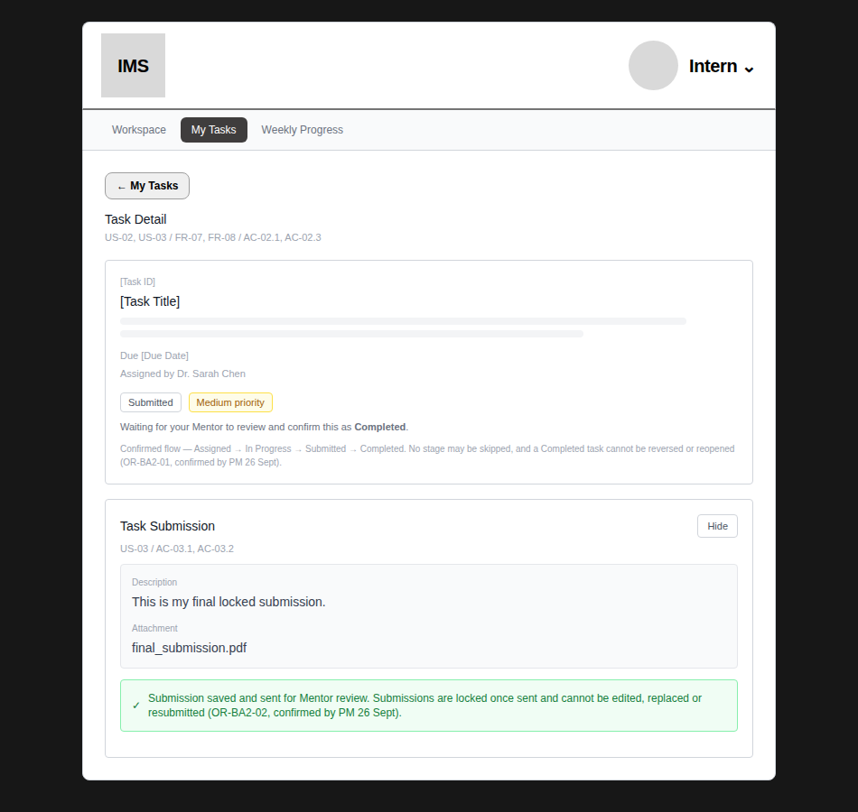
3.2 Confirmed Completed-state behaviour (PM revision, 26 Sept)
VERIFIED — after a Mentor marks a task Completed, the submitted Description and Attachment remain fully visible in the Mentor's view alongside the completion banner — completion changes status only, it does not remove the submitted work. Tested explicitly: the submitted text is still visible immediately after clicking Mark Completed.
Figure 7 — Review Progress — Completed state, submitted content stays visible (PM-confirmed)
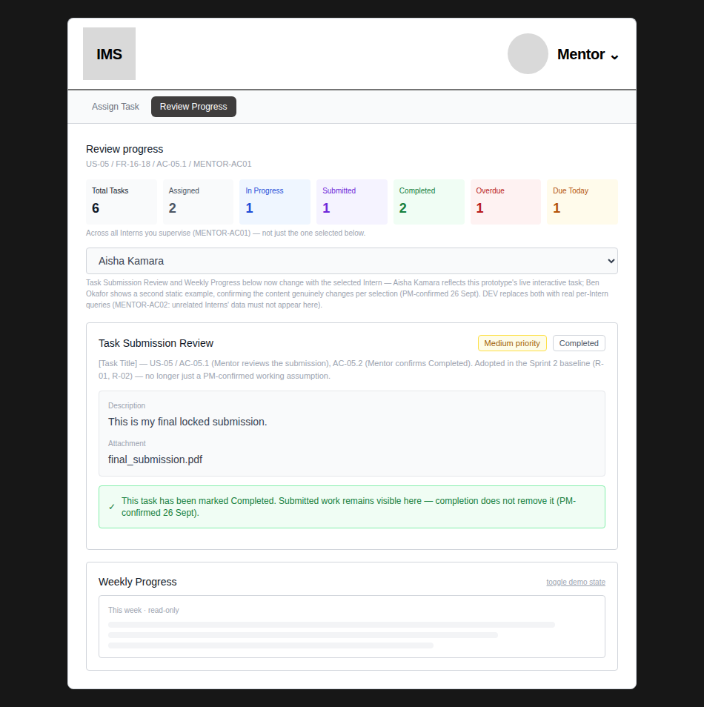
4. Compact Task Progress / Status Summary
Metrics and formulas exactly as defined by BA (Section 6.2 of the re-alignment doc) — not approximated:
Metric | Formula
Total Tasks | All tasks in the active role-specific scope
Assigned | status = Assigned (this is what the client's “Pending” example maps to)
In Progress | status = In Progress
Submitted | status = Submitted — added by BA; not in the client's original 6-card example
Completed | status = Completed
Overdue | due date < today AND status is Assigned or In Progress
Due Today | due date = today AND status is Assigned or In Progress

VERIFIED — SUM-AC01/02 — both summaries sit inside existing views (Intern Workspace, Mentor Review Progress) — no new page or dashboard.
VERIFIED — SUM-AC03 — tested: Intern's summary counts only her own tasks (verified against a hand-calculated expected result, not just “looks right”).
VERIFIED — SUM-AC04 — tested: Mentor's summary aggregates across both supervised Interns — confirmed the total is genuinely the sum, not one Intern's data repeated.
VERIFIED — SUM-AC05 — tested: no “Pending” label appears anywhere; “Assigned” is used throughout, matching existing lifecycle terminology.
VERIFIED — SUM-AC06 — Overdue/Due Today tested against hand-calculated values from the mock dataset — correct in both the Intern-scoped and Mentor-aggregate views.
Figure 8 — Intern Workspace — compact summary, all 7 metrics
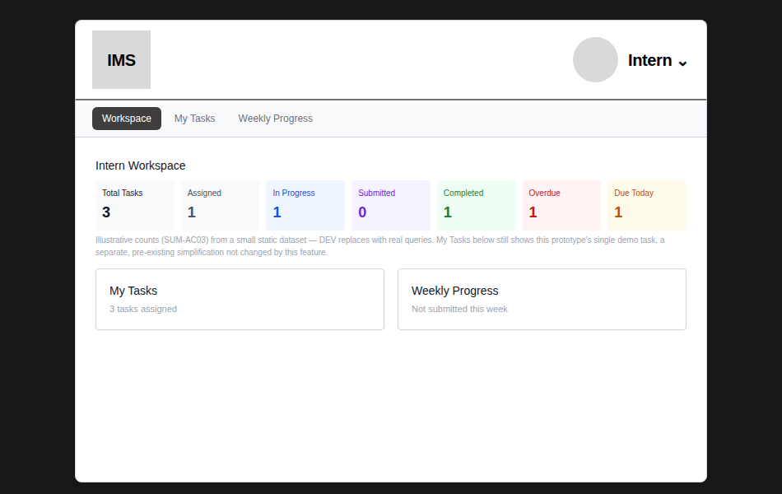
My Tasks tile below was updated to use the same count as the summary (3), fixing an inconsistency caught during review — see Section 7.
Figure 9 — Mentor Review Progress — aggregate summary across both supervised Interns (6 total, not 3)
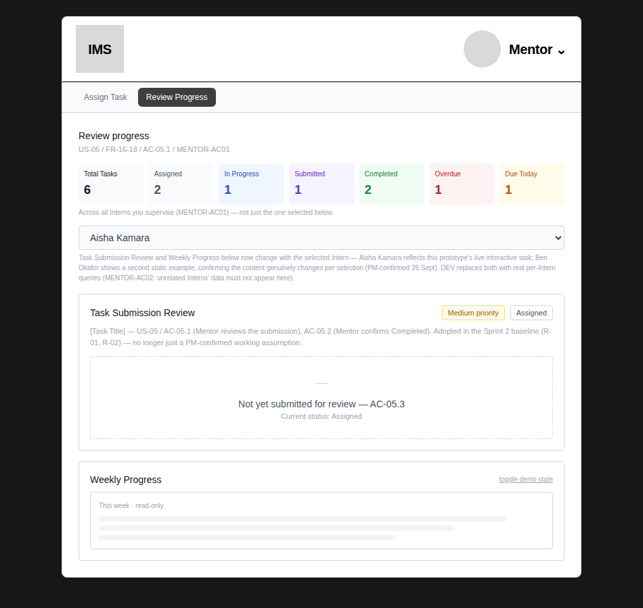
KNOWN PROTOTYPE LIMITATION — task data behind the summary is a small static illustrative set (6 mock tasks), not live data — explicitly agreed as acceptable for this prototype. The counting formulas above are the real deliverable; DEV replaces the dataset with real queries against actual task records.
5. Mentor Visibility Across Multiple Interns
VERIFIED — MENTOR-AC01 — the static “[Intern Name]” placeholder on Review Progress is now a real dropdown, scoped to the Mentor's permitted Interns (reusing the same permitted-intern list already established for Assign Task).
VERIFIED — MENTOR-AC02 — by construction, the mock dataset only contains the Mentor's permitted Interns; an unrelated Intern cannot appear in the summary or selector.
VERIFIED — PM revision (26 Sept) — the aggregate summary stays fixed regardless of selection, while the Task Submission Review and Weekly Progress content below now genuinely changes per selected Intern. Aisha Kamara shows this prototype's live interactive task; Ben Okafor shows a second, clearly different static example (High priority, Assigned, no submission yet) — tested that switching between them changes the detail content while the summary numbers stay identical.
Figure 10 — Review Progress — Aisha Kamara selected, showing the live task's real content
Figure 11 — Review Progress — Ben Okafor selected, showing a genuinely different example; summary above is unchanged
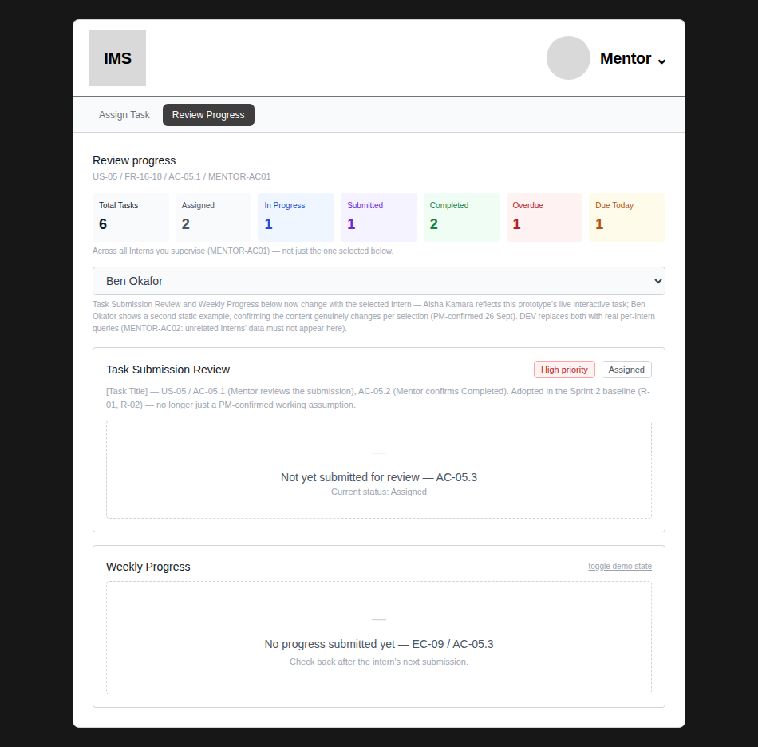
Compare the summary row in both figures — identical (6, 2, 1, 1, 2, 1, 1) — confirming the aggregate does not react to the selector.
KNOWN PROTOTYPE LIMITATION — both Interns' detail content in the prototype comes from a small static/live illustrative combination, not a real multi-record data source — explicitly agreed as acceptable for this prototype. DEV replaces this with real per-Intern queries scoped to the Mentor's permitted relationships (MENTOR-AC02).
6–7. Validation, feedback, terminology, and navigation impact
Area | Impact
Navigation | No new screens or pages added — all changes sit inside existing Workspace, Assign Task, and Review Progress views, per explicit client/BA/PM direction.
Terminology | Existing lifecycle terms used throughout (Assigned, In Progress, Submitted, Completed) — client's “Pending” is never shown, only “Assigned.”
Validation | No new required fields — reference attachment is optional (ATT-AC02), consistent with existing validation patterns.
Visual conventions | Summary cards use colours already present elsewhere in the app (green from success banners, red from errors, amber from Medium priority) plus two new but standard ones (blue, purple) — not an arbitrary new palette.

8. DEV-ready handoff summary
Distinguishing what the prototype demonstrates from what DEV still needs to connect to live implementation:
Feature | Demonstrated by prototype | DEV must still connect
Mentor reference attachment | Real file selection, storage in browser memory, working Preview/Download via blob URLs, correctly kept separate from Task Submission's own attachment (ATT-AC05). | Persistence to real storage/API; the file must survive beyond the browser session and be retrievable by the correct Intern.
Compact summary metrics | All 7 metrics computed correctly per the BA's exact formulas (Section 4), against a small static dataset, for both Intern and Mentor scope. | Live queries against real task records, replacing the static dataset; must recompute as task data changes in real time.
Mentor → multiple Interns | Real dropdown scoped to permitted Interns; selecting a different Intern changes the detail content below, proven with two genuinely different examples. | Real per-Intern queries for Task Submission Review and Weekly Progress, authorized so only permitted Interns' data can ever be returned (MENTOR-AC02).
Submission lock (OR-BA2-02) | Once submitted, the form becomes read-only in the UI — no edit/resubmit path exists. | Backend must also reject any edit/resubmit attempt server-side; UI-only enforcement is not sufficient security.
Lifecycle integrity (OR-BA2-01) | No skip/reverse/reopen action exists anywhere in the UI. | Backend must reject any out-of-sequence status transition, not rely on the UI never offering one.

Unaffected by this task — remain open, not addressed here
- OR-BA2-03 — reference attachment file type/size/storage constraints — DEV implementation detail unless it creates a product limitation.
- FUT-BA2-01 — Weekly Progress ↔ assigned-task linkage — Sprint 3.
- FUT-BA2-02 — onboarding email/NDA automation — Sprint 3, not part of Team B Core MVP.
Change log
- v2 (26 Sept): PM revision addressed. A deeper re-check of OR-BA2-01/02 specifically (not just re-confirming the first pass) found and fixed two real gaps: Task Submission was reachable before Start task, allowing a stage to be skipped; and the submission lock was undone by navigation, silently re-exposing the editable form. Both fixed and tested across multiple navigation paths. Also confirmed Completed-state content visibility, made the Intern selector genuinely change detail content while keeping the aggregate summary fixed, and restructured Section 8 to explicitly separate what the prototype demonstrates from what DEV must still connect. Full existing test suite re-run after every change — 29 of 29 checks pass on the final version.
- v1 (26 Sept): implements all 3 confirmed current-Sprint UX changes from the client re-alignment. All BA acceptance statements (ATT-AC01–05, SUM-AC01–06, MENTOR-AC01–02) explicitly tested, not assumed. One inconsistency was caught during review (Workspace's My Tasks tile showing a different count than the new summary card) and fixed before this handoff was finalised.

