Client Feedback & Core MVP UX Re-alignment
Post-23 September client meeting — UX handoff for confirmed Sprint 2 changes
Team: Team 40 / Team B — Intern Management System
Task: [CLIENT VALIDATION] — Client Feedback & Core MVP Requirements Re-alignment
UX Designer: Faridullah Jabbar Khil
Sprint: Sprint 2 — Week 2
Inputs reviewed: PM Client Feedback Consolidation & Action Summary (Jianqi Lu, 26 Sept); BA Client Feedback & Core MVP Requirements Re-alignment (Shakthijhaa Sivagnanam, 26 Sept); existing approved UX baseline
Not reviewed: 23 September Client Meeting Minutes were not provided for this task and were not available at time of writing — this handoff relies on the PM and BA documents' own summaries of that meeting
Purpose
This handoff assesses the UX impact of client feedback from the 23 September Team A/B meeting, as consolidated by PM and formally re-aligned by BA, against the existing approved Core MVP. Per task scope, only items confirmed through the PM/BA re-alignment are implemented here — nothing is introduced from raw client comments directly, and unaffected parts of the approved baseline are left untouched.
1–2. Inputs reviewed and classification
Client feedback item | BA classification | UX action
Mentor task reference attachment | CHANGED — current Sprint | Must Implement — Section 3
Compact Task Progress/Status summary | CHANGED — current Sprint | Must Implement — Section 4
Mentor visibility across multiple Interns | CLARIFIED (workflow/data-scope) | Must Implement — Section 5
Task Submission purpose (final vs. draft) | CLARIFIED / UNCHANGED | No Change — already correct
Weekly Progress ↔ assigned-task linkage | DEFERRED — Sprint 3 / future | No Change — out of scope

The client's provided summary-card image (Total Tasks, Pending, In Progress, Completed, Overdue, Due Today) was treated as a visual reference only, per BA direction — the BA's own metric definitions (Section 4 below) are what was actually built, including one metric the client's example omitted (Submitted).
3. Mentor Task Reference Attachment
Implemented as a real, functional file attachment — not a UI mock. Verified against all 5 BA acceptance statements (ATT-AC01–05):
VERIFIED — ATT-AC01 — Add attachment control is available within the task content/description area on Assign Task (positioned directly under Description, per BA/PM direction to keep it simple, not a rich-text editor).
VERIFIED — ATT-AC02 — tested explicitly: a task can be assigned successfully with no reference file selected.
VERIFIED — ATT-AC03 — a file selected during assignment is associated with that task and available to the assigned Intern (uses the browser's real File API, not a placeholder string).
VERIFIED — ATT-AC04 — on Intern Task Detail, the file is identifiable by name, with working Preview and Download links (real blob URLs, confirmed by test, not mock hrefs).
VERIFIED — ATT-AC05 — tested explicitly: attached a different file at Task Submission stage and confirmed the Mentor's reference file remained unaffected and visually distinct from the Intern's own submission attachment.
Figure 1 — Assign Task — Reference file control, positioned under Description
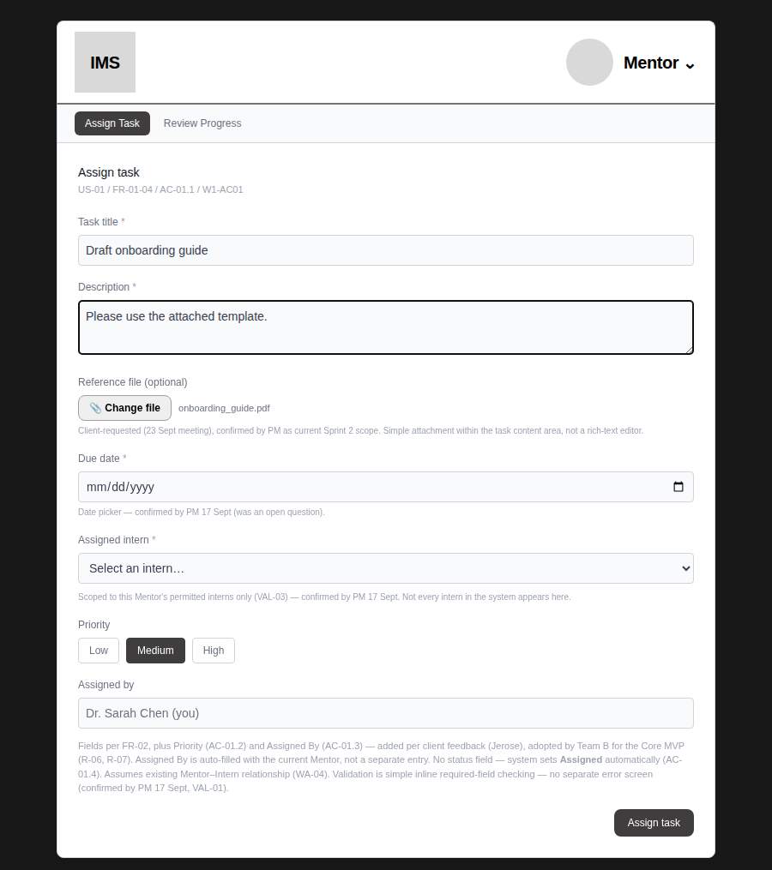
Figure 2 — Task Detail — Intern sees the Mentor's reference file, with working Preview/Download
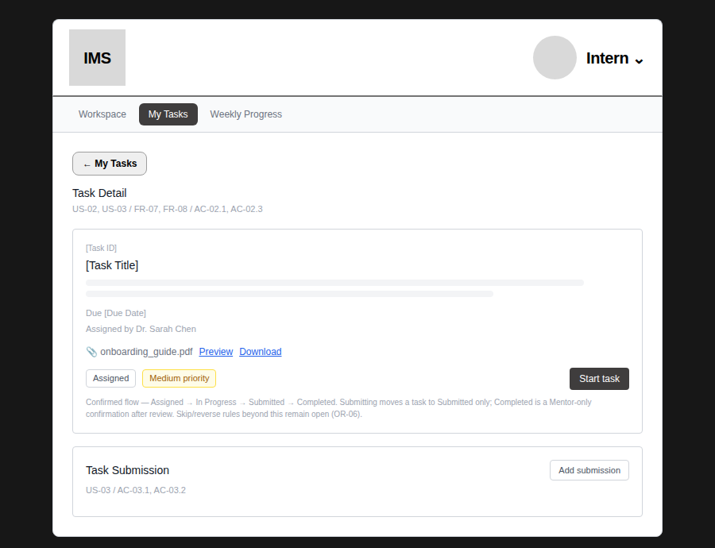
Figure 3 — Task Detail — ATT-AC05 verified: Mentor's reference file and the Intern's own submission attachment are distinct and both correctly visible
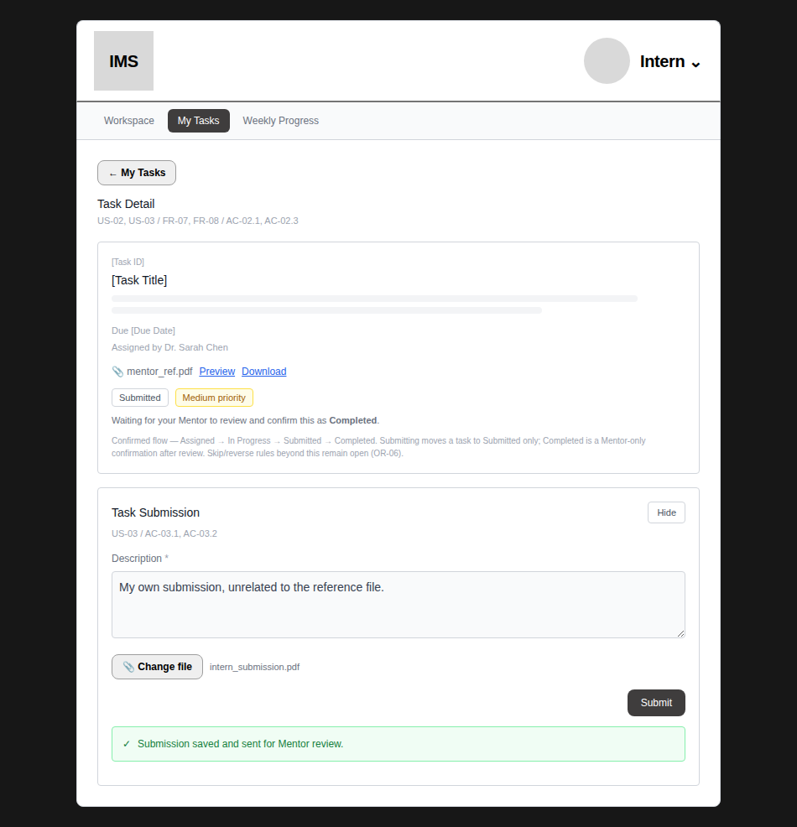
mentor_ref.pdf (top, from Assign Task) and intern_submission.pdf (bottom, from Task Submission) are two different files, confirmed not to interfere with each other.
4. Compact Task Progress / Status Summary
Metrics and formulas exactly as defined by BA (Section 6.2 of the re-alignment doc) — not approximated:
Metric | Formula
Total Tasks | All tasks in the active role-specific scope
Assigned | status = Assigned (this is what the client's “Pending” example maps to)
In Progress | status = In Progress
Submitted | status = Submitted — added by BA; not in the client's original 6-card example
Completed | status = Completed
Overdue | due date < today AND status is Assigned or In Progress
Due Today | due date = today AND status is Assigned or In Progress

VERIFIED — SUM-AC01/02 — both summaries sit inside existing views (Intern Workspace, Mentor Review Progress) — no new page or dashboard.
VERIFIED — SUM-AC03 — tested: Intern's summary counts only her own tasks (verified against a hand-calculated expected result, not just “looks right”).
VERIFIED — SUM-AC04 — tested: Mentor's summary aggregates across both supervised Interns — confirmed the total is genuinely the sum, not one Intern's data repeated.
VERIFIED — SUM-AC05 — tested: no “Pending” label appears anywhere; “Assigned” is used throughout, matching existing lifecycle terminology.
VERIFIED — SUM-AC06 — Overdue/Due Today tested against hand-calculated values from the mock dataset — correct in both the Intern-scoped and Mentor-aggregate views.
Figure 4 — Intern Workspace — compact summary, all 7 metrics
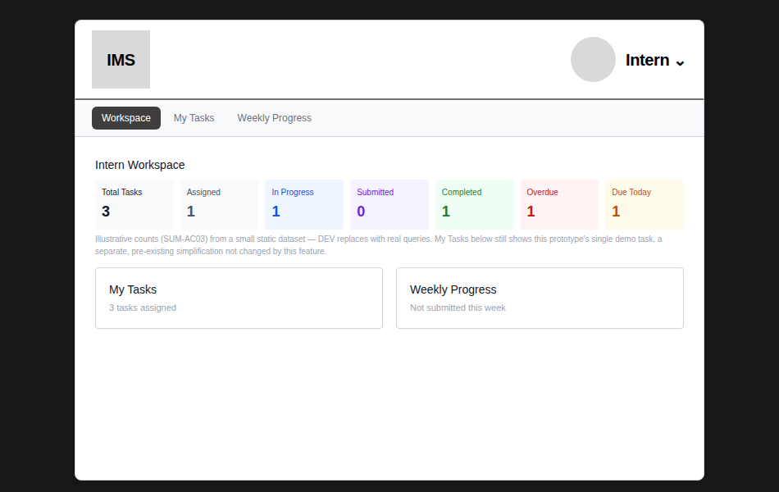
My Tasks tile below was updated to use the same count as the summary (3), fixing an inconsistency caught during review — see Section 7.
Figure 5 — Mentor Review Progress — aggregate summary across both supervised Interns (6 total, not 3)
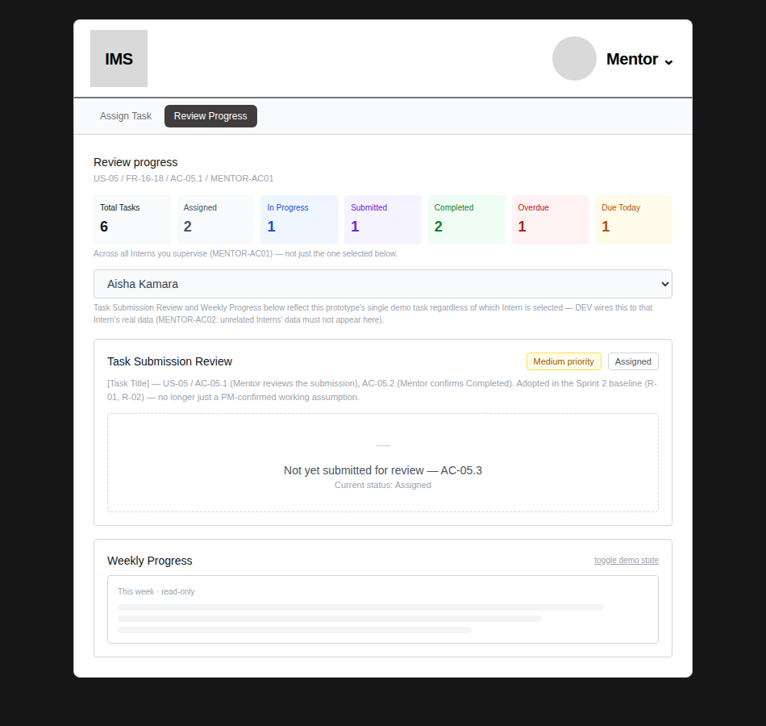
KNOWN PROTOTYPE LIMITATION — task data behind the summary is a small static illustrative set (6 mock tasks), not live data — explicitly agreed as acceptable for this prototype. The counting formulas above are the real deliverable; DEV replaces the dataset with real queries against actual task records.
5. Mentor Visibility Across Multiple Interns
VERIFIED — MENTOR-AC01 — the static “[Intern Name]” placeholder on Review Progress is now a real dropdown, scoped to the Mentor's permitted Interns (reusing the same permitted-intern list already established for Assign Task) — tested that selecting a different Intern actually changes the selection.
VERIFIED — MENTOR-AC02 — by construction, the mock dataset only contains the Mentor's permitted Interns; an unrelated Intern cannot appear in the summary or selector.
Figure 6 — Review Progress — real Intern selector; switching Interns does not change the aggregate summary above it, as expected
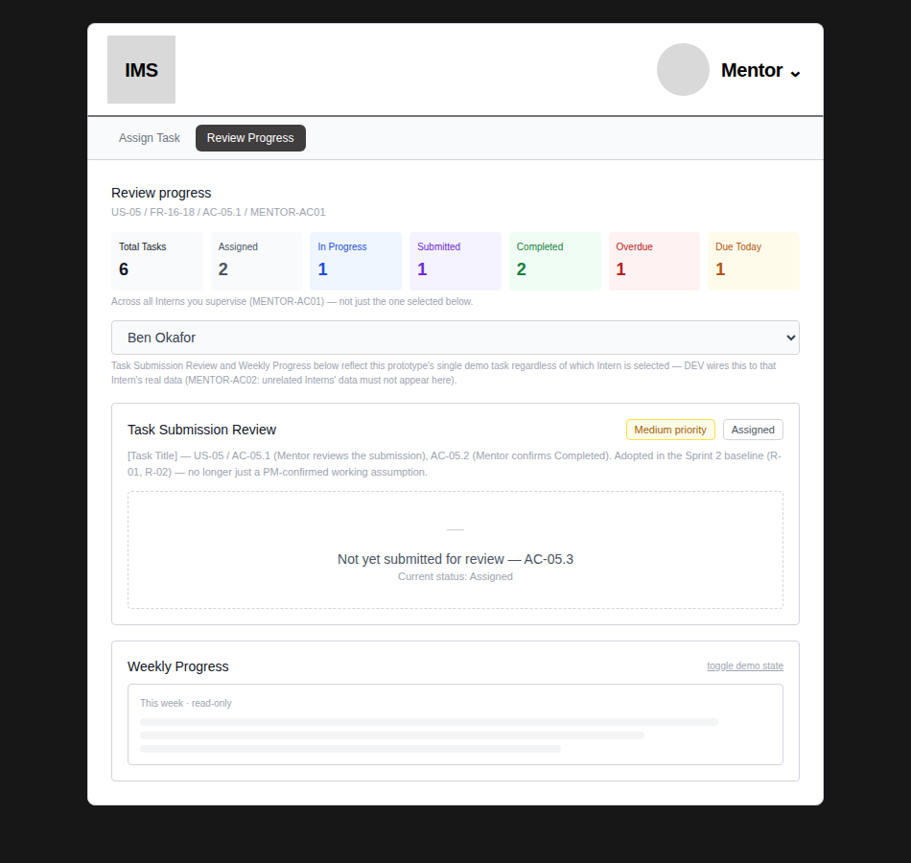
KNOWN PROTOTYPE LIMITATION — the Task Submission Review and Weekly Progress sections below the selector still reflect this prototype's single demo task regardless of which Intern is selected — stated directly in the UI itself, not hidden. DEV wires the selector to that Intern's real submission and progress data; unrelated Interns' data must not appear there (MENTOR-AC02).
6–7. Validation, feedback, terminology, and navigation impact
Area | Impact
Navigation | No new screens or pages added — all changes sit inside existing Workspace, Assign Task, and Review Progress views, per explicit client/BA/PM direction.
Terminology | Existing lifecycle terms used throughout (Assigned, In Progress, Submitted, Completed) — client's “Pending” is never shown, only “Assigned.”
Validation | No new required fields — reference attachment is optional (ATT-AC02), consistent with existing validation patterns.
Visual conventions | Summary cards use colours already present elsewhere in the app (green from success banners, red from errors, amber from Medium priority) plus two new but standard ones (blue, purple) — not an arbitrary new palette.

8. DEV-ready handoff summary
- Mentor reference attachment: extend task data/API/storage to persist an optional file per task; Intern Task Detail must expose preview (where supported) and download.
- Compact summary: implement the 7 metrics and formulas in Section 4 as real queries, scoped per Section 6.1 of the BA doc (Intern = own tasks; Mentor = all permitted supervised Interns).
- Multi-Intern selector: replace the static placeholder with a real query-backed Intern picker, scoped to the Mentor's permitted relationships only (MENTOR-AC02).
Unaffected by this task — remain open, not addressed here
- OR-BA2-01 — status skip/reverse/reopen exception rules.
- OR-BA2-02 — Task Submission post-submit edit/replacement.
- OR-BA2-03 — reference attachment file type/size/storage constraints — DEV implementation detail unless it creates a product limitation.
- FUT-BA2-01 — Weekly Progress ↔ assigned-task linkage — Sprint 3.
- FUT-BA2-02 — onboarding email/NDA automation — Sprint 3, not part of Team B Core MVP.
Change log
- This handoff (26 Sept): implements all 3 confirmed current-Sprint UX changes from the client re-alignment. All BA acceptance statements (ATT-AC01–05, SUM-AC01–06, MENTOR-AC01–02) explicitly tested, not assumed. One inconsistency was caught during review (Workspace's My Tasks tile showing a different count than the new summary card) and fixed before this handoff was finalised.

