Core MVP — Final UI & Interaction Polish
Prototype refinement pass — Team 40 / Team B (Intern Management System for Social Enterprise Workforce Development)
Prepared by: Faridullah Jabbar Khil (s4020393) — UX
Task: [UX REFINEMENT] – Core MVP Final UI & Interaction Polish : 120 · Sprint 2, Week 3
Scope confirmed with PM (Jianqi Lu): audit the approved Core MVP prototype itself for UI/UX inconsistencies and polish opportunities — not a DEV-implementation acceptance test.

1. Purpose & Scope
This task, per the PM's Sprint 2 Week 3 execution plan, is an independent UX line running separately from the PM → DEV → BA technical/acceptance line for this week:
PM task description (Week 3 board)
“Review the approved Core MVP UX and current implementation for final Sprint 2 presentation/interaction quality. Focus on visual consistency, terminology, task/status presentation, feedback/empty states, navigation clarity and Team A/B design consistency. This is refinement rather than another acceptance test. Do not introduce new business rules or features. Functional defects should be raised to DEV/BA.”

This review was conducted against the prototype itself (App.tsx) — not DEV's deployed build, which is covered separately by the parallel PM → DEV → BA line this week. Every fix below is presentation-only: no task status, validation rule, permission, or workflow behaviour was changed.

2. Method
This review was done in two passes over the same task, the second specifically to check for anything the first pass missed rather than to re-conf7irm it:
- Read the current prototype source end-to-end and compared every screen's headings, labels, badge styling, and empty/success states against every other screen for internal consistency.
- Rendered the prototype in a live dev environment and exercised the full task lifecycle (Assigned → In Progress → Submitted → Completed) plus both Intern selections on Review Progress, using real browser automation — not a static code read — to confirm what a reviewer actually sees on screen.
- Re-verified after each fix: no console or page errors, and the existing confirmed behaviours from earlier rounds (one Task Submission per task, one Weekly Progress per week, the submission lock surviving navigation) still hold — this task deliberately did not touch any of that logic.
- Second pass: specifically checked whether any on-screen text depends on state that can actually change during a live demo (submit-then-navigate-back, switch role, switch reviewed Intern), rather than only checking each screen in isolation. This is what surfaced items 8–10 below — all three are cases where a value was static or bound to the wrong thing, so it went stale once the real state changed underneath it.

3. Findings & Fixes Applied — Must Fix (implemented across both passes)
All ten items below are presentation or data-binding corrections: text, colour, ordering, a redundant link, or wiring a display to the state it should have reflected all along. None change a status name, a validation rule, or a permission.

# | Issue | Where | Fix applied
1 | Status badges didn’t reflect status. StatusBadge was plain gray for every status, while the Compact Task Summary cards directly above it already colour-coded the same four statuses (gray / blue / purple / green) — the same status read as two different visual systems on one screen. | Task Detail, My Tasks, Review Progress | StatusBadge now uses the same four colours as the Summary cards (Assigned = gray, In Progress = blue, Submitted = purple, Completed = green).
2 | Page heading didn’t match its own nav tab: “Assign task” (page) vs “Assign Task” (tab); “Review progress” (page) vs “Review Progress” (tab). | Assign Task / Review Progress screens | Headings now match the tab label casing exactly.
3 | Badge order was inconsistent — Review Progress showed Priority before Status; My Tasks and Task Detail show Status before Priority. | Review Progress → Task Submission Review | Reordered to Status-then-Priority everywhere, matching My Tasks and Task Detail.
4 | Button label casing inconsistent — “Mark Completed” was the only action button in Title Case; every other action button uses sentence case (“Start task”, “Submit progress”). | Review Progress | Relabeled to “Mark completed”.
5 | Developer traceability codes bled into user-facing copy inconsistently — “My Tasks — US-02 / FR-05, FR-06 / AC-02.1” combined the heading and the citation into one line, and two empty states appended a code (“… — EC-01”) straight onto the message a user reads. Every other screen keeps the citation on its own muted line, separate from real product copy. | My Tasks heading; “no tasks assigned” and “no progress submitted” empty states | Split the code out to its own line, consistent with how every other screen already presents it.
6 | Redundant navigation — Weekly Progress carried a “← Intern Workspace” back link even though it’s already a top-level tab. Task Detail (a genuine drill-down, reached only by clicking into a task) rightly keeps its own back link. | Weekly Progress | Removed the redundant back link; Task Detail’s back link is unchanged.
7 | Dead code — an unused Field component left over from an earlier round, superseded once Weekly Progress got real wired-up inputs. No visual effect, but worth a clean handoff. | Component definitions | Removed.
8 | Mentor's Weekly Progress review was disconnected from the Intern's real submission. It was driven by a demo-only toggle, not by whether the Intern had actually submitted — so submitting real Weekly Progress as the Intern and then switching to Mentor to review it would still show generic placeholder content, not what was actually typed. This undercut the “live interactive task” narrative the Intern selector on this screen exists to demonstrate. | Review Progress → Weekly Progress panel | Aisha Kamara (the live Intern) now shows her real accomplishments / blockers / next steps once she submits. Ben Okafor (the static comparison example) keeps the demo toggle, since he has no real backing data for it to reflect. The toggle is now hidden while viewing Aisha, since it would otherwise click with no visible effect.
9 | Workspace's “Weekly Progress” tile always read “Not submitted this week”, even after the Intern had actually submitted — the same category of stale-static-text issue already fixed once for the “My Tasks” tile in the v4 pass, but missed on this tile. | Intern Workspace | Tile now reads “Submitted this week” / “Not submitted this week” based on the real submission state.
10 | Access-denied preview code was inconsistent across Intern screens — three showed a readable “no dedicated AC in Sprint 2 baseline”, but Workspace showed a bare “—”, which reads like a missing value rather than an intentional one. | Access-denied preview (Workspace) | Workspace now shows the same readable text as the other three Intern screens.

4. Before / After

4.1 Status colour + heading casing — My Tasks
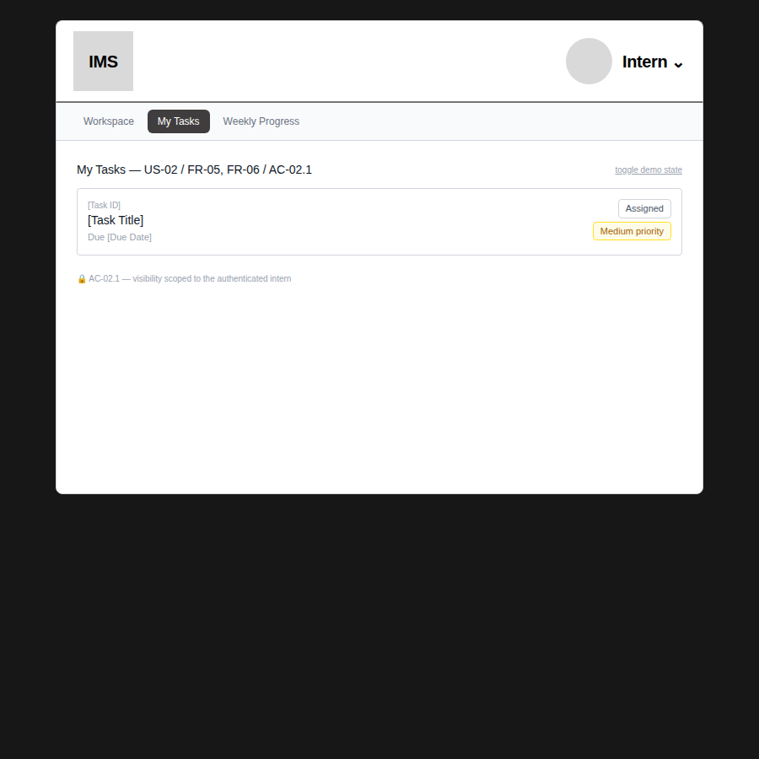  Before — codes inline in heading, Assigned badge plain | 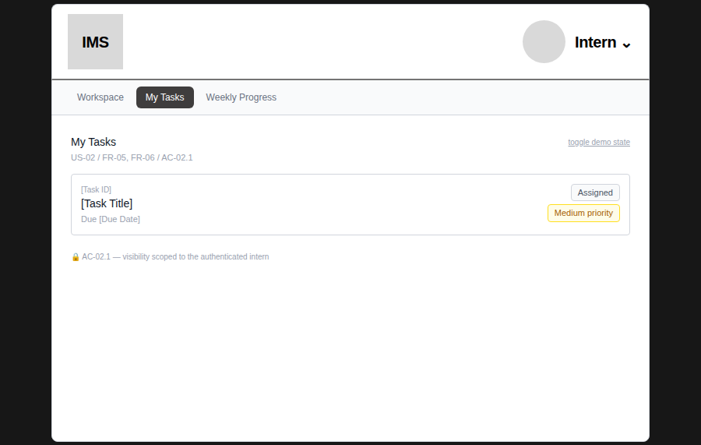  After — heading and codes separated

4.2 Badge order + heading casing — Review Progress
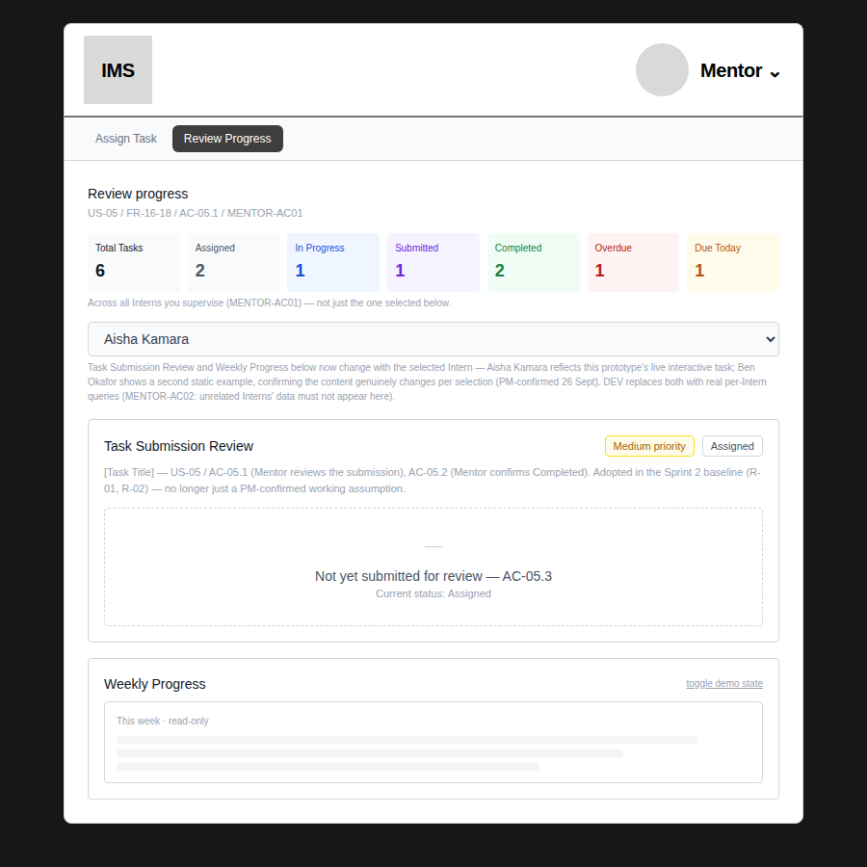  Before — “Review progress”, Priority-then-Status | 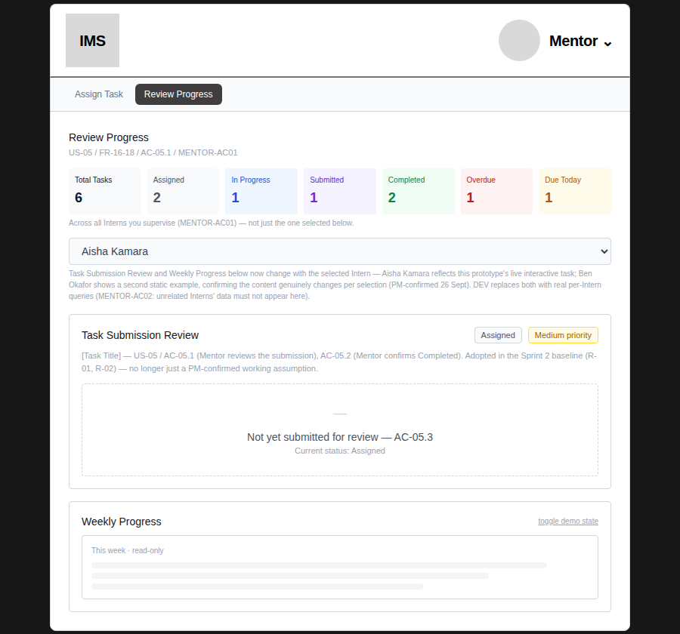  After — “Review Progress”, Status-then-Priority

4.3 Heading casing — Assign Task
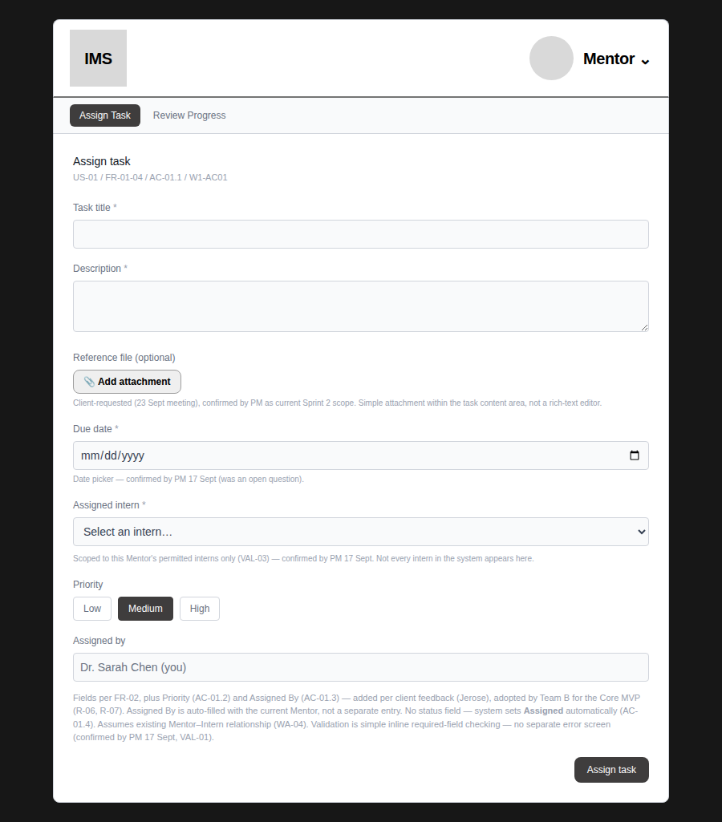  Before — “Assign task” (page) vs “Assign Task” (tab) | 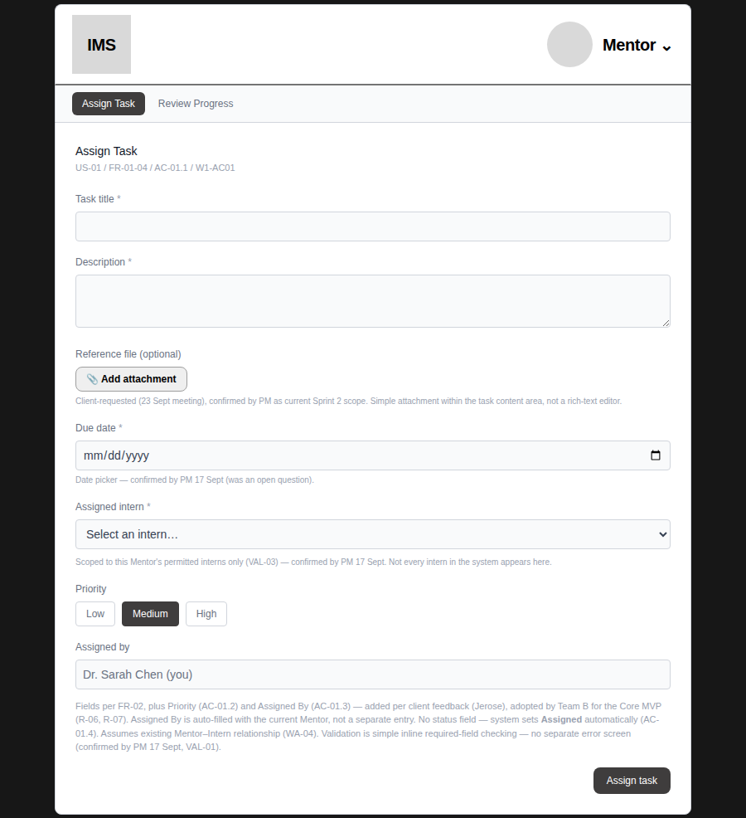  After — page heading matches the tab

4.4 Status colour across the full lifecycle (after fix)
Confirmed by driving the prototype through every status with Playwright — not just inspecting the code — so the colours shown are what actually renders, not what the source claims.
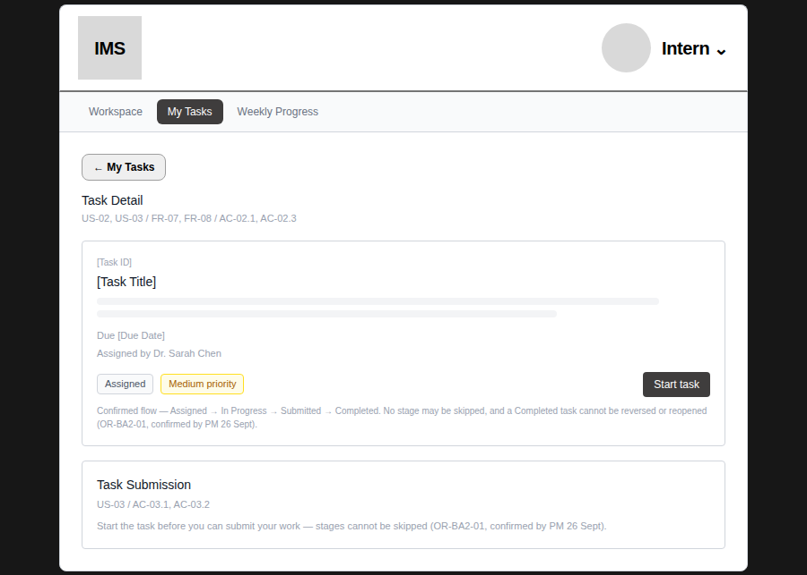
Task Detail — Assigned (gray)
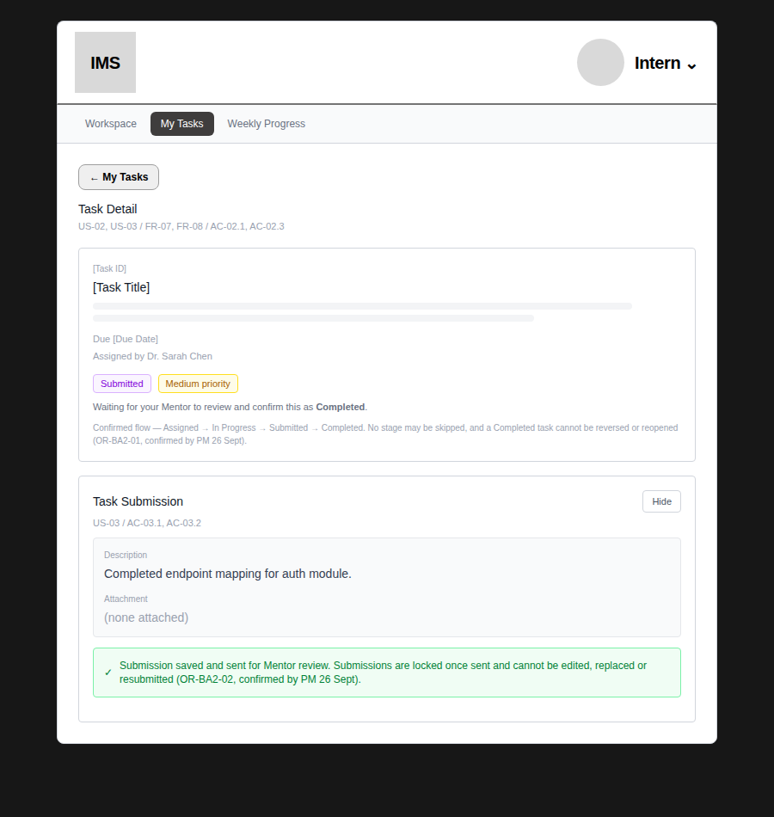
Task Detail — Submitted (purple), after completing the submission form
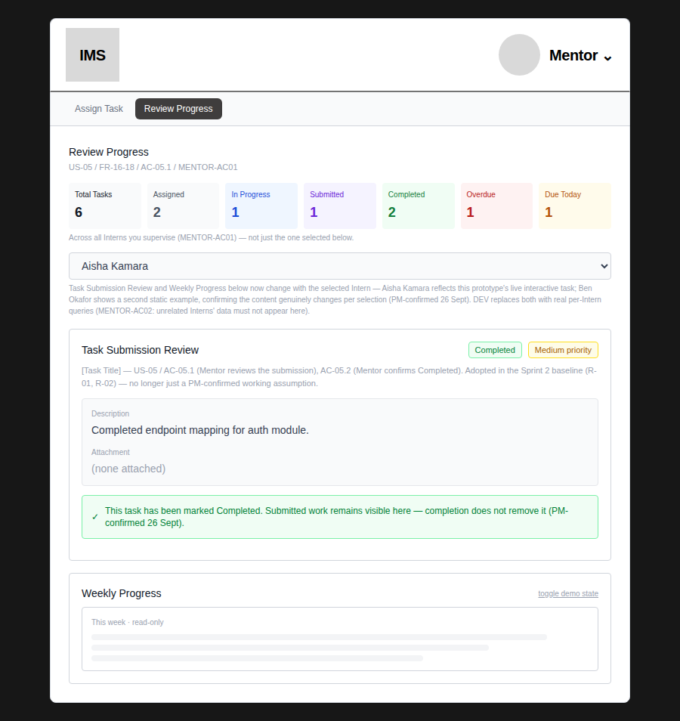
Review Progress — Completed (green), after “Mark completed”

4.5 Redundant back link removed — Weekly Progress
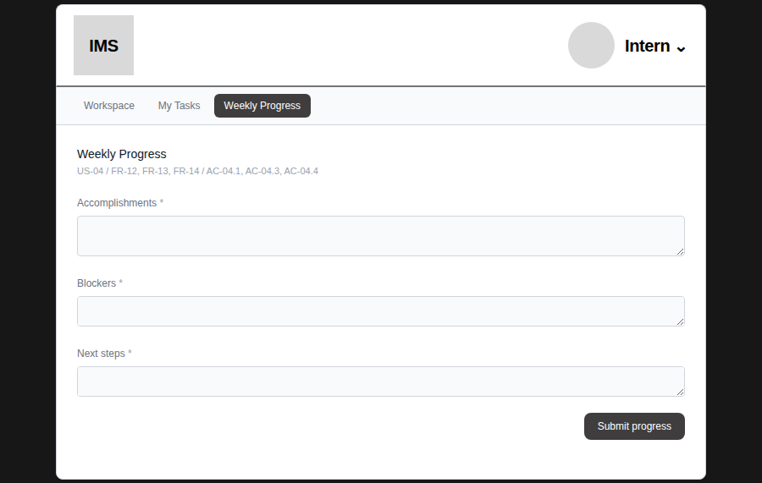
Weekly Progress — no back link; already reachable via its own tab

4.6 Mentor's Weekly Progress now reflects the Intern's real submission
Captured by actually submitting Weekly Progress as the Intern (Aisha Kamara), then switching to Mentor and opening Review Progress — not by inspecting the code.
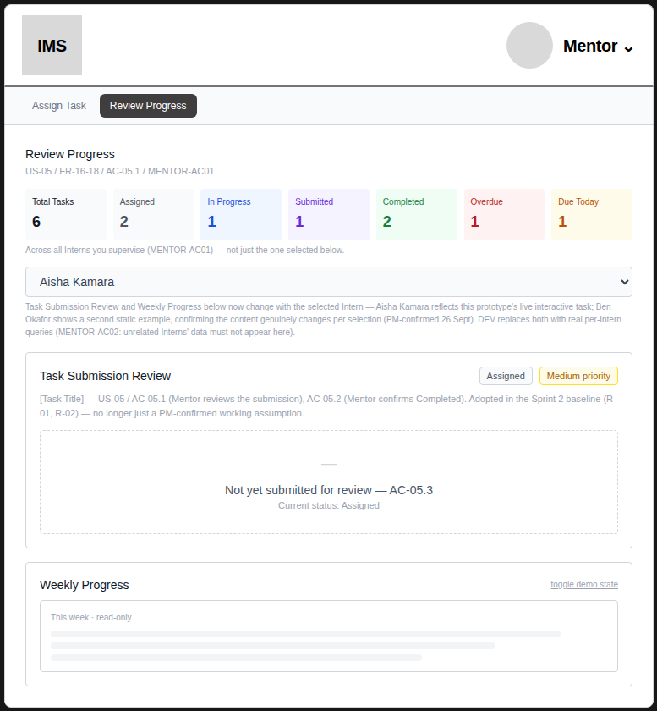  Before — generic placeholder bars and an always-visible “toggle demo state” control, regardless of what the Intern actually submitted | 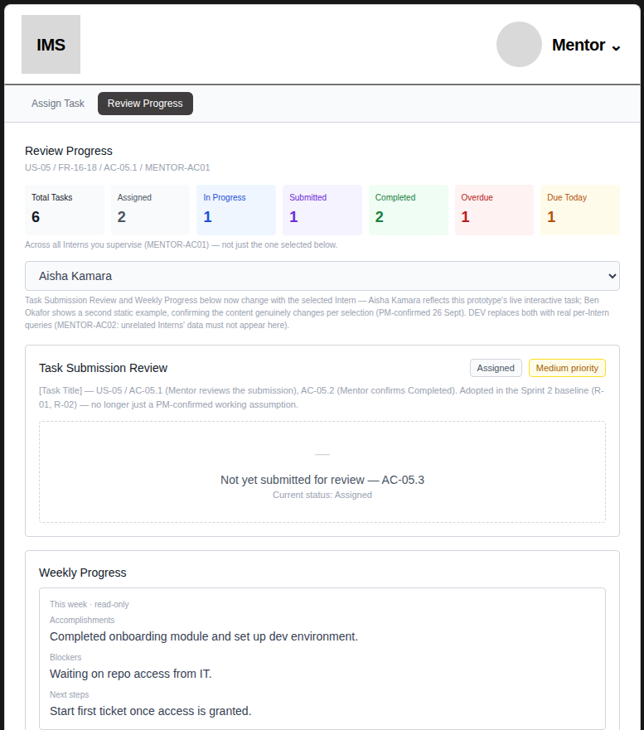  After — shows the Intern's real accomplishments, blockers and next steps; the toggle is hidden since it no longer applies to the live Intern

4.7 Workspace tile now reflects real submission state
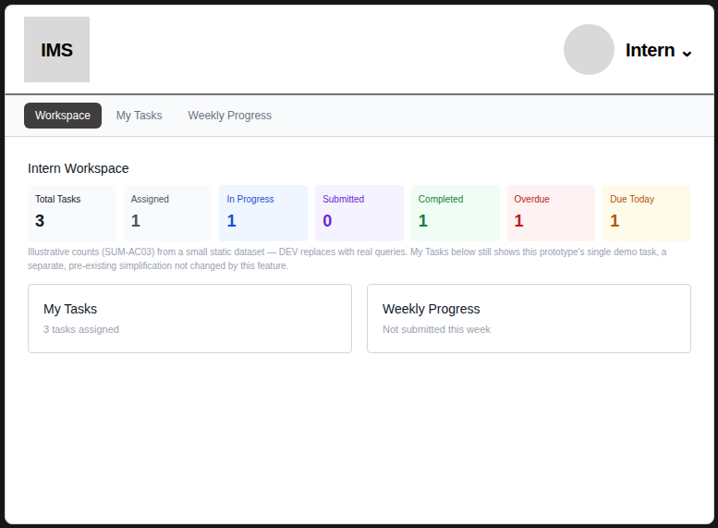  Before — always “Not submitted this week”, even after a real submission | 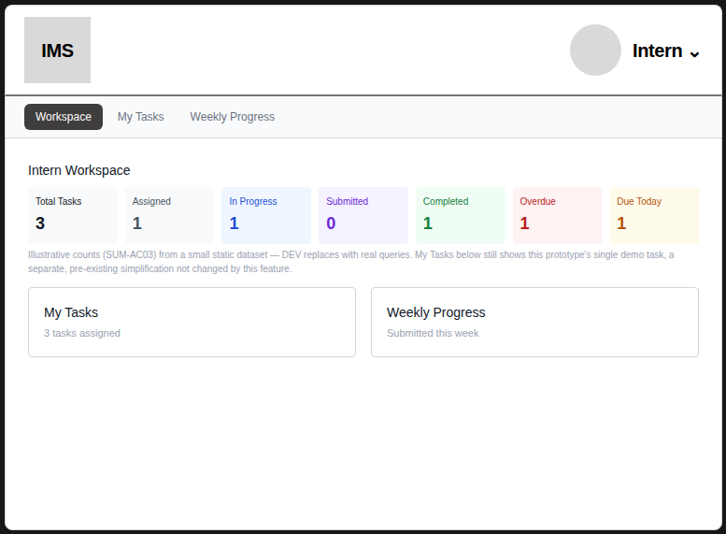  After — “Submitted this week” once the Intern has actually submitted

4.8 Access-denied preview code — Workspace
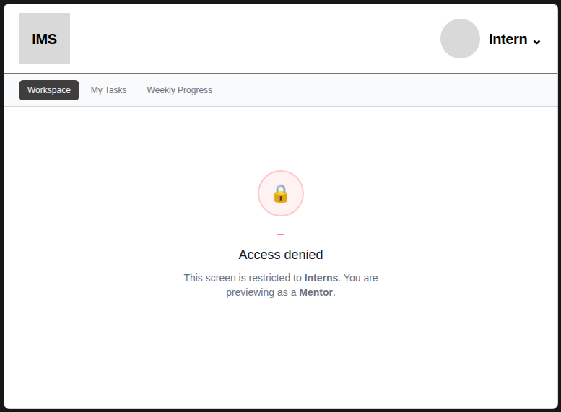  Before — bare “—” placeholder above “Access denied” | 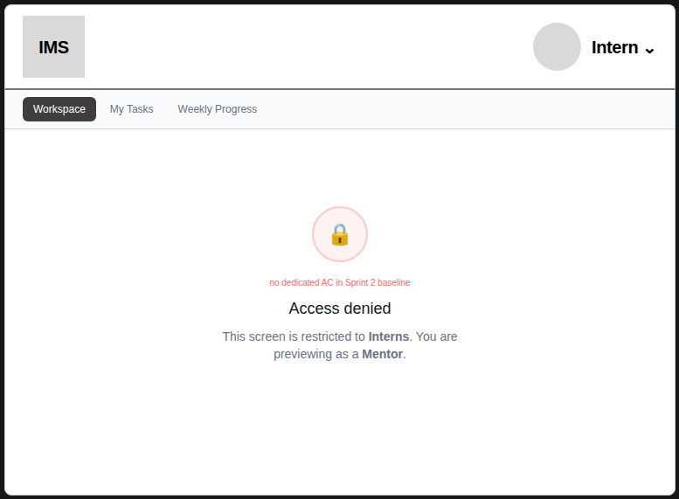  After — “no dedicated AC in Sprint 2 baseline”, matching the other three Intern screens

5. Recommended — Sprint 3 Polish (not implemented this round)
These are flagged for a future pass, not implemented now — each needs a design or scope decision beyond a same-screen text/colour fix, which is outside what a refinement task should silently resolve.
1. The “Total Tasks” and “Assigned” Summary cards currently share the same neutral gray, which can read as ambiguous next to each other. A distinct accent for the Total card would touch the already BA-confirmed colour spec (SUM-AC03, Section 6.2) and should get a quick PM/BA sign-off rather than being changed unilaterally here.
2. The 7-card summary grid wraps to an uneven row of 3 at the narrowest breakpoint tested in this prototype (4 columns). Worth a pass against real device widths once DEV's responsive breakpoints exist — this prototype is a desktop-oriented canvas, not a true responsive build.
3. Whether developer-facing requirement codes (US-xx / FR-xx / AC-xx) should appear in the shipped product UI at all, or be stripped as UX-only annotations before DEV's build, is a cross-cutting decision that touches every screen. Recommend PM/BA confirm the intended DEV behaviour rather than deciding it silently inside the prototype.

6. Handoff Summary
Confirmed
All ten Must Fix items above are implemented and verified in the current prototype (App.tsx, v5), across two audit passes. No task status, validation rule, permission, or workflow behaviour changed — this was a presentation and data-binding pass, per the task's own instruction not to introduce new business rules or features.

Open for PM/BA input
The three Sprint 3 Polish items in Section 5 are recommendations only. None block this task or Sprint 2 Playback.

File: App.tsx (v5) — core-mvp-prototype. Figma Make prototype link and Sprint 2 Playback evidence to follow separately per the PM's Task 2 (Core MVP UX Evidence & Demo Handoff).

