Task Management Implementation — UX Review & Priority Fix List
Sprint 2 Week 1 — validating DEV's build against the approved UX handoff/prototype
Team: Team 40 / Team B — Intern Management System
Task: [UX VALIDATION] — Task Management Implementation UX Review & Priority Fix List
UX Designer: Faridullah Jabbar Khil
Sprint: Sprint 2 — Week 1
Evidence reviewed: Screen recording of the live DEV build (localhost:5173), supporting screenshots, and the independent Team40_Week1_Functional_Testing_Evidence report (20 Sept)
Compared against: Mentor Task Assignment Developer Handoff v2; approved Sprint 1 prototype; Sprint 2 Week 1 Task Management Implementation Clarifications (BA, 17 Sept)
PM status: PM has reviewed the implementation and confirmed it looks good, with no changes required
Purpose
This review compares the actual DEV implementation (a working build, not a prototype) against the approved UX v2 handoff, screen by screen. Per the task's acceptance criteria, this introduces no new feature scope — it only checks whether what was built matches what was specified, flags any material inconsistencies with concrete correction guidance, and separates must-fix issues from optional polish.
An independent functional test (Team40_Week1_Functional_Testing_Evidence, 20 Sept) was conducted separately and reached the same result across all 6 tested areas: Mentor Task Assignment, Required Fields, Database Persistence, Intern Assigned-Task Viewing, Task Detail, and Assigned → In Progress all PASS, with no functional defect identified. That report's database evidence additionally confirms Assigned Intern and Assigned By are stored as proper relational references (assigned_intern_id, assigned_by_mentor_id), not just display names — a detail this review's own evidence didn't show directly. Findings below are cross-referenced against that report where relevant.
1. Mentor Task Assignment vs. the approved UX v2 handoff
CONFIRMED MATCH — field order matches exactly — Task title, Description, Due date, Assigned intern, Priority, Assigned by.
CONFIRMED MATCH — Priority is a 3-way pill selector (Low/Medium/High), defaults to Medium, matches the handoff's interaction and visual spec.
CONFIRMED MATCH — Assigned By is read-only and auto-filled with “{name} (you)” — matches AC-01.3/VAL-04 exactly.
CONFIRMED MATCH — Due Date is a real calendar date picker — satisfies the PM's 17 Sept decision. Uses dd/mm/yyyy format, which differs from the handoff doc's mm/dd/yyyy placeholder example; this is very likely correct for an Australian client and not a defect, just noting the difference for the record.
CONFIRMED MATCH — Success message matches the handoff's exact pattern: “Task assigned to {name} ({priority} priority).” Form correctly resets after success — title, description, due date, and intern selection all clear, Priority returns to Medium — while the success message still names the intern and priority that were actually just submitted, not the reset values. This is the same capture-before-reset behaviour specified in the handoff, correctly implemented.
Figure 1 — Assign Task — filled and ready to submit
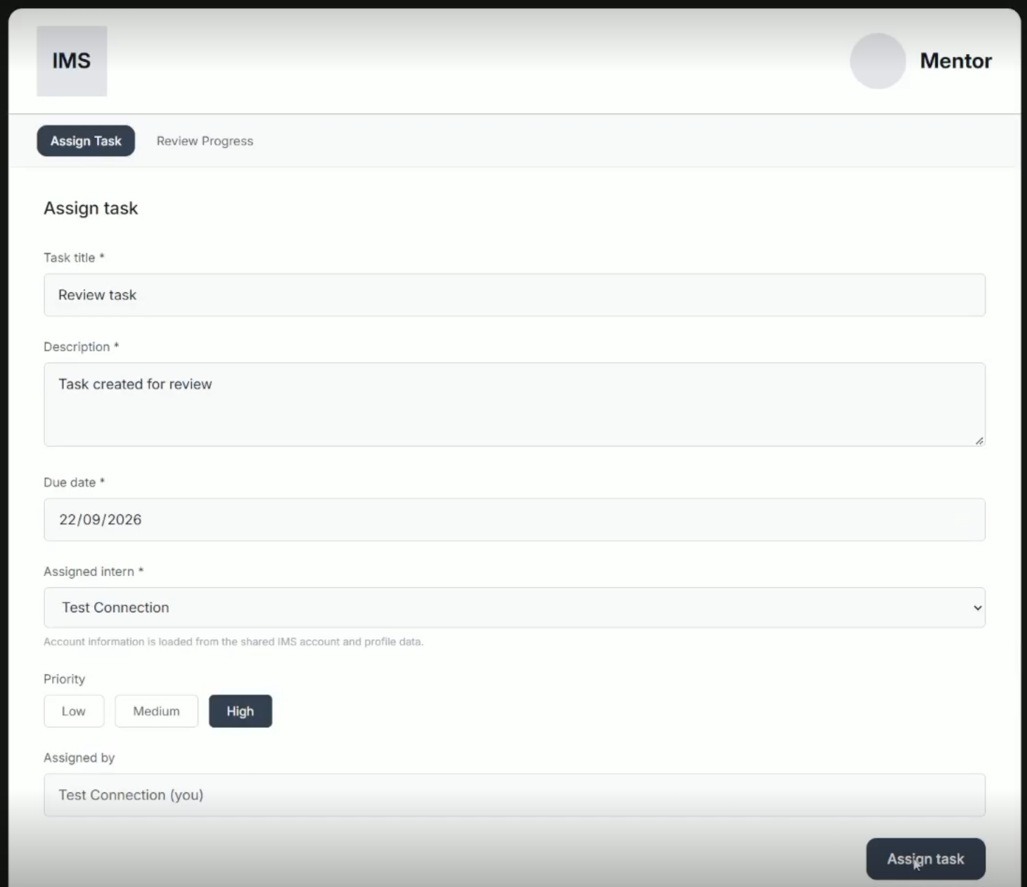
Figure 2 — Assign Task — success confirmation, form reset
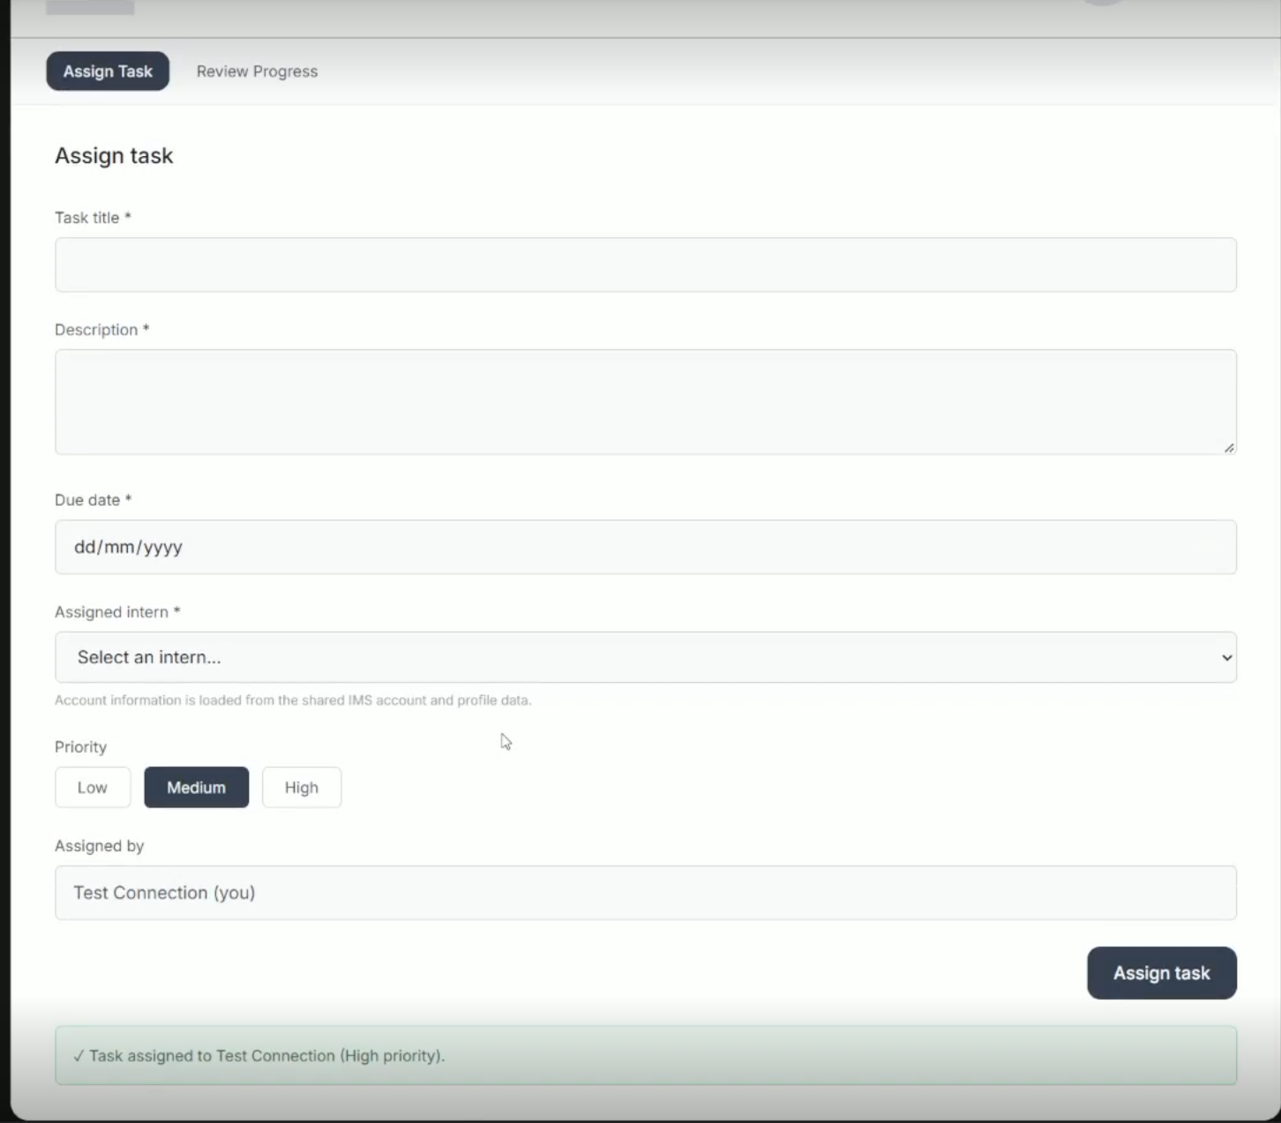
Priority pill visibly back to Medium, but the banner correctly still reads “High priority” — confirms the value was captured before the reset, not read from the reset state.
Note: the Assigned Intern dropdown's scoping to permitted interns only could not be tested in this environment, since only a single test account exists (the same account used for both assigning and being assigned in this test data) — there is no second intern to distinguish a correctly-scoped list from an unscoped one. This is a test-environment limitation, not an application concern, and does not need separate verification here.
2. Intern Task List, Task Detail, and the Assigned → In Progress interaction
CONFIRMED MATCH — My Tasks list shows Task ID, Title, Due date, Status badge, and Priority badge — matches the handoff's structure and terminology.
CONFIRMED MATCH — Task Detail shows the task's Status and Priority badges together, Assigned by, and a working “Start task” action. Clicking it correctly transitions Assigned → In Progress, and the change persists (confirmed across multiple screenshots of the same task at different points).
CONFIRMED MATCH — DEV added a line not in the original handoff: “Task status for this flow is limited to Assigned → In Progress. Submission and completion are handled in later workflow stages,” with the Task Submission section correspondingly disabled (“Submission is handled in the next implementation stage”). This correctly enforces the Week 1 scope freeze from the BA clarification (Section 3.3, Section 6 deferred items) — the approved prototype shows the full 4-stage lifecycle because it represents the whole Core MVP, not just this slice. This is an appropriate, spec-compliant narrowing, not a mismatch.
Figure 3 — Task Detail — Assigned, before Start task
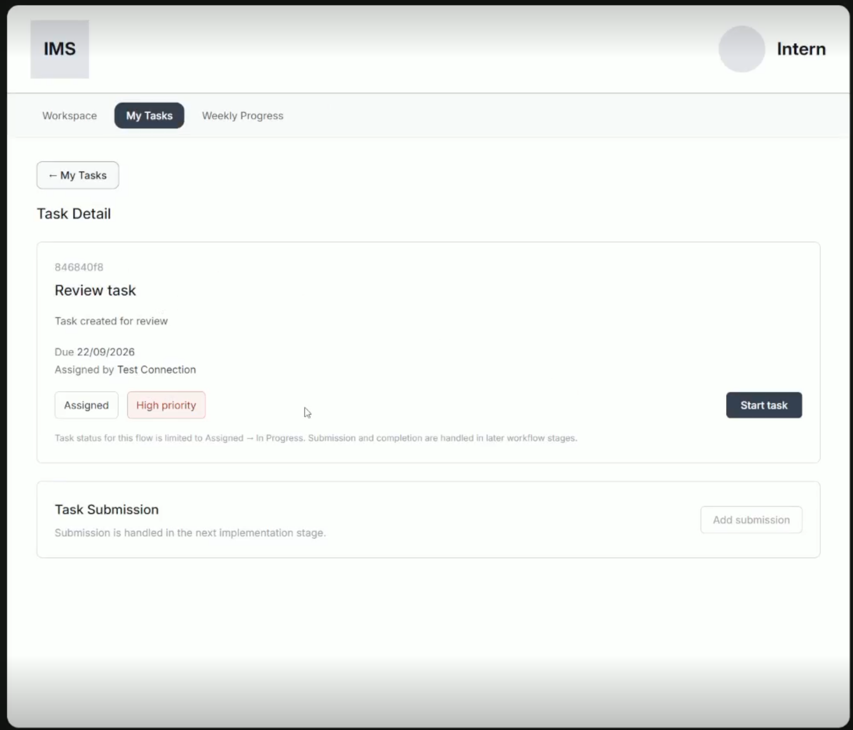
Figure 4 — Task Detail — In Progress, after Start task, status persisted
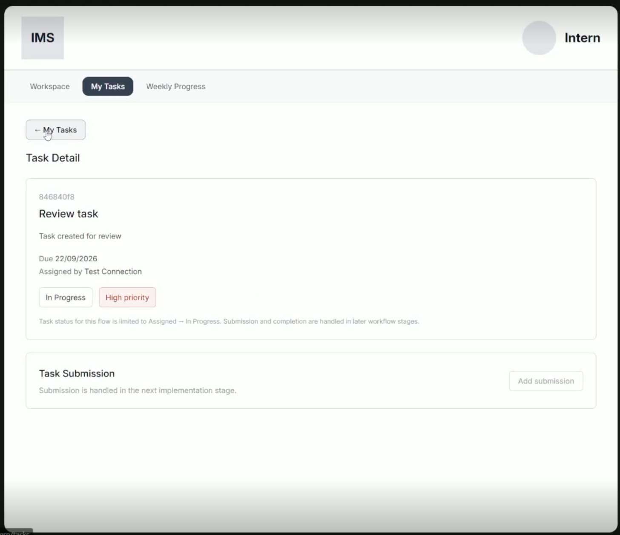
3. Validation, success, empty/error, and status feedback
CONFIRMED MATCH — success feedback for Assign Task and for the Assigned → In Progress transition both work as specified (see Sections 1 and 2).
CONFIRMED MATCH — empty-submission validation is implemented and confirmed working — attempting to submit with required fields missing shows a clear inline error (“Please complete all required fields.”) and does not create a task. This is independently corroborated by the Team40_Week1_Functional_Testing_Evidence report (20 Sept), which records this as a PASS: “Incomplete form was rejected and a clear required-fields error was displayed.”
Figure 5 — Assign Task — empty submission correctly rejected with inline error
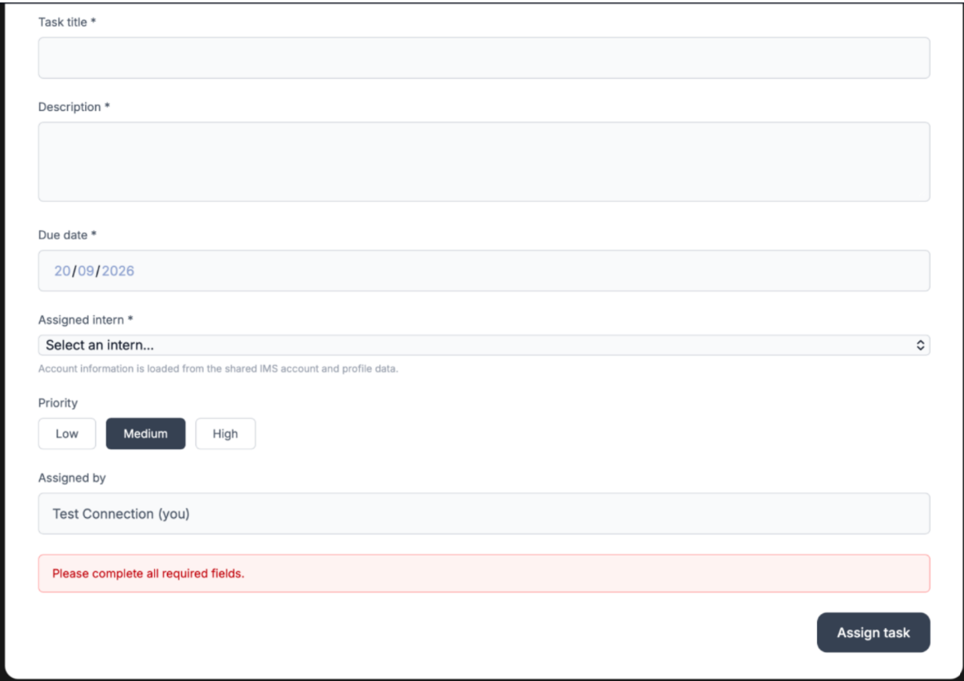
4. Navigation, terminology, and shared IMS visual consistency
CONFIRMED MATCH — header (logo box, avatar, role label), nav tabs (Workspace / My Tasks / Weekly Progress for Intern; Assign Task / Review Progress for Mentor), and all field labels match the handoff's terminology exactly.
CONFIRMED MATCH — primary button colour and styling are visually consistent with the Team A-aligned spec across every screen shown.
Exact hex values could not be pixel-verified from these screenshots the way they were for the prototype (compression and screen capture can shift colour slightly) — nothing looks visually off, but a live pixel check is the only way to confirm with the same certainty as the prototype review.
5. Prioritised Fix List
Must Fix
None identified. Nothing in the reviewed evidence contradicts the approved UX handoff.
Needs Verification
None remaining. Both items originally raised here (Assigned Intern dropdown scoping, and empty-submission validation) are resolved: the dropdown-scoping question is not testable in the current single-account test environment and is not an application concern; validation is confirmed working and independently corroborated (Section 3).
Sprint 3 Polish (non-blocking)
- Due date format is dd/mm/yyyy versus the handoff doc's mm/dd/yyyy example — almost certainly correct for this client, just noted for the record.
Sign-off
PM has reviewed the implementation directly and confirmed it looks good, with no changes required. This review's findings agree with that assessment and with the independent functional testing report's PASS result across all tested areas — no outstanding items remain from this review.

