Team 40 - Team B
Sprint 2 Technical Baseline
Intern Management System (IMS)

Prepared by | Chan Hoang Truong
Role | Developer (Team B)
Date | 10 September 2026

Food Systems Collective Capstone

1. Purpose and Scope
This document records the technical baseline established for Team 40 Team B before Sprint 2 development. The work focused on preparing the Team B Core MVP database structure, checking its compatibility with the existing shared IMS account/profile foundation, and verifying that the backend, frontend and database development path is operational.
The evidence below is intended to make the Sprint 1 Playback and Sprint 2 handoff reviewable: it shows what was created, how relationships were tested, and how local development connectivity was verified.

2. Technical Baseline Summary
- Created Team B Core MVP tables in the Supabase public schema: tasks, task_submissions, weekly_progress and weekly_progress_tasks.
- Reused the existing shared_accounts/person_profile foundation rather than creating a separate Team B user model.
- Verified foreign-key/data relationships by creating test records across the Team B tables.
- Verified the NestJS backend starts with zero compilation errors and initializes the configured TypeORM/PostgreSQL connection.
- Verified the React Router frontend can communicate with the NestJS backend in local development through a temporary connectivity test.

3. Database Setup and Verification
The database baseline was created in Supabase using the existing public schema. Row Level Security (RLS) was enabled when the new tables were created; detailed access policies remain a Sprint 2 implementation dependency.

3.1 Tasks
The tasks table provides the Team B task-management baseline. The test record confirms that a task can be created with a title, description, status and priority while retaining links for intern/mentor assignment through the shared account foundation.
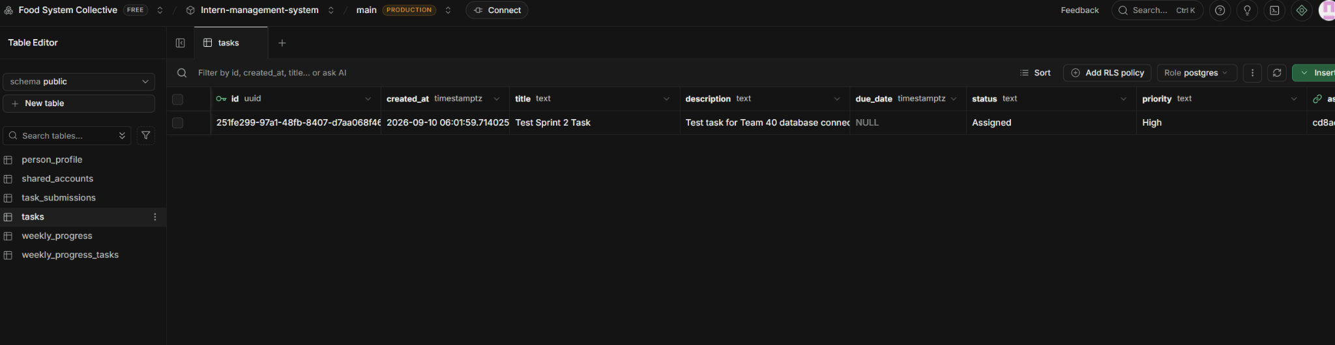
Figure 1. Supabase tasks table showing the Sprint 2 verification task.

3.2 Task Submissions
Task Submission is kept as a separate concept from task status and Weekly Progress. A test submission was created with a task reference and a submitting intern reference, confirming the intended relationship path.
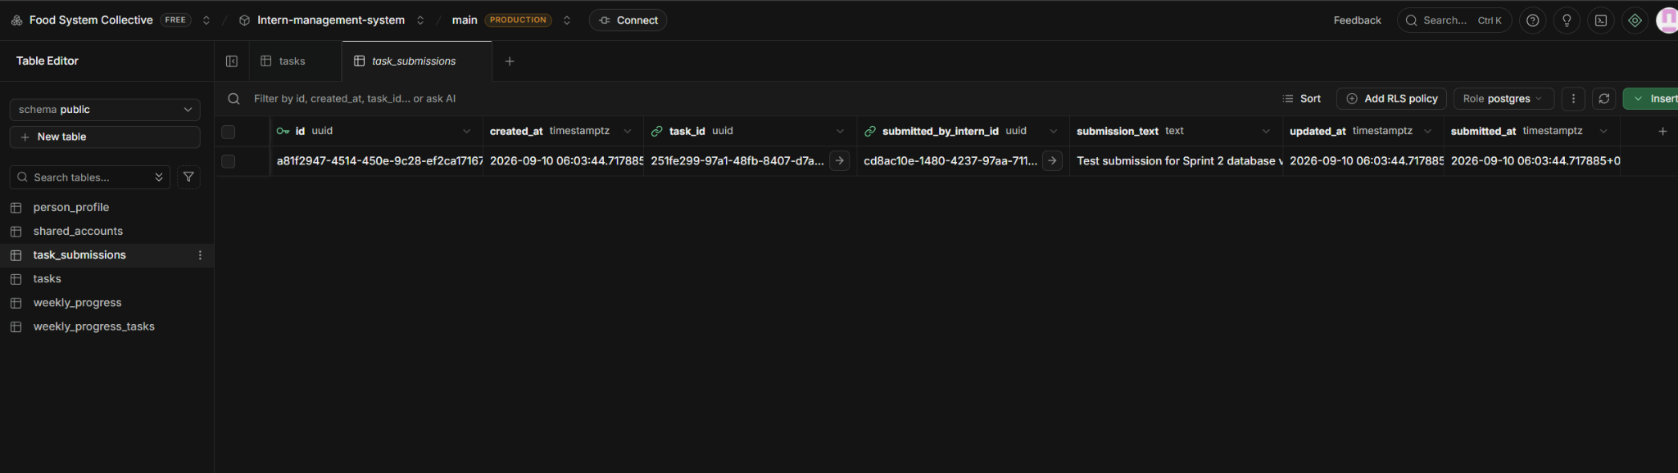
Figure 2. task_submissions test record linked to a task and shared account.

3.3 Weekly Progress
The weekly_progress table stores an intern's reporting week, accomplishments, blockers and next steps. A test record was created against the existing shared account foundation to verify the relationship.
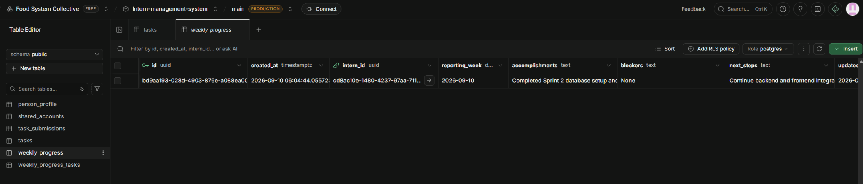
Figure 3. weekly_progress test record used for database relationship verification.

3.4 Weekly Progress to Task Relationship
The weekly_progress_tasks junction table allows a Weekly Progress record to reference relevant tasks without merging the two concepts. This supports the current Team B model in which Weekly Progress remains a separate reporting record.
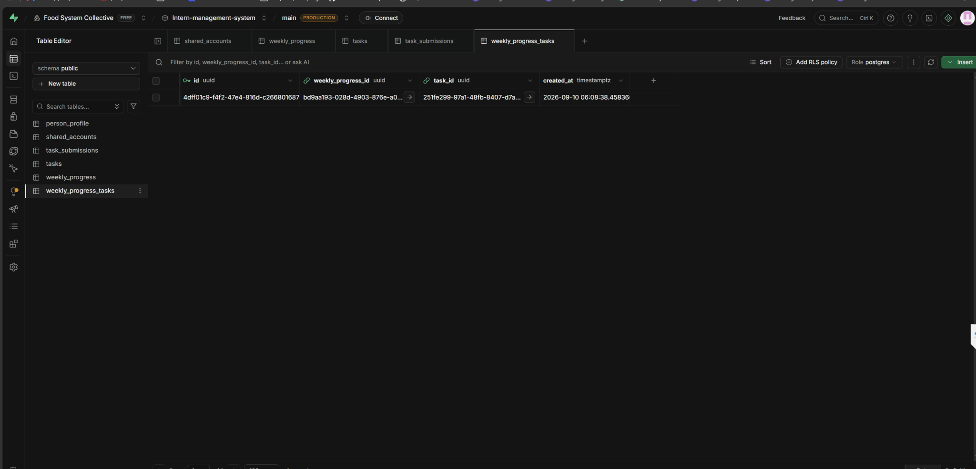
Figure 4. weekly_progress_tasks record linking Weekly Progress to a Task.

4. Backend and Database Readiness
The NestJS backend was started locally using the development command. The terminal output showed zero compilation errors, successful initialization of TypeOrmModule/TypeOrmCoreModule dependencies, route mapping, and successful Nest application startup. This verifies that the backend can initialize its configured PostgreSQL/Supabase connection in the current development environment.
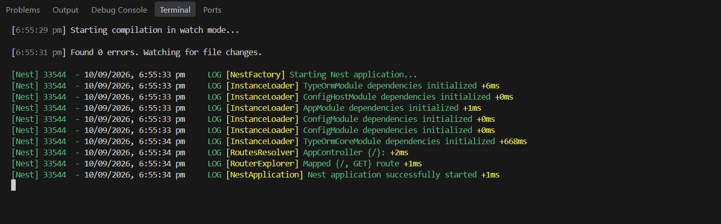
Figure 5. NestJS startup showing zero errors, TypeORM initialization and successful application startup.

5. Frontend-to-Backend Development Path
A temporary local connectivity test was used to verify the frontend-to-backend path. The React Router frontend at localhost:5173 requested the NestJS backend at localhost:3000 and displayed the returned 'Hello World!' response with Connection Status: SUCCESS. The temporary test/CORS changes were removed after verification so the repositories returned to their clean working state.

Figure 6. Local frontend-to-backend connectivity verification showing SUCCESS.
This test verifies the frontend-to-backend development path. Together with the backend TypeORM initialization evidence and the Supabase relationship tests, it establishes the development baseline for Sprint 2. It was not a full Team B CRUD flow from the frontend through a production API endpoint.

6. Sprint 2 Readiness and Remaining Dependencies
No blocker to beginning Sprint 2 development was found during the local verification. The following items remain implementation dependencies and should be addressed as the relevant features are built:
- Define RLS policies for the new Team B tables before client/API access is treated as final.
- Capture the new Team B database schema in a version-controlled backend migration for reproducibility and team handoff.
- Implement permanent frontend/backend CORS or proxy configuration; the connectivity verification used temporary local CORS configuration.
- Confirm exact Task Submission fields, Mentor review details and detailed RBAC rules before those areas are finalized.
- Coordinate any material BA/UX/client requirement changes before final data-model sign-off.

7. Relevant Links
The following project locations are relevant to this technical baseline. Direct URLs can be added/updated in the task Notes and in this section after the document PR is opened.
Resource | Location / Link
Supabase environment | Intern-management-system | Food System Collective | Supabase
Document PR

