Prototype Addendum — Priority & Assigned By
New fields added per client-confirmed feedback
Team: Team 40 / Team B — Intern Management System
Related deliverable: Shared-IMS-Design-Alignment-and-Prototype updated version.docx (this adds to it, does not replace it)
UX Designer: Faridullah Jabbar Khil
Sprint: Sprint 1 — Design & Bootstrap
1. What changed and why
The client (Jerose) reviewed Team B's Core MVP assumptions and recommended adding Priority and Assigned By/Mentor to Task Assignment, “if these are feasible to implement within the available time.” The PM's reply confirmed both as adopted. Neither field existed in the prototype until now.
- Priority — a Low / Medium / High selector, set by the Mentor when assigning a task.
- Assigned By — auto-filled with the current Mentor's name. This is a display, not a separate entry field — the Mentor doing the assigning is obviously who it's assigned by, so there's nothing for them to manually pick.
- Both fields are now visible everywhere the task itself is shown, not just on the assignment form: My Tasks, Task Detail, and the Mentor's Task Submission Review.
2. Not included in this update
The client's second suggestion — linking Weekly Progress to the intern's assigned tasks for that reporting period — was explicitly framed as an enhancement “if scope and timeline permit,” not a confirmed requirement. Recommended to defer to Sprint 3 rather than risk destabilizing the tested Sprint 1 baseline this late — pending PM confirmation.
3. Screenshots — new fields only
These four screens are the only ones that changed. Everything else in the prototype is unchanged from the previous version.
Figure 1 — Assign Task — Priority selector and Assigned By display
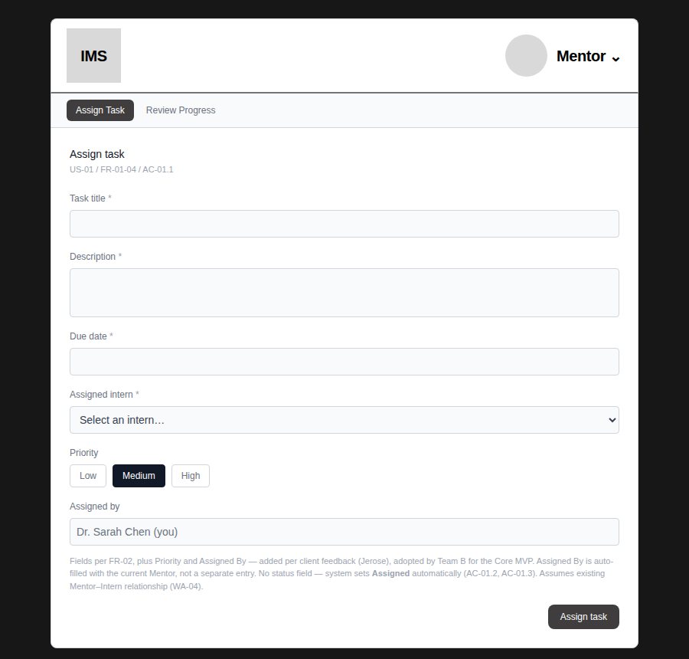
Figure 2 — Assign Task — success confirmation naming the selected priority
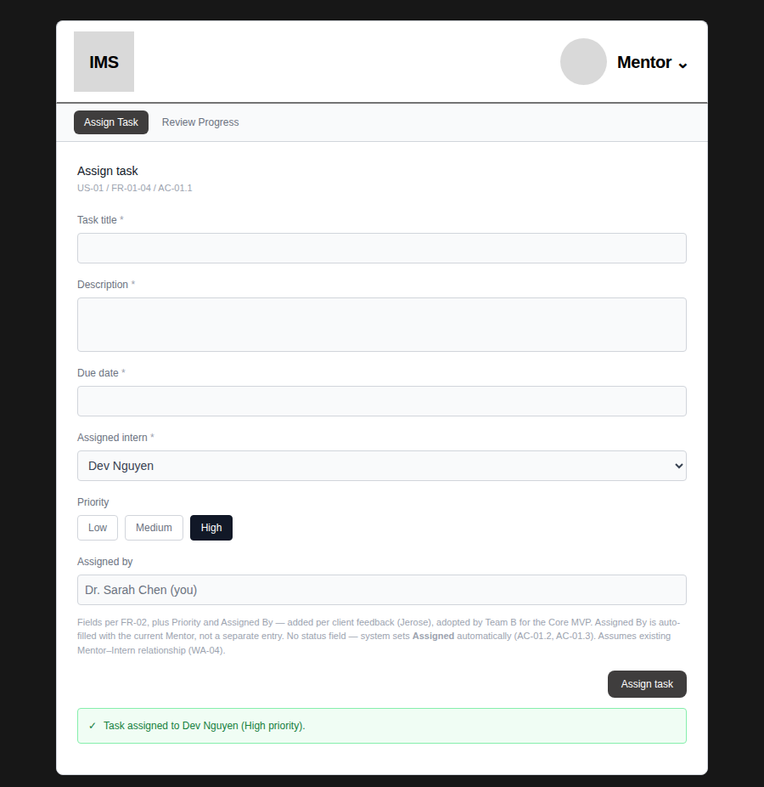
“High priority” in the confirmation message matches exactly what was selected — confirmed by test, not assumed.
Figure 3 — My Tasks — Priority badge visible on the Intern's own task list
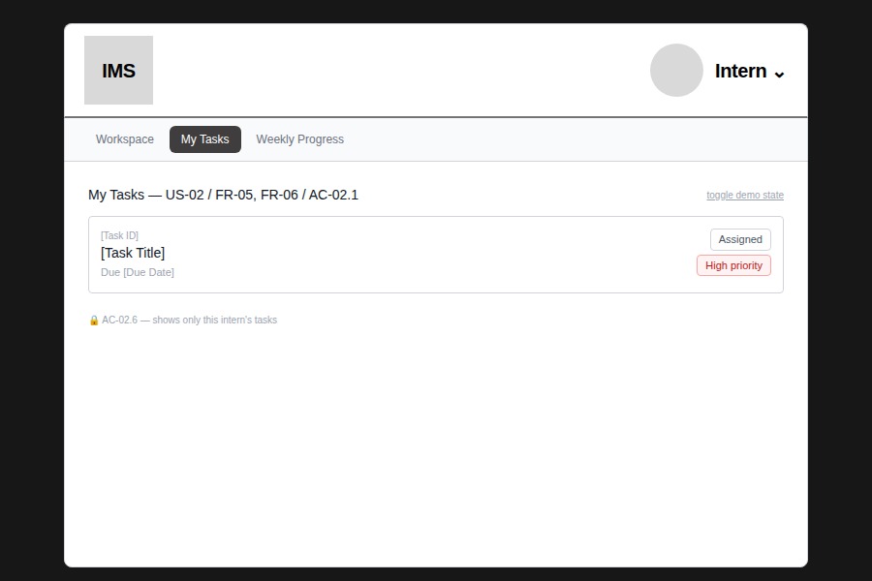
Same priority set by the Mentor in Figure 2, now visible to the Intern — confirms the data is shared correctly, not a placeholder.
Figure 4 — Task Detail — both new fields visible together (“Assigned by Dr. Sarah Chen” + High priority badge)
