Shared IMS Design Alignment and Detailed Core MVP Prototype
UX deliverable — Sprint 1
Team: Team 40 / Team B — Intern Management System
Task: [UX DESIGN] — Shared IMS Design Alignment and Detailed Core MVP Prototype
UX Designer: Faridullah Jabbar Khil
Sprint: Sprint 1 — Design & Bootstrap
Due date: 10 September 2026 (extended per Team A/B Sprint 1 Playback Preparation Meeting, 9 September)
1. Purpose
This document records the work completed against the 11-item checklist for this task: reviewing Team A's shared Figma conventions, aligning Team B's prototype navigation and component styling to match, and completing all four Core MVP flows as a single interactive prototype. Screenshots throughout are rendered directly from the working prototype code — not mockups.
2. Checklist status
# | Item | Status
1 | Review Week 3 Validation and Sprint 2 Readiness Coordination Record | Not reviewed — document not yet provided
2 | Review existing Team B requirements, wireframes and prototype | Done
3 | Review Team A shared Figma/design conventions | Done — queried Team A's live file directly via Figma MCP
4 | Align shared visual, navigation, form, button and interaction patterns | Done — see Section 3
5 | Complete the Mentor Task Assignment flow | Done
6 | Complete the Intern Assigned Task / Task Submission flow | Done
7 | Complete the Weekly Progress Submission flow | Done
8 | Complete the Mentor Progress Review flow | Done
9 | Ensure the relevant Core MVP flow is fully interactive and review-ready | Done — see Section 4
10 | Incorporate material BA updates received during parallel work | No new BA material received since the Detailed Wireframes corrections
11 | Prepare the final Figma prototype for Sprint 1 Playback / Sprint 2 reference | Published to Figma Make (see link)

3. Team A design alignment
Team A's shared Figma file (“Captsone wireframes”) was reviewed directly via the Figma MCP connector — not estimated from screenshots. The file has no formal design-token system (no color styles, one bound variable in the whole file), so alignment was done at the component level: the exact pixel, color, and typography values of their header and buttons were extracted and applied to Team B's prototype.
Element | Team A (measured) | Team B (before) | Team B (now)
Logo box | 71×71px, #d9d9d9, square corners | Padding-sized, gray-200, rounded | 71×71px, #d9d9d9, square corners
Avatar | 55px circle | 32px circle | 55px circle
Header text | 20px Inter Semibold, black, -0.4px tracking | 14px, gray, Medium | 20px Inter Semibold, black, -0.4px tracking
Header border | 2px solid #747474 (bottom) | 1px gray, all sides | 2px solid #747474 (bottom)
Primary button | #3f3d3d fill, 8px radius | Generic gray-900 | #3f3d3d fill, 8px radius
Secondary (“Back”) | #efefef fill, #9e9e9e border, 8px radius | Plain text link | #efefef fill, #9e9e9e border, 8px radius

Team A's numbered step-circle navigation (1→2→3→4) was deliberately not copied. Their flow is a linear application wizard; Team B's Intern and Mentor screens are independent destinations, not a fixed sequence, so a stepper would misrepresent how the product actually works. Team A's nav bar style (logo box + avatar/name dropdown, clean sub-nav row) was matched; the stepper pattern was not.
Figure 1 — Team A reference — Application Portal
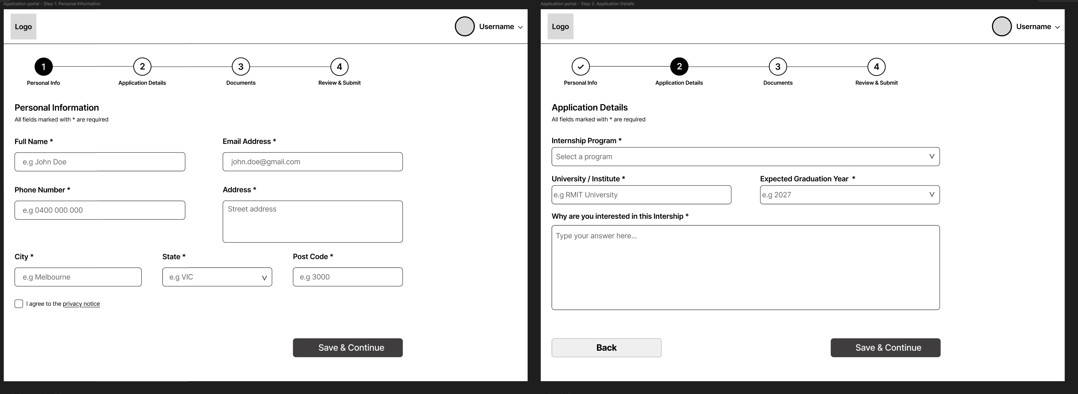
4. Prototype screens — all states
Every distinct screen and state in the prototype, in the order a user would naturally reach them.
4.1 Intern flow
Figure 2 — Intern Workspace
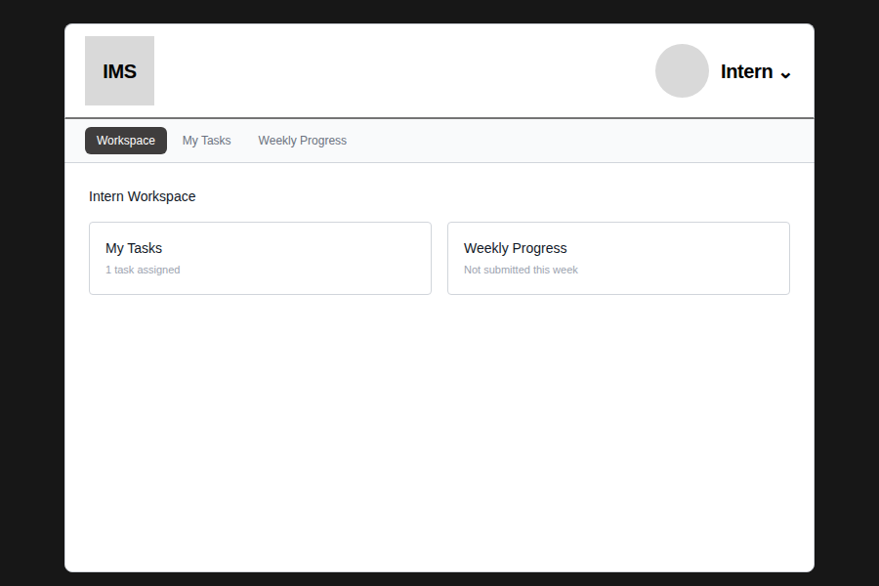
Figure 3 — My Tasks — task assigned
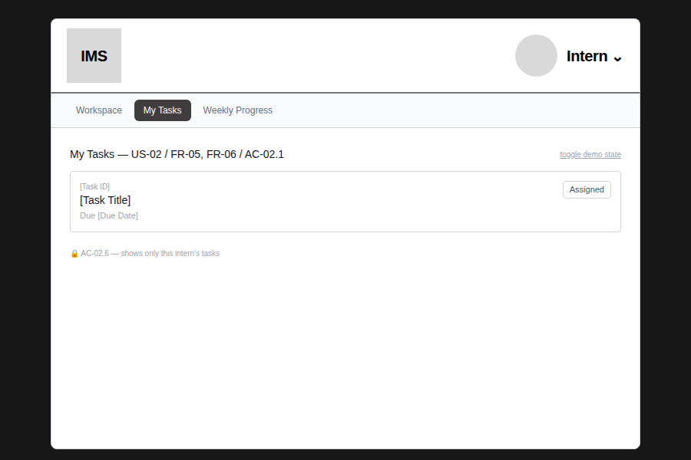
Figure 4 — My Tasks — no task assigned (EC-01 / AC-02.2)
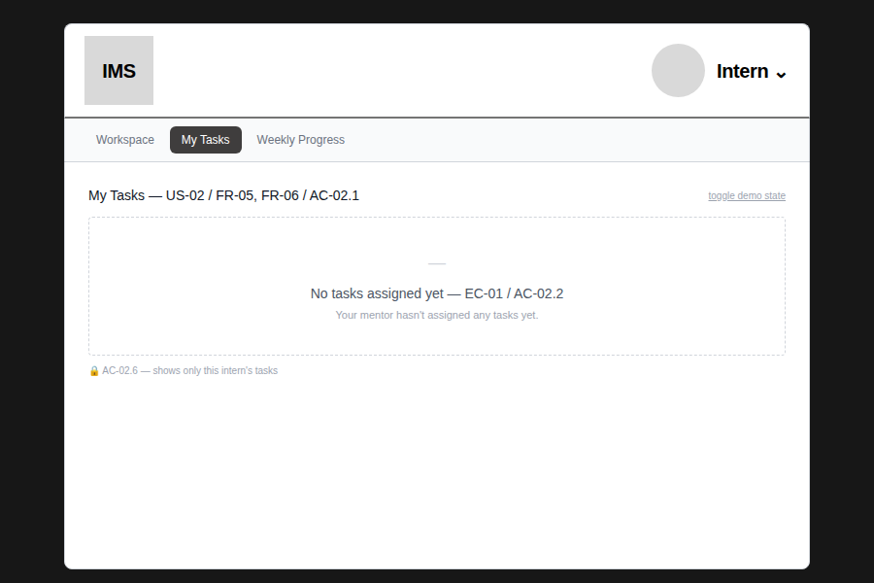
Figure 5 — Task Detail — Assigned
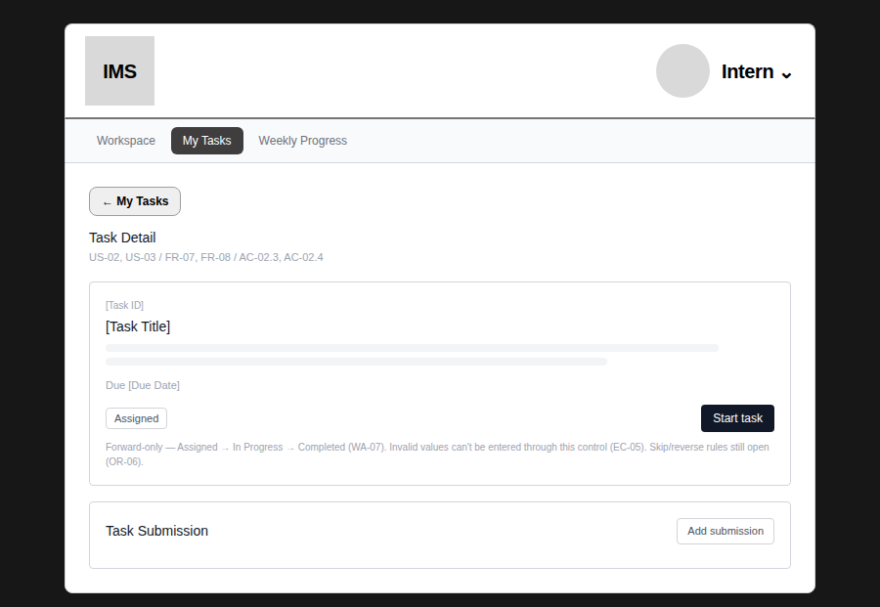
Figure 6 — Task Detail — In Progress
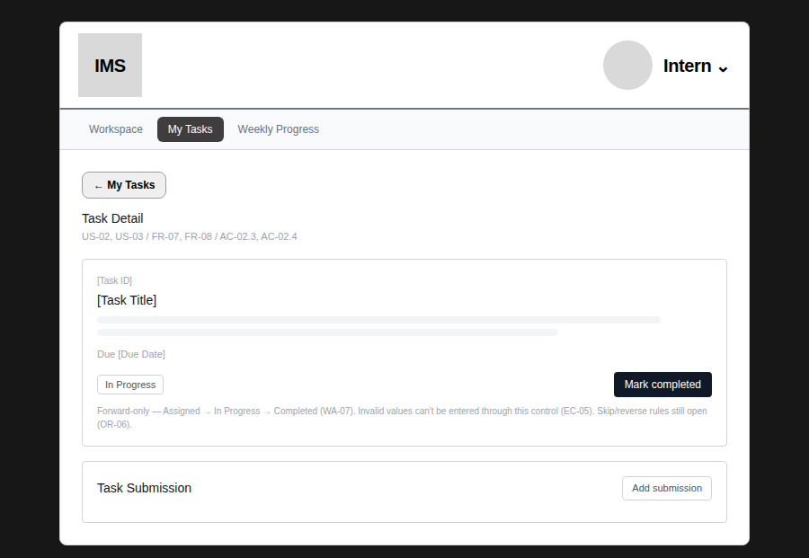
Figure 7 — Task Detail — Completed (final state, no further action)
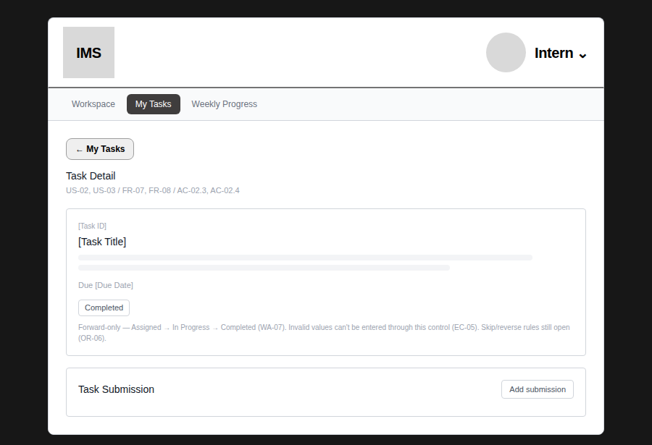
Figure 8 — Task Submission — form open (OR-03, generic by design)
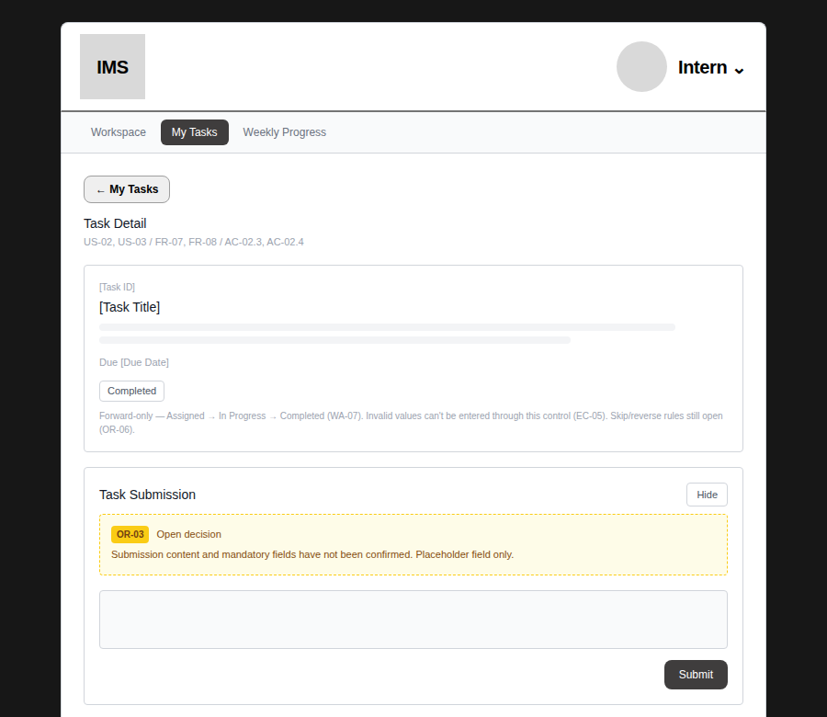
Figure 9 — Task Submission — success confirmation
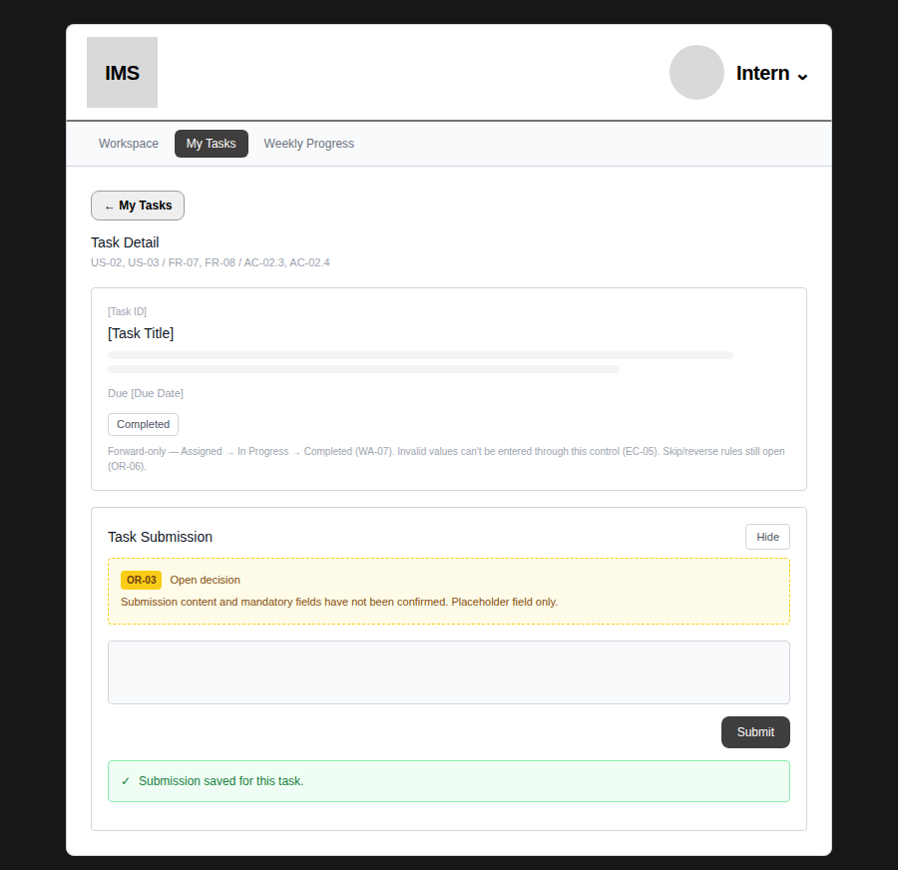
Figure 10 — Weekly Progress — form
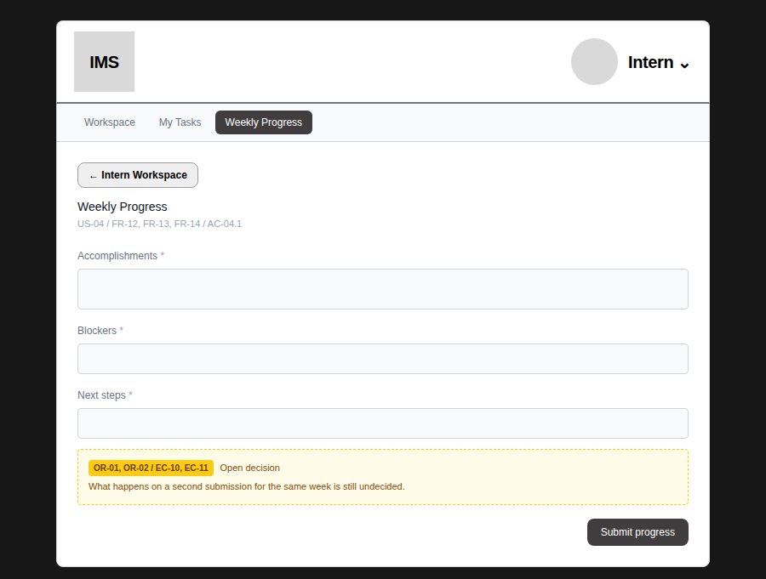
Figure 11 — Weekly Progress — success confirmation
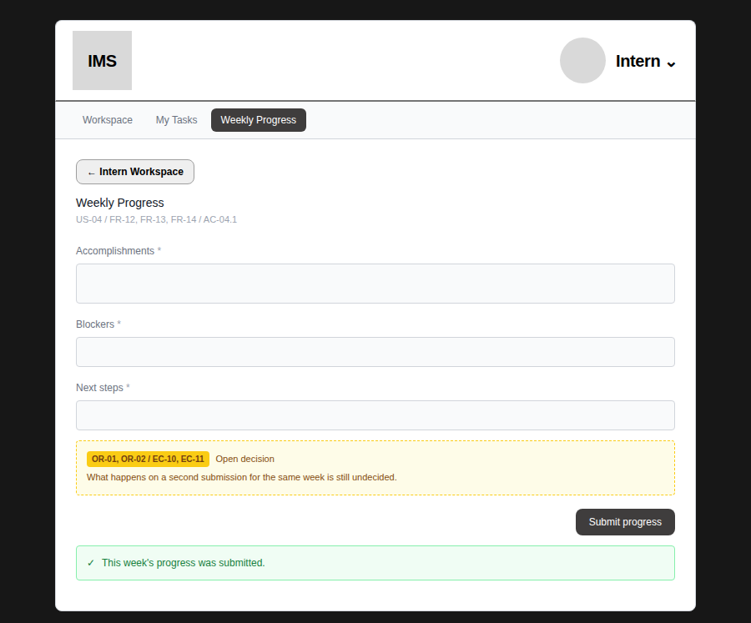
4.2 Mentor flow
Figure 12 — Assign Task — form
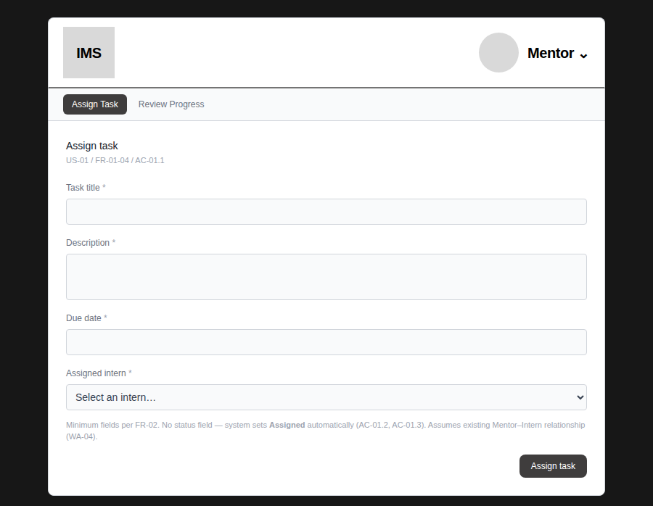
Figure 13 — Assign Task — intern selected
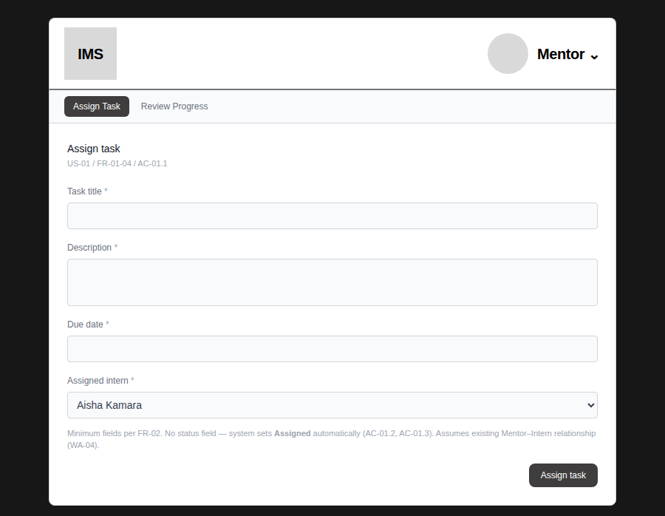
Figure 14 — Assign Task — success confirmation
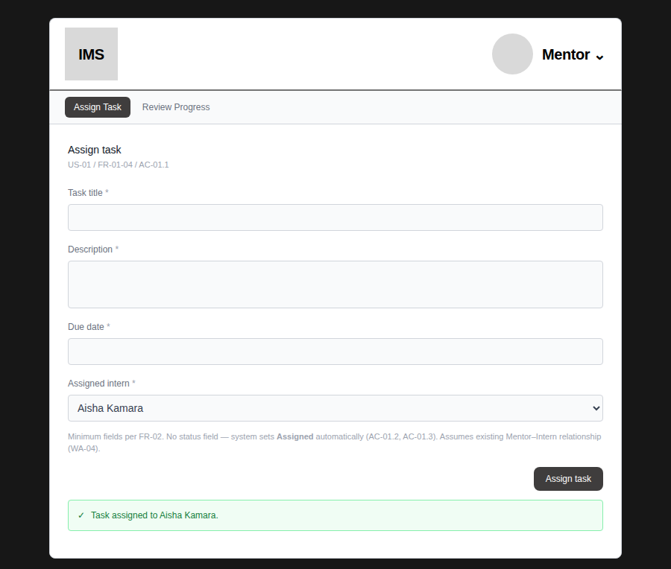
Figure 15 — Review Progress — submission present
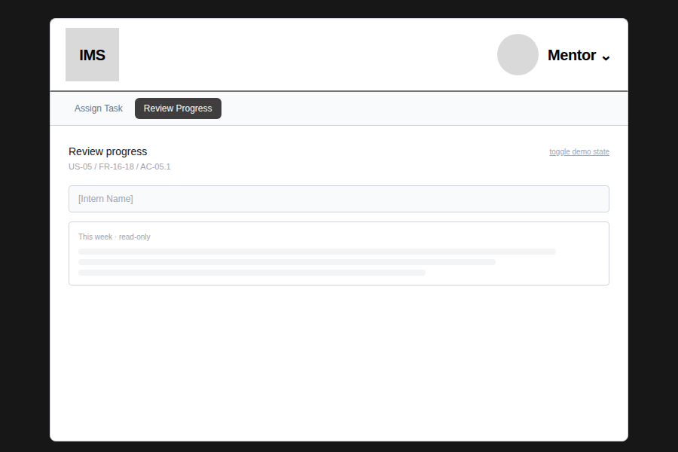
Figure 16 — Review Progress — no submission (EC-09 / AC-05.2)
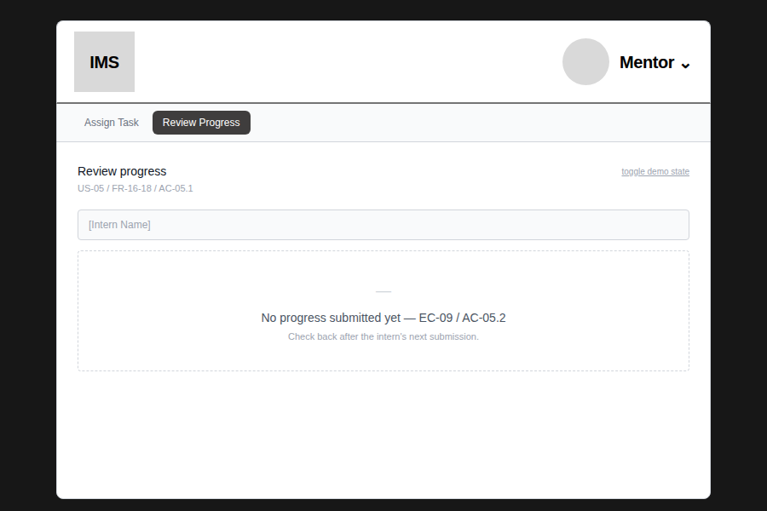
4.3 Shared / prototype tools
Figure 17 — Nav dropdown menu — role switch and prototype-only tools
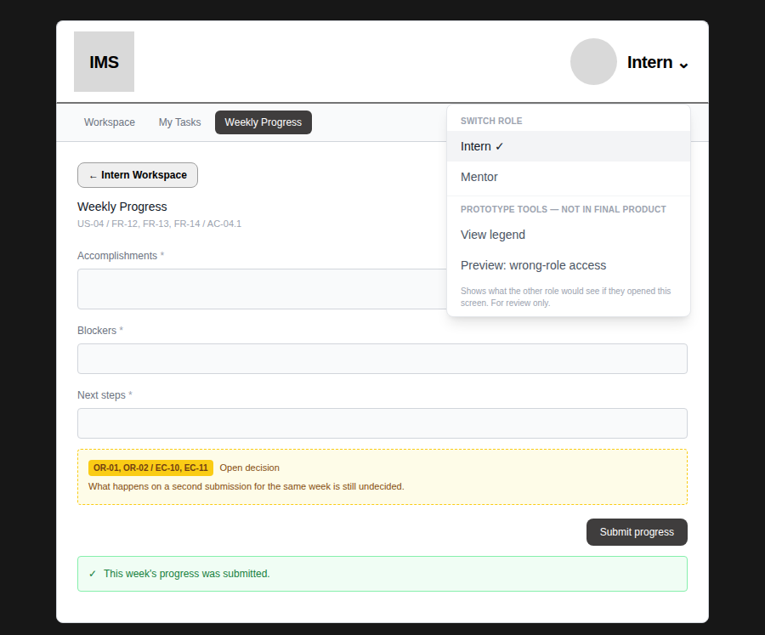
“View legend” and “Preview: wrong-role access” are labeled as review-only, not final-product features.
Figure 18 — Legend — key interactions and validation reference
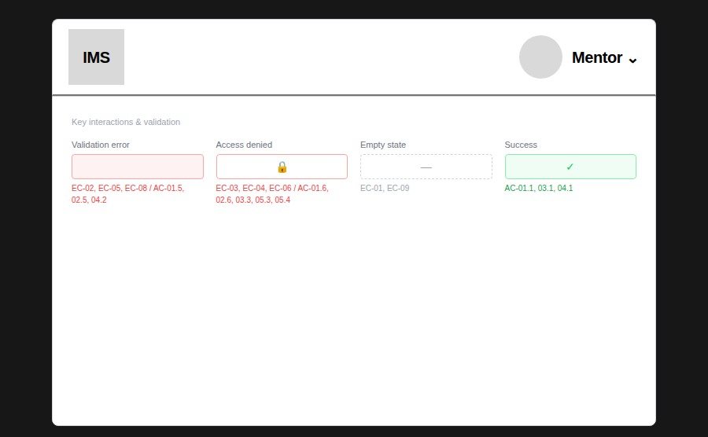
Figure 19 — Access denied — Intern previewing a Mentor-only screen (AC-05.3)
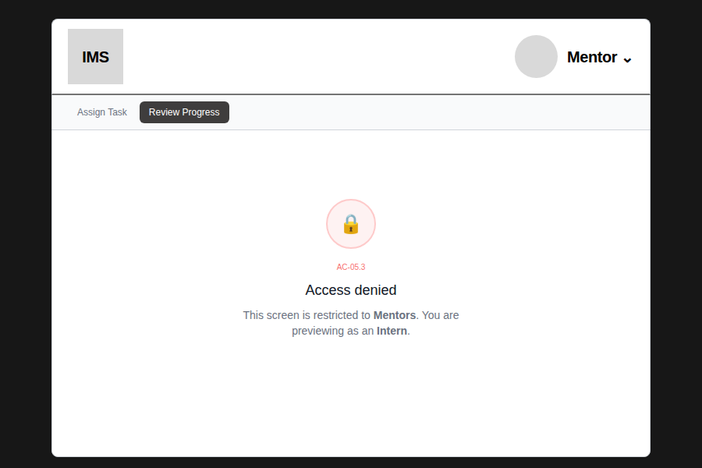
Figure 20 — Access denied — Mentor previewing an Intern-only screen (AC-02.6)
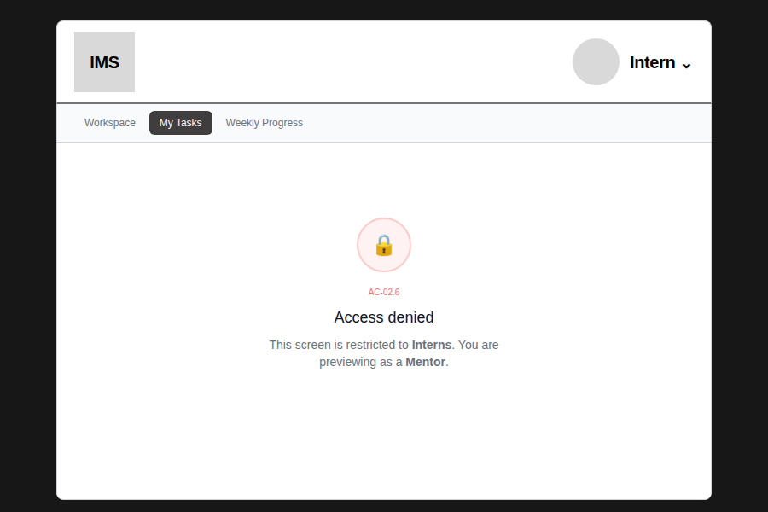
5. Notes and open items
- The Intern/Mentor role switcher and the wrong-role-access preview are review-only conveniences for this prototype stage. Neither will appear in the final product — role will come from the signed-in user's account, not a manual toggle.
- Item 1 (Week 3 Validation and Sprint 2 Readiness Coordination Record) could not be reviewed — this document has not been shared with UX. Please provide it if it affects scope.
- Item 10 (material BA updates) — no BA material has been received beyond the corrections already applied to the Detailed Wireframes doc. If new BA updates exist from this week, please share them.
- Individual Task Submission remains intentionally generic (OR-03) — no specific fields should be built against until content is confirmed.

