Applicant-to-Intern Onboarding — UX Review
Sprint 3 — Team 40 / Team B (Intern Management System for Social Enterprise Workforce Development)
Prepared by: Faridullah Jabbar Khil (s4020393) — UX
Task: [ONBOARDING UX REVIEW] – Applicant-to-Intern Transition · Sprint 3 · due 18/10/2026
Review type: post-implementation review of the live Intern workspace (two Intern accounts, 18 October 2026) and DEV’s code (PRs #21, #22 and #25)
Inputs: PM task description; earlier UX reviews “Team A/B Role Entry & Workspace” and “Integrated Workspace Navigation & Role-State Polish”; PM alignment document “Team A/B Role Routing & Workspace Alignment”

1. Purpose & Scope
PM task description
“Review the integrated Applicant-to-Intern journey after DEV completes the onboarding implementation. Focus on whether users can understand the transition from an accepted Applicant to an Intern, whether their account and navigation remain consistent, and whether the system provides clear guidance when entering the Intern workspace. Identify only the UX corrections necessary for a smooth onboarding experience.”

This review follows the two earlier UX reviews. It walks the journey in three steps: the accepted Applicant, the first Intern sign-in, and account and navigation continuity across the two. Every recommendation changes wording or presentation of behaviour that already exists; none adds business functionality.
What this review is and is not
Seen on screen: the live Intern workspace, with two Intern accounts. Read in code only: the Applicant side, the promotion step, the first-arrival (no tasks) state and the old-page behaviour after promotion. DEV’s onboarding PR (#25) contains tests only, with no new screens. Applicant sign-in and an accepted-Applicant screen were not seen, and whether an acceptance email is sent was not checked.

2. Summary
Already consistent — no change needed
One shared account: an Applicant promoted to Intern keeps the same email and password, and the role is read from the backend on every protected page, so promotion takes effect without a new login (from the code). Sign-in sends each role to its own workspace. The Intern header, tabs and wording are consistent across all four Intern pages.

Needs correction — 2 items, both High
A newly accepted Applicant gets no welcome or first-steps guidance when they arrive as an Intern (01), and the Sign out menu that DEV built is not on the live site (02). Full table in Section 5.

3. Journey Review

3.1 Accepted Applicant
The Applicant journey is the four-step application form at /application, which accepts Applicants only. Admin screening uses the statuses Submitted, Reviewing, Accepted and Rejected, and promotion to Intern is a confirmed admin action that “changes the candidate’s account role to Intern and locks their application profile”. There is no applicant-facing status or acceptance message in the app, because once promoted the person is routed to the Intern workspace instead of the Applicant page. The moment of acceptance is therefore the first Intern sign-in (finding 01).

3.2 First Intern sign-in
The promoted Intern lands on /intern/workspace, titled Intern Workspace, with summary cards and the My Tasks and Weekly Progress tiles (Fig. 1, Fig. 2). The screen is clear for an established Intern. For a new Intern it offers no explanation of what has changed or what to do first (finding 01).

3.3 Account and navigation continuity
The account is the same one used to apply, and the header shows the person’s name. The only continuity gap is that the live header has no account menu, so there is no way to sign out (finding 02). If a promoted person opens an old application link, DEV’s code shows “This area is for Applicants. You’re signed in as an Intern.” with a “Go to my workspace” button, which is clear (Section 6).
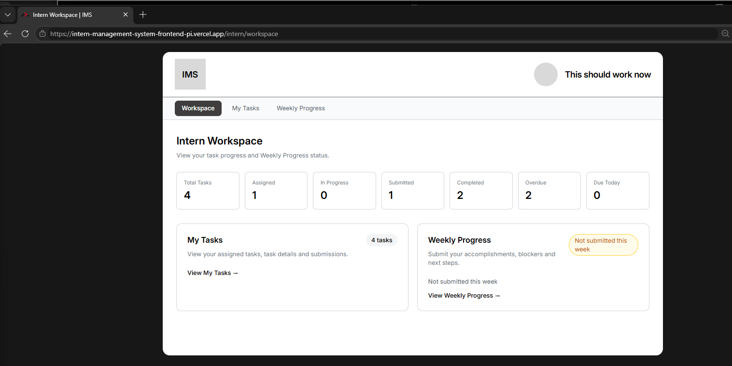
Fig. 1 — Live Intern workspace: empty avatar, plain name, no account menu
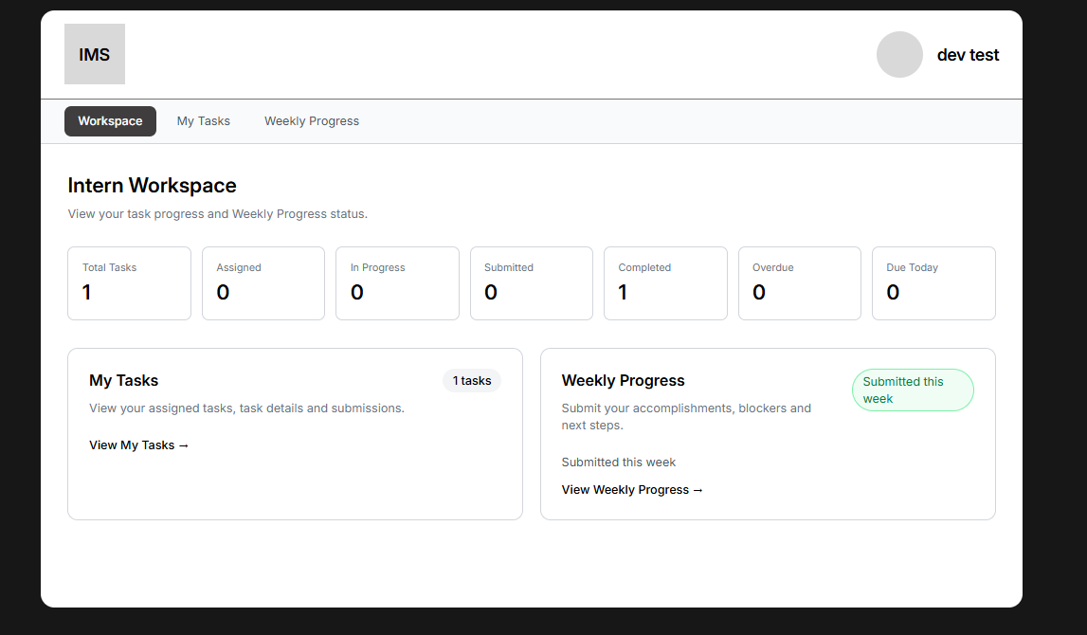
Fig. 2 — Second Intern account: same header, no account menu

4. Status of the Earlier Review Findings
The two corrections from the previous review have been built by DEV (PR #22), but the live site does not show them yet.
Earlier finding | Status | Evidence
Interns and Mentors cannot sign out | Fixed in code, not yet on the live site | DEV’s PR #22 adds an account menu with Sign out. The live headers still show an empty avatar and a plain name (Fig. 1, Fig. 2).
Access screen did not name the roles | Fixed in code, not seen live | PR #22 changes the message to “This area is for Interns. You’re signed in as a Mentor.” Read in code only.

5. Findings & Prioritised Correction Handoff
Two corrections, in the order DEV should apply them. Each Check names how to confirm the fix.
# | Priority | Finding & evidence | Correction for DEV | Check (BA / UX)
01 | High | Nothing tells a newly accepted Applicant that they are now an Intern, or what to do first  When an admin promotes an Applicant, the account role changes to Intern and the application is locked. The next sign-in goes straight to the standard Intern Workspace (/intern/workspace), the same screen every Intern sees (Fig. 1, Fig. 2). There is no applicant-facing acceptance status in the app, and the workspace has no welcome or first-steps wording. For a brand-new Intern with no tasks the screen shows seven zero counters, “0 tasks”, and an amber “Not submitted this week” label, which reads like something is overdue rather than “you have just started”. Both Intern accounts available for this review already had tasks, so the empty first-arrival screen was not captured; it is described from the code. | Add one short notice at the top of the Intern Workspace, shown only while the Intern has no tasks yet (no new data or setting needed): “Welcome, [name]. Your application was accepted and this is your Intern workspace. You sign in with the same email and password. Your Mentor will assign your first task, and it will appear under My Tasks.” Once a task exists the notice disappears and the workspace looks as it does today. | A newly promoted Intern signs in and sees the notice above the summary cards, with their name. After a Mentor assigns a task, the notice is gone. An Intern who already has tasks never sees it.
02 | High | The Sign out menu is not on the live site  Account continuity depends on being able to sign out and back in, for example when a promoted Applicant or a tester wants to check the new role. On the live site both Intern headers show an empty grey avatar and a plain name with no menu arrow (Fig. 1, Fig. 2), so there is no Sign out. DEV’s PR #22 adds the account menu (initials in the avatar, a menu arrow, and Sign out), but it is not what the live site is showing. | Deploy PR #22 to the live site. No design change is needed. | On the live site the header shows initials and a menu arrow for both Intern and Mentor; Sign out returns to /sign-in and the browser Back button does not reopen the workspace.

6. Open Items and Deferred Observations

Open items needing an owner
- Acceptance email: whether an email is sent when an Applicant is accepted or promoted was not checked, because it sits outside the frontend. If one exists, it should say that the same email and password are used. Owner: PM with Team A.
- First-arrival state: confirm finding 01 on a newly promoted account once DEV has built the notice. Owner: BA (Shakthijhaa).

Deferred — no action requested this sprint
Noted during the review. None is needed for a smooth onboarding experience.
- Old application page after promotion: the message is clear. A friendlier line such as “Your application is complete; your account is now an Intern account” would be polish only.
- Different page styles: the Applicant pages are a plain white form, while the Intern workspace uses the IMS header shell. The Intern first meets the IMS shell at promotion. Finding 01 gives the guidance at that point, so no separate change is needed.

7. Handoff to DEV
For DEV (Chan)
Apply findings 01 and 02 in order. 01 is one short notice on the Intern Workspace, shown only while the Intern has no tasks; use the wording in Section 5 or similar. 02 is a deployment: PR #22 is already built and only needs to reach the live site. Keep the shared authentication foundation and existing Team B Core MVP behaviour unchanged. BA validates the result against the deployed build.

Files: this document; the earlier UX reviews listed above.

