BA Feedback Response
Core MVP Detailed Wireframes — corrections applied and confirmed
Team: Team 40 / Team B — Intern Management System
Deliverable: Core-MVP-Detailed-Wireframes.docx
UX Designer: Faridullah Jabbar Khil
BA Reviewer: Shakthijhaa Sivagnanam
PM: Jianqi Lu
Sprint: Sprint 1 — Design & Bootstrap
Source feedback: Team40_TeamB_Core_MVP_Wireframe_BA_Feedback_Shakthijhaa_S4065078.pdf
1. Purpose
This document records how the Core MVP Detailed Wireframes were revised in response to the Business Analyst review, and confirms that both the BA and PM have since signed off on the corrected version.
2. BA Review Outcome
The BA review confirmed that the wireframes align with the current Team B Core MVP baseline and that no screen-layout redesign was required. Two traceability corrections were identified for the supporting documentation and one on-screen annotation.
3. Corrections Addressed
3.1 Ownership-table citation
- Issue identified: Section 9 of the Applicant-to-Intern Transition document (Client-Supported Decisions), not Section 6 (Team A/Team B Ownership Boundaries).
- Correction applied: The citation in the Detailed Wireframes doc (Section 7, “Explicitly not in this file”) was corrected from Section 9 to Section 6.
- Status: Applied and confirmed by BA.
3.2 Assign Task field justification
- Issue identified: WA-08 still lists Status as part of minimum Task Assignment information, without distinguishing Mentor-entered fields from the system-set initial status.
- Correction applied: The citation was corrected from WA-08 to FR-02 (Mentor is not required to manually select initial status) and FR-03 (system sets Assigned automatically) — updated in the document text and in the wireframe's own on-screen annotation. The Assign Task screenshot was re-captured to reflect the corrected text.
- Status: Applied and confirmed by BA. Per BA feedback, the WA-08 update in the transition document itself is a separate BA action, not a UX one.
Before / after — Assign Task screen
Before (WA-08 reference)
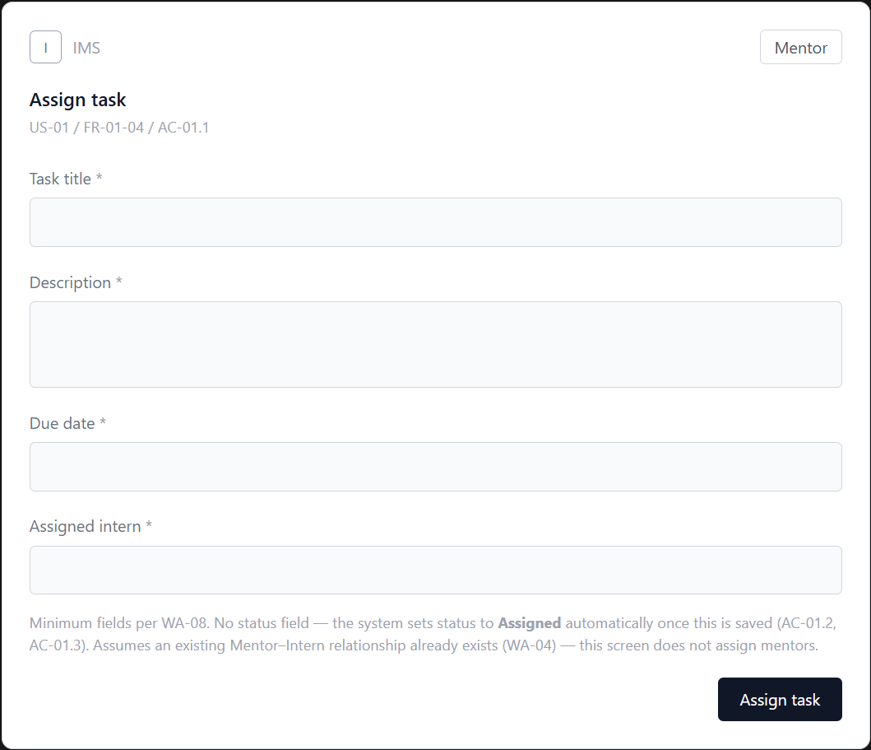
After (FR-02 / FR-03 reference)
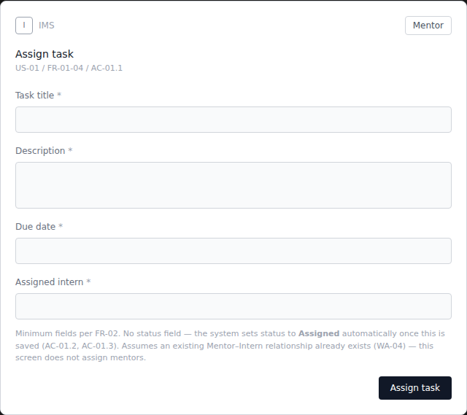
Both rendered directly from the wireframe code — the “before” from the originally reviewed file, the “after” from the corrected version submitted for BA re-check.
4. Confirmed Wireframe Decisions (unchanged)
The following were reviewed and confirmed correct as originally designed — no changes were required:
- Individual Task Submission is intentionally generic, with no labeled fields, since submission content remains an open requirement (OR-03).
- All three Weekly Progress fields (Accomplishments, Blockers, Next Steps) are required under the current Week 2 baseline.
- The Assigned → In Progress → Completed task-status flow may remain as designed; skip/reverse/post-completion rules stay open under OR-06.
5. Sign-off
“Thank you for the update. I've reviewed the latest version and confirmed that both corrections from my BA review have now been applied correctly. The ownership-table reference has been updated from Section 9 to Section 6, and the Assign Task traceability has been corrected to FR-02/FR-03 in both the document text and the updated wireframe annotation. Everything now aligns with the current Week 2 BA baseline, and I don't have any further required changes from the BA side at this stage.”
— Shakthijhaa Sivagnanam, Business Analyst
“I've completed the BA review of the updated Core MVP Detailed Wireframes. I've checked the revised UX document against the BA feedback, and both requested traceability corrections have now been applied correctly. From the BA side, the document now aligns with the current Week 2 requirements and I have no further required changes at this stage.”
— Jianqi Lu, Project Manager
6. Note on deliverable versioning
During review, the Deliverable link briefly pointed to an outdated copy of the document, so an initial BA re-check still showed the pre-correction references. This was traced to the linked file not matching the corrected version; the corrected file was re-shared directly, after which BA confirmed both corrections were present as intended.

