Core MVP Wireframe Review, Revision and Prototype
Checklist status record
Team: Team 40 / Team B — Intern Management System
Task: [UX] — Core MVP Wireframe Review, Revision and Prototype
UX Designer: Faridullah Jabbar Khil
Sprint: Sprint 1 — Design & Bootstrap
Related deliverables: Core-MVP-Detailed-Wireframes.docx; Core MVP Prototype (Figma Make)

1. Purpose
This document consolidates evidence for the 8 checklist items on this task. Five items were confirmed through BA review, PM review, and prior deliverables rather than new design work; this record exists so that confirmation is traceable in one place rather than scattered across chat and review documents. Two items remain genuinely pending on other people's input and are marked as such, not assumed complete.

2. Checklist status
Item | Status | Evidence
1. Task Submission / Weekly Progress distinguished | Done | Confirmed by BA review — Section 3
2. Requirements-to-screen coverage confirmed | Done | Detailed Wireframes doc, Section 3 mapping table
3. BA review completed, alignment confirmed | Done | BA feedback received; 2 corrections applied and confirmed — Section 4
4. Approved Week 2 changes verified in design | Done | Task status flow, Weekly Progress fields, Task Submission — Section 5
5. Shared Team A/Team B UX conventions reviewed | Pending | Message sent to Wyatt (Team A UX) — Section 6
6. Revised wireframes approved for prototyping | Done | PM approval, Jianqi Lu — Section 7
7. Core MVP prototype created, key flows connected | Done | Figma Make prototype — Section 8
8. Prototype reviewed, ready for Week 3 | Pending | Submitted to PM for review — Section 9

3. Item 1 — Task Submission and Weekly Progress distinguished
Confirmed by BA review (Shakthijhaa Sivagnanam): “The generic Task Submission treatment is correct... Weekly Progress should remain separate from individual Task Submission.” Reflected in the wireframe and prototype: Task Submission lives inside Task Detail (per-task), Weekly Progress is a standalone Workspace-level screen (FR-14, WA-09).

4. Item 2 — Requirements-to-screen coverage
Full mapping is documented in Core-MVP-Detailed-Wireframes.docx, Section 3 — every screen tied to its US/FR/AC code. Not duplicated here to avoid two sources of truth; see that document for the complete table.

5. Item 3 — BA review completed and requirements alignment confirmed
BA review received from Shakthijhaa Sivagnanam. Overall outcome: wireframes align with the Team B Core MVP baseline, no screen-layout redesign required. Two traceability corrections were identified and applied:
- Ownership-table citation corrected from Section 9 (Client-Supported Decisions) to Section 6 (Team A/Team B Ownership Boundaries) of the transition document.
- Assign Task field justification corrected from WA-08 to FR-02/FR-03, both in the doc and in the wireframe's on-screen annotation — the screenshot was re-captured to match.
Confirmed back to Shakthijhaa directly after applying both corrections.

6. Item 4 — Approved Week 2 changes verified in the design
- Task status flow (Assigned → In Progress → Completed, system-set initial status): confirmed may remain; skip/reverse/post-completion rules remain open under OR-06.
- Weekly Progress fields (Accomplishments, Blockers, Next Steps, all required): confirmed correct per FR-13, AC-04.2, WA-06 — the old “Blockers optional” distinction does not carry over.
- Individual Task Submission (generic, no labeled fields): confirmed correct per FR-10, AC-03.5, OR-03 — content remains an open requirement.

7. Item 5 — Shared Team A/Team B UX conventions reviewed
Status: Pending. A message has been sent to Wyatt (Team A UX) covering the landing page split (Applicant vs Intern sign-in), login/authentication look, shared navigation and layout conventions, and the Applicant-to-Intern transition hand-off screen. [Insert Wyatt's response and date once received.] This does not block prototype delivery per PM's approval, which noted the remaining clarification does not block the current deliverable.

8. Item 6 — Revised wireframes approved for prototyping
PM approval received from Jianqi Lu: “Approved as complete and ready to be used as the UX baseline for the next Sprint 1 prototype and handoff work.”

9. Item 7 — Core MVP prototype created and key flows connected
Built as a single connected Figma Make prototype (not static stacked screens). Carries over all requirement citations and BA-review corrections from the Detailed Wireframes.
- Real navigation: Intern Workspace → My Tasks → Task Detail, with working back-navigation
- Role switcher: toggles between Intern nav (Workspace / My Tasks / Weekly Progress) and Mentor nav (Assign Task / Review Progress)
- Task status control on Task Detail actually advances Assigned → In Progress → Completed
- Task Submission section expands/collapses in place, generic per OR-03
- Demo toggles reproduce the empty-state screens (My Tasks, Review Progress) without needing separate static pages
- “Preview: wrong-role access” control makes the access-denied state a real, reachable interaction tied to the correct AC code for whichever screen is active, rather than only a legend entry
Note: the Intern/Mentor role switcher and the “Preview: wrong-role access” control shown in this prototype are review-only conveniences, so both role experiences and the denial state can be checked from a single file. Neither will appear in the final product — role is determined by the signed-in user's actual account, not a manual toggle.

10. Item 8 — Prototype reviewed and ready for Week 3
Status: Pending. Prototype submitted to Jianqi Lu for review. [Insert PM review outcome and date once received.]

11. Prototype evidence
Rendered directly from the prototype code (Figma Make) — these are real screenshots of the running app, not mockups.
Figure 1 — Intern Workspace
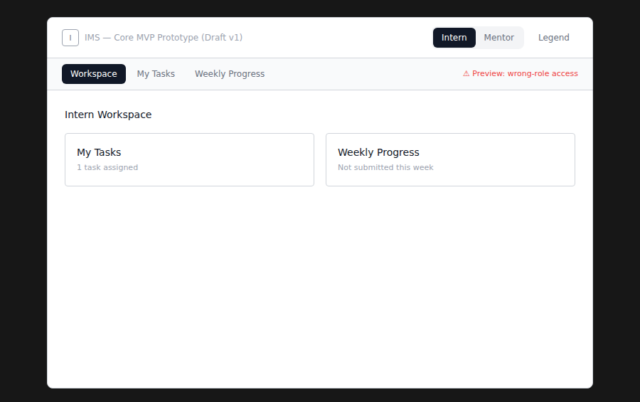
Figure 2 — My Tasks → Task Detail
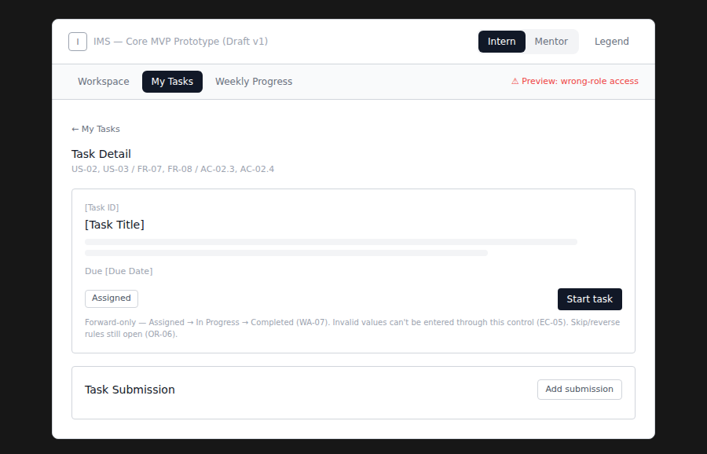
The “My Tasks” tab is active and the breadcrumb shows the drill-down — confirms this is real navigation, not a static frame.
Figure 3 — Assign task (Mentor nav)
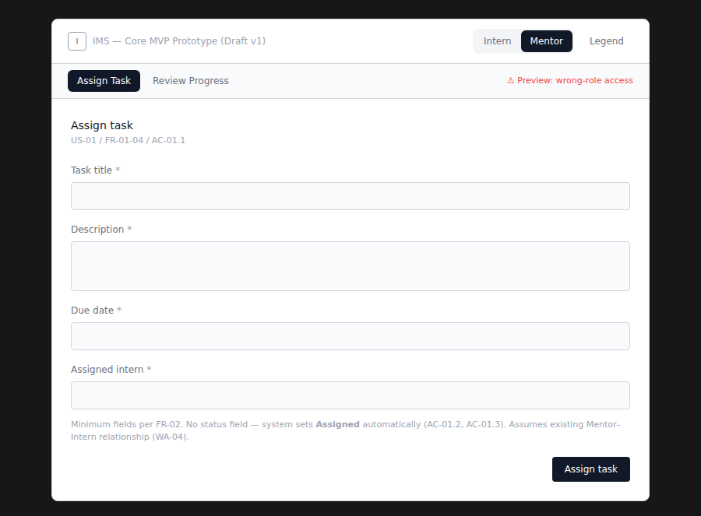
Confirms the FR-02 correction from the BA review is live in the running prototype, not just the static wireframe doc.
Figure 4 — “Preview: wrong-role access” state
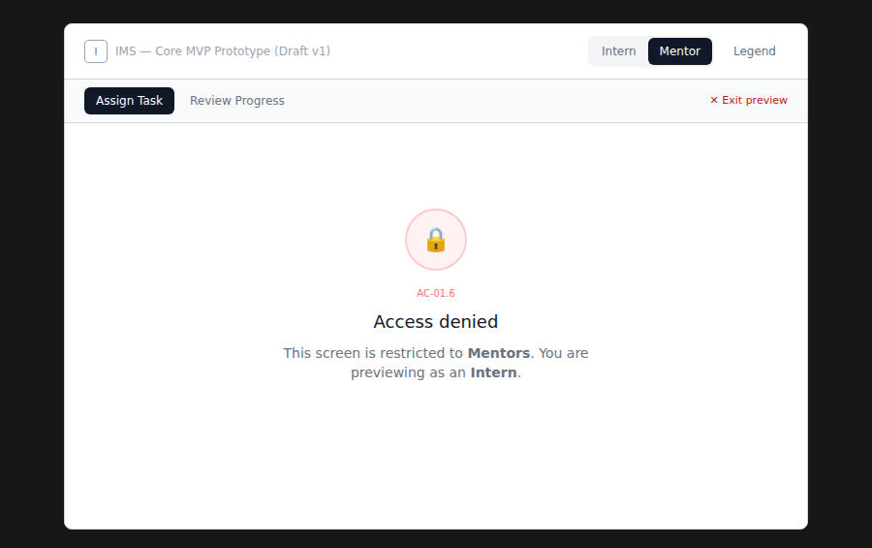
Shown here previewing Assign Task (Mentor-only, AC-01.6) as an Intern.

