Integrated Workspace Navigation & Role-State Polish — UX Review
Sprint 3 Week 1 — Team 40 / Team B (Intern Management System for Social Enterprise Workforce Development)
Prepared by: Faridullah Jabbar Khil (s4020393) — UX
Task: [UX REFINEMENT] – Integrated Workspace Navigation & Role-State Polish · Sprint 3 Week 1 · due 11/10/2026
Review type: post-implementation review of the deployed build (main, including Team A’s RBAC merge #20) with Intern and Mentor test accounts; DEV’s PR #21 read in code
Inputs: PM task description; PM alignment document “Team A/B Role Routing & Workspace Alignment” (9 October 2026); BA “Role-Based Routing Requirements & Acceptance Criteria”; the earlier UX review “Team A/B Role Entry & Workspace — UX Review”

1. Purpose & Scope
PM task description
“Review the implemented role-based routing and integrated workspaces after DEV completes the first routing pass. Check that Applicant, Intern and Mentor users arrive in the expected context and that navigation, terminology, role-state presentation and visible actions remain consistent with the approved Core MVP and shared IMS experience. Record only focused UX corrections required for final Core MVP integration; do not introduce new business functionality.”

This review follows last night’s entry-flow review. It checks what is now live: where each role lands after login, and whether navigation, terminology, role state and visible actions are consistent inside the Intern and Mentor workspaces. Every recommendation changes presentation or wording of behaviour that already exists; none adds business functionality.
What this review is and is not
Evidence comes from the deployed build, signed in once as an Intern and once as a Mentor. DEV’s PR #21 (role-aware post-login routing, “Go to my workspace” button, unknown-role screen) was read in code only and was not yet deployed, so it is noted where relevant but not judged on screen. The inner pages (My Tasks, Task Detail, Weekly Progress, Review Progress) were checked in code for header and tab consistency; the live screens seen were the two landing pages and the access screens. Applicant sign-in was not tested.

2. Summary
Already consistent — no change needed
Each role lands in its own workspace after login. The shared header shell, tab bar and name display are the same across all four Intern pages and both Mentor pages. Wrong-role URLs no longer show the other role’s workspace. Last night’s two findings are fixed or largely fixed on the deployed build (Section 4).

Needs correction — 2 items
Interns and Mentors have no way to sign out (01, High), and the access screen does not name the roles involved (02, Medium). Full table in Section 5. Smaller observations are in Section 6.

3. Entry & Workspace Review

3.1 Applicant
Not tested. In PR #21 a new registration goes to the Team A application form (/application), and that route accepts Applicants only. Applicants are not otherwise affected by the findings below.

3.2 Intern
After login the Intern lands on /intern/workspace, titled Intern Workspace, with summary cards and the tabs Workspace | My Tasks | Weekly Progress (Fig. 1). The header and tabs are repeated unchanged on My Tasks, Task Detail and Weekly Progress. Navigation and terminology are consistent. The only gap is the missing Sign out (finding 01).

3.3 Mentor
After login the Mentor lands on /mentor/tasks/assign (Assign Task), with the tabs Assign Task | Review Progress (Fig. 2). The header matches the Intern header and shows the Mentor’s name, and the form shows “Assigned by: [name] (you)”. Navigation is consistent. The same missing Sign out applies (finding 01).
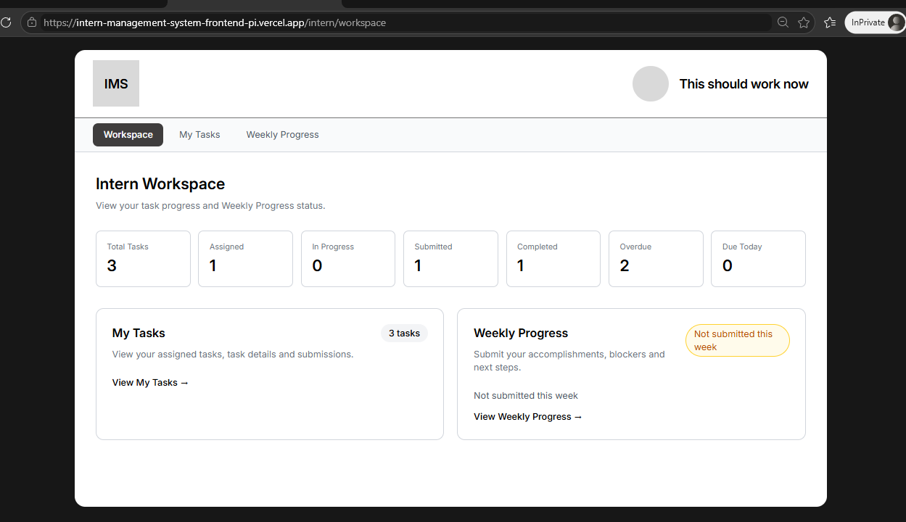
Fig. 1 — Intern lands on /intern/workspace: name shown, no Sign out
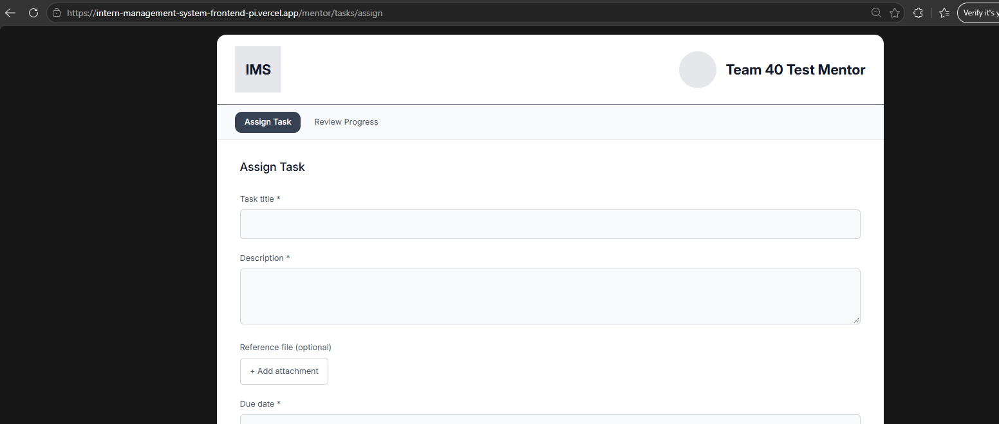
Fig. 2 — Mentor lands on /mentor/tasks/assign: same header, no Sign out

4. Status of the Earlier Review Findings
Last night’s review raised two High findings against the deployed build as it was then. Team A’s RBAC merge (#20) has since changed it.
Last night’s finding | Status on deployed build | Evidence
Intern login landed on the applicant form | Fixed | Intern now lands on /intern/workspace (Fig. 1); Mentor lands on /mentor/tasks/assign (Fig. 2).
Wrong-role URL showed the other role’s workspace | Mostly fixed | A Mentor opening /intern/workspace now gets a 403 screen with a Return button (Fig. 3). The wording is still generic (finding 02).
No screen for an unknown role | In DEV PR #21, not yet deployed | PR #21 adds “We couldn’t find a workspace for your account” with Sign out. Read in code only; not seen live.

5. Findings & Prioritised Correction Handoff
Two corrections, in the order DEV should apply them. Each Check names how to confirm the fix, with BA criteria where one applies.
# | Priority | Finding & evidence | Correction for DEV | Check (BA / UX)
01 | High | Interns and Mentors cannot sign out  The Intern and Mentor headers show only an avatar and the user’s name (Fig. 1, Fig. 2). Neither is clickable and there is no Sign out anywhere in either workspace. In the code, Sign out exists only on the Admin screens (the AdminAccount menu) and, in PR #21, on the unknown-role screen. Anyone who needs to leave an account, such as a tester switching between Intern and Mentor or a shared computer, has no way to do it from the interface. | Reuse the existing AdminAccount pattern in the Intern and Mentor headers: the name and avatar become a small menu with Sign out, and Sign out returns to /sign-in. Make it one shared header component so all four Intern pages and both Mentor pages get it. No other header change. | Signed in as Intern: open the header menu, choose Sign out, land on /sign-in; the browser Back button does not reopen the workspace. Repeat as Mentor. Both roles show the same menu.
02 | Medium | The access screen does not say which role the area is for  A Mentor opening an Intern URL lands on /unauthorized: “403 — You cannot access this page. Your account does not have permission to view this area.” with a Return button (Fig. 3). It does not name the area, the role it is for or the role the user is signed in as, and “Return” does not say where it leads. DEV’s PR #21 changes the button to “Go to my workspace” but keeps the generic wording. | Keep PR #21’s “Go to my workspace” button. Change the message to name both roles, for example: “This area is for Interns. You’re signed in as a Mentor.” Keep the screen otherwise as it is (same layout, same 403 label). | Mentor opens /intern/workspace and Intern opens /mentor/tasks/assign: each sees the message naming both roles, and the button lands in their own workspace. BA: AR-06, AC-RR07.

Supporting evidence for finding 02
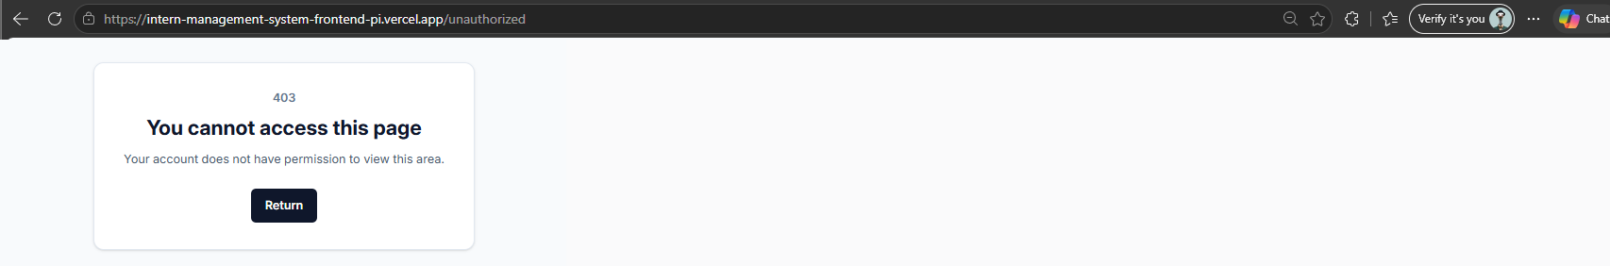
Fig. 3 — Mentor on /intern/workspace: generic 403 message, “Return” button

6. Open Items and Deferred Observations

Open items needing an owner
- Merge order: PR #21 is approved but was not on the deployed build when this review was done. Its “Go to my workspace” button and unknown-role screen should be confirmed after merge. Owner: DEV (Chan) with Team A.
- The Check column for finding 01 has no BA criterion behind it, since sign-out is not in the routing rules. Owner: BA (Shakthijhaa) to decide whether to add one.

Deferred — no action requested this sprint
Noted during the review. None is needed for final Core MVP integration.
- Home page: the public home page (/) shows “Start or continue your internship application” with Create account and Sign in (Fig. 4). If a signed-in Intern or Mentor opens it, they see applicant-only wording. To confirm with a signed-in account before any change.
- Header fallback: where a name is missing, the header shows the bare role (“Intern” or “Mentor”). Likely test data; worth showing the email instead.
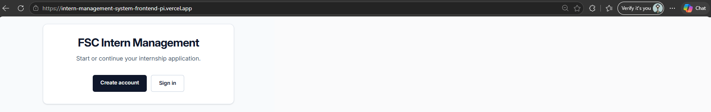
Fig. 4 — Home page (/): applicant-only wording

7. Handoff to DEV
For DEV (Chan)
Apply findings 01 and 02 in order. 01 is one shared header component: reuse the existing AdminAccount menu so Interns and Mentors get the same name menu with Sign out. 02 is a wording change on /unauthorized; keep the “Go to my workspace” button from PR #21 and name both roles in the message. Keep the shared authentication foundation and existing Team B Core MVP behaviour unchanged. After PR #21 is merged, re-check the unknown-role screen and the redirect. BA validates against the deployed build.

Files: this document; the earlier review “Team A/B Role Entry & Workspace — UX Review”.

